Devotion on Lenten Hymns – Lo! He comes, an Infant Stranger - 27 November 2018, Anno Domini

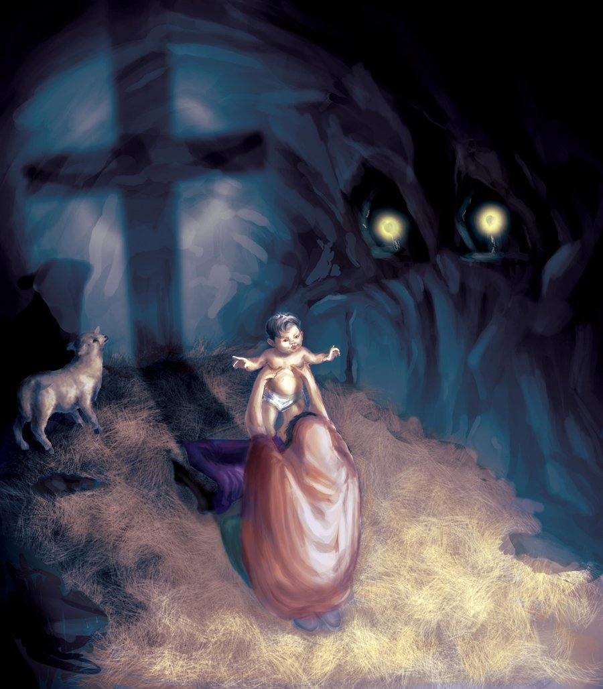

W
ho hath believed our report? and to whom is the arm of the LORD revealed? 2 For he shall grow up before him as a tender plant, and as a root out of a dry ground: he hath no form nor comeliness; and when we shall see him, there is no beauty that we should desire him. 3 He is despised and rejected of men; a man of sorrows, and acquainted with grief: and we hid as it were our faces from him; he was despised, and we esteemed him not. (Isaiah 53:1-3)

This hymn does not appear in the 1940 Hymnal, but is a classic among Advent/Christmas hymns and carols. Written in 1833 by Richard Mant, the tune is the composition of Martin Madan entitled, HELMSLEY. It speaks of the commonality of appearance in the coming of the Lord Jesus Christ at first Advent. He died a shameful death as well, but those points are the ones that raises His glory and purpose above every other. He was a Prince, a King, the Son of God – yet, He did not hesitate to offer His all on a cruel cross for us. He was a stranger whom we esteemed not.

Lo! He Comes an Infant Stranger

Lo! he comes, an infant stranger, of a lowly mother born,
Swathed and cradled in a manger, of his pristine glory shorn!
Hallelujah! hallelujah! hallelujah! Praise the incarnate Word of God!

Lo! he comes, by man unfriended, fain with stable-beast to rest;
Shepherds, who their night-fold tended, hailed alone the new-born guest.
Hallelujah! hallelujah! hallelujah! Praise ye Jesse's tender rod!

Lo! he comes; but who the weakness of his coming may declare,
When, with more than human meekness, more than human woes he bare?
Hallelujah! hallelujah! hallelujah! Praise him, emptied of his might!

Lo! he comes, around him pouring all the armies of the sky;
Cherub-, seraph-host, adoring, swell his state and loudly cry:
Hallelujah! hallelujah! hallelujah! Praise ye him, the living Light!

Lo! he comes, around him pouring all the armies of the sky; Cherub-, seraph-host, adoring, swell his state and loudly cry: Hallelujah! hallelujah! hallelujah! Praise ye him, the living Light! There is much contradiction in the first coming of Christ and the second. Indeed, His first coming was attended by the singing of the heavenly chorus, but only a select few heard that divine performance; and these were mere lowly shepherds – not the royalty of the palace grounds. He came as a baby, but He also came in might. Even as a baby in a manger, He yet wielded the scepter of infinite Sovereignty. His title and claim was wrapped up in that of the Father, and the Father in Him. He came a Light shining in darkness and, of course, the darkness comprehended it not. Judah, and the entire world, was shrouded in primitive spiritual darkness ere the Son of God came as a child in a manger. He was born quietly and without ceremony in a small but historic hamlet called Bethlehem. Wherever His name is called in faith today, there you will see the Light that penetrated the darkness from the first day of Creation.

Lo! he comes, by man unfriended, fain with stable-beast to rest; Shepherds, who their night-fold tended, hailed alone the new-born guest. Hallelujah! hallelujah! hallelujah! Praise ye Jesse's tender rod! Indeed, He came by man unfriended. There was not even room found for Him in the Inn. Perhaps there is no room for Him today in the Inn of your heart, but I pray that there is. The beasts of burden, and of sacrifice, among which our Lord was born were privileged far above us to witness this glorious event. Without Christ in our hearts, we are worse than those beasts for they saw Him and knew Him if only for a night. The beasts of the field cry also unto thee. . . . (Joel 1:20) If the beasts cry unto God, how much more should we who are endowed with greater spiritual awareness? Shepherds were the lowest of the lot in Israel; yet these were honored above kings and princes to witness that Holy Night and the Angel Choir. These poor men were the only witnesses of that first night of jubilation.

Lo! he comes; but who the weakness of his coming may declare, When, with more than human meekness, more than human woes he bare? Hallelujah! hallelujah! hallelujah! Praise him, emptied of his might! Not emptied of His might, but having that might held in reserve by the Providence of the Father. Yes, He was born among the beasts of the field, and laid in a manger – an instrument for the feeding of beasts. But He also came as the Bread of Heaven to feed our emaciated souls and to quench, as the Water of Life, our spiritual thirst. He was, at the same time, the poorest among us and the wealthiest! We can take nothing from the glory of His coming. That Angelic Choir that heralded His first coming shall return with Him in the Armies of Heaven to bring Judgment upon the dying world of sin and greed.

Lo! he comes, around him pouring all the armies of the sky; Cherub-, seraph-host, adoring, swell his state and loudly cry: Hallelujah! hallelujah! hallelujah! Praise ye him, the living Light! Unless we consider the bending of light near massive gravitational bodies in distant space, light always travels in a straight line. It does not make banking turns. It is steady as long as the Source remains steady. After 400 hundred years of darkness – from the close of Malachi’s prophecy until John the Baptist – the people that walked in darkness have seen a great light: they that dwell in the land of the shadow of death, upon them hath the light shined. (Isaiah 9:2)

That Light came as a candle (a small baby); but was truly the Light of the World and the Sun of Righteousness! (see Malachi 4:2) As the Candle of the Lord burned during His ministry, He waxed greater in revealed Light for us. We have also a more sure word of prophecy; whereunto ye do well that ye take heed, as unto a light that shineth in a dark place, until the day dawn, and the day star arise in your hearts: (2 Peter 1:19) The faith of Abraham was born up on the Promise of a coming Messiah. But we today have a more sure Word in the accomplished event. The dawning of the day is a gradual revelation of more and more light until the Day Star (the Sun of Righteousness) arises in our hearts and we know and understand more fully.

Yes, He is the Light of the world; and He tells us that we who are the called according to His purpose are also the Light of the world, but not in the same sense as is He. He is the Light Source (as the Sun) and we bear His reflected Light (as the Moon). We must carry the Light always and every place. We must all be the Olympic Torchbearers for Christ. As they carry the torch of friendly competition from Mt. Olympus to every country wherein the world event occurs, we must carry the Torch of Christ to every nation, kindred, and tongue of God’s green earth. Perhaps we should begin, as did Christ, with our neighbors.

