Hymns of the Church – Lift up your Heads, Ye Mighty Gates – 20 March 2018, Anno Domini (In the Year of our Lord)

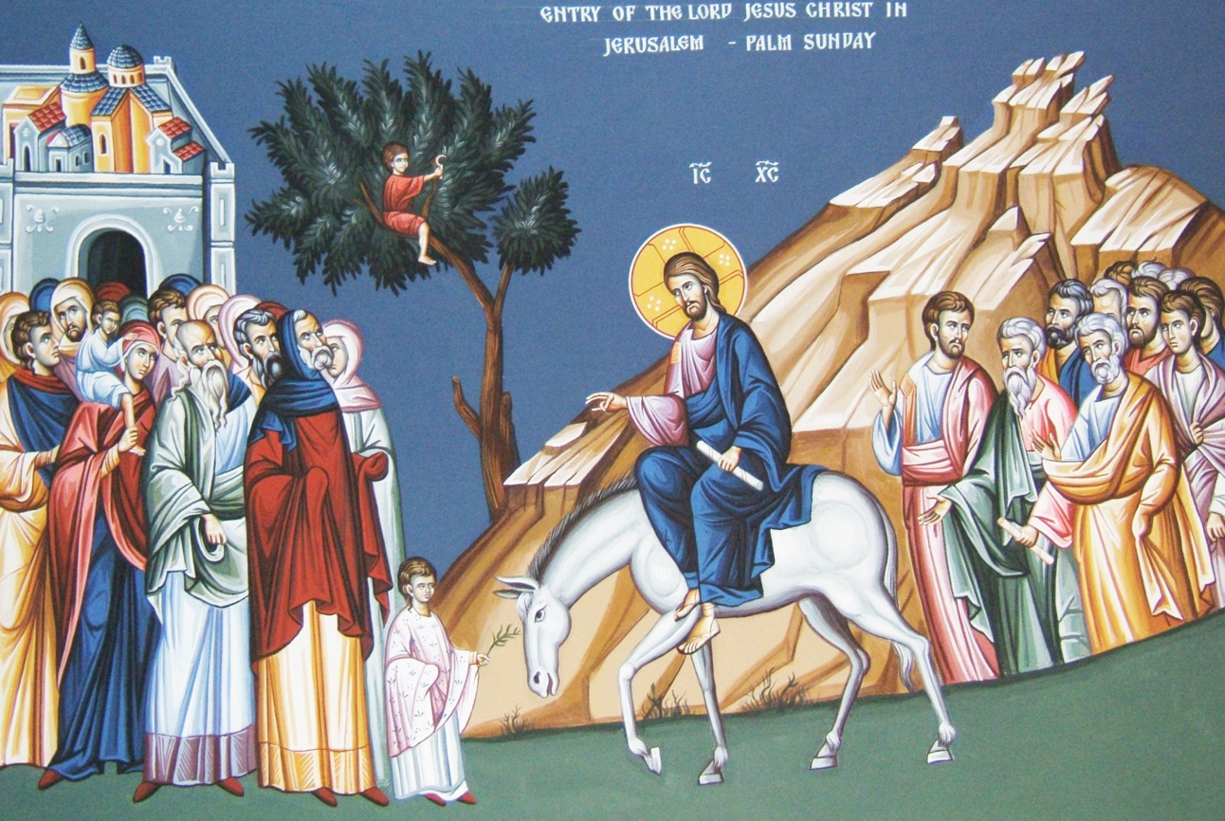

A
nd when they drew nigh unto Jerusalem, and were come to Bethphage, unto the mount of Olives, then sent Jesus two disciples, 2 Saying unto them, Go into the village over against you, and straightway ye shall find an ass tied, and a colt with her: loose them, and bring them unto me. 3 And if any man say ought unto you, ye shall say, The Lord hath need of them; and straightway he will send them. 4 All this was done, that it might be fulfilled which was spoken by the prophet, saying, 5 Tell ye the daughter of Sion, Behold, thy King cometh unto thee, meek, and sitting upon an ass, and a colt the foal of an ass. 6 And the disciples went, and did as Jesus commanded them, 7 And brought the ass, and the colt, and put on them their clothes, and they set him thereon. 8 And a very great multitude spread their garments in the way; others cut down branches from the trees, and strawed them in the way. 9 And the multitudes that went before, and that followed, cried, saying, Hosanna to the Son of David: Blessed is he that cometh in the name of the Lord; Hosanna in the highest. 10 And when he was come into Jerusalem, all the city was moved, saying, Who is this? 11 And the multitude said, This is Jesus the prophet of Nazareth of Galilee. (Matt 21:1-11)

Majestic and grand is this martial tune of the Lord’s entry into the gates of Jerusalem – both geographical and Heavenly. This Lenten hymn is the composition of Georg Weissel in 1642 and translated into the English from the German by Catherine Winkworth in 1855. The compelling musical score is titled, TRURO, by Thomas Williams published in 1789. The majesty and grandeur of Christ is anciently depicted and preserved in this hymn – even its title.

Lift up your Heads, Ye Mighty Gates

Lift up your heads, ye mighty gates;
Behold, the King of glory waits;
The King of kings is drawing near;
The Savior of the world is here!

O blest the land, the city blest,
Where Christ the Ruler is confessed!
O happy hearts and happy homes
To whom this King in triumph comes!

Fling wide the portals of your heart;
Make it a temple, set apart
From earthly use for heaven’s employ,
Adorned with prayer and love and joy.

Redeemer, come, with us abide;
Our hearts to Thee we open wide;
Let us Thy inner presence feel;
Thy grace and love in us reveal.

So come, my Sov’reign; enter in!
Let new and nobler life begin;
Thy Holy Spirit guide us on,
Until the glorious crown be won. Amen

Lift up your heads, ye mighty gates; Behold, the King of glory waits; The King of kings is drawing near; The Savior of the world is here! Just as the Sun rises in the east, so it is expected that Christ shall appear as the Sun of Righteousness in the east as He returns. He approaches Jerusalem from the east on Palm Sunday which gate was likely the Golden Gate on the east wall of the city facing the Mount of Olives and the Kidron Valley. Those gates of Jerusalem had brooded over many terrible and sad moments, as well as days of joy. They now are to have their longing fulfilled in the prophesied Messiah coming, as prophesied, through the East Gate, or Golden Gate. 7 Lift up your heads, O ye gates; and be ye lift up, ye everlasting doors; and the King of glory shall come in. 8 Who is this King of glory? The Lord strong and mighty, the Lord mighty in battle. 9 Lift up your heads, O ye gates; even lift them up, ye everlasting doors; and the King of glory shall come in. 10 Who is this King of glory? The Lord of hosts, he is the King of glory. Selah. Psalms 24:7-10 (KJV) The advance of our Lord into that gate symbolized a far greater gate of future promise – the very gates of Heaven. He would enter as a King, but depart with the crowns of all kingdoms. The long darkness is over, and joy cometh in the morning. That Gate is shut today in accordance with prophecy: This gate shall be shut, it shall not be opened, and no man shall enter in by it; because the LORD, the God of Israel, hath entered in by it, therefore it shall be shut. (Ezekiel 44:2)

O blest the land, the city blest, Where Christ the Ruler is confessed! O happy hearts and happy homes To whom this King in triumph comes! Though our Lord made His royal procession into old Jerusalem, He was figuratively entering New Jerusalem on High. The land and city that were blest by His triumphal entry was not restricted to the manmade city limits of Jerusalem, but to every nation, tribe, and tongue who confesses the faith and promise of Abraham. Old Israel was merely a symbol of that which was to come. They were a beginning point for the revelation of God to the world, her rulers having rejected Christ, The old physical kingdom failed of the law and prophets. The Jewish leaders, priests, scribes and Pharisees failed to accept Christ (though I firmly believe they knew precisely who He was); therefore were the keys of the kingdom taken from them and given to those who believed that same promise made to Abraham whether Jew, Greek, Man, woman, or stranger in the land. Therefore say I unto you, The kingdom of God shall be taken from you, and given to a nation bringing forth the fruits thereof. (Matt 21:43 (KJV) and, 6 Even as Abraham believed God, and it was accounted to him for righteousness. 7 Know ye therefore that they which are of faith, the same are the children of Abraham. 8 And the scripture, foreseeing that God would justify the heathen through faith, preached before the gospel unto Abraham, saying, In thee shall all nations be blessed. (Gal 3:6-8) Those all nations include you and me, friend.

Fling wide the portals of your heart; Make it a temple, set apart From earthly use for heaven’s employ, Adorned with prayer and love and joy. Perhaps you never considered the portals of your heart to be mighty gates, but they are the mightiest gates to which you have access. If the King of Love has entered into those mighty gates, He will abide there forever and become your Lord and Sovereign. That dwelling place will always reflect the tastes and character of its Sovereign. Prayer, love, and joy are not predicated upon any external, environmental concerns. The heart is a strong fortress if the Lord abides therein. When war parties gather without the gates, life and joy continue within the strong walls, towers, and ramparts of the fortress.

Redeemer, come, with us abide; Our hearts to Thee we open wide; Let us Thy inner presence feel; Thy grace and love in us reveal. It is not written that the Lord will sojourn (visit for a time) with all who accept His Lordship – rather He promises to ABIDE (live with forever) with those persons. The ruler of the soul is the heart. If the heart is filled with hate and demons, then the outward behavior will reflect that character. But if the King of Glory abides in our hearts, who is full of mercy and grace; we will likewise exhibit that same character of mercy, grace, and love to others. We are his subjects, His brothers and sisters, His family, and we are One with Him as He is One with the Father. Being sons and daughters of God, we are a royal priesthood, If our Father is King, then are we princes and princesses, and we must be mindful to deport ourselves accordingly.

So come, my Sov’reign; enter in! Let new and nobler life begin; Thy Holy spirit guide us on, Until the glorious crown be won. AMEN Not all who profess Christ with their lips do so with their hearts. The Lord is like an iron Magnet which will draw only those metals of a like nature to itself. 21 Not every one that saith unto me, Lord, Lord, shall enter into the kingdom of heaven; but he that doeth the will of my Father which is in heaven. 22 Many will say to me in that day, Lord, Lord, have we not prophesied in thy name? and in thy name have cast out devils? and in thy name done many wonderful works? 23 And then will I profess unto them, I never knew you: depart from me, ye that work iniquity. (Matt 7:21-23) I judge not when I say such pulpit dandies as those who preach lies and deceit, and a SOFT Gospel, are bound for the hottest fires of Hell – it is God’s Word that judges. For unto whomsoever much is given, of him shall be much required: and to whom men have committed much, of him they will ask the more. (Luke 12:48)

