Hymns of the Church – Jonah and the Whale – 14 February 20917, Anno Domini (Saint Valentine’s Day)

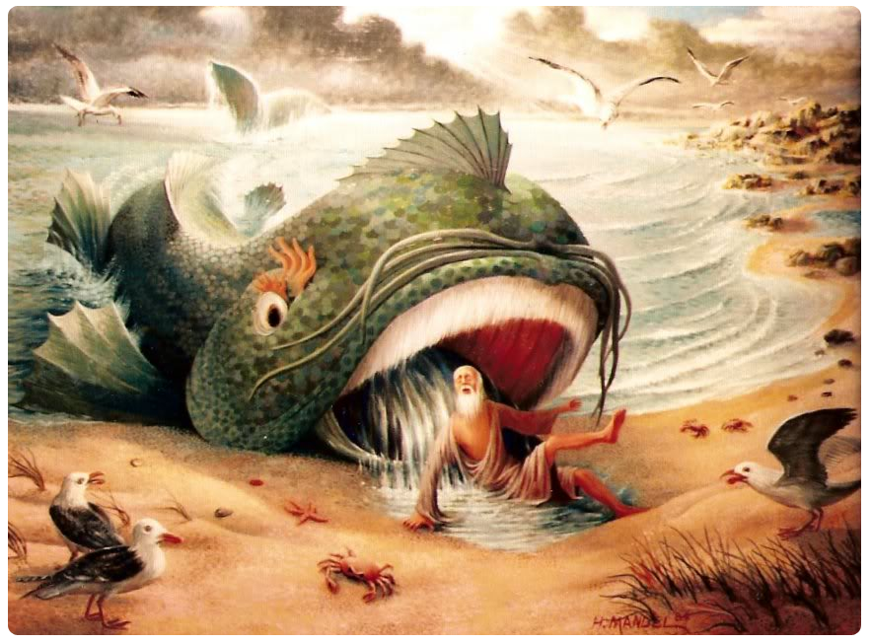

2 Arise, go to Nineveh, that great city, and cry against it; for their wickedness is come up before me. 3 But Jonah rose up to flee unto Tarshish from the presence of the LORD, and went down to Joppa; and he found a ship going to Tarshish: so he paid the fare thereof, and went down into it, to go with them unto Tarshish from the presence of the LORD. (Jonah 1:2-3)

Here is an excellent old hymn that helps teach us a story of an actual event in the Old Testament relating to a prophet whose memory is often associated, wrongly so, with cowardice. It is unfortunate that we do not know the author of this hymn – only his initials – W.E.S. The hymn first appeared in The Joy Bells of Canaan: Burning Bush Songs No. 2, edited by Arthur Ingler & Elisha Hoffman (Chicago, Illinois: Burning Bush, 1905). Music arrangement is Over There by Ingler.

Jonah and the Whale

In the Bible we are told
Of a prophet who was called
To a city that was steeped in awful sin;
All the people in that place
Were devoid of saving grace,
And the prophet seemed afraid to enter in.
Refrain

Refrain
Over there, over there,
In that land bright and fair,
Oh, he’ll tell me all about it over there;
On the hallelujah strand
I’ll take Jonah by the hand,
And he’ll tell me all about it over there.

Then this prophet forth was sent
That old Nineveh might repent,
But instead of that to Tarshish he set sail;
Oh! the winds began to blow,
Overboard did Jonah go,
And he found a mercy seat inside the whale.
Refrain

In the cold and briny deep
Tears of grief did Jonah weep,
And the big fish threw him out upon the shore;
Then he gladly went his way,
Preached to Nineveh night and day,
And he did not care to backslide any more.
Refrain

Oh, some people don’t believe
That a whale could him receive.
But that does not make my song at all untrue;
There are whales on every side,
With their big mouths open wide
Refrain

Just take care, my friend, or one will swallow you. .

Many souls are tossed about
By the whales of fear and doubt,
But the Savior wants to take them by the hand.
If they will His voice obey,
He will save them right away,
And will guide them safely to the promised land.
Refrain

In the Bible we are told Of a prophet who was called To a city that was steeped in awful sin; All the people in that place Were devoid of saving grace, And the prophet seemed afraid to enter in. The failures and weaknesses of the ancient prophets often receive undeserved and libelous appraisal from those of us reading in the comfort of our armchairs. We immediately frown upon Jonah’s failure to immediately follow the Counsel of God, and we may consider him to be so much lower than our noble selves. Hundreds of sermons could be written on Jonah, therefore, we learn much from this prophet which we would not have learned had he not been found wanting in the immediacy of his service. Well, there are no whales or other sea monsters, in our studies, so we judge from a considerably more advantageous vantage point than that to which Jonah was confronted. So why did Jonah balk at going to Nineveh? It was more out of an outrageous jealousy than out of abject fear that detained Jonah from his calling. Many of us would have the same emotions about going to Raca, or Mosel, and teach the Gospel to the heartless and rabid fighters of the Islamic State in Syria (ISIS). Most of us do not consider such infidels worthy of the grace of God; but if we consider our own souls worthy of that grace, we would be badly mistaken. Yes, there would be inordinate fear about going into the den of lions in the Levant, but the overriding reluctance would, at least initially, be of wonder that God would consider such a people for His grace. If Jonah was indeed governed by fear, it is a sad indictment against a prophet to fear men more than God.

Then this prophet forth was sent That old Nineveh might repent, But instead of that to Tarshish he set sail; Oh! the winds began to blow, Overboard did Jonah go, And he found a mercy seat inside the whale. Even well-meaning men and women of faith often wind up going in precisely the opposite direction that God commands for our lives. In this case, Tarshish (Spain) was diametrically opposite the way to Nineveh. Though God was waiting in Nineveh as Jonah’s Protector, He was also tarrying on the Ocean Seas as Jonah’s Prosecutor to bring him to heel.

It would be a bit awkward to be swallowed by a whale. The muscles of the whale’s alimentary canal would painfully cramp our lifestyle as we were forced, by the peristaltic action of that canal, into the whale’s belly. There the digestive fluids would inflict a burning torture to our flesh much like those suffered by the Rich Man in Hell who had favored sumptuously while Lazarus starved in rags beyond his gate. Moreover, every strand of seaweed or sea life that whale swallowed would be our fellow travelers in the depths of the sea. Jonah was in the belly of the whale in precisely the same manner in which Christ lay in the Garden Tomb. How do I know? Because our Lord tells us: An evil and adulterous generation seeketh after a sign; and there shall no sign be given to it, but the sign of the prophet Jonas: For as Jonas was three days and three nights in the whale's belly; so shall the Son of man be three days and three nights in the heart of the earth. The men of Nineveh shall rise in judgment with this generation, and shall condemn it: because they repented at the preaching of Jonas; and, behold, a greater than Jonas is here. (Matt 12:39-41) You do not suppose that the adulterous generation to which our Lord referred could be compared to that of our own day, do you? Surely, today’s generations do not run to apostate churches to see charismatic wonders and fake miracles, do they?

Our Lord lay dead in the Tomb over the Sabbath Day just as Jonah lay in Hell during those same three days in the whale’s belly. Examine Jonah’s prayer from Hell as his spirit fainted in him: 2 And said, I cried by reason of mine affliction unto the LORD, and he heard me; out of the belly of hell cried I, and thou heardest my voice. 3 For thou hadst cast me into the deep, in the midst of the seas; and the floods compassed me about: all thy billows and thy waves passed over me. 4 Then I said, I am cast out of thy sight; yet I will look again toward thy holy temple. 5 The waters compassed me about, even to the soul: the depth closed me round about, the weeds were wrapped about my head. 6 I went down to the bottoms of the mountains; the earth with her bars was about me for ever: yet hast thou brought up my life from corruption, O LORD my God. 7 When my soul fainted within me I remembered the LORD: and my prayer came in unto thee, into thine holy temple. 8 They that observe lying vanities forsake their own mercy. 9 But I will sacrifice unto thee with the voice of thanksgiving; I will pay that that I have vowed. Salvation is of the LORD. (Jonah 2:2-9)

In the cold and briny deep Tears of grief did Jonah weep, And the big fish threw him out upon the shore; Then he gladly went his way, Preached to Nineveh night and day, And he did not care to backslide any more. There was no point of time in which Jonah was out of sight of God, but it must have seemed so. Sin creates a great abyss between us and God. The sperm whale is capable of diving just over 7,000 ft. depth in the sea at which the uniform temperature would approach 37-38 degrees (not comfortable for humans traveling in the cramped state room of a fish. Suddenly, with head wrapped in sea weed and debris, a little jaunt over to Nineveh became most appealing to Jonah. God has a way of making alternatives to disobedience seem quite enticing! ‘

Oh, some people don’t believe That a whale could him receive. But that does not make my song at all untrue; There are whales on every side, With their big mouths open wide. There are some convincing accounts that have gained some scientific credibility of men swallowed by whales and remaining alive after being vomited out. One such lengthy study is included at the following web page and is concluded accurate by a notable scientist named Henri de Parville: see http://www.reasons.org/articles/a-modern-jonah But God’s Creative Omnipotence does not depend upon the science of man for proof since God is the Maker of all true sciences.

Just take care, my friend, or one will swallow you. Many souls are tossed about By the whales of fear and doubt, But the Savior wants to take them by the hand. If they will His voice obey, He will save them right away, And will guide them safely to the promised land. Believe it or not, there are many different sizes, shapes, and types of whales that may be sent after you owing to your disobedience of God’s Call such as lust for unlawful sex, greed for money or power, inordinate jealousy, an idle brain or body, financial ruin, illness, etc. When we are given as much, and more, of that for which we crave, even THAT can become Jonah’s whale. Fear and doubt are the foremost whales, but a disdain for the lost is a great one. God’s arm is never shortened from saving us no matter the distance we have wandered from Him – even the depths of the sea in a whale’s belly. God’s main concern with the disobedient is not the distance he has backslidden, but rather the direction he is presently traveling – either AWAY or TOWARD God!

