Devotion on Hymns of the Church – Hymn - Jesus Christ is Risen Today – 4 April 2018, Anno Domini

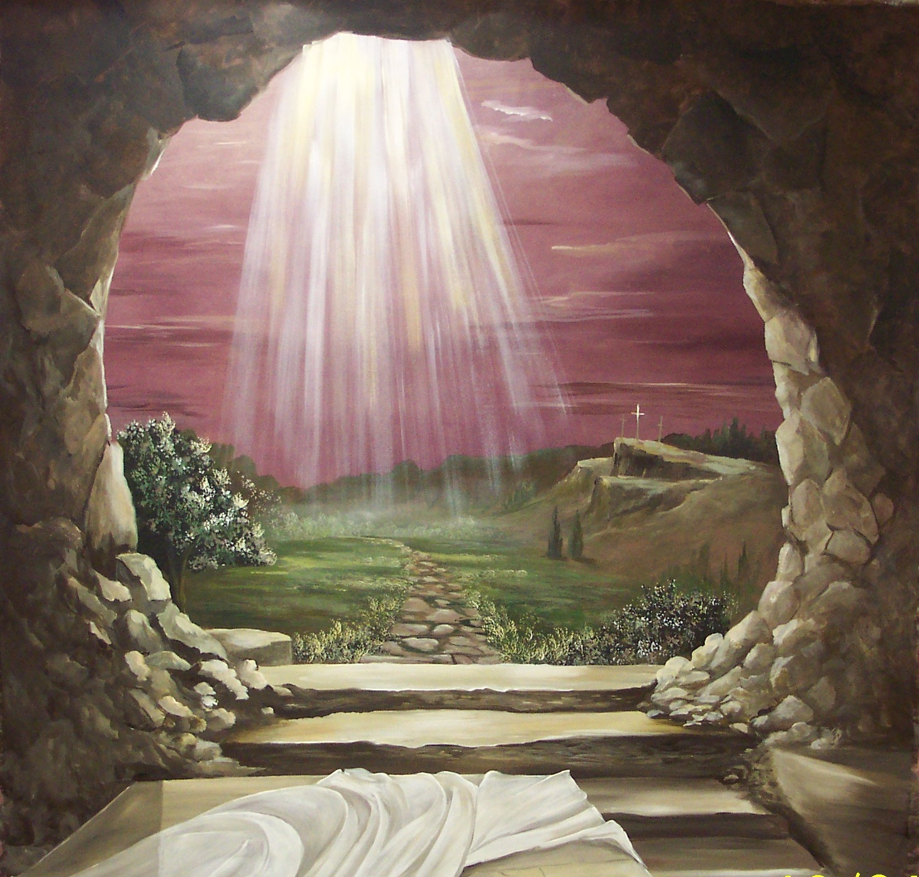

I
n the end of the sabbath, as it began to dawn toward the first day of the week, came Mary Magdalene and the other Mary to see the sepulchre. 2 And, behold, there was a great earthquake: for the angel of the Lord descended from heaven, and came and rolled back the stone from the door, and sat upon it. 3 His countenance was like lightning, and his raiment white as snow: 4 And for fear of him the keepers did shake, and became as dead men. 5 And the angel answered and said unto the women, Fear not ye: for I know that ye seek Jesus, which was crucified. 6 He is not here: for he is risen, as he said. Come, see the place where the Lord lay. (Matt 28:1-6)

The writer of this grand hymn of Praise and Satisfaction is unknown. Be it sufficient to say that it was heavily plagiarized by Holy Writ and the unmistakable markings of the Holy Ghost. It represents an early translation (14th century) from the Latin to English in Lyra Davidica. The musical composer is also unknown, but the score first appeared in London in 1708 under the most fitting title of EASTER HYMN. I can hear in my memory, as clear as the Bells of Saint Peter and Saint Paul in the City of Washington, the deep and strong strains of this Easter Hymn as the Crucifer bears the Cross ahead of the advancing Procession.

Jesus Christ is Risen Today!

c. 1372

Translated by unknown, 1708-1882

Jesus Christ Is risen today, Alleluia!
Our triumphant holy day, Alleluia!
Who did once upon the cross Alleluia!
Suffer to redeem our loss. Alleluia!

Hymns of praise, then, let us sing Alleluia!
Unto Christ, our heavenly King, Alleluia!
Who endured the cross and grave Alleluia!
Sinners to redeem and save. Alleluia!

But the pains which He endured Alleluia!
Our salvation have procured. Alleluia!
Now above the sky He's King, Alleluia!
Where the angels ever sing. Alleluia!

Sing we to our God above, Alleluia!
Praise eternal as His love: Alleluia!
Praise Him, all ye heavenly host, Alleluia!
Father, Son. and Holy Ghost. Alleluia!

Jesus Christ Is risen today, Alleluia! Our triumphant holy day, Alleluia! Who did once upon the cross Alleluia! Suffer to redeem our loss. Alleluia! That horror-filled day at Golgotha was followed by the exhilarating savor of Garden bloom three days later by the Open Tomb. Those two events – the completed work of Atonement on the Cross, followed by the glorious Resurrection, define the very CRUX of all time. Just as the Latin term, CRUX, comes from the word, CRUCIFIXION, so was the Cross the only possible dividing line between Eternity Past and Eternity Future. His Passion, death, burial, and Resurrection was a once-only event. Though the very life-blood of Christ was shed on that cross, a single drop of its healing and redemptive essence would have been sufficient to atone for the sins of the world. BUT HE GAVE ALL! 27 And as it is appointed unto men once to die, but after this the judgment: 28 So Christ was once offered to bear the sins of many; and unto them that look for him shall he appear the second time without sin unto salvation. (Heb 9:27-28)

Hymns of praise, then, let us sing Alleluia! Unto Christ, our heavenly King, Alleluia! Who endured the cross and grave Alleluia! Sinners to redeem and save. Alleluia! If David, before the Resurrection, found reason to sing praises to our God both day and night, how much greater cause have we to sing them now that the resurrection is an historically accomplished event! Our Lord endured the cross and the grave for us. It was the cruelest cross and grave of all for it was redemptive and substitutionary. He was the only Person in all of time and eternity who could qualify to endure those two events on our behalf. By conquering death and hell, He opened the floodgates of mercy for you and me.

But the pains which He endured Alleluia! Our salvation have procured. Alleluia! Now above the sky He's King, Alleluia! Where the angels ever sing. Alleluia! You and I will never be able to fathom the depth of pain our Lord felt on the cross. He was One who was without the slightest blemish of sin who was sentenced to die by a Roman Proconsul who had, himself, pronounced Christ innocent. He was beaten, mocked, and torn. It would be horrible enough for those of us whose guilt deserve such treatment; but what of the pain of an innocent man? He was One whose virtue exceeded that of any possible goodness of any others. Yet, He was stripped naked and humiliated before the multitudes, and hung high on the cross for all to see and revile. 6 For when we were yet without strength, in due time Christ died for the ungodly. 7 For scarcely for a righteous man will one die: yet peradventure for a good man some would even dare to die. 8 But God commendeth his love toward us, in that, while we were yet sinners, Christ died for us. (Romans 5:6-8)

Sing we to our God above, Alleluia! Praise eternal as His love: Alleluia! Praise Him, all ye heavenly host, Alleluia! Father, Son. and Holy Ghost. Alleluia! One great thought on the security of the believer: the love of God is eternal. He never revokes His love though none enjoy that love beyond the abysmal walls of Hell. To know your security is a great comfort. How do you know? Do you love God with an unrelenting love? If so, this is evidence in itself of your eternal security. Love is the means by which we honor God and are enable to keep His commandments. Love is not of our own initiative, but rather that of God: 7 Beloved, let us love one another: for love is of God; and every one that loveth is born of God, and knoweth God. 8 He that loveth not knoweth not God; for God is love. 9 In this was manifested the love of God toward us, because that God sent his only begotten Son into the world, that we might live through him. 10 Herein is love, not that we loved God, but that he loved us, and sent his Son to be the propitiation for our sins. (1 John 4:7-10) and the grand finale of truth: We love him, BECAUE HE FIRST LOVED US. (1 John 4:19)

Night in the Garden
By ©2007 Jerry Ogles
Judas then, having received a band of men and officers from the chief priests and Pharisees, cometh thither with lanterns and torches and weapons. (John 18:3)

Out of the darkest Halls of Hell
Came the marchers with torches raised.
Into the Garden quiet and still
They wandered forlorn and crazed.

Up to the Sovereign Lord of Love
Their spears shining bright in the mist
With arrogant air and a hateful shove
They took Him who wouldn’t resist.

Now to the head of Scribe and Priest
Was the Savior led that night,
And to Herod’s Court and Pilate’s Seat
Where Right gave way to the Night.

To the craggy heights of the Lonely Skull
They took Him and laid Him down
And into His Hands of Love they drove
Iron spikes with a terrible Sound!

On His Brow a thorny Crown He wore
And His flesh was torn and bruised.
His Heart of Grace grew cold and sore
As the Spirit of Life was loosed.

The world of woe a Hope has found
In the Promise made sure by His Death
And the hymns of praise to the saints redound,
And by the Open Tomb are blessed!

AMEN

