Hymns of the Church – I saw One hanging on a Tree – 19 June 2018, Anno Domini

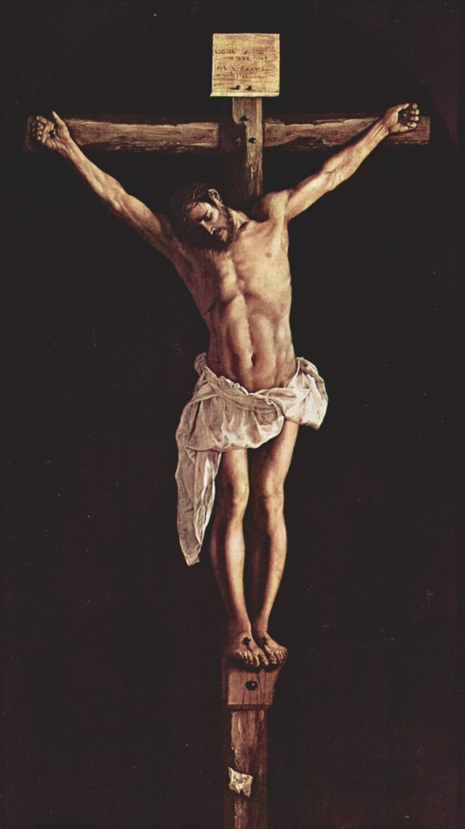

A
nd as Moses lifted up the serpent in the wilderness, even so must the Son of man be lifted up: 15 That whosoever believeth in him should not perish, but have eternal life. (John 3:14-15)

There are many today in churches who close their ears to any mention of the cross. They find it offensive and lacking in sophistication; yet, it is the only means whereby we are saved. But we preach Christ crucified, unto the Jews a stumblingblock, and unto the Greeks foolishness. (1 Cor 1:23)

It is a great benefit to those who love the classic old hymns that John Newton, whose redemption came after a long period of debauchery, did not abhor the cross, but embraced it with the love and passion of a child reborn. He is the author of this wonderful hymn (1779) – along with hundreds more called the Olney Hymns. Music is the composition of Edwin O. Excell in 1917.

I saw One hanging on a Tree
By John Newton

I saw One hanging on a tree,
In agony and blood,
Who fixed His languid eyes on me,
As near His cross I stood.
Refrain
O, can it be, upon a tree,
The Savior died for me?

My soul is thrilled, my heart is filled,
To think He died for me!
Sure, never to my latest breath,
Can I forget that look;
It seemed to charge me with His death,
Though not a word He spoke.
Refrain

My conscience felt and owned the guilt,
And plunged me in despair,
I saw my sins His blood had spilt,
And helped to nail Him there.
Refrain

A second look He gave, which said,
I freely all forgive;
This blood is for thy ransom paid;
I die that thou mayst live.
Refrain

I saw One hanging on a tree, In agony and blood, Who fixed His languid eyes on me, As near His cross I stood. The reference to the cross as a tree is a quaint but quite meaningful expression. The cross of Christ can be most accurately referred to in this way since the Tree of Life (Jesus Christ) was not pleasing to our ancient father in Eden. Certainly, neither was the crude instrument of torture, called the cross, upon which our Lord suffered and died. Christ looked down from the cross to where the sinners stood – either in sympathy as the women disciples, or in wrath such as the Jewish rulers. The Lord sees us all at the foot of the cross; yet, He knows our hearts and frames. He readily identifies His called and chosen from among the reprobate sinners. He fixes His eyes upon each of us, and there is no escape from His piercing vision. He knows His own. John Newton approached the cross when all hope was forlorn and thereby found grace in the eyes of the Lord.

Sure, never to my latest breath, Can I forget that look; It seemed to charge me with His death, Though not a word He spoke. Rightly so may we ascribe His death to our own sinfulness since He died for the sins of the whole world, and we are part of that equation. He looked from that cross long before Golgotha. In fact, from before the foundation of the world. It was on the cross that He engraved the names of His elect by the piercing nails upon the palms of His hands. Behold, I have graven thee upon the palms of my hands; thy walls are continually before me. (Isaiah 49:16) Can you forget that look? Could Peter forget that look of the Lord when Peter denied the third time? And Peter said, Man, I know not what thou sayest. And immediately, while he yet spake, the cock crew. And the Lord turned, and looked upon Peter. And Peter remembered the word of the Lord, how he had said unto him, Before the cock crow, thou shalt deny me thrice. And Peter went out, and wept bitterly. (Luke 22:60-62)

My conscience felt and owned the guilt, And plunged me in despair, I saw my sins His blood had spilt, And helped to nail Him there. Facing our guilt is the only means whereby we may approach the cross. No self-righteous person ever is able to look upon the cross without intense guilt. The great despair we feel when we own our guilt and hopelessness is the means to open the door to the utmost joy and solicitude in salvation. We all had a hand in nailing our Lord to the cross – demur not!

A second look He gave, which said, I freely all forgive; This blood is for thy ransom paid; I die that thou mayst live. The grief over our sins, and our subsequent confessions, are not necessarily vocal. Peter never spoke the words of repentance, but he proved it by his tears for the three days that our Lord was in the tomb. Even in the grave, our Lord knew of Peter’s remorse. On His resurrection, the angel at the tomb specifically mentioned only Peter’s name when he asked the women to go and tell the others. The angel said: But go your way, tell his disciples and PETER that he goeth before you into Galilee: there shall ye see him, as he said unto you. (Mark 16:7)

Refrain
O, can it be, upon a tree, The Savior died for me? My soul is thrilled, my heart is filled, To think He died for me! Have you ever considered that every lost soul is found by God under that Tree. Just as the first death – an innocent animal – had to die to provide covering garments for Adam and Eve – and symbolically, a covering for their sin – so did the innocent Lamb of God have to die upon the cross to purchase for us the spotlessly white Robe of Righteousness to cover our sins. He did so while we were yet under that Tree. Let’s look at this point a bit more. We see at least four different trees in scripture that point to man and his sin.

1) The Tree of the knowledge of Good and Evil BEHIND which the Serpent spoke;

2) The tree UNDER which Adam hid from the Lord in Eden. And they heard the voice of the Lord God walking in the garden in the cool of the day: and Adam and his wife hid themselves from the presence of the Lord God amongst the trees of the garden. (Gen 3:8)

3) The man IN the tree who sought to see Jesus – Zacchaeus – who was saved along with his whole household.

4) The Man ON the Tree which is our Tree of Life.

Like Zacchaeus, if we will be saved, we must begin our salvation IN that Tree of Life. No need to hide our faces when He passes. He already knows His own as does every good Shepherd of the flock.

