Hymns of the Church - I Shall not be Moved – 14 July 2020, Anno Domini (In the Year of our Lord)

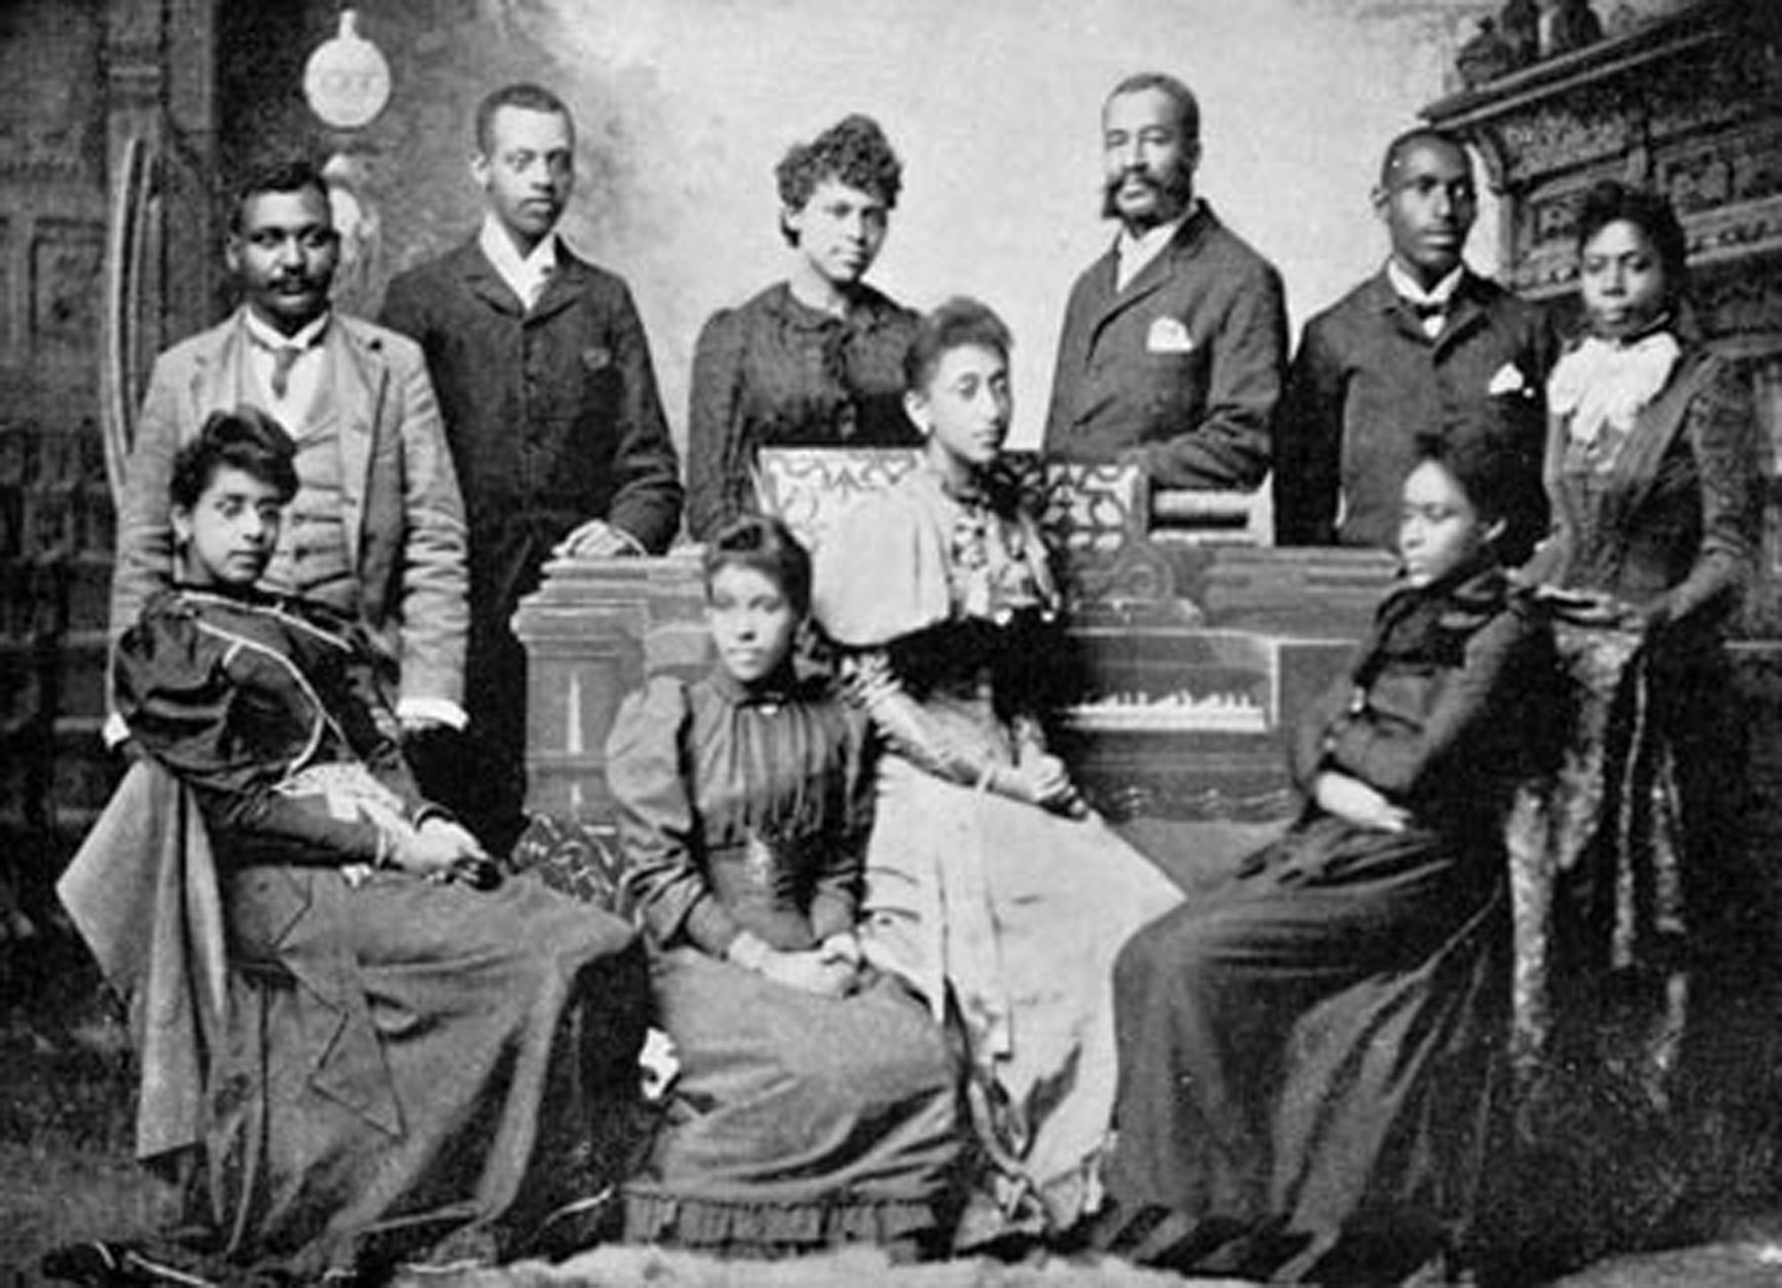

T
HE LORD is the portion of mine inheritance and of my cup: thou maintainest my lot. 6 The lines are fallen unto me in pleasant places; yea, I have a goodly heritage. 7 I will bless the LORD, who hath given me counsel: my reins also instruct me in the night seasons. 8 I have set the LORD always before me: because he is at my right hand, I shall not be moved. 9 Therefore my heart is glad, and my glory rejoiceth: my flesh also shall rest in hope. 10 For thou wilt not leave my soul in hell; neither wilt thou suffer thine Holy One to see corruption. (Psalm 16:5-10)

A
ND he shall be like a tree planted by the rivers of water, that bringeth forth his fruit in his season; his leaf also shall not wither; and whatsoever he doeth shall prosper. (Psalm 1:3)

When the Hebrew children were captive in Babylon, they dreamed dreams of the fair land of Canaan. Their sorrow and remorse were ridiculed by the Babylonians. ‘﻿By the rivers of Babylon, there we sat down, yea, we wept, when we remembered Zion. We hanged our harps upon the willows in the midst thereof. For there they that carried us away captive required of us a song; and they that wasted us required of us mirth, saying, Sing us one of the songs of Zion. How shall we sing the LORD’s song in a strange land?’ (Psalms137:1-4) There, likewise, was a deep yearning in the hearts of the negro slaves brought against their will to the New World for their homeland and people across the blue waters of the Atlantic. Even those born in America entertained a deep and mysterious yearning for something that was missing in their lives which was Africa. As a result, they eagerly grasped every word spoken of the glories of Heaven and the Lord Jesus Christ whose great love extended, not only to the conqueror, but to the slave as well.

The folksy Gospel song for today is an example of the songs they sang ‘by the rivers of Babylon.’ The tune and lyrics are products of the men and women who labored under the sun in the fields of their masters. You might say, both lyrics and tune are gifts of the Holy Ghost. The tune to which the hymn is sung is ‘I SHALL NOT BE MOVED.’ There are many verses to this song and almost every version is different; however, the three verses below are the most common in modern hymnals.

I Shall not be Moved

Jesus is my Savior, I shall not be moved;
In His love and favor, I shall not be moved,
Just like a tree that’s planted by the waters,
Lord, I shall not be moved.

In my Christ abiding, I shall not be moved;
In His love I’m hiding, I shall not be moved,
Just like a tree that’s planted by the waters,
Lord, I shall not be moved.

If I trust Him ever, I shall not be moved;
He will fail me never, I shall not be moved,
Just like a tree that’s planted by the waters,
Lord, I shall not be moved.

Jesus is my Savior, I shall not be moved; In His love and favor, I shall not be moved, Just like a tree that’s planted by the waters, Lord, I shall not be moved. The Lord Jesus Christ is, indeed, our Fortress, our Protector, our Redeemer, and the very ROCK of our Salvation. He is a great Stone that is fixed and immovable – the same yesterday, today, and forever. His something else, too, to His elect – He is the Ark which they are called to enter in order to escape the coming wrath and ruin to befall the world. If Christ cannot be moved (and He cannot be), then all who are in Him shall likewise be immovable from that security that is only available in that great Ark of God. ‘﻿27 And this word, Yet once more, signifieth the removing of those things that are shaken, as of things that are made, that those things which cannot be shaken may remain. 28 Wherefore we receiving a kingdom which cannot be moved, let us have grace, whereby we may serve God acceptably with reverence and godly fear. (Hebrews 12:27-28)

The green and flourishing tree stands at the very brink of the river. It sinks its roots deep down into the sub-soil for that nourishing Water of Life beneath at depths uncommon for the shrub. It is like that Tree of Life that was removed to the Paradise of God: ’﻿1 And he shewed me a pure river of water of life, clear as crystal, proceeding out of the throne of God and of the Lamb. 2 In the midst of the street of it, and on either side of the river, was there the tree of life, which bare twelve manner of fruits, and yielded her fruit every month: and the leaves of the tree were for the healing of the nations.’ This is the Tree of the Garden which Adam rejected and which symbolizes the Lord of Life, Jesus Christ!

In my Christ abiding, I shall not be moved; In His love I’m hiding, I shall not be moved, Just like a tree that’s planted by the waters, Lord, I shall not be moved. When the Holy Spirit draws a believer to the Mercy Seat of Christ (Christ is, Himself, the Mercy Seat), The Lord Jesus Christ comes to abide in that person’s heart – He does no sojourn for a time, He abides in that heart forever. The mystery of Christ’s Lordship is an amazing wonder for He not only abides in us, but we, too, abide in Him. ‘﻿4 Abide in me, and I in you. As the branch cannot bear fruit of itself, except it abide in the vine; no more can ye, except ye abide in me. 5 I am the vine, ye are the branches: He that abideth in me, and I in him, the same bringeth forth much fruit: for without me ye can do nothing. 6 If a man abide not in me, he is cast forth as a branch, and is withered; and men gather them, and cast them into the fire, and they are burned.’ (John 15:4-6)

If I trust Him ever, I shall not be moved; He will fail me never, I shall not be moved, Just like a tree that’s planted by the waters, Lord, I shall not be moved. Trusting the Lord is walking in the Way of which He has told us – the Straight and Narrow Way. On either side are the treacheries of stone and briar, ravine and wild beast. On that Narrow Way, we shall not be moved though the very earth quakes all around. Our Lord will never fail us. He is able! ‘﻿Wherefore he is able also to save them to the uttermost that come unto God by him, seeing he ever liveth to make intercession for them.’ (Hebrews 7:25)

Note
Many of the old Negro Spirituals are upbeat and happy projecting the faith-ordained hope of a better day; songs such as ‘O Them Golden Slippers,’ ‘Roll Jordan, Roll!’ and ‘Down by the River Side.’ But some are quite sad and reflect the pitiful circumstances in which they came to be sung – songs such as ‘Swing Lo, Sweet Chariot,’ ‘Steal Away Home to Jesus,’ ‘Nobody Knows the Trouble I’ve Seen,’ and ‘Go Down Moses.’

It is an amazing gift of the Holy Spirit that gives us, in all our conditions and straights, a song in the night even to those whose plight seems to mimic that of the prophet Job: ‘﻿By reason of the multitude of oppressions they make the oppressed to cry: they cry out by reason of the arm of the mighty. But none saith, Where is God my maker, who giveth songs in the night; Who teacheth us more than the beasts of the earth, and maketh us wiser than the fowls of heaven?’ (Job 35:10-11)

It is my hope and prayer that God has given each reader of this devotion a multitude of songs in the night, for sorrows come upon each and every one.

