Hymns of the Church – Hosanna, Loud Hosanna – 19 February 2019, Anno Domini

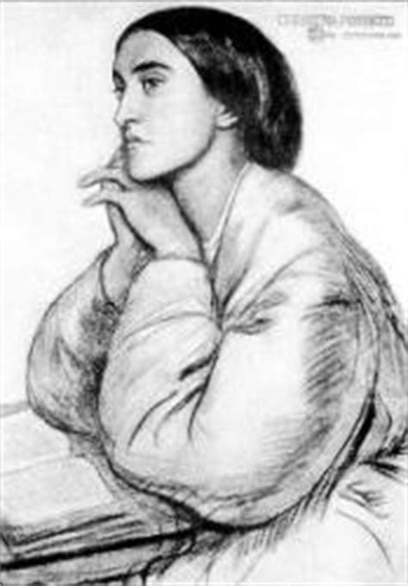

A
ND Jesus went into the temple of God, and cast out all them that sold and bought in the temple, and overthrew the tables of the moneychangers, and the seats of them that sold doves, 13 And said unto them, It is written, My house shall be called the house of prayer; but ye have made it a den of thieves. 14 And the blind and the lame came to him in the temple; and he healed them. 15 And when the chief priests and scribes saw the wonderful things that he did, and the children crying in the temple, and saying, Hosanna to the Son of David; they were sore displeased, 16 And said unto him, Hearest thou what these say? And Jesus saith unto them, Yea; have ye never read, Out of the mouth of babes and sucklings thou hast perfected praise? 17 And he left them, and went out of the city into Bethany; and he lodged there. (Matt 21:12-17)

This coming Sunday is Sexagesima Sunday which marks the middle of the Pre-Lent Season. It is a time of preparation for the solemn observance of Lent and Holy Week in contemplation our Lord’s crucifixion, death, burial, and resurrection. The hymn under study today is an excellent beginning to that preparation.

The author of this sweet hymn is Jeanette Threlfall (1821-1880) who had a very sad young life being orphaned at an early age of childhood. Her adult life was also visited by a tragic accident that rendered her lame, and a second which resulted in her becoming an invalid. She wrote the lyrics to this hymn in 1873. She saw a special beauty of Christ to the little child who needs a friend so close as the heart gate, and one who is able to be of greater worth than all others. Miss Threlfall was also a noted church soloist for her time. The cheerful tune is, ELLACOMBE, which was taken from a German hymn tune written in 1768.

Hosanna, Loud Hosanna

Hosanna, loud hosanna,
the little children sang,
through pillared court and temple
the lovely anthem rang.
To Jesus, who had blessed them
close folded to his breast,
the children sang their praises,
the simplest and the best.

From Olivet they followed
mid an exultant crowd,
the victor palm branch waving,
and chanting clear and loud.
The Lord of earth and heaven
rode on in lowly state,
nor scorned that little children
should on his bidding wait.

"Hosanna in the highest!"
that ancient song we sing,
for Christ is our Redeemer,
the Lord of heaven our King.
O may we ever praise him
with heart and life and voice,
and in his blissful presence
eternally rejoice!

Hosanna, loud hosanna, the little children sang, through pillared court and temple the lovely anthem rang. To Jesus, who had blessed them close folded to his breast, the children sang their praises, the simplest and the best. As I considered the biblical text, serving as a basis for this song, I was impressed with the important part the parent plays as a role model for the child. For example, where did the children learn to praise the Lord with such an exalted term as ‘HOSANNA?’ Hosanna is the combination of two Hebrew root words meaning ‘salvation’ and ‘prayer’ so, “salvation in answer to prayer” would seem the meaning.

The children learned to shout this phrase from the adults who did the same as Jesus entered into Jerusalem, And the multitudes that went before, and that followed, cried, saying, Hosanna to the Son of David: Blessed is he that cometh in the name of the Lord; Hosanna in the highest. (Matt 21:9) It is a pity the example that children must follow in the greater American society today. The terms in which they learn to think and to speak is a far cry from those children shouting ‘Hosanna’ in the Temple. What beauteous echoes these shouts must have created in the marble halls of the Temple that day! To the One who had commanded, Suffer not the little children come unto me, for of such is the Kingdom of Heaven, these dear children paid fitting homage that day. He loved them, and they KNEW it! How important it is to have children attend worship – not in a so-called youth church where games are played – but in a solemn worship with their parents at which they can witness the importance their parents place on prayer and worship. And what of our houses of worship today? Have they become like unto a den of thieves where men preach for filthy lucre, and car washes and yard sales characterize the main money-raising activities? Would our Lord tolerate these money-grubbing events?

From Olivet they followed mid an exultant crowd, the victor palm branch waving, and chanting clear and loud. The Lord of earth and heaven rode on in lowly state, nor scorned that little children should on his bidding wait. Mount Olivet rises to the east of Jerusalem, and this was appropriately the approach Jesus took in entering the City of Jerusalem from the East. The Temple itself is oriented to the East, and when Christ returns, He will return in that same grandeur. It is heartbreaking to witness the inconstancy of the human heart revealed in the behavior of the multitudes that greeted our Lord at the eastern gate. See how His entry is contrasted with the events only five days later: And when he was come into Jerusalem, all the city was moved (Matt 21:10) What a tumult of praise greeted His entry; but what a shameful demonstration of betrayal came from the same throats of those outside the courtyard of Pontius Pilate five days later: Pilate saith unto them, What shall I do then with Jesus which is called Christ? They all say unto him, Let him be crucified. And the governor said, Why, what evil hath he done? But they cried out the more, saying, Let him be crucified. When Pilate saw that he could prevail nothing, but that rather a tumult was made, he took water, and washed his hands before the multitude, saying, I am innocent of the blood of this just person: see ye to it. Then answered all the people, and said, His blood beon us, and on our children. (Matt 27:22-25) But from the lips of children come the purest form of worship. Out of the mouth of babes and sucklings hast thou ordained strength because of thine enemies, that thou mightest still the enemy and the avenger. (Psalm 8:2)

“Hosanna in the highest!" that ancient song we sing, for Christ is our Redeemer, the Lord of heaven our King. O may we ever praise him with heart and life and voice, and in his blissful presence eternally rejoice! The world will not be happy at your singing of that very biblical hymn, Hosanna in the highest. (Matt 21:9) It is as ancient as the Holy Bible itself for it is part of it. The Jewish leaders were outraged when the children sang it. Depending on the kind of church you attend, the leaders there may take a dim view as well when it is sung with such exultation. When the Lord Jesus Christ is restored to the central focus of the Church, there will be many ministers and entertainers who will be outraged by it. And when the chief priests and scribes saw the wonderful things that he did, and the children crying in the temple, and saying, Hosanna to the Son of David; they were sore displeased, And said unto him, Hearest thou what these say? Before we subject our little children to the false glitter of the world, their hearts are full of innocence and love, but please consider the mess we have made of the lives of our youth in modern America. We have refused to allow school prayer – a practice observed in our schools from the Founding of America. We have allowed them to be taught sex education that has resulted in their being exposed to a level of pornography for which the offense would have landed previous generations in prison. We have legalized the mass murder of innocents in the mother’s womb before they have chanced to behold their first glorious sunrise. We have promoted perversions in sex and elevated the abominable sin of Leviticus 18:22 and Romans 1 to the dignity of law. The family is the building block of nations, according to God’s plan, and that foundation has been eroded to the point of near extinction in America today.

What have we done to the children?

