Hymns of the Church – Holy Spirit, Lord of Light – 2 June 2020, Anno Domini

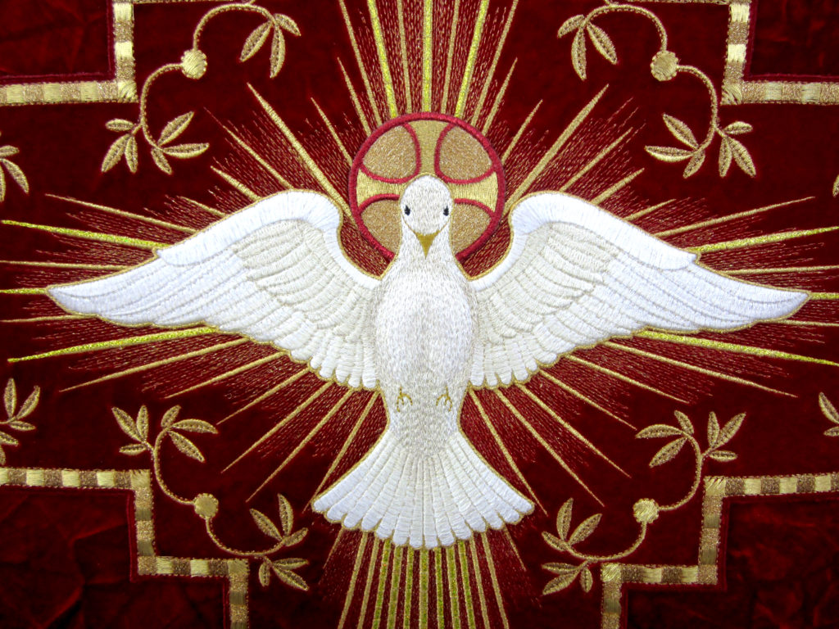

Here is a fitting hymn of an ancient origin for the week of Whitsun week. The Sunday of Pentecost concludes a series of major events in the Church – Good Friday, Easter, Ascension, Pentecost – the coming of the Holy Ghost. The author of this hymn is quite unusual – King Robert the Second of France 970-1031. He had a sad personal life even living like a pauper when he upset the See of Rome. He was well-beloved by his people for the simplicity of life he lived having devoted much of his time to church and writing. He died of a fever at Thelun in 1031. The English version was translated by Edward Caswall. 1814-1878. Caswall was an Oxford graduate who, like many of that ilk, deserted his ordination vows and joined the Roman Church with his confederate, another traitor to his oath, Cardinal Newman; nonetheless, the translation is appreciated.

Holy Spirit, Lord of Light

Holy Spirit, Lord of Light,
From Thy clear celestial height,
Thy pure beaming radiance give:
Come, Thou Father of the poor!
Come, with treasures which endure!
Come, Thou Light of all that live!

Thou, of all consolers best,
Visiting the troubled breast,
Dost refreshing peace bestow;
Thou in toil art comfort sweet,
Pleasant coolness in the heat,
Solace in the midst of woe.

Light immortal! Light divine!
Visit Thou these hearts of Thine,
And our inmost being fill;
Where Thou art not, man hath naught,
Nothing good in deed or thought,
Nothing free from taint of ill.

Heal our wounds, our strength renew;
On our dryness pour Thy dew;
Wash the stains of guilt away;
Bend the stubborn heart and will;
Melt the frozen, warm the chill;
Guide the steps that go astray.

Thou, on those who evermore
Thee confess and Thee adore,
In Thy sevenfold gifts, descend:
Give them comfort when they die,
Give them life with Thee on high,
Give them joys that never end.
Amen.

1 Holy Spirit, Lord of Light, From Thy clear celestial height, Thy pure beaming radiance give: Come, Thou Father of the poor! Come, with treasures which endure! Come, Thou Light of all that live! Light being a characteristic of each of the Three Persons of the Trinity, it is the role of the Holy Ghost to illumine the hearts of men by that Light through the Holy Scripture. That Light is not a false or simulated Light, but pure and effulgent in its radiance. The Holy Ghost has only one depository of the treasures of His followers, and those are beyond the Gates of Splendor. There are none living eternally apart from the ministry of the Holy Ghost.

2 Thou, of all consolers best, Visiting the troubled breast, Dost refreshing peace bestow; Thou in toil art comfort sweet, Pleasant coolness in the heat, Solace in the midst of woe. God only offers the best when He sends One to comfort us and console us. Even in the throes of death, the Christian soul takes comfort that he does not go into that chamber alone. The Holy Spirit is his ever companion in life and at the moment of death. In our work and routine chores of the day, we will feel the presence of the Holy Spirit is we love and follow Him. When ominous clouds arise, the Christian has the Holy Spirit to lean upon while others simply wait in dread abandon.

3 Light immortal! Light divine! Visit Thou these hearts of Thine, And our inmost being fill; Where Thou art not, man hath naught, Nothing good in deed or thought, Nothing free from taint of ill. The Holy Spirit imparts immortality in Christ to those whose hearts are the Temple of His abode. Without the comforting and reassurance of the Holy Spirit, man’s heart is empty and his deeds nothing but filthy rags. Without the imputed righteousness of God, we are all alike sinners.

4 Heal our wounds, our strength renew; On our dryness pour Thy dew; Wash the stains of guilt away; Bend the stubborn heart and will; Melt the frozen, warm the chill; Guide the steps that go astray. Just as the great eagle renews its strength after years of neglect, those of the Lord shall likewise renew themselves in Christ by the prompting of the Holy Spirit. The blessings of the Lord descend as cool water on parched earth when led precipitated by the Holy Spirit. The Holy Spirit is able to bind the will of kings and potentates – Caesars and emperors such as Cyrus the Great. Just as the Triune God created our universe Holy spirit makes our cold spirits warm and our hot spirits cool in such wise to make a mean temperature on this earth that would make human life sustainable.

5 Thou, on those who evermore Thee confess and Thee adore, In Thy sevenfold gifts, descend: Give them comfort when they die, Give them life with Thee on high, Give them joys that never end. Amen. Naturally, we should love and adore our Comforter, but only inasmuch as He constantly reveals our Lord Jesus Christ to us. We are Christians – not a church of the Holy Spirit though we love ad admire his gentle favors. Perhaps the face we may behold at the moment of death will be that of the Holy Spirit beckoning to the Light.

Amen, and so be it evermore.

