Hymns of the Church - Holy Bible, Book Divine – 15 September 2015, Anno Domini (In the Year of our Lord)

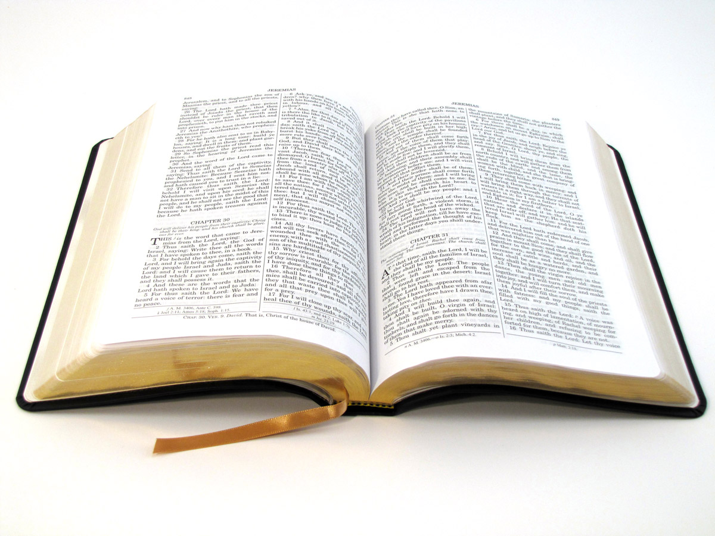

39 Search the scriptures; for in them ye think ye have eternal life: and they are they which testify of me.. (John 5:39)

I cannot imagine a more simple and unambiguous statement as this uttered by our Lord in reference to Holy Scripture, yet men (even Bible scholars) are constantly contriving to add, or detract, from the Word of God based upon a presumed knowledge, sophistication, and interpretation that goes well beyond the limits and simplicity of God's Word. If we resolve to accept that God is God, and we are His creatures, the picture of our understanding in contrast to His becomes of sharper focus.

Read the assessment of a great Christian general regarding the Holy Bible:

The Bible is the Book of Books - a book which supplies the place of all others and cannot be replaced by any other. I prefer the Bible to any other book. There is enough in that to satisfy the most ardent thirst for knowledge; to open the way to TRUE wisdom; and to teach the only road to salvation and eternal happiness. It is not above human comprehension, and is sufficient to satisfy all its desires. General Robert E. Lee, perhaps the greatest military commander ever produced on our native soil, and former Superintendent of the US Military Academy at West Point.

The Bible itself is a sufficient tool, and is incomparably superior to all writings of men, to teach true faith, religion, doctrine, and wisdom. God's Word is our lamp on a dark road. All other writings of mere men are simply of merit based upon their echoing the wisdom of God's Book. Solomon best summarizes the case: 11 The words of the wise are as goads, and as nails fastened by the masters of assemblies, which are given from one shepherd. 12 And further, by these, my son, be admonished: of making many books there is no end; and much study is a weariness of the flesh. 13 Let us hear the conclusion of the whole matter: Fear God, and keep his commandments: for this is the whole duty of man. 14 For God shall bring every work into judgment, with every secret thing, whether it be good, or whether it be evil. (Eccl 12:11-14) I love and learn from the writings of the great Reformers and from men such as Bishop JC Ryle and Charles Spurgeon; but these are only beneficial to me by pointing back to the original source from which they, too, drew their wisdom - the Bible.

The lyrics to this simple hymn were written by John Burton, Sr., in 1803. The most popular accompanying tune was the work of William B. Bradbury entitled, Aletta, composed in 1858. It was the most commonly heard tune around my house for many years as it was sung in the daily morning assembly at my son, Michael's, Christian Elementary Academy (this hymn was written for children, but adults of our time need to know it):

Holy Bible, Book Divine
Holy Bible, Book divine,
Precious treasure, thou art mine;
Mine to tell me whence I came;
Mine to teach me what I am.

Mine to chide me when I rove;
Mine to show a Savior’s love;
Mine thou art to guide and guard;
Mine to punish or reward.

Mine to comfort in distress;
Suffering in this wilderness;
Mine to show, by living faith,
Man can triumph over death.

Mine to tell of joys to come,
And the rebel sinner’s doom;
O thou holy Book divine,
Precious treasure, thou art mine.

Holy Bible, Book divine, Precious treasure, thou art mine; Mine to tell me whence I came; Mine to teach me what I am. The very first four words of this hymn set forth the stellar nature of the Holy Bible. It is BOTH Holy and Divine. Its premises are Heavenly and Holy Ground, and its Author is God Almighty! It is the most precious treasure given to man representing the authorship of the Triune God. These words are breathed by God the Father, transmitted by the Holy Ghost, and lived out in the Life and Works of the Word Incarnate - Jesus Christ. It belongs to us insofar as we receive its teachings into the privileged chambers of our hearts. Thy word have I hid in mine heart, that I might not sin against thee. (Psalm 119:11) If we have hidden God's Word in our hearts, it will have the efficacious effect of changing who we are, and changing our behavior from one of habitual sin, to one of habitual righteousness. We are continually reminded in God's Word that we are not our own, but belong to the Father who is our Maker. Know ye that the LORD he is God: it is he that hath made us, and not we ourselves; we are his people, and the sheep of his pasture. (Psalm 100:3) We know, from Holy Writ, that we are made by the very hands of God. We are not products of evolutionary accident, or descended from apes (except for some college professors). We have often discussed how the Bible is a mirror to the soul to reveal to us our total depravity apart from Christ. We see our shameful natures in Adam, in Cain, in those who remain without the Ark of Noah, in Saul, David, the Woman taken in Adultery, the Woman at the Well, the tragic failure of Peter at the tribunal of Christ, and in countless others pictured for us in Scripture; yet those mentioned who turned to Christ were forgiven, restored, and admitted to the sanctuary of grace. So, the picture we see in Scripture of our depravity stands in stark relief to the salvation made available by the grace and shed blood of our Lord and Savior.

Mine to chide me when I rove; Mine to show a Savior’s love; Mine thou art to guide and guard; Mine to punish or reward. There are churches today who believe that the Holy Ghost speaks to the individual believer in words that are extraneous to Scripture. This is a fatal error. It is a man-centered religion of wealth and health that teaches so. Does the Holy Ghost speak to us? Yes, He does; but what vocabulary and phraseology does He use in speaking? It is those words and truths revealed already in Holy Scripture. But the Comforter, which is the Holy Ghost, whom the Father will send in my name, he shall teach you all things, and bring all things to your remembrance, whatsoever I have said unto you. (John 14:26) We are forgetful souls. We may not always remember those basic truths that are vital to our understanding. Yet, we are told that the Holy Ghost will teach us by bringing truths to our remembrance concerning the Words of Christ. How can we be reminded of something in Scripture that we have never taken the trouble to even read?

The purpose of the Holy Ghost is never to boast of Himself, but always to point to the glorious Christ. Howbeit when he, the Spirit of truth, is come, he will guide you into all truth: for he shall not speak of himself; but whatsoever he shall hear, that shall he speak: and he will shew you things to come. He shall glorify me: for he shall receive of mine, and shall shew it unto you. (John 16:13-14) The Holy Spirit is God's Comforter to encourage and direct our steps on the WAY. He also protects us from falling for the deceitful preaching of the false churches if we have hidden God's Word in our hearts! Finally, the Holy Bible and its Living Word, offers a choice of reward for faithfulness, or punishment for disobedience. This punishment is not a mortal punishment, but one designed to open our eyes and remind us that I am with thee alway, even unto the end of the world.

Mine to comfort in distress; Suffering in this wilderness; Mine to show, by living faith, Man can triumph over death. The world is a wilderness of sin and depravity; but it is a wilderness through which the Children of God must pass just as Israel wandered through the Wilderness of Sinai before approaching the Land of Promise. But along the way in this wilderness, have we not seen the lovely Rose of Sharon and the Lily of the Valleys (not valley) blooming beautifully along the way. Have we not looked up in the dark sky of that wilderness and seen the Bright and Morning Star gleaming brilliantly from the beginning of darkness until the morning dawn of the Sun of Righteousness arising and scattering the darkness? No, man cannot triumph over death, but Christ has done so FOR us. Though we are in no wise worthy, we can triumph over death in our Ark of Salvation which is Christ! We appear before God as righteous because we have - not our own - but the IMPUTED righteousness of Christ by which we gain Heaven.

Mine to tell of joys to come, And the rebel sinner’s doom; O thou holy Book divine, Precious treasure, thou art mine. God, like the loving Father that He is, presents us with challenges and hardships that cause us to grow stronger and able to face the vicissitudes of sinful man about us; but He also points to that City set upon a Hill that emits the glorious beams of truth and salvation to all who seek it. The rebel sinner is one who rebels against God's authority and includes all who claim to be 'atheists' - there is no such thing - and those who commit lascivious acts of the flesh. They are reprobates whose sinful rebellion has seared their consciences and hindered their ability to hear the soft whispers of the Holy Ghost - not that the Holy Ghost has stopped speaking, but they have stopped their ears to His Voice.

The Holy Bible was not written for the benefit of God or His angels, but for US! He sent His Word into the world that we might understand His voice and know God in intimate ways that we could not have done without a redeeming Savior. And the Word was made flesh, and dwelt among us, (and we beheld his glory, the glory as of the only begotten of the Father,) full of grace and truth. (John 1:14)

I will end this hymn devotion with a statement and a question from the Lord: I am the resurrection, and the life: he that believeth in me, though he were dead, yet shall he live: And whosoever liveth and believeth in me shall never die. Believest thou this? (John 11:25-26)

