Hymns of the Church - He Lives! – 19 November 2019, Anno Domini (In the Year of our Lord)

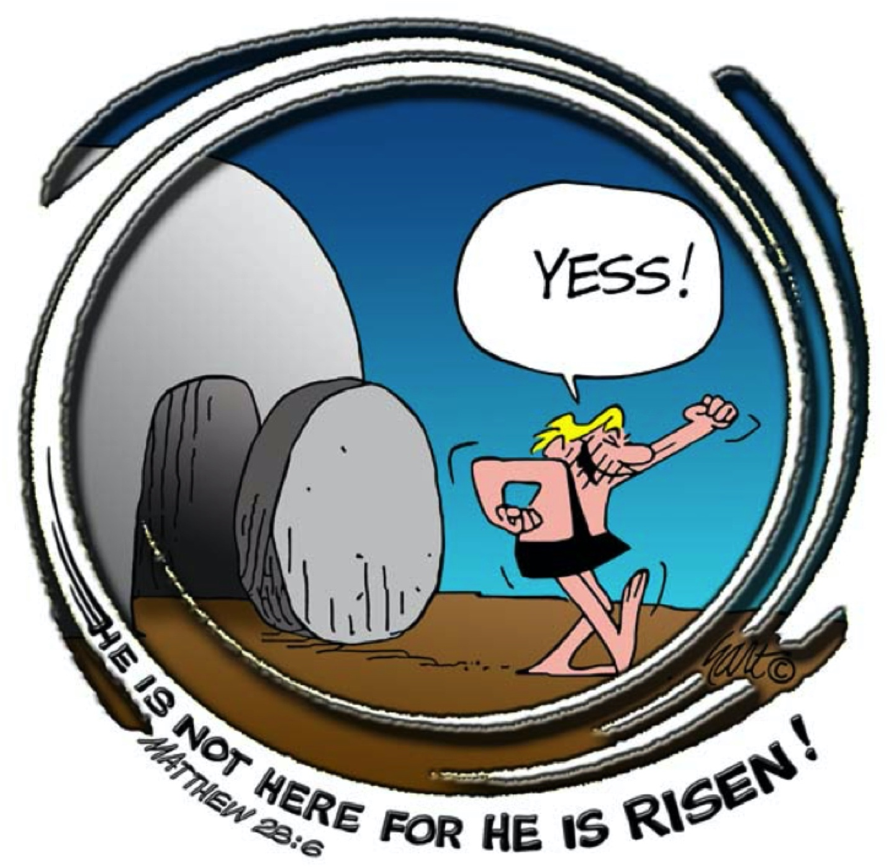

I
N the end of the sabbath, as it began to dawn toward the first day of the week, came Mary Magdalene and the other Mary to see the sepulchre. ² And, behold, there was a great earthquake: for the angel of the Lord descended from heaven, and came and rolled back the stone from the door, and sat upon it. ³ His countenance was like lightning, and his raiment white as snow: ⁴ And for fear of him the keepers did shake, and became as dead men. ⁵ And the angel answered and said unto the women, Fear not ye: for I know that ye seek Jesus, which was crucified. ⁶ He is not here: for he is risen, as he said. Come, see the place where the Lord lay. ⁷ And go quickly, and tell his disciples that he is risen from the dead; and, behold, he goeth before you into Galilee; there shall ye see him: lo, I have told you. (Matthew 28:1-7)

There is an interesting narrative behind the writing of this hymn by Rev Alfred Ackley in 1932. Just before Sunday service in his California Presbyterian Church, he was listening to a famous New York preacher on the radio. It was Easter. The New York preacher opened with his opinion that it did not “matter whether Christ was alive today, or remained buried in a tomb in Palestine.” The important thing is that His Word lives on!” This resulted in an outrage in the mind of the Rev. Ackley. His sermon that day was heavily focused on the living Christ, and again in the evening sermon. But he felt he had not fully addressed the issue. At the suggestion of his wife, he sat down and wrote this hymn along with the accompanying music, that very night. The tune is entitled, “ACKLEY.”

He Lives

I serve a risen Savior, He's in the world today;
I know that He is living whatever men may say;
I see His hand of mercy, I hear His voice of cheer,
And just the time I need Him, He's always near.
Refrain:
He lives, He lives,
Christ Jesus lives today!
He walks with me and talks with me
Along life's narrow way.
He lives, He lives,
Salvation to impart!
You ask me how I know He lives?
He lives within my heart.

In all the world around me I see His loving care,
And tho' my heart grows weary I never will despair;
I know that He is leading thro' all the stormy blast,
The day of His appearing will come at last.
Refrain

Rejoice, rejoice, O Christian, lift up your voice and sing
Eternal hallelujahs to Jesus Christ the King!
The hope of all who seek Him, the help of all who find,
None other is so loving, so good and kind.
Refrain

I serve a risen Savior, He's in the world today; I know that He is living whatever men may say; I see His hand of mercy, I hear His voice of cheer, And just the time I need Him, He's always near. Before we discuss the meaning suggested in the title of this hymn, allow me to ask you, the reader, a question. The question: “Are YOU alive or dead?” If you are truly alive, you enjoy that life in Christ our Lord. But if you are not IN Christ, you are dead already. “And you hath he quickened, who were dead in trespasses and sins; Wherein in time past ye walked according to the course of this world, according to the prince of the power of the air, the spirit that now worketh in the children of disobedience: Among whom also we all had our conversation in times past in the lusts of our flesh, fulfilling the desires of the flesh and of the mind; and were by nature the children of wrath, even as others.” (Ephesians 2:1-3) If He has not quickened you (made alive) then you are still dead in trespasses and sins. Our Lord Jesus Christ represents life eternal to those who believe. They are in Christ and it is He who works in and through them. In Christ is no death – He is the Way, the Truth, and the LIFE! We both see and feel His mercy, and we hear that still, small voice in our hearts that guide and direct our paths in the way of righteousness. He is always right beside when we need Him – and when we do not feel we need Him.

In all the world around me I see His loving care, And tho' my heart grows weary I never will despair; I know that He is leading thro' all the stormy blast, The day of His appearing will come at last. If we do not see the very works of our Lord in the beauty and perfection of nature about us, we are blind to that beauty and dumb in hearing and believing His Word. “In the beginning was the Word, and the Word was with God, and the Word was God. The same was in the beginning with God. All things were made by him; and without him was not any thing made that was made. In him was life; and the life was the light of men.” John 1:1-4 (KJV) We gather life and hope in reading of Scripture. We should learn that Christ is with us in our moments of despair just as He was with the two men on the Road to Emmaus following the resurrection. The great hope of the soldier on the long march is that he knows his commander will not press him beyond his physical ability to repair. The long march for us ends in victory for the Church and for you and me.

Rejoice, rejoice, O Christian, lift up your voice and sing Eternal hallelujahs to Jesus Christ the King! The hope of all who seek Him, the help of all who find, None other is so loving, so good and kind. On the morning of the dawn of Creation, the angels sang together. “Where wast thou when I laid the foundations of the earth? declare, if thou hast understanding. Who hath laid the measures thereof, if thou knowest? or who hath stretched the line upon it? Whereupon are the foundations thereof fastened? or who laid the corner stone thereof; When the morning stars sang together, and all the sons of God shouted for joy?” (Job 38:4-7) If the angels of God sang together at Creation morn, should you and I not rejoice at the new beginning made for us in Christ. Should that great joy not be multiplied at His return in total victory? He is the Lord of Lords and the King of Kings, and He is also the King of Love.
Refrain
He lives, He lives, Christ Jesus lives today! He walks with me and talks with me Along life's narrow way. He lives, He lives, Salvation to impart! You ask me how I know He lives? He lives within my heart. When we walk into the Eastern Orthodox or Roman Catholic Church, we will see a crucifix with the Lord remaining there nailed as He was before He came down, was buried, and rose from the tomb. IN Protestant, and especially Reformed churches, we a vacant cross. Why? Because of our view of the Holy Communion Service. In the Reformation faith, we do not believe in the doctrine of transubstantiation – a believe that the prayers of the priest actually mystically transforms the elements of bread and wine into the real physical body and blood of Christ. The English Reformation Church believes in the Real Presence of Christ during the Communion, but it is a ‘spiritual presence’ and not physical – else Christ could not be physically at the right-hand of the Father. We do not have a piece of furniture called and ‘altar’ in our Book of Common Prayer because we do not believe in sacrificing our Lord anew. Our table of the elements is called the Lord’s Table. What purpose could an altar serve in churches that believe Christ made the once-and-for-all sacrifice?

If we are walking with Christ, it will definitely be along the Narrow Way that leads up to salvation. We know Him in an intimate way because He is just as close to us as our hearts if that organ has become His Temple. Is your heart a Temple or a Prison?

For further enlightenment, read 2 Cor 4:6-7, 2 Cor 13:5, and Romans 8:10.

Of course, it does matter, for if Jesus remains buried in Palestine, there is no Christianity, there is no God of our Fathers, it is all a lie. The famous New York preacher was amongst either the most ignorant or evil.

