Hallelujah for the Cross - 12 April 2016, Anno Domini

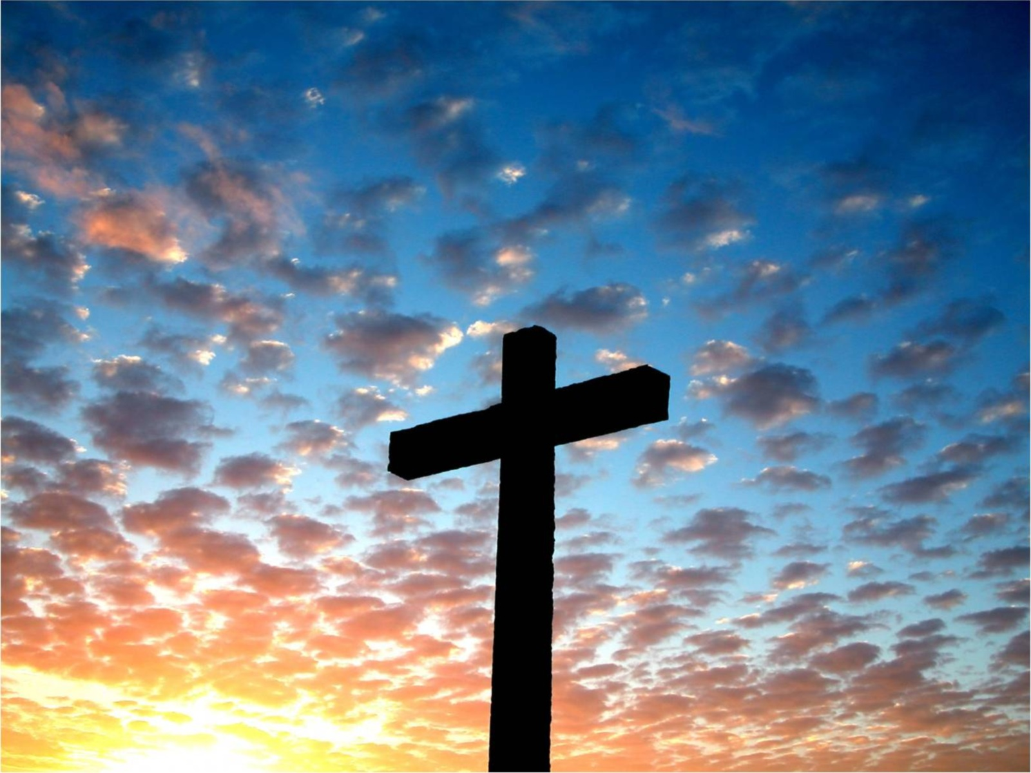

But God forbid that I should glory, save in the cross of our Lord Jesus Christ, by whom the world is crucified unto me, and I unto the world. (Gal 6:14)

This hymn is composed by one of my favorite ministers of the Gospel, Horatius Bonar (19 December 1808 – 31 July 1889), a minister of the Church of Scotland and, later, the Free Church of Scotland which he joined in 1843 after graduating Edinburg. Though he is most remembered for his hymns, he was also a great expositional preacher of the Word. I have learned much from reading his sermon material.

This hymn was titled, Crown of Life, when released in 1875. Later in 1882, James McGranahan wrote the present musical score.

Hallelujah is the word that best describes our perception of Christ's work on the Cross. It comes from two Hebrew words: Hallel - meaning praise to many; and Jah (or Yah) meaning God.

Hallelujah for The Cross

The cross, it standeth fast—
Hallelujah, hallelujah!
Defying every blast—
Hallelujah, hallelujah!
The winds of hell have blown,
The world its hate hath shown,
Yet it is not overthrown—
Hallelujah for the cross!
Refrain
Hallelujah, hallelujah,
Hallelujah for the cross;
Hallelujah, hallelujah,
It shall never suffer loss!

It is the old cross still—
Hallelujah, hallelujah!
Its triumph let us tell—
Hallelujah, hallelujah!
The grace of God here shone
Thru Christ, the blessèd Son,
Who did for sin atone—
Hallelujah for the cross!
Refrain

’Twas here the debt was paid—
Hallelujah, hallelujah!
Our sins on Jesus laid—
Hallelujah, hallelujah!
So round the cross we sing
Of Christ, our offering,
Of Christ, our living king—
Hallelujah for the cross!
Refrain

The cross, it standeth fast— Hallelujah, hallelujah! Defying every blast— Hallelujah, hallelujah! The winds of hell have blown, The world its hate hath shown, Yet it is not overthrown—Hallelujah for the cross! The Cross of Christ is Immovable in Time and Cause. It did, as we have said many times, divide Eternity precisely in two. Nothing else could have done so. So momentous was the event of the Crucifixion that is stands at mid-point - not only of Time, but also of the Mysteries of God and His Word. No amount of slander or deceit can unravel the meaning of that event. Men seek tirelessly to obscure the name of Christ from every religious holiday (read Holy-Day) to no avail. Christmas has become Winter Break. Easter has become Spring Break, and Thanksgiving has been labeled 'Turkey Day' or Fall Break. Such animosity toward Christ cannot be disguised as expediency or utilitarian. No one can deny the witness of our calendar which tells us that something so very spectacular occurred 2,016 years ago that we date our calendars to that reference point. Some years ago, the Jehovah Witnesses, who deny the divinity of Christ, conceived of a manner to hide the profundity of His Birth. Instead of labeling the year as Anno Domini (In the Year of our Lord) - AD - they began using the spurious term "Common Era or CE" Atheistic scientists and secular publishers were eager to take up this term invented by the Jehovah Witness. But that does not remove the evidence that something very special happened 2,016 years ago that was so profound as to date our calendar by the date whether we adhere to the correct AD or the spurious CE - Let God be true and every man a liar" (Romans 3:4)

It is the old cross still—Hallelujah, hallelujah! Its triumph let us tell—Hallelujah, hallelujah! The grace of God here shone Thru Christ, the blessèd Son, Who did for sin atone—Hallelujah for the cross! The shadow of the cross was given Abraham on Mount Moriah when he anticipated the sacrifice of His only begotten son, Isaac; however, God taught us thereby that He would not demand the redemptive wage of sin be paid by any man - nor could he - but that God would provide Himself a Lamb for the sacrifice. The Cross has, since Abraham until now, been the steadfast Ensign of the Christian religion. The Cross was not only the sacrifice of our Lord Jesus Christ, but also of the Father who endured the pitiful ordeal of seeing His only Begotten Son so mercilessly treated by sinful men - the very ones for whom He bled and died! It was not an act of justice, but of grace alone toward us. It was justice in the eyes of God that someone must pay the wages of sin under the terms of the Immutable Law of God. This, Christ did, and was the only One worthy of doing so. It was an act of Justice married to Mercy and Grace. The atonement makes us One with God if we have believed fully. (At-One-Ment)

’Twas here the debt was paid—Hallelujah, hallelujah! Our sins on Jesus laid—Hallelujah, Hallelujah! So round the cross we sing Of Christ, our offering, Of Christ, our living king—Hallelujah for the cross! The sacrifice was made once and for all. For Christ also hath once suffered for sins, the just for the unjust, that he might bring us to God, being put to death in the flesh, but quickened by the Spirit: (1 Peter 3:18) We can pay no offering to God that will benefit Him for all belongs to Him - even every hair of our heads. So Praise is our only offering of worth. Unlike the disciples of that dreaded day who feared to come near the cross, we gather now in confident courage since the price is paid, the victory won, and the danger past. There has never been a time when Christ was not living. His Spirit lived on as His body lay lifeless in the Garden Tomb. He is the Living King of Kings and Lord of Lords. Though crude, ugly, and tortuous, we praise God for the Cross, remembering that we, too, have a cross to bear - not of gold or silver, but of like crude wood and splinters.

Refrain
Hallelujah, hallelujah, Hallelujah for the cross; Hallelujah, hallelujah, It shall never suffer loss! No, the Cross cannot suffer loss because it was an act of Eternal import. At the cross, the victory was won over the disdainful Adversary. Once unconditional victory has been won, there is no recourse to that victory of Christ at Calvary. Neither can we suffer loss. We live our lives in constant struggle and growing infirmities. But the end is to capitalize on that victory won for us by our Lord - a newness of life, heart, mind and glorified body with Him. This is just cause for the Hallelujah chorus in three parts - Hallelujah, Hallelujah, Hallelujah - to God the Father, God the Son, and God the Holy Ghost. Amen.

If any man's work shall be burned, he shall suffer loss: but he himself shall be saved; yet so as by fire.
(1 Cor 3:15)

