Hymns of the Church – Good King Wenceslas – 27 December 2016, Anno Domini

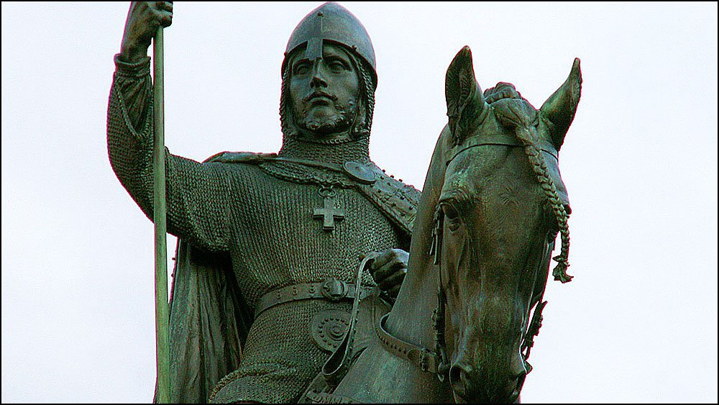

54 When they heard these things, they were cut to the heart, and they gnashed on him with their teeth. 55 But he, being full of the Holy Ghost, looked up stedfastly into heaven, and saw the glory of God, and Jesus standing on the right hand of God, 56 And said, Behold, I see the heavens opened, and the Son of man standing on the right hand of God. 57 Then they cried out with a loud voice, and stopped their ears, and ran upon him with one accord, 58 And cast him out of the city, and stoned him: and the witnesses laid down their clothes at a young man's feet, whose name was Saul. 59 And they stoned Stephen, calling upon God, and saying, Lord Jesus, receive my spirit. 60 And he kneeled down, and cried with a loud voice, Lord, lay not this sin to their charge. And when he had said this, he fell asleep. (Acts 7:54-60)

Today’s devotion is more a commentary on the Feast of St. Stephen than on the jolly old carol that makes mention of his Feast Day. But there are lessons incorporated in the hymn that give example of the selfless sacrifice of St. Stephen. King Wenceslas (known as Vaclav) was born in 907 in Bohemia – now part of the Czech Republic. His statue stands at the center of the City of Prague and has been the central point around which many Czech national events have coalesced. The historical annals suggest that he was, indeed, a good Christian, a good king, and a patriot of his homeland. His carol below was written by the English hymn-writer John Mason Neale and published in 1853. Wenceslas has become the symbol of Christian charity throughout the realm of the Church. The carol is not included as a hymn in the 1940 Hymnal owing to its lack of direct biblical references which define a proper hymn. The tune is an old Norwegian one.

Good King Wenceslas

Good King Wenceslas looked out
On the feast of Stephen
When the snow lay round about
Deep and crisp and even
Brightly shone the moon that night
Though the frost was cruel
When a poor man came in sight
Gath'ring winter fuel

"Hither, page, and stand by me
If thou know'st it, telling
Yonder peasant, who is he?
Where and what his dwelling?"
"Sire, he lives a good league hence
Underneath the mountain
Right against the forest fence
By Saint Agnes' fountain."

"Bring me flesh and bring me wine
Bring me pine logs hither
Thou and I will see him dine
When we bear him thither."
Page and monarch forth they went
Forth they went together
Through the rude wind's wild lament
And the bitter weather

"Sire, the night is darker now
And the wind blows stronger
Fails my heart, I know not how,
I can go no longer."
"Mark my footsteps, my good page
Tread thou in them boldly
Thou shalt find the winter's rage
Freeze thy blood less coldly."

In his master's steps he trod
Where the snow lay dinted
Heat was in the very sod
Which the Saint had printed
Therefore, Christian men, be sure
Wealth or rank possessing
Ye who now will bless the poor
Shall yourselves find blessing.

“Good King Wenceslas looked out On the feast of Stephen When the snow lay round about Deep and crisp and even Brightly shone the moon that night Though the frost was cruel When a poor man came in sight Gath'ring winter fuel.” The winters of Bohemia are particularly harsh with temperatures ranging below freezing and nothing to mollify the biting edge of the open winds. The beauty of the scene described betrays the misery it inflicts on any soul exposed to its unceasing gales and ice-laden blasts. The poor have no choice concerning choice of weather and elements to make provision for their families. Out of his comfort, King Wenceslas spots a man in his misfortune and hardship gathering wood in weather than can only grow more severe for its coldness.

King Wenceslas, at the moment of sighting a man of such dire need and circumstance, has the charity of heart to inquire of him: "Hither, page, and stand by me If thou know'st it, telling Yonder peasant, who is he? Where and what his dwelling?" "Sire, he lives a good league hence Underneath the mountain Right against the forest fence By Saint Agnes' fountain." The way is not convenient to travel even on a good day, much less a night of treacherous cold. But no impediment of weather or terrain can hinder the intention of a good heart.

“Bring me flesh and bring me wine Bring me pine logs hither Thou and I will see him dine When we bear him thither." Page and monarch forth they went Forth they went together Through the rude wind's wild lament And the bitter weather.” The peasant fellow is seeking wood for warmth, yet King Wenceslas prepares for ALL of the man’s needs, and not just his immediate ones. One can observe, too, that the charity of a good master leads to that of his subjects just as those who follow Christ provisions them with courage and love.

“Sire, the night is darker now And the wind blows stronger Fails my heart, I know not how, I can go no longer." "Mark my footsteps, my good page Tread thou in them boldly Thou shalt find the winter's rage Freeze thy blood less coldly." The good king’s page lacks the kind of fortitude that is sustained by inordinate love in the heart of his master; but he follows on borrowing the courage of the king and walking in his footsteps. The Christian is also emboldened to go where he might otherwise lack the courage to go without having that courage imparted by his Lord.

“In his master's steps he trod Where the snow lay dinted Heat was in the very sod Which the Saint had printed Therefore, Christian men, be sure Wealth or rank possessing Ye who now will bless the poor Shall yourselves find blessing.” This is the mystery of St. Stephen – the first deacon and first Christian martyr. He followed so perfectly in the footsteps of our Lord that he preached to the unbelievers all that was written of Christ in the Law and Prophets before being stoned by the Jewish rulers; and in his last breath, he cited the very sentiments of Christ at His crucifixion: And he kneeled down, and cried with a loud voice, Lord, lay not this sin to their charge. And when he had said this, he fell asleep. (Acts 7:60)

31 When the Son of man shall come in his glory, and all the holy angels with him, then shall he sit upon the throne of his glory: 32 And before him shall be gathered all nations: and he shall separate them one from another, as a shepherd divideth his sheep from the goats: 33 And he shall set the sheep on his right hand, but the goats on the left. 34 Then shall the King say unto them on his right hand, Come, ye blessed of my Father, inherit the kingdom prepared for you from the foundation of the world: 35 For I was an hungred, and ye gave me meat: I was thirsty, and ye gave me drink: I was a stranger, and ye took me in: 36 Naked, and ye clothed me: I was sick, and ye visited me: I was in prison, and ye came unto me. 37 Then shall the righteous answer him, saying, Lord, when saw we thee an hungred, and fed thee? or thirsty, and gave thee drink? 38 When saw we thee a stranger, and took thee in? or naked, and clothed thee? 39 Or when saw we thee sick, or in prison, and came unto thee? 40 And the King shall answer and say unto them, Verily I say unto you, Inasmuch as ye have done it unto one of the least of these my brethren, ye have done it unto me. 41 Then shall he say also unto them on the left hand, Depart from me, ye cursed, into everlasting fire, prepared for the devil and his angels: 42 For I was an hungred, and ye gave me no meat: I was thirsty, and ye gave me no drink: 43 I was a stranger, and ye took me not in: naked, and ye clothed me not: sick, and in prison, and ye visited me not. 44 Then shall they also answer him, saying, Lord, when saw we thee an hungred, or athirst, or a stranger, or naked, or sick, or in prison, and did not minister unto thee? 45 Then shall he answer them, saying, Verily I say unto you, Inasmuch as ye did it not to one of the least of these, ye did it not to me. 46 And these shall go away into everlasting punishment: but the righteous into life eternal. (Matt 25:31-46)

