Hymns of the Church – Give to the Winds thy Fears – 15 May 2018, Anno Domini

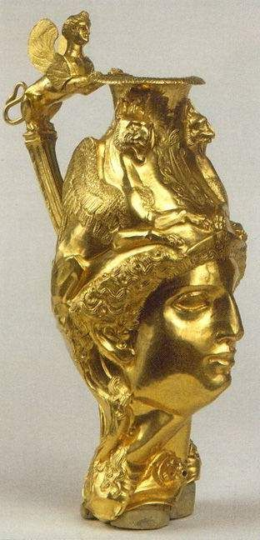

8 The wind bloweth where it listeth, and thou hearest the sound thereof, but canst not tell whence it cometh, and whither it goeth: so is every one that is born of the Spirit. (John 3:8)

This beautiful and meaningful old hymn is like a golden vessel imprisoned in the galley of a great sailing ship at the bottom of the sea. I had never heard of it until very recently, but the hymn is almost four centuries old. It is the work of another of the great Lutheran hymn writers, Paul Gerhardt in 1656 and translated into English in 1737 by the Anglican cleric, John Wesley. There are at least four different tunes to which the hymn is sung, but my favorite is the oldest, St. Bride, composed in 1762 by Samuel Howard.

The hymn was of great comfort (in his own words) to Zachary Macauley, Governor of Sierra Leone in 1796 during the devastation caused by the French Invasion of that land. I will try to cover all briefly:

Give to the Winds thy Fears

Give to the winds thy fears,
Hope and be undismayed.
God hears thy sighs and counts thy tears,
God shall lift up thy head.

Through waves and clouds and storms,
He gently clears thy way;
Wait thou His time; so shall this night
Soon end in joyous day.

Still heavy is thy heart?
Still sinks thy spirit down?
Cast off the world, let fear depart
Bid every care begone.

What though Thou rulest not;
Yet heaven, and earth, and hell
Proclaim, God sitteth on the throne,
And ruleth all things well.

And whatsoe’er Thou will’st,
Thou dost, O King of kings;
What Thine unerring wisdom chose,
Thy power to being brings.

Leave to His sovereign sway
To choose and to command;
So shalt thou, wondering, own that way,
How wise, how strong this hand.

Far, far above thy thought,
His counsel shall appear,
When fully He the work hath wrought,
That caused thy needless fear.

Thou seest our weakness, Lord;
Our hearts are known to Thee;
O lift Thou up the sinking hand,
Confirm the feeble knee!

Let us in life, in death,
Thy steadfast truth declare,
And publish with our latest breath
Thy love and guardian care.

Give to the winds thy fears, Hope and be undismayed. God hears thy sighs and counts thy tears, God shall lift up thy head. There is no more secure deposit for your fears than the Winds of the Holy Spirit. 8 The wind bloweth where it listeth, and thou hearest the sound thereof, but canst not tell whence it cometh, and whither it goeth: so is every one that is born of the Spirit. (John 3:8) The One who loves you most is your Maker and Almighty God. He watches over you during the night watches as well as the toils of the day.

Through waves and clouds and storms, He gently clears thy way; Wait thou His time; so shall this night Soon end in joyous day. Should we not take courage at the promise of His Word? Fear thou not; for I amwith thee: be not dismayed; for I am thy God: I will strengthen thee; yea, I will help thee; yea, I will uphold thee with the right hand of my righteousness. (Isaiah 41:10)

Still heavy is thy heart? Still sinks thy spirit down? Cast off the world, let fear depart Bid every care begone. Remember the words of King George VI on the Eve of World War II) to the British Empire on Christmas Day, December 25th, 1939:

And I said to the man who stood at the gate of the year:
Give me a light that I may tread safely into the unknown.
And he replied:
Go out into the darkness and
put your hand into the Hand of God.
That shall be to you better than light
and safer than a known

What though Thou rulest not; Yet heaven, and earth, and hell Proclaim, God sitteth on the throne, And ruleth all things well. He hath done all things well. (Mark 7:37b) Indeed, our Lord has done all things well, and His arm is not shortened in our day. Even the families of perdition will bow the knee to the Lord our God. As I live, saith the Lord, every knee shall bow to me, and every tongue shall confess to God. (Romans 14:11)

And whatsoe’er Thou will’st, Thou dost, O King of kings; What Thine unerring wisdom chose, Thy power to being brings. God is Omnipotent, Omniscient, and Omnipresent. There is no power which does not depend upon His will. 4 Where wast thou when I laid the foundations of the earth? declare, if thou hast understanding. 5 Who hath laid the measures thereof, if thou knowest? or who hath stretched the line upon it? 6 Whereupon are the foundations thereof fastened? or who laid the corner stone thereof; 7 When the morning stars sang together, and all the sons of God shouted for joy? 8 Or who shut up the sea with doors, when it brake forth, as if it had issued out of the womb? 9 When I made the cloud the garment thereof, and thick darkness a swaddlingband for it, 10 And brake up for it my decreed place, and set bars and doors, 11 And said, Hitherto shalt thou come, but no further: and here shall thy proud waves be stayed? (Job 38:4-11)

Leave to His sovereign sway To choose and to command; So shalt thou, wondering, own that way, How wise, how strong this hand. In owning the way of God to ourselves, we conform completely to HIS will and not our will that was formerly in bondage and not free at all. The only Liberty is found in Christ!

Far, far above thy thought, His counsel shall appear, When fully He the work hath wrought, That caused thy needless fear. Think back, Reader, to some moment when the fears and terrors overwhelmed your soul. All seemed lost and ruined; but, by and by, the Lord turned your misery into joy, and your fears to unimaginable courage. You will see His fingerprint on all such issues of life.

Thou seest our weakness, Lord; Our hearts are known to Thee; O lift Thou up the sinking hand,Confirm the feeble knee! 14 I will praise thee; for I am fearfully and wonderfully made: marvellous are thy works; and that my soul knoweth right well. 15 My substance was not hid from thee, when I was made in secret, andcuriously wrought in the lowest parts of the earth. 16 Thine eyes did see my substance, yet being unperfect; and in thy book all my members were written, which in continuance were fashioned, when as yet there was none of them. (Psalm 139:14-16) If the eyes of the Lord were upon you in your mother’s womb, how much more so outside that dark beginning?

Let us in life, in death, Thy steadfast truth declare, And publish with our latest breath Thy love and guardian care. Fear God, and keep his commandments: for this is the whole duty of man. (Eccl 12:13)

