Hymns of the Church – Fountain of Mercy, God of Love – 9 June 2020, Anno Domini

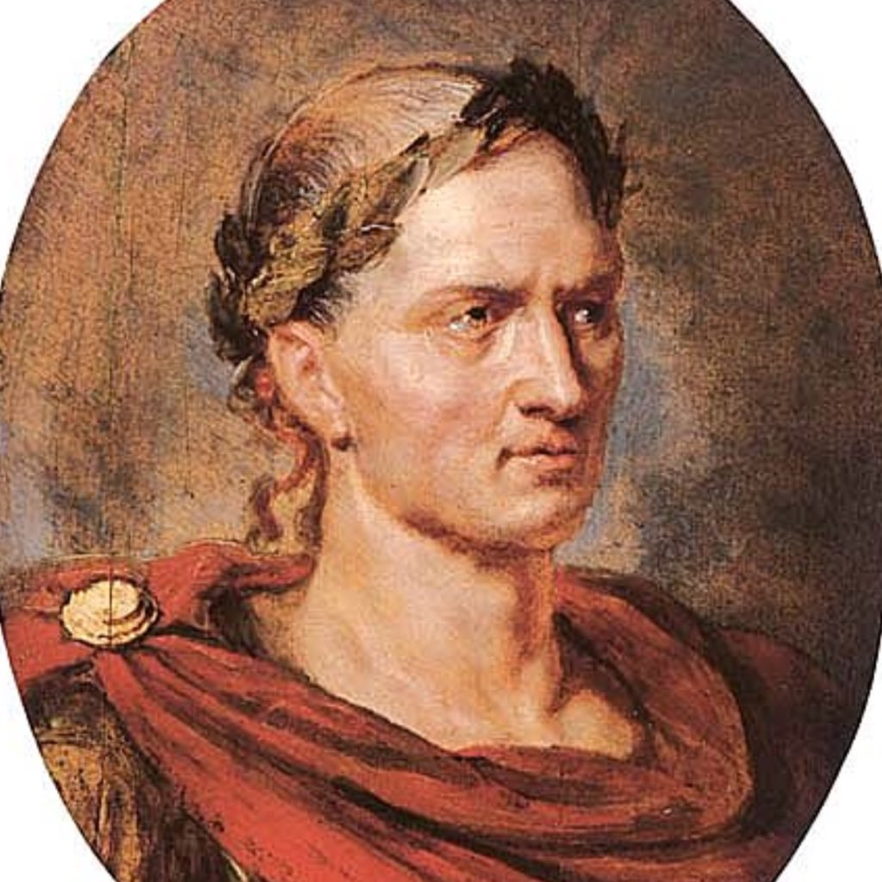

An ancient Trinity Season Hymn by Mrs. Alice Flowerdew (1759-1830), of Ipswich, England. The tune is by John B. Dykes in 1875. Interestingly, the title, BEATITUDO, (the condition of blessedness) was first coined by none other than Marcus Tullius Cicero in 44, BC.

Fountain of Mercy, God of Love

Fountain of mercy, God of love,
How rich Thy bounties are!
The rolling seasons, as they move,
Proclaim Thy constant care.

When in the bosom of the earth
The sower hid the grain,
Thy goodness marked its secret birth,
And sent the early rain.

The spring's sweet influence, Lord, was Thine;
The plants in beauty grew;
Thou gav'st refulgent suns to shine,
And the refreshing dew.

These various mercies from above
Matured the swelling grain;
A kindly harvest crowns Thy love,
And plenty fills the plain.

We own and bless Thy gracious sway;
Thy hand all nature hails;
Seed-time nor harvest, night nor day,
Summer nor winter, fails.

1 Fountain of mercy, God of love, How rich Thy bounties are! The rolling seasons, as they move, Proclaim Thy constant care. There is a mighty difference between a Fountain and puddle. One is living and fresh – the latter is stale and impure. The flow of a Fountain is self-generating. The water of the Fountain is sourced at some great distance and depth of a mountain stream. The Love of God is self-generating and comes from afar to bless us. Apart from God, there is no love for He is the Author of love. A Fountain spring is unstopping. It provides a continuous and consistent flow. The season of the year are gifts of beauty from God, the luscious greenery of spring, the rich maturity of the crops in summer, the beauty of the autumn leaves and foliage of Fall, and the pure white snows of winter provide a montage of color, atmosphere, and reflection for us.

2 When in the bosom of the earth The sower hid the grain, Thy goodness marked its secret birth, And sent the early rain. Not only does all love descend from God on High, but all LIFE as well. He is the Author and Giver of life. The tiny seed has even a smaller kernel and spark of life hidden deep within which responds to the warmth and moisture of the soil in performing its germinating process. The creation of life is no different from that of all beings. The Lord gives life to plants, animals and fish of the sea with the same love and care. He sends the rain in due season to nourish the seed. He sends rains of blessing to us as well in due season to give us hope and strength.

3 The spring's sweet influence, Lord, was Thine; The plants in beauty grew; Thou gav'st refulgent suns to shine, And the refreshing dew. All physical energy on earth is sourced in our Sun. All of our Life’s energy is sourced in the Son of God. The sun’s radiance creates nourishment in the tender leaves as they break the plane of the earth and reach toward heaven. The refreshing dew comes in imperceptible condensation during the hours of darkness and early morn. That is very much like the refreshing graces of the Holy Ghost that come in silent and imperceptible approach to comfort our troubled hearts and to refresh our spirits. We cannot see its coming, but we feel the joy and benefits of it.

4 These various mercies from above Matured the swelling grain; A kindly harvest crowns Thy love, And plenty fills the plain. All the early life of the seed-plant takes place in utter darkness just as in the formation of a child in its mother’s womb. 12 Yea, the darkness hideth not from thee; but the night shineth as the day: the darkness and the light are both alike to thee. 13 For thou hast possessed my reins: thou hast covered me in my mother’s womb. 14 I will praise thee; for I am fearfully and wonderfully made: marvellous are thy works; and that my soul knoweth right well. 15 My substance was not hid from thee, when I was made in secret, and curiously wrought in the lowest parts of the earth. 16 Thine eyes did see my substance, yet being unperfect; and in thy book all my members were written, which in continuance were fashioned, when as yet there was none of them. 17 How precious also are thy thoughts unto me, O God! how great is the sum of them! (Psalm 139:12-17) Consider the great and loving Mind that cares for the seedling as well as the baby.

5 We own and bless Thy gracious sway; Thy hand all nature hails; Seed-time nor harvest, night nor day, Summer nor winter, fails. That same earthly sphere, with its wondrous beauties of green, blue, and heavenly lights which God sat in motion at the primitive beginning shall continue in its orb and cycle consistent with the covenant made with Noah: While the earth remaineth, seedtime and harvest, and cold and heat, and summer and winter, and day and night shall not cease. (Gen 8:22) The plant and animal kingdom comply perfectly with the natural laws God established at the beginning. Only the vicisitudes of human nature provide any exception to that natural law. Man has the time and means to imagine every unnatural and wicked thing, and he makes full use of that faculty. If you doubt, look about you at our modern society and witness wickedness unmentionable just a few decades ago. But God has placed corrective measures in heaven and in earth to bring such excesses into judgment and destruction. May our nation awaken before it is too late to stay that mighty hand of judgment.

