Hymns of the Church – Do you see what I see? – 3 December 2019, Anno Domini

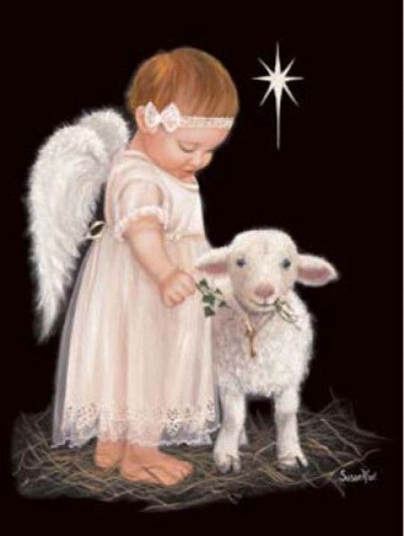

A
ND he took up his parable, and said, Balaam the son of Beor hath said, and the man whose eyes are open hath said: ¹⁶ He hath said, which heard the words of God, and knew the knowledge of the most High, which saw the vision of the Almighty, falling into a trance, but having his eyes open: ¹⁷ I shall see him, but not now: I shall behold him, but not nigh: there shall come a Star out of Jacob, and a Sceptre shall rise out of Israel, and shall smite the corners of Moab, and destroy all the children of Sheth. (Numbers 24:15-17)

N
OW when Jesus was born in Bethlehem of Judaea in the days of Herod the king, behold, there came wise men from the east to Jerusalem, ² Saying, Where is he that is born King of the Jews? For we have seen his star in the east, and are come to worship him. ³ When Herod the king had heard these things, he was troubled, and all Jerusalem with him. (Matthew 2:1-3)

If there was ever a true to goodness childrens’ Christmas carol, this is the one before us. It exudes warmth and beauty to minds that are still tender to sense it. It is not a hymn since it does not specifically reinforce Bible doctrine; but it does express in lovely

The author, Noel Regney, was a French citizen with a promising musical career ahead of him at the outbreak of World War II and was conscripted, against his will, into the German army. But he served the French underground at the same time. Later, he defected to the underground for the remainder of the war. He came to hate war and plead for peace. In October 1962, the United States and the Soviet Union were engaged in an intense Cold War. Cuba, and the missile build-up there, had become a threatening venue for all out war. By this time, Regney had immigrated to the United States. He knew war, and yearned for peace more than anything else. His disposition, as he walked the streets of New York, were similar to another great word artist – Henry Wadsworth Longfellow who had, on the beginning of the Advent Season (1863), received news that his son, serving in the Union Army during the War Between the States, had been severely wounded at the Battle of New Hope Church. Similarly affected, Longfellow wrote the Christmas Carol, I HEARD THE BELLS ON CHRISTMAS EVE.” One line expresses his depression, and another later demonstrates the victory of the Spirit above the lines of battle:

Then from each black, accursed mouth, The cannon thundered in the South, And with the sound, The carols drowned, Of peace on earth, good-will to men!

And then the victorious theme sounds above his grief and doubt:

Then pealed the bells more loud and deep: "God is not dead, nor doth He sleep; The Wrong shall fail, The Right prevail, With peace on earth, good-will to men.

But the words, and whole spirit, of Regney’s carol emanates love and peace from beginning to end.

Do you see what I see?

Said the night wind to the little lamb,
"Do you see what I see?
Way up in the sky, little lamb,
Do you see what I see?
A star, a star, dancing in the night
With a tail as big as a kite,
With a tail as big as a kite."

Said the little lamb to the shepherd boy,
"Do you hear what I hear?
Ringing through the sky, shepherd boy,
Do you hear what I hear?
A song, a song high above the trees
With a voice as big as the sea,
With a voice as big as the sea."

Said the shepherd boy to the mighty king,
"Do you know what I know?
In your palace walls, mighty king,
Do you know what I know?
A Child, a Child shivers in the cold--
Let us bring him silver and gold,
Let us bring him silver and gold."

Said the king to the people everywhere,
"Listen to what I say!
Pray for peace, people, everywhere,
Listen to what I say!
The Child, the Child sleeping in the night
He will bring us goodness and light,
He will bring us goodness and light.

Said the night wind to the little lamb, "Do you see what I see? Way up in the sky, little lamb, Do you see what I see? A star, a star, dancing in the night With a tail as big as a kite, With a tail as big as a kite." Well, little lambs are very near-sighted and perhaps unable to see the promise of the bright star in the sky; but I would wager that the little lamb can see and remember the beauty and profound wonder that lies beyond that star. It is a mystery unsolved to the believer that the desperate sinner is too blind to see the same light as the believer has been gifted to see in the Gospels. These still sit in darkness because they refuse to stand and see.

Said the little lamb to the shepherd boy, "Do you hear what I hear? Ringing through the sky, shepherd boy, Do you hear what I hear? A song, a song high above the trees With a voice as big as the sea, With a voice as big as the sea." The baby Christian may be dim of vision, but he is often able to hear heavenly beauty that the shepherd boy may have forgotten in his growth. That Voice is more than “as big as the sea.” It is the Master of the Seas and its Maker.

Said the shepherd boy to the mighty king, "Do you know what I know? In your palace walls, mighty king, Do you know what I know? A Child, a Child shivers in the cold-- Let us bring him silver and gold, Let us bring him silver and gold." The Star and the Angels did not appear to the high-born royalty of Jerusalem, but to the ancients Persian Magi and the poor shepherds in the fields tending their flocks at night above sleepy Bethlehem. Instead of delivering comfort to the child, this King would seek to destroy the baby. Here, we see that the carol fails in its direct application of absolute biblical truth. It was GOLD, FRANKINCENSE, AND MYRRH to be brought as tokens of prophecy to the child. Gold to signify His royalty as King of Kings; Frankincense to illustrate His Divinity and worthiness of worship; and Myrrh to symbolize His death for us. (Myrrh was used to anoint and embalm the dead.

Said the king to the people everywhere, "Listen to what I say! Pray for peace, people, everywhere, Listen to what I say! The Child, the Child sleeping in the night He will bring us goodness and light, He will bring us goodness and light. This king, Herod, could care less about peace – he craved power and security on his throne. He had been informed of the prophecies of our Lord’s birth, yet he was repelled at the idea. The carol represents Regney’s highest ideal and hope for peace, not the reality of the mundane. But, yes indeed, He will bring us goodness and Light for He was the only righteous born of woman, and He was, and is now, the Light of the World.

