Devotion on Hymns of the Church - Christ the Lord is Risen Today - Easter Tuesday - 29 March 2016, Anno Domini

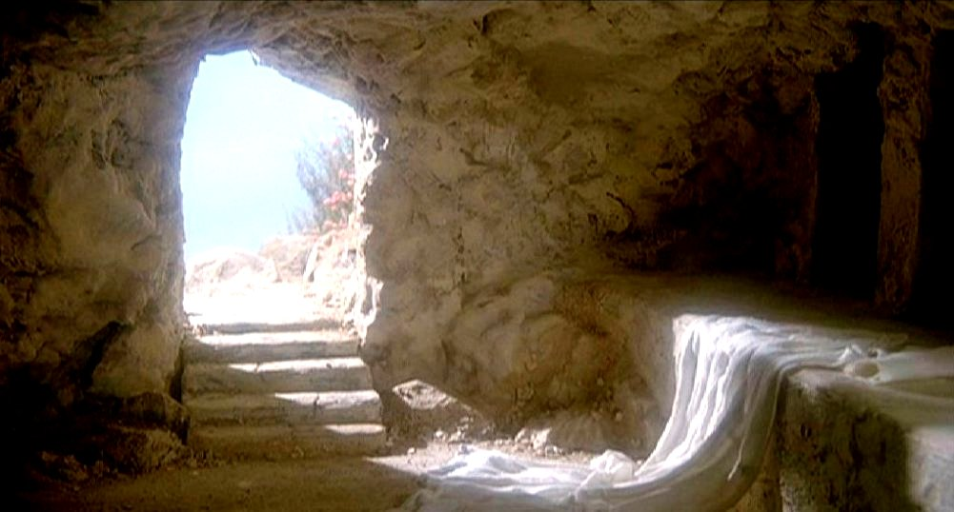

And the angel answered and said unto the women, Fear not ye: for I know that ye seek Jesus, which was crucified. He is not here: for he is risen, as he said. Come, see the place where the Lord lay. (Matt 28:5-6)

I am the resurrection, and the life: he that believeth in me, though he were dead, yet shall he live: And whosoever liveth and believeth in me shall never die. Believest thou this? (John 11:25-26)

Millions of faithful voices sang this hymn this week at the Easter Service. How many of them truly believed Jesus Christ rose even as they sang the hymn? He did! His resurrection was timeless and not limited to a single hour or day. Jesus is the I AM of the Resurrection. "I am the Resurrection and the Life." Note the Divine title of Christ - the I AM! That titled is qualified in His special role as the Resurrection. If He is not the Resurrection, we are without hope. His Resurrection is ongoing since Godly souls rise in Him every moment of the day - now and forever as long as seed time and harvest remain.

Written by Charles Wesley and first published in 1756, the hymn is the product of a number of writers and hymnists. The most popular tune is Easter Hymn - author unknown to man, and known only to God.

It is interesting to note how modern Bible versions (translated from corrupt manuscripts) pass along the error of their specious translation in their English translation. See how Matt 28:6 is changed in its significant meaning from the Received Text rendering above: "He is not here; he has risen, just as he said."

Matt 28:6 (NIV) Observe the past tense 'has risen" as opposed to "is risen." This may seem a trivial change, but it is not. It goes to the heart of who Jesus is as the Great I AM!

Christ the Lord is risen today, Alleluia!
Earth and heaven in chorus say, Alleluia!
Raise your joys and triumphs high, Alleluia!
Sing, ye heavens, and earth reply, Alleluia!

Lives again our glorious King, Alleluia!
Where, O death, is now thy sting? Alleluia!
Once he died our souls to save, Alleluia!
Where's thy victory, boasting grave? Alleluia!

Love's redeeming work is done, Alleluia!
Fought the fight, the battle won, Alleluia!
Death in vain forbids him rise, Alleluia!
Christ has opened paradise, Alleluia!

Soar we now where Christ has led, Alleluia!
Following our exalted Head, Alleluia!
Made like him, like him we rise, Alleluia!
Ours the cross, the grave, the skies, Alleluia!

Christ the Lord is risen today, Alleluia! Earth and heaven in chorus say, Alleluia! Raise your joys and triumphs high, Alleluia! Sing, ye heavens, and earth reply, Alleluia! The Christian heart is securely buried in Christ. His entire hope of resurrection lies in the hope of resurrection offered in Christ; therefore, as Christ rises today, so do all who are in Christ - just as those who were in the secure chambers of Noah's Ark. Christ is our Ark and we rise with Him daily. His is the place of security, and we are invited to enter in. This does not nullify the fact that Christ did visibly and gloriously arise on the First Day of the week from the Garden Tomb; but that resurrection illustrates the ongoing resurrection the believer has in Christ. Every Word of God must evoke an echo in our own hearts so that both Heavens and Earth reply.

The Greek alliteration of the Hebrew word, Hallelujah/Alleluia, occurs sixteen times in the hymn; therefore, it deserves some illumination. Here is how Jamiesson, Fauscett, Brown describes it: " Alleluia--Hebrew, "Praise ye JAH," or JEHOVAH: here first used in Revelation, whence ELLICOTT infers the Jews bear a prominent part in this thanksgiving. JAH is not a contraction of "JEHOVAH," as it sometimes occurs jointly with the latter. It means "He who Is": whereas Jehovah is "He who will be, is, and was." It implies God experienced as a PRESENT help; so that "Hallelujah," says KIMCHI in BENGEL, is found first in the Psalms on the destruction of the ungodly. "Hallelu-Jah" occurs four times in this passage. Compare Psalms 149:4-9, which is plainly parallel, and indeed identical in many of the phrases, as well as the general idea. Israel, especially, will join in the Hallelujah, when "her warfare is accomplished" and her foe destroyed." Note the correct interpretation of the nature of Christ in this explanation: " It means "He who Is": whereas Jehovah is "He who will be, is, and was." It implies God experienced as a PRESENT help.

Lives again our glorious King, Alleluia! Where, O death, is now thy sting? Alleluia! Once he died our souls to save, Alleluia! Where's thy victory, boasting grave? Alleluia!" Jesus experienced the pains of death so that we will be spared that death. He lay in the tomb over the Sabbath Day in rest. Just as the Creator (Jesus Christ) rested on the Seventh Day after creating the worlds and all living, so He rested on that Passover Sabbath after completing that spiritual Creation which He sealed with His death and burial. We may exclaim with Paul, O death, where is thy sting? O grave, where is thy victory? The sting of death is sin; and the strength of sin is the law. But thanks be to God, which giveth us the victory through our Lord Jesus Christ. (1 Cor 15:55-57)

Love's redeeming work is done, Alleluia! Fought the fight, the battle won, Alleluia! Death in vain forbids him rise, Alleluia! Christ has opened paradise, Alleluia!" There is an old gospel song my mother used to sing on sunny and cloudy days which proclaims,

I was sinking deep in sin,
Far from the peaceful shore,
Very deeply stained within,
Sinking to rise no more;
But the Master of the sea
Heard my despairing cry,
From the waters lifted me,
Now safe am I.
Love lifted me!
Love lifted me!
When nothing else could help,
Love lifted me.

I am pleased to proclaim it was a Divine, Immutable and Infinite Love that compelled Christ to the Cross for us. And it was that same divine Love that denied the tomb its most esteemed Occupant. It is not in the nature of death to surrender any who comes into its domain; but Christ is the Master of Land, Sea and Heaven. He is that brilliant Light before which the darkness of death can only flee and not confront. The labors of the Creator of Paradise at Eden, over which He labored and which was marred by the sin of Adam, yet exists in Heaven to where the Tree of Life has been quartered. God will not surrender the labor of His hands to Satan, but will, rather, restore all living of Eden and of earth (of believers) to that Edenic Paradise. 1 And he shewed me a pure river of water of life, clear as crystal, proceeding out of the throne of God and of the Lamb. 2 In the midst of the street of it, and on either side of the river, was there the TREE OF LIFE, which bare twelve manner of fruits, and yielded her fruit every month: and the leaves of the tree were for the healing of the nations. (Rev 22:1-2)

Soar we now where Christ has led, Alleluia! Following our exalted Head, Alleluia! Made like him, like him we rise, Alleluia! Ours the cross, the grave, the skies, Alleluia! Before we rise on the wings of love with Christ, we must first have followed Him along the dreary trails of this world - not only along the lush shores of Galilee's happy waters, but along the dreary rocks and crevices of the Wilderness. Not only do we follow Him to the feast and banquet, but also on the tiresome journey to Samaria, to the coasts of Tyre and Sidon, and to Gennesret (and up from Jericho as the Good Samaritan). If we are to enjoy a safe passage, we must, at least, be willing to walk on the sea as did Peter. We take up our "I AM" crosses daily and follow Him on the Via Dolorosa and on to Golgotha, and to the Garden Tomb (for we must die daily to self). Planted there in that Garden, as was He, we shall also follow on that glorious resurrection morning when stark and brilliant light shall separate the heavens and all shall rise in Christ to eternal life and bliss. ALLELUIA!

