Hymns of the Church – Children of Jerusalem – 15 August 2017, Anno Domini (In the Year of our Lord)

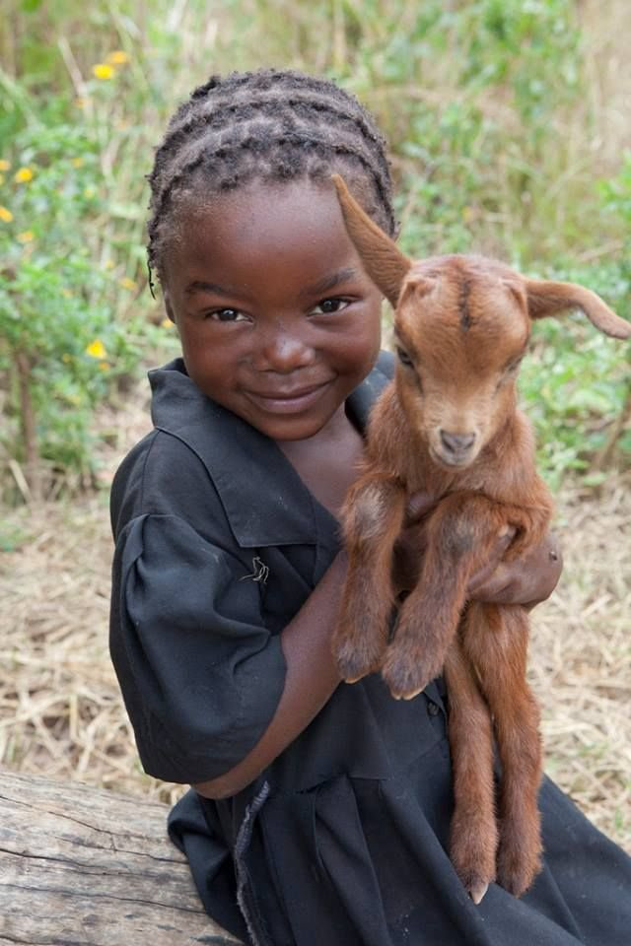

A
nd when the chief priests and scribes saw the wonderful things that he did, and the children crying in the temple, and saying, Hosanna to the Son of David; they were sore displeased, 16 And said unto him, Hearest thou what these say? And Jesus saith unto them, Yea; have ye never read, Out of the mouth of babes and sucklings thou hast perfected praise? (Matt 21:15-16)

An old hymn that reminds us of the voice of children singing praises to our Lord in the very perfection of praise. Is it still so? The lyrics were composed by John Henley in 1841, and the music is the composition taken from Curwen’s Tune Book of 1842. The children of the lesser Temple in Jerusalem sang “Hosanna to the Son of David” but will our children sing the same in the Holy Temple of New Jerusalem? Unfortunately, the modern churches believe the only way to attract the children of the world is to imitate the worlds songs and music. It is often more worldly and sensual than it is spiritual and biblically sound.

Children of Jerusalem

Children of Jerusalem
Sang the praise of Jesus’ Name:
Children, too, of modern days
Join to sing the Savior’s praise.
Refrain
Hark, hark, hark!
While infant voices sing,
Hark, hark, hark!
While infant voices sing
Loud hosannas, loud hosannas,
Loud hosannas to our King.

We are taught to love the Lord,
We are taught to read His Word;
We are taught the way to Heav’n:
Praise for all to God be giv’n.
Refrain

Parents, teachers, old and young,
All unite to swell the song;
Higher and yet higher rise,
’Til hosannas fill the skies.
Refrain

Children of Jerusalem Sang the praise of Jesus’ Name: Children, too, of modern days Join to sing the Savior’s praise. I hope the children of our churches today can become like unto the Children of Jerusalem in the day they sang simple praises to our Lord untainted by modern vulgarity. But I believe the hymn writer may have been overly optimistic in the future purity of the churches to teach the young people Godliness and reverence. Innocent children have a unique talent, given by the Holy Ghost, to find innocence and joy wherever it can be found. These children of Christian antiquity were overwhelmed with joy at the words and works of Christ in the Temple. God put an immediate song in their hearts as He does for all who are touched by His Word. They did not refrain from expressing their joy in song.

We are taught to love the Lord, We are taught to read His Word; We are taught the way to Heav’n Praise to all for God be giv’n In the day that this hymn was written, it was a common practice to teach them Bible stories and hymns at their mother’s knee. Even as late as my childhood, my mother taught me simple lessons of Jesus at her knee. Though there was much labor to be performed in those days, there also were fewer distractions to the moral mind. Honesty was more a common characteristic of the general population. Today, many parents haul their children off to Sunday School and Church, and leave them there at the door. But the most important teachers in the life of the child returns home and leaves all teaching to the Sunday School teacher, and the public educators who often teach error and corrupt morals. The practice of Old Time Religion was to teach the child to love the Lord; to read His Word; to live morally sound lives; and to praise God for every blessing. Honestly, how many children in our culture are so taught in our day?

Parents, teachers, old and young, All unite to swell the song; Higher and yet higher rise, ‘Til hosannas fill the skies. Hosanna means “Save us, Lord” in its ancient origin, but came to mean a prayer of praise to God. It has the connotation of the Latin, EXCELSIOR, meaning ever upward, and is the motto of the State of New York. Of course, the Narrow Way described by our Lord leads ever upward as Hosanna suggests. Do parents, teachers, old and young, join their voices to swell the heavens with Hosannas? Shouldn’t we? If we do not do so, does this not point to a Laodicean characteristic in the modern church? If we are disturbed by this fact, we needn’t be since we have it in our power to belatedly join our voices in Hosannas to the Son of David!

Refrain

Hark, hark, hark! While infant voices sing, Hark, hark, hark! While infant voices sing Loud hosannas, loud hosannas, Loud hosannas to our King. In the imperative sense, HARK means to ‘listen’ with intense focus of thought. Often, we consider that children should be seen and not heard; however, children can teach us great lessons. Perhaps we should HEAR the children. The innocence of the infant should be nurtured by good and Holy teaching, example in living, and service to God. If the parents fail in that enterprise, what shall the children do?

In the coarser years of a man life, after traveling a road of sin and wickedness for many years, it is not impossible for him to regain that innocence of childhood in the call of the Holy Ghost to his heart. Such coarse men may show the sweetest and most endearing livelihood once they have answered that call. John Newton (Amazing Grace) is a perfect example of that change. 3 Verily I say unto you, Except ye be converted, and become as little children, ye shall not enter into the kingdom of heaven. 4 Whosoever therefore shall humble himself as this little child, the same is greatest in the kingdom of heaven. 5 And whoso shall receive one such little child in my name receiveth me. 6 But whoso shall offend one of these little ones which believe in me, it were better for him that a millstone were hanged about his neck, and that he were drowned in the depth of the sea. (Matt 18:3-6)

