Hymns of the Church – And Can it Be? – 24 March 2020, Anno Domini (In the Year of our Lord)

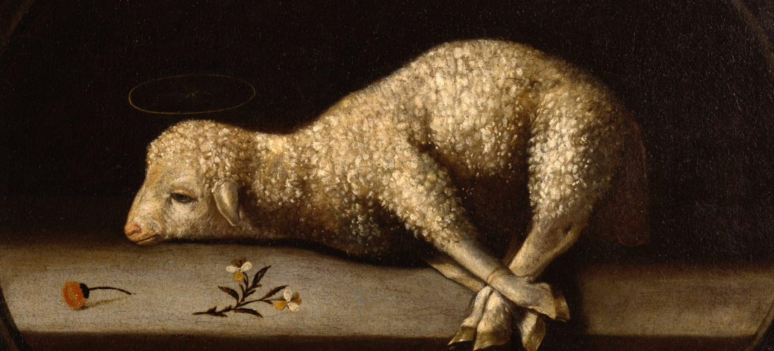

A
CCORDING to my earnest expectation and my hope, that in nothing I shall be ashamed, but that with all boldness, as always, so now also Christ shall be magnified in my body, whether it be by life, or by death. 21 For to me to live is Christ, and to die is gain. (Philippians 1:20-21)

F
OR when we were yet without strength, in due time Christ died for the ungodly. 7 For scarcely for a righteous man will one die: yet peradventure for a good man some would even dare to die. 8 But God commendeth his love toward us, in that, while we were yet sinners, Christ died for us. 9 Much more then, being now justified by his blood, we shall be saved from wrath through him. 10 For if, when we were enemies, we were reconciled to God by the death of his Son, much more, being reconciled, we shall be saved by his life. 11 And not only so, but we also joy in God through our Lord Jesus Christ, by whom we have now received the atonement. (Romans 5:6-11)

In my opinion, this hymn gains power with the size of the congregation singing it with enthusiastic joy. The lyrics are fundamental expressions that are germane to every believer. It rises near to the level of an anthem in its power and appeal. As we sing the lyrics, we feel the great mercy and grace that impelled our Lord to the cross. Such love manifested in that sacrifice is beyond our comprehension to understand. This hymn poses that question, and then, in many lines, answers it beautifully.

The hymn was written by Charles Wesley in 1738 and is often claimed to be the greatest of his more than 6,000 hymns. The tune is, SAGINA, by Thomas Campbell.

Advocates of ‘methodism,’ which led to the founding of the Methodist Church, Charles (and his brother John), remained priests of the Anglican Church until death. I am certain that neither would condone the modern spiritual depravity of many Methodists, or Anglican, churches today.

And Can it Be
And can it be that I should gain
An int'rest in the Savior's blood?
Died He for me, who caused His pain?
For me, who Him to death pursued?
Amazing love! how can it be
That Thou, my God, should die for me?

Refrain:
Amazing love! how can it be
That Thou, my God, should die for me!

'Tis mystery all! Th'Immortal dies!
Who can explore His strange design?
In vain the firstborn seraph tries
To sound the depths of love divine!
'Tis mercy all! let earth adore,
Let angel minds inquire no more. [Refrain]

He left His Father's throne above,
So free, so infinite His grace;
Emptied Himself of all but love,
And bled for Adam's helpless race;
'Tis mercy all, immense and free;
For, O my God, it found out me. [Refrain]

Long my imprisoned spirit lay
Fast bound in sin and nature's night;
Thine eye diffused a quick'ning ray,
I woke, the dungeon flamed with light;
My chains fell off, my heart was free;
I rose, went forth and followed Thee. [Refrain].

No condemnation now I dread;
Jesus, and all in Him is mine!
Alive in Him, my living Head,
And clothed in righteousness divine,
Bold I approach th'eternal throne,
And claim the crown, through Christ my own. [Refrain]
Amen.

1 And can it be that I should gain An int'rest in the Savior's blood? Died He for me, who caused His pain? For me, who Him to death pursued? Amazing love! how can it be That Thou, my God, should die for me? One of the most compelling effects of the classical hymn is the repetitious enumeration of biblical doctrines in lyrical form which are easily committed to memory. This hymn is a perfect example of that repetitious approach. The QUESTION? “Can it be?” compels a deeper thought on the part of the believer as the ways and means by which he or she has come to the Throne of Grace and Mercy. Though not reasonable at all in human logic that one would come and die for those who were at all odds with the Father and Son, yet the reality of the sacrifice is an absolute fact even if it does defy reason. The author used precisely the correct description of the event – AMAZING!

2 'Tis mystery all! Th'Immortal dies! Who can explore His strange design? In vain the firstborn seraph tries To sound the depths of love divine! 'Tis mercy all! let earth adore, Let angel minds inquire no more. How can immortality die, or the Creator succumb to the conditions of His Creation?

A
ND my speech and my preaching was not with enticing words of man's wisdom, but in demonstration of the Spirit and of power: ⁵ That your faith should not stand in the wisdom of men, but in the power of God. ⁶ Howbeit we speak wisdom among them that are perfect: yet not the wisdom of this world, nor of the princes of this world, that come to nought: ⁷ But we speak the wisdom of God in a mystery, even the hidden wisdom, which God ordained before the world unto our glory: ⁸ Which none of the princes of this world knew: for had they known it, they would not have crucified the Lord of glory. ⁹ But as it is written, Eye hath not seen, nor ear heard, neither have entered into the heart of man, the things which God hath prepared for them that love him.” (1 Corinthians 2:4-9)

But the mystery is of such great magnitude that the angels still seek to understand more fully: “¹¹ Searching what, or what manner of time the Spirit of Christ which was in them did signify, when it testified beforehand the sufferings of Christ, and the glory that should follow. ¹² Unto whom it was revealed, that not unto themselves, but unto us they did minister the things, which are now reported unto you by them that have preached the gospel unto you with the Holy Ghost sent down from heaven; which things the angels desire to look into.” (1 Peter 1:11-12)

3 He left His Father's throne above, So free, so infinite His grace; Emptied Himself of all but love, And bled for Adam's helpless race; 'Tis mercy all, immense and free; For, O my God, it found out me. Imagine your own father sending you into a hostile land to live among those who despise your father and who will seek to kill you, too, out of that outrage and malice! He left the splendor of opulent palace home to come and purchase an elect people for His Father. Yes, He did empty Himself of all but love, for that great Fountain of Love could never be emptied of its infinite abundance. Yes, free mercy and free grace – free to us, but very costly to the Savior. We were walking dead ere we came to know Christ as Lord – unable to lift a single finger, or make a single decision, to save ourselves. He was the only One able and sufficient to redeem us.

4 Long my imprisoned spirit lay Fast bound in sin and nature's night; Thine eye diffused a quick'ning ray, I woke, the dungeon flamed with light; My chains fell off, my heart was free; I rose, went forth and followed Thee.” Living this life without Christ is no different from lying in a stone-cold tomb with Lazarus. We are helpless to save ourselves and to be made alive. Our sins are the chains of our prison. Suddenly, the Light of Christ pierced the dark prison walls and a Voice called out our name, “Martha, or Jacob, or Sarah, or Michael: Come forth!” And we came forth still wearing our grave clothes, but He set us free even of those sins at which time our Lord issues that sanctifying command,“Loose him and and let him go!”

5 No condemnation now I dread; Jesus, and all in Him is mine! Alive in Him, my living Head, And clothed in righteousness divine, Bold I approach th'eternal throne, And claim the crown, through Christ my own. Have you realized the full meaning of your salvation – that those old sins of your worldly walk are completely erased? “24 Verily, verily, I say unto you, He that heareth my word, and believeth on him that sent me, hath everlasting life, and shall not come into condemnation; but is passed from death unto life.” (John 5:24) Is Christ your Living Head? He must be if you have taken on that mind which was in Jesus Christ. “5 Let this mind be in you, which was also in Christ Jesus:” (Philippians 2:5)

Refrain
Amazing love! how can it be That Thou, my God, should die for me! Amen. No proper hymn can end with less than the Amen to its great beauty and meaning. The REFRAIN repeats the immortal question from the hymn’s beginning and, mysteriously, the very answer is suggested by the question. “How can it be? That Thou, my God, should die for me?” The mystery dissolves once we understand our mortality and His Immortality. Our ways are not His ways, and our thoughts are not His thoughts. Only Almighty God could have died as a redemption for our sins; and an Almighty God could only have the vast reservoir of Love to do so! AMEN!

