Hymns of the Church – Blessed Quietness – 10 September 2019, Anno Domini

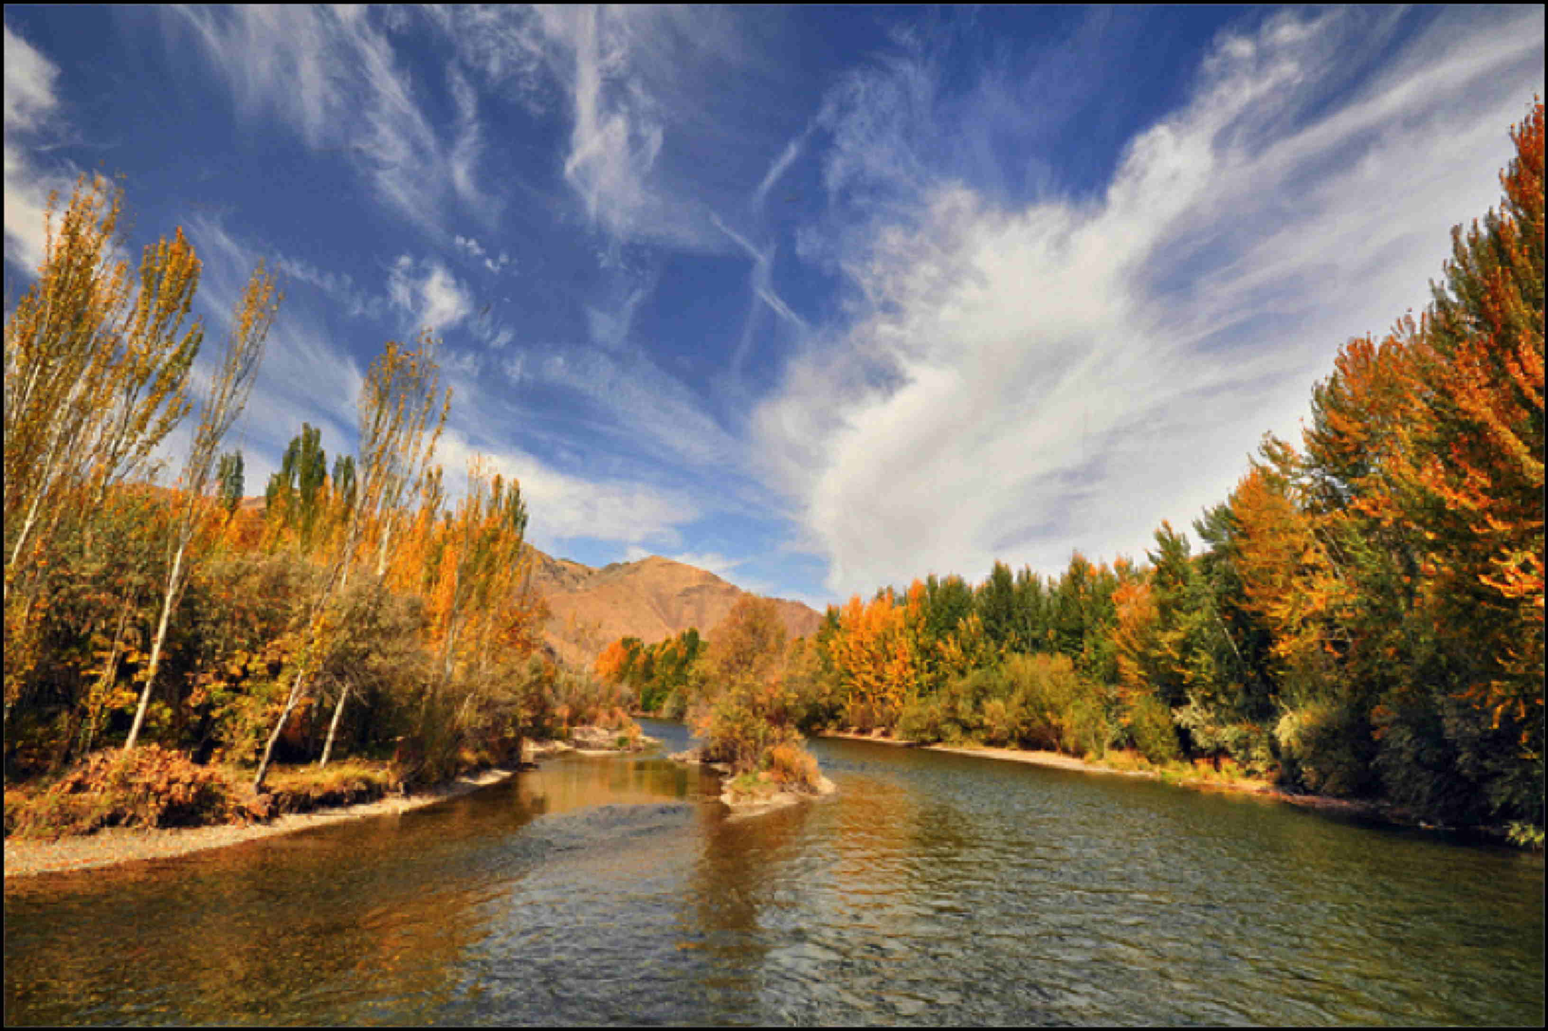

G
OD is our refuge and strength, a very present help in trouble. ² Therefore will not we fear, though the earth be removed, and though the mountains be carried into the midst of the sea; ³ Though the waters thereof roar and be troubled, though the mountains shake with the swelling thereof. Selah. ⁴ There is a river, the streams whereof shall make glad the city of God, the holy place of the tabernacles of the most High. ⁵ God is in the midst of her; she shall not be moved: God shall help her, and that right early. (Psalm 46:1-5)

For the past two Tuesdays, we have studied two different rivers and related hymns, each compared to one of the Persons of the Triune Godhead. (On Jordan’s Stormy Banks) - The first river, the River Jordan, we compared, in characteristics, to Christ. The Jordan River has it source in three mountain springs of Mt. Hermon. It flows down to the lowest point on earth (the Dead Sea) where it dies. It makes the banks and valleys where it flows green with life. It is only a little over 100 miles long. This river is like Christ in several ways – 1) He has His origins on high; 2) He gives life everywhere He goes; He came down to the lowest of sinners, and 3) He died for us in the Wilderness Sea of our sins. The second river, the Nile River, was compared to God the Father in the hymn, “Like a River Glorious.” You will remember that the Nile is the mightiest of rivers and has its source in the highest, snow-clad peak in Africa (Kilimanjaro). Many tributaries feed into the Nile and lose their identity in that great river just as the sinner who comes to Christ loses his identity in that great Fountain of Living Waters. The Nile carries minerals and other nutrients to the fertile crescent in Lower Egypt some 4,000 miles distant. It is so abundant that it overflows and fertilizes the delta plain region. It is very much like God the Father for its many amazing characteristics.

Today, we will discuss a river that most of my readers will not know about – the Zayanderud River in Iran. I lived by this beautiful river for more than five years and was enchanted by its gifts and the beauty of its peaceful flow. In the Persian language, Zayanderud means, “Giver of Life,” and that is exactly what the Zayanderud does everywhere it goes. It is about the same length as the Jordan River and it, too, dies in a salt sea (Ghav-Khuni ‘Blood of the Ox’) across the desert from its major city (Esfahan). While the Jordan River and the Zayanderud are so much alike, how can they accurately depict two different Persons of the Godhead? One, the Jordan, depicts Christ; and the other, the Zayanderud, depicts the Holy Spirit. It does not represent an improper relationship for both the Lord Jesus Christ, and the Holy Ghost of God, have the exact same purpose - for they are One in meaning, purpose, and will. I will describe the Zayanderud more fully at the conclusion of this devotion but, first, let us examine a hymn that very closely parallels the Holy Ghost and the Zayanderud River in character:

Joys are flowing like a river,
Since the Comforter has come;
He abides with us forever,
Makes the trusting heart His home.
Refrain
Blessed quietness, holy quietness—
What assurance in my soul!
On the stormy sea He speaks peace to me.
How the billows cease to roll!

Bringing life and health and gladness
All around, this heavenly Guest
Banished unbelief and sadness,
Changed our weariness to rest.
Refrain

Like the rain that falls from heaven,
Like the sunlight from the sky,
So the Holy Ghost is given,
Coming to us from on high.
Refrain

See a fruitful field is growing
Blessed fruits of righteousness,
And the streams of life are flowing
In the lonely wilderness.
Refrain

What a wonderful salvation
Where we always see His face!
What a perfect habitation!
What a quiet resting place!

The smoothly flowing and lively lyrics of this hymn so wonderfully relate the beauty of Holiness and the Spirit of God that speaks to us in the solitude and quietness of desert places. This hymn was composed by Miss Manie Payne of Carlew, Ireland in 1897. Manie (1850 – 8 June 1932) was a troubled woman whose burden of sin was unbearable until that moment of quietness when the Holy Spirit suddenly illuminated her dark soul as if someone had unexpectedly thrown open the shutters on a sunny, fair day. Light and love filled her soul for the first time. As we pray in the Lord’s Prayer, Manie’s Soul “Cup overflowed” with the wine of the Holy Ghost. She was, as the old southern expression goes, “Beside herself.” As Festus said to Paul: “. . . Paul, thou art beside thyself; much learning doth make thee mad.” (Acts 26:24) It is a wonderful amazement that when a person finally comes to their right mind in God, the world perceives us to be somewhat ‘peculiar.’ Manie could not refrain from penning the words to this beautiful hymn following the Light which came to one who had sat many long years in darkness. She later married T.P. Ferguson who, together with Manie, established missions in Egypt, China and the West Coast of the US.

The Holy Ghost is, indeed, very much like a bountiful river. It never ceases its flow, and it grows in abundance as the river banks cannot hold in that Living Water. Christ must have made a temporary separation in order for the Comforter, or Holy Ghost, to descend as a common benefit to all who believe. The Holy Ghost testifies of Christ and continues the work our Lord sealed with His Blood by illuminating our minds to the truth we read and study in scripture. The troubled seas of our souls are made still and silent in the presence of the Holy Ghost just as Galilee was made still and calm at the command of Christ! “And he arose, and rebuked the wind, and said unto the sea, Peace, be still. And the wind ceased, and there was a great calm.” (Mark 4:39) The Holy Ghost brings a great inward calm and peace to the soul even if the outward gales are howling.

Make no mistake, this River of the Holy Ghost can be dammed so that the healing waters cease to flow into one’s heart by calloused disregard to its pleadings and promptings. To offend the Holy Spirit of God is to bid the “long good-bye.”

Joys are flowing like a river, Since the Comforter has come; He abides with us forever,
Makes the trusting heart His home. I can see that River Zayanderud in the camera of my memory – it's silver and golden glitter in the desert, starlit night, as it meanders out eastward toward its final demise. During the daytime, it is an aqua-blue ribbon of Life that makes the fertile soil on either bank blossom with the fruits of harvest. It gives life and it, too, descends from the melting snows of the Zagross Mountain Range to the West of Esfahan. Those farming communities that dwell near the River’s Banks trust in its constant gift of life and thirst-satisfying waters even in a desert place. The waters of the Zayanderud are cold and clear in contrast to the parched and blurred desert through which it flows. About seventy miles east of Esfahan, the river feeds into a dead sea called, as before explained, the Blood of an Ox. Why do you suppose this salt sea is called that? If you stand on the shore of this dead sea you will perceive that the sea looks precisely like a large basin of blood. It is blood-red. It is the Holy Spirit’s means of reminding us again of the Blood of Christ that made us free – but, in His case, the Blood of the Lamb slain from before the Foundations of the World.

Bringing life and health and gladness All around, this heavenly Guest Banished unbelief and sadness, Changed our weariness to rest. In the rugged mountains that stand silent sentinel over the desert basin, live the eagle, the wolf, and many gazelle that take their drink from the Giver of Life. Though the desert sands are silent, they, like the Holy Ghost, are full of life. No creature doubts the continuous provision of the waters of the Giver of Life.

Like the rain that falls from heaven, Like the sunlight from the sky, So the Holy Ghost is given, Coming to us from on high. Though the Holy Ghost may come as the latter rains, it also comes, more prevalently, as the morning dew. The dew of the morning distills in the pre-dawn darkness. One cannot see its silent distillation on the leaves and fruits of the field. That is the way the Holy Spirit operates in the life of a believer – unseen, but full of provision. The EFFECT of the Holy Spirit is the same as the sudden Brightness of the Sun at sunrise. Now is the time of labor and joy. Jesus ascended that the Holy Spirit might descend to us, being our ever-present help and guide.

See a fruitful field is growing Blessed fruits of righteousness, And the streams of life are flowing In the lonely wilderness. Where the soil (heart) is fertile, the waters of the Holy Spirit, combined with the Precious Seed of God’s Word, flourish in the fields of God. They produce the same good fruit in like nature to the Seed planted – works of righteousness. Life is made fuller and more vibrant by the flowing of the Holy Spirit. The effects of the Holy Spirit are most profound in Wilderness places. What a joy to see a bountiful river flowing full and steadily out among the desert sands and dunes. It is where the Spirit has so much less to distract the heart away. If you wish to commune with the Holy Spirit, do not seek to do so in the casino, the bar, the rock concert, or other noisy place. Go to the desert wilderness of the heart, kneel down, and listen intently to the small, still voice of God.

What a wonderful salvation Where we always see His face! What a perfect habitation! What a quiet resting place! We do see the face of Christ in the teachings of the Holy Ghost. Even in the heat of intense battle, the heart resting in the Holy Spirit rests in quiet and peace. It is much like that Underground River at Shechem where the Samaritan Maid came to Jacob’s Well that day seeking water for the flesh and left with the Living Water of Christ. That river flows silently under the streets of the city without being noticed during the hustle and bustle of the day. But when night falls, and the feet are silenced, the gurgling flow of its waters can be heard many feet below the streets of Shechem. The Holy Spirit flows in our hearts in like manner. It cannot be heard in the course of business and daily concourse, but when the soul is silenced, then the Holy Ghost utters its unimaginable words of beauty in our silent ears.

Refrain
Blessed quietness, holy quietness—What assurance in my soul! On the stormy sea He speaks peace to me.How the billows cease to roll! With what voice does the Holy Ghost speak? With the same Voice that spoke on the Galilean Sea, and by the Banks of Jordan Waters. The Voice of God is always the same in purpose, meaning and intent. When we enter into the church on every worship day, we do so in quiet reverence. We observe some moments of prayer before the service begins. Such reverence allows the Holy Spirit to prepare our hearts and ears for the worship of our Lord and Savior. It is a blessed quietness, and an assuring quietness as we allow our hearts to be opened to the sunlight of God’s Word. Then, in our daily lives, as the storm clouds build and the thunder rolls, the Voice of the Holy Spirit may be heard “Peace, be Still,” and even on the foaming brine, our vessels are safe and the storms subside.

I believe I am in the common company of believers who love to hear, to read, and to study God’s Word. And I believe that company of believers love, as well, to see hymns of beauty written to illustrate the deeper meaning of God’s Word. I love my sons and daughters – both of my flesh, and of those God has given me in my church. I love to hear them commended for their righteousness. When we love a Person, we are happy to hear beautiful things said about them. I believe that we feel the same about hymns that glorify and honor the Lord our God. My heart is made purer and my ears more attentive when the classic old hymns are sung in worship. My understanding of doctrinal truths is made so much more vivid by true and biblical hymns. They come to me as instruments of the Holy Spirit to bring to my remembrance all things written about Christ in God’s Holy Word. I hope you will feel the same way, Friend.

