Hymns of the Church – Beautiful Savior – 7 June 2016, Anno Domini

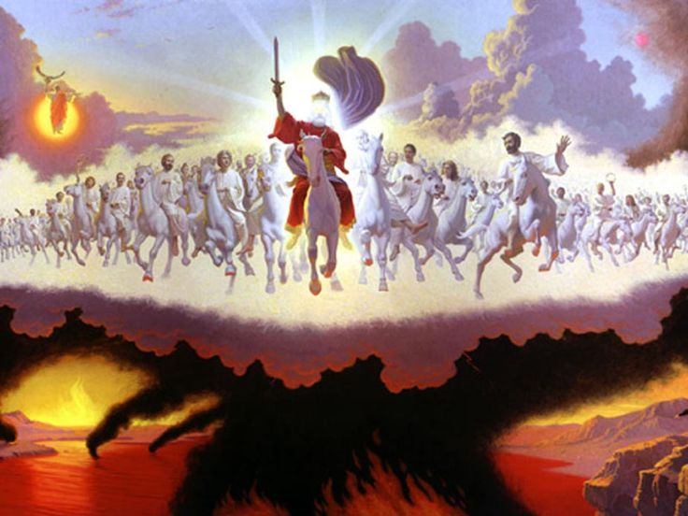

10 My beloved is white and ruddy, the chiefest among ten thousand. 11 His head is as the most fine gold, his locks are bushy, and black as a raven. 12 His eyes are as the eyes of doves by the rivers of waters, washed with milk, and fitly set. 13 His cheeks are as a bed of spices, as sweet flowers: his lips like lilies, dropping sweet smelling myrrh. 14 His hands are as gold rings set with the beryl (Song 5:10-14)

. . . . fair as the moon, clear as the sun, and terrible as an army with banners? (Song 6:10)

I have written of this hymn before, but choose to do so again for its beauty as a rose unfolding with time. We may consider the beauty of our Lord Jesus Christ to be fully comprehended in an instant of time, but with the passage of those moments, we see even more glorious and resplendent beauty in His magnificent Personage. I was reminded of this great old hymn by a dear friend recently, and could not resist a re-visitation.

The hymn is known as the Crusader Hymn for it was sung by the children who, en masse, marched off to their demise to its notes on Crusade from Europe. All were captured and enslaved, or died, during the event.

A fond memory that is written, in indelible love, on my heart was to hear this great hymn sung at breakfast time during retreat in north Alabama by the Samford University Acapella Choir under the able direction of the good Dr. L. Gene Black in 2002. The choir was comprised of some 200 members, and their harmonious singing of this hymn lifted us all to the very gates of Heaven. The most popular modern version of the hymn is entitled, Fairest Lord Jesus; but the original translation by Joseph A. Seiss – a Lutheran theologian – was entitled Beautiful Savior. It is Seiss’ translation that I will comment on in this devotion. The lyrics of this hymn were written by Jesuit scholars (date unknown), and the tune is a Silesian folk tune called CRUSADER.

Beautiful Savior, King of Creation

Beautiful Savior, King of Creation
Son of God and Son of Man!
Truly I’d love Thee, truly I’d serve Thee,
Light of my soul, my joy, my crown.

Fair are the meadows, Fair are the woodlands,
Robed in the flowers of blooming spring;
Jesus is fairer, Jesus is purer,
He makes our sorrowing spirit sing.

Fair is the sunshine, Fair is the moonlight,
Bright the sparkling stars on high;
Jesus shines brighter, Jesus shines purer
Than all the angels in the sky.

Beautiful Savior, Lord of the nations,
Son of God and Son of Man!
Glory and honor, Praise, adoration
Now and forevermore be Thine!

Beautiful Savior, King of Creation Son of God and Son of Man! Our Lord Jesus Christ is the Master Artist who drew out and flung the stars into their orbits at the early instant of Creation. He is King of Kings and Lord of Lords, and thus the King of Creation itself since All things were made by him; and without him was not any thing made that was made. John 1:3 (KJV) He placed the sun and moon at their stations, and artfully fashioned the mountains, meadows, seas, vegetation, and you and me. When we view the multi-colored and beautiful sunrise, how much more of beauty must be the Artist who fashioned them! Our Lord Jesus Christ is both the Son of God, and also the Son of Man. Possessing both natures, He was able to relate to us the character of the Father, and to redeem us from our sins as the unblemished Lamb of God.

Truly I’d love Thee, truly I’d serve Thee, Light of my soul, my joy, my crown. How can we truly love and adore a Lord of such high majesty and power? How could the sinner, over-burdened with guilt and the filthy rags of sin, presume to love One of such exalted Nature? We love him, because he first loved us. 1 John 4:19 (KJV) We could never have approached the Throne of Mercy and Grace had the scepter not been lowered to us. He is the Light of our souls and the Light of Life itself: In him was life; and the life was the light of men. (John 1:4) Nothing of greater meaning or beauty can exist for us than the One who gave us life by the giving of His own Life; the One who became our Day Star of Light in a dark sky of sin.

The Jordan River, like the life of our Lord, is a short river that has its origins in the snowy heights of Mount Herman. As it flows south, it creates a beautiful band of green life on its way. It spills into the Sea of Galilee which teems with life. Emerging on the south tip of that Sea, it continues through the wilderness – down and down to the lowest place on earth – the Dead Sea. The Jordan dies in the desert Wilderness just as our Lord died in the desert Wilderness of our sins. The Dead Sea is dead because it surrenders not a drop of the Water of Life which it receives; but the Wilderness of sin could not hold the Water of Life that came down from Heaven, for He arose as victor over death and sin. Fair are the meadows, Fair are the woodlands, Robed in the flowers of blooming spring; everywhere our Lord goes, He gives life and light to the wilderness darkness.

Our Lord places a melody in our hearts, and a burning Light in our souls. Jesus is fairer, Jesus is purer, He makes our sorrowing spirit sing. The song He gives us a divine and heavenly one: Ye shall have a song, as in the night when a holy solemnity is kept; and gladness of heart, as when one goeth with a pipe to come into the mountain of the LORD, to the mighty One of Israel. And the LORD shall cause his glorious voice to be heard, and shall shew the lighting down of his arm, with the indignation of his anger, and with the flame of a devouring fire, with scattering, and tempest, and hailstones. (Isaiah 30:29-30)

Fair is the sunshine, Fair is the moonlight, Bright the sparkling stars on high; The sunshine, the moonlight, and the sparkling stars are things of great beauty; but these are simply the icing on the cake of Creation. What of the sons and daughters of God? Since these things were made for our comfort, must not our Lord consider us to be of even greater beauty in His Crown? When I consider thy heavens, the work of thy fingers, the moon and the stars, which thou hast ordained; What is man, that thou art mindful of him? and the son of man, that thou visitest him? For thou hast made him a little lower than the angels, and hast crowned him with glory and honour. (Psalm 8:3-5) The crowning achievement of God’s Creation is the man and woman which He created in the Garden eastward at Eden. Though many souls have been misappropriated by the serpent of that Garden, the Lord knows, and shall reclaim, His own from among them: And they shall be mine, saith the LORD of hosts, in that day when I make up my jewels; and I will spare them, as a man spareth his own son that serveth him. (Mal 3:17)

Jesus shines brighter, Jesus shines purer Than all the angels in the sky. Jesus does, indeed, shine brighter and purer because He is the Personification of Light. Without Him, all is darkness and there could be no light to shine. I am the light of the world: he that followeth me shall not walk in darkness, but shall have the light of life. (John 8:12) Some have questioned this as a contradiction of Matthew 5:14 in which our Lord tells His people Ye are the light of the world. This is to be viewed in the same sense as we consider the light of the moon. Any elementary astronomy knows that the moon has no light except that which it receives from the Sun. Likewise, no Christian has any light except that Light which it receives from the sun of righteousness and the Day Star of our salvation.

The last verse is a benediction to all that precedes it: Beautiful Savior, Lord of the nations, Son of God and Son of Man! Glory and honor, Praise, adoration Now and forevermore be Thine! Can you imagine anything more beautiful than the strong and Everlasting Arm that reaches down to pull your drowning soul from the swirling waters of the sea of sin? He is King of Kings, and Lord of Lords – of ALL kings, and of all LORDS. We cannot honor, praise, and adore Him enough. But that of which we are capable – our ALL – is due Him. And that will be enough. If we are crowned with the Ensign of Love, if we are called and chosen according to His purpose, if we love as we are loved, we shall not suffer shame or damnation. The River we cross at last shall be a glorious Jordan whose far banks are lit continually with the Light of our Beautiful Savior.

