Hymns of the Church – O Blessed Babes of Bethlehem – 28 December 2019, Anno Domini
Christmas Hymn Devotion for Holy Innocents Day

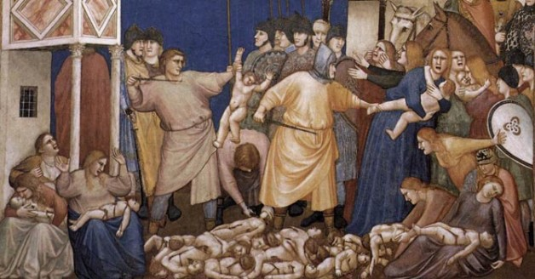

T
HUS saith the LORD; A voice was heard in Ramah, lamentation, and bitter weeping; Rahel weeping for her children refused to be comforted for her children, because they were not. ¹⁶ Thus saith the LORD; Refrain thy voice from weeping, and thine eyes from tears: for thy work shall be rewarded, saith the LORD; and they shall come again from the land of the enemy. ¹⁷ And there is hope in thine end, saith the LORD, that thy children shall come again to their own border. (Jeremiah 31:15-17)

An important observance during the Twelve Days of Christmas is that of the martyred Holy Innocents of Bethlehem ruthlessly murdered by Herod’s army at Bethlehem. We observe that event on the 28th of December. I was minded to write upon a Christmas hymn memorializing that event by a recent article by my friend, Rev David McMillan, of Andalusia, Alabama. I am grateful for his reminder.

This hymn is composed by Lawrence Housman (1865-1959) who died at Glastonbury, England. Housman was, among other things, a playwright who made two statements with which I profoundly agree:

- I still think that if the human race, or even one nation, could only get right about its God the rest would follow.

- I believe absolutely in love being the central motive force of the universe.

Feast day of the Holy Innocents, Martyrs, is December 28;

When Christ was born in Bethlehem,
Fair peace on earth to bring,
In lowly state of love He came
To be the children’s King.

And round Him, then, a holy band
Of children blest was born,
Fair guardians of His throne to stand
Attendant night and morn.

And unto them this grace was giv’n
A Savior’s name to own,
And die for Him Who out of Heav’n
Had found on earth a throne.

O blessèd babes of Bethlehem,
Who died to save our King,
Ye share the martyrs’ diadem,
And in their anthem sing!

Your lips, on earth that never spake,
Now sound th’eternal word;
And in the courts of love ye make
Your children’s voices heard.

Lord Jesus Christ, eternal Child,
Make Thou our childhood Thine;
That we with Thee the meek and mild
May share the love divine.

When Christ was born in Bethlehem, Fair peace on earth to bring, In lowly state of love He came To be the children’s King. Yea, and not only the children’s king, but the King of Kings of all. He debased His place at the Throne of His Father to be made flesh and dwell among those who were, in their sins, the enemies of God. He came among the simple, the poor, the powerful, and the lowly shepherds.

And round Him, then, a holy band Of children blest was born, Fair guardians of His throne to stand Attendant night and morn. We may often forget that many other children, bound to die a tragic death at by the sword of imperial madmen sent by King Herod, were born that same night in Bethlehem and many nights closely associated therewith. All those male infants born within two years of the coming of the Magi were slain.

And unto them this grace was giv’n A Savior’s name to own, And die for Him Who out of Heav’n Had found on earth a throne. You may be contemplating the wickedness of such a mass murder; however, you may as well be one who dismisses the murder of the totally innocent in their mother’s womb today as an act of mere medical convenience – at least this has been the position of many in society today. I will quote below from Rev McMillan’s good letter on the issue:

We should protect life from the womb and listen to the Word of God which teaches that all life is precious. The prayer for today reflects our action that should be taken,

'O ALMIGHTY God, who out of the mouths of babes and sucklings hast ordained strength, and madest infants to glorify thee by their deaths; Mortify and kill all vices in us, and so strengthen us by thy grace, that by the innocency of our lives, and constancy of our faith even unto death, we may glorify thy holy Name; through Jesus Christ our Lord. Amen. ' Psalm 8:2

Blessed Christmastide as we go into the new Year and continue to celebrate how God has delivered us from our sins and given us eternal life through trust in His Son Jesus Christ. We should practice life here in its memory of the blessed babes who had no life on earth but live in heaven. This should include killing all vices in us by God's grace and saving others as we are light and salt to those around us.

O blessèd babes of Bethlehem, Who died to save our King, Ye share the martyrs’ diadem, And in their anthem sing! Actually, these babes made no conscious effort to save our Lord but, in the process of time, He would die to save them; but they do, indeed, bear the martyr’s diadem for dying in the place of our Lord Jesus Christ whom the Father, in providence, saved for a greater purpose.

Your lips, on earth that never spake, Now sound th’eternal word; And in the courts of love ye make Your children’s voices heard. Reverberating throughout this sordid tale of the martyr of the babes of Bethlehem is the resounding reality of the great judicial and spiritual travesty of our days in sponsoring the same murder of millions with our ill-intended tax dollars. We all bear the guilt of those murders collectively as citizens of a nation who allows such.

Lord Jesus Christ, eternal Child, Make Thou our childhood Thine; That we with Thee the meek and mild May share the love divine. All believers remain children of the Most High God under the Lordship of our Savior, Jesus Christ! In being children of God, we must evidence that meek and lowly trust of a child in the Father. The prophets had foretold the massacre at Bethlehem centuries before the actual event: Thus saith the LORD; A voice was heard in Ramah, lamentation, and bitter weeping; Rahel weeping for her children refused to be comforted for her children, because they were not. Thus saith the LORD; Refrain thy voice from weeping, and thine eyes from tears: for thy work shall be rewarded, saith the LORD; and they shall come again from the land of the enemy. And there is hope in thine end, saith the LORD, that thy children shall come again to their own border.

You will recall that the favored wife of Jacob, Rachel, died in childbirth, too, at Ramah (Bethlehem): And they journeyed from Bethel; and there was but a little way to come to Ephrath: and Rachel travailed, and she had hard labour. And it came to pass, when she was in hard labour, that the midwife said unto her, Fear not; thou shalt have this son also. And it came to pass, as her soul was in departing, (for she died) that she called his name Benoni: but his father called him Benjamin. And Rachel died, and was buried in the way to Ephrath, which is Bethlehem. And Jacob set a pillar upon her grave: that is the pillar of Rachel's grave unto this day. And so may Rachel’s grave be seen without the gate of Bethlehem even today!

