Hymns of the Church – At Sea – 6 August 2019, Anno Domini

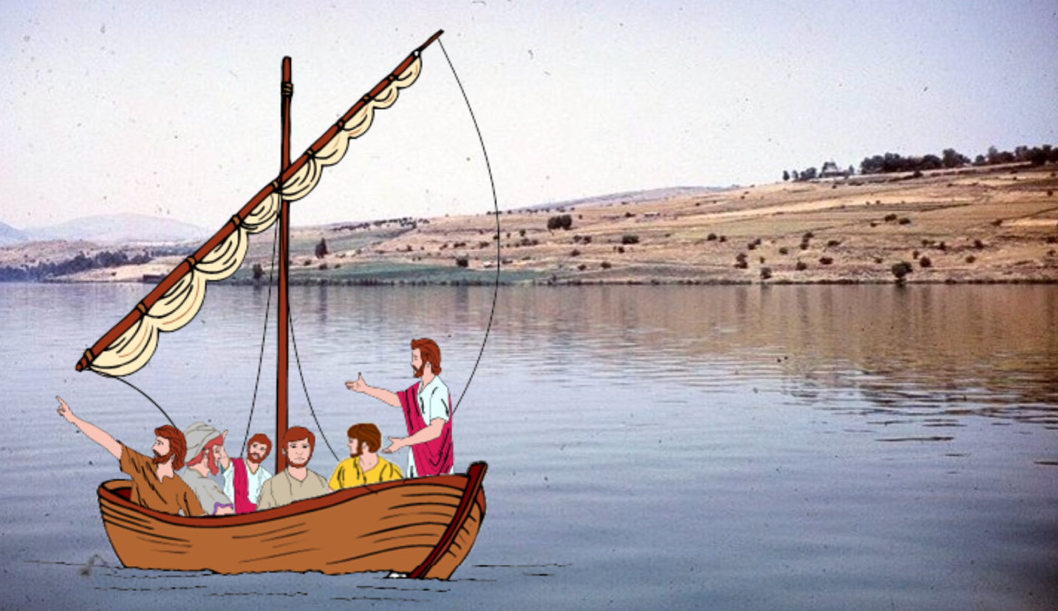

A
ND when he was entered into a ship, his disciples followed him. ²⁴ And, behold, there arose a great tempest in the sea, insomuch that the ship was covered with the waves: but he was asleep. ²⁵ And his disciples came to him, and awoke him, saying, Lord, save us: we perish. ²⁶ And he saith unto them, Why are ye fearful, O ye of little faith? Then he arose, and rebuked the winds and the sea; and there was a great calm. ²⁷ But the men marvelled, saying, What manner of man is this, that even the winds and the sea obey him! (Matthew 8:23-27)

Here is a beautiful old hymn that reminds us of the many times our souls would have fainted had it not been for the steady hand of the Master of the Sea at the Helm. When every other means of remedy for our predicament, it is then that we most often call upon the Lord to steady, not only the ship, but the sea as well. This hymn is the composition of Mr. Charles Wesley in the latter part of the 18thcentury. There are two excellent tunes to which it may be sung – ‘NUREMBERG’(a variation of Liebster Jesu) by Johann Rudolf Ahle (1669), and ‘ASCENSION’ Bby N. D. Gould (1861).

At Sea
by Charles Wesley

﻿Lord! whom winds and seas obey,
Guide us through the watery way;
In the hollow of Thy hand,
Hide and bring us safe to land.

Father, let our faithful mind Rest,
on Thee alone reclined:
Every anxious thought repress,
Keep our souls in perfect peace.

Keep the friends whom now we leave;
Bid them to each other cleave;
Bid them walk on life’s rough sea,
Bid them come, by faith, to Thee.

Save, till all these tempests end,
All who on Thy love depend;
Waft our happy spirits o’er;
Land us on the heavenly shore.

1 Lord! whom winds and seas obey, Guide us through the watery way; In the hollow of Thy hand, Hide and bring us safe to land. The winds are sent by God to perform the purpose for which He sends them. The Lord even, figuratively, rides upon the “wings of the wind.” (Psalm 18:10) The ocean seas were, as well, made by the Lord to serve the same purpose in His Creation. They separate nation from nation, and great land mases, too, so that men do not become so comingled as to undertake again the rebuilding of the Tower of Babel. The sea serves the man that God has made in providing food and transport. Both combine to make that transport possible under sail. There is no safer place than the hollow of the Lord’s Hand, though the nail scars will remind us of how He has cut our names there. “Can a woman forget her sucking child, that she should not have compassion on the son of her womb? yea, they may forget, yet will I not forget thee. Behold, I have graven(CUT)thee upon the palms of my hands; thy walls are continually before me.” (Isaiah 49:15-16) The palms of His Hands are no different from the wings of the hen, or eagle, in covering and protecting her young. “Because thou hast been my help, therefore in the shadow of thy wings will I rejoice.” (Psalm 63:7)

2 Father, let our faithful mind Rest, on Thee alone reclined: Every anxious thought repress, Keep our souls in perfect peace.It is only by way of faith that we can trust in Him and be comforted in the buffeting billows of the sea of life. He is not only our Passover, but our Sabbath Rest. The inner peace the love of God conveys is not subject to any external storm or disturbance. Trusting in Him, and obeying His Commandments, renders our ship in a safe harbor and haven. The long dark hours of night may bring an unsettled sorrow, but Light breaks anew with the coming morning. “ . . . in his favour is life: weeping may endure for a night, but joy cometh in the morning.” (Psalm 30:5) Under the watchful eyes of the Lord, the blue bird, in perfect peace, builds her nest in a safe place – on the branch of a tree behind a raging waterfall where no predator dare come.

3 Keep the friends whom now we leave; Bid them to each other cleave; Bid them walk on life’s rough sea, Bid them come, by faith, to Thee.” At each parting upon life’s seas, we should offer up a prayer to the Sovereign of the Sea that He will not only favor us with safe passage but keep in safety and comfort those we leave behind. The greater part of the Prayers of our Lord on the night of His betrayal were for those of His faithful disciples whom He must leave for a time. He prayed to His Father, and our Father, that He would keep them all as One with Him as He (Jesus) is One with the Father. By faith in Christ we can rise above the stormy seas of life and even walk upon the turbulent deep – as Peter did when he uttered the shortest, but very effective prayer, of the Bible, “Lord, save me!” (Matt 14:30) This proves to us that prayers do not need long sentences or impressive vocabulary. Proclaimed out of faith and need, the Holy Ghost already knows the yearning of the heart behind the prayer. At last, and always, we pray that the Lord will bid us, and those we leave behind, to Him – just as He had bade Peter to walk upon the Sea.

4 Save, till all these tempests end, All who on Thy love depend; Waft our happy spirits o’er; Land us on the heavenly shore.We are counselled in Scripture to study to prove ourselves approved of God. “Study to shew thyself approved unto God, a workman that needeth not to be ashamed, rightly dividing the word of truth.” 2 Timothy 2:15 (KJV) The truth of the matter is we will always study and persevere to the end if we are truly the chosen and elect of God – driven by the claims of the Holy Ghost. The evidence of our salvation is our enduring faith and obedience to God. If the Father has placed us in the Hands of our Lord and Savior, we shall not fall from that sure grasp. All that Father gave into His hand, He kept – except that one who was doomed by a reprobate heart from the beginning (Judas). The Lord is able to save to the uttermost. That uttermost makes not exceptions! There is one body of water that looms before us all at some point of our lives – that River of Life lies beyond the Stormy Jordan Banks. If we have no Savior whose hand we may hold, we will not be able to cross alone; however, with His strong and uplifting arm, He will ford the waters with us.

I have appended below a poem I authored several years ago that expressed the fuller meaning of this hymn to me and the Lord of whom it speaks:

Walking on the Sea

As a child I read how Jesus walked
upon the Galilean Sea,
On stormy waves he bade a man to
walk as well as He.

And Peter walked upon the deep with
eyes fixed on the Lord,
But as he cast his eyes below upon
the murky flood,
His foot gave way to billows dark as
he cried out, “Lord, Save Me!”

When I look back upon life’s seas and
count the times I doubted,
I know my eyes were off the Lord
in every case recounted.

But knowing He would not forsake
nor leave me in my failings,
I cried for help and felt His Hand
above the Seas prevailing.

And so His nail-scarred Hand remains
outstretched across life’s seas,
To rescue every drowning soul
as He has lifted me.
©2011 Bishop Jerry Ogles

