Hymns of the Church – All Creatures of our God and King – 24 July 2018, Anno Domini

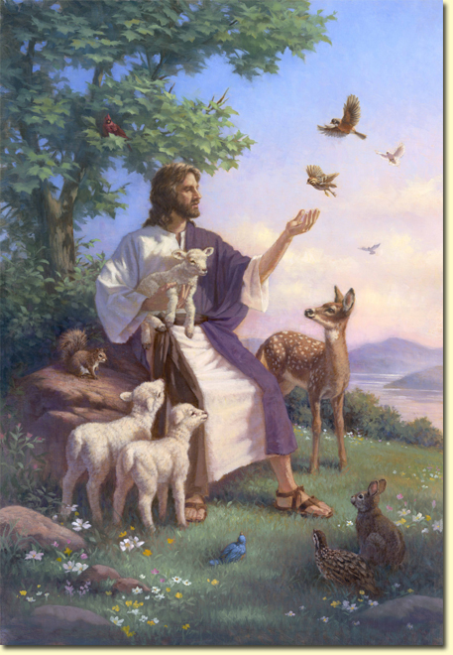

I
will praise the name of God with a song, and will magnify him with thanksgiving. 31 This also shall please the LORD better than an ox or bullock that hath horns and hoofs. 32 The humble shall see this, and be glad: and your heart shall live that seek God. 33 For the LORD heareth the poor, and despiseth not his prisoners. 34 Let the heaven and earth praise him, the seas, and every thing that moveth therein. (Psalm 69:30-34)

I received a suggestion this morning from Cinder Carroll, our National Secretary, that I might write on this beautiful and wonderfully uplifting hymn. I was surprised to learn that I had not previously written on it since it is one of my top ten favorites. So, I am happy to write on this hymn today.

This classical work praising the Creation of God in its full dimensions was written by Francis of Assissi shortly before his death in 1225. The lyrics were not widely published until 400 years later. Music is the German composition, Lasst Uns Erfreuen, by Peter von Brachel (1663). The tune was harmonized later by Ralph Vaughan Williams in 1906.

The story of Francis of Assissi is fascinating in itself, but this devotion will be primarily limited to an assessment of the hymn which so gloriously reflects his faith and love of all creatures of God. He rightly considered every creature of God’s making a thing of great value: All things of creation are children of the Father and thus brothers of man. ... God wants us to help animals, if they need help. Every creature in distress has the same right to be protected. Francis

All Creatures of Our God and King

All creatures of our God and King
Lift up your voice and with us sing,
Alleluia! Alleluia!
Thou burning sun with golden beam,
Thou silver moon with softer gleam!
Refrain
O praise Him! O praise Him!
Alleluia! Alleluia! Alleluia!

Thou rushing wind that art so strong
Ye clouds that sail in Heaven along,
O praise Him! Alleluia!
Thou rising moon, in praise rejoice,
Ye lights of evening, find a voice!
Refrain

Thou flowing water, pure and clear,
Make music for thy Lord to hear,
O praise Him! Alleluia!
Thou fire so masterful and bright,
That givest man both warmth and light.
Refrain

Dear mother earth, who day by day
Unfoldest blessings on our way,
O praise Him! Alleluia!
The flowers and fruits that in thee grow,
Let them His glory also show.
qRefrain

And all ye men of tender heart,
Forgiving others, take your part,
O sing ye! Alleluia!
Ye who long pain and sorrow bear,
Praise God and on Him cast your care!
Refrain

And thou most kind and gentle Death,
Waiting to hush our latest breath,
O praise Him! Alleluia!
Thou leadest home the child of God,
And Christ our Lord the way hath trod.
Refrain

Let all things their Creator bless,
And worship Him in humbleness,
O praise Him! Alleluia!
Praise, praise the Father, praise the Son,
And praise the Spirit, Three in One!
Refrain

All creatures of our God and King Lift up your voice and with us sing, Alleluia! Alleluia! Thou burning sun with golden beam, Thou silver moon with softer gleam! All creatures! It might be of benefit to recall that those wonderful creatures God created in the Garden were free from sin until the one whose responsibility it was to care for them fell from grace in the Garden at Eden. It was an innocent creature of the animal kingdom that was the first to die in order that Adam and Eve’s nakedness could be covered. This was the first shadowing type of the Lamb of God who was to come and die as a sin-covering for man. (Genesis 3:21) It is worth noting that these animal creations of God still bear an innocence above that of man.

THE REFRAIN: O praise Him! O praise Him! Alleluia! Alleluia! Alleluia! Every verse of this hymn is an invitation to Praise our Creator and King. Even the moon, stars, and sun praise Him who flung them into their orbits with a single whisper: O praise Him! O praise Him!Alleluia! Alleluia! Alleluia! - 4 Where wast thou when I laid the foundations of the earth? declare, if thou hast understanding. 5 Who hath laid the measures thereof, if thou knowest? or who hath stretched the line upon it? 6 Whereupon are the foundations thereof fastened? or who laid the corner stone thereof; 7 When the morning stars sang together, and all the sons of God shouted for joy? (Job 38:4-7)

Thou rushing wind that art so strong Ye clouds that sail in Heaven along, O praise Him! Alleluia! Thou rising moon, in praise rejoice, Ye lights of evening, find a voice! There are winds capable of destroying the most formidable structures of men’s hands. The clouds depict the fine art of God in the heavens. Even the distant stars have been found to emit high frequency sounds now detectable by our technology. Praise ye him, sun and moon: praise him, all ye stars of light. Praise him, ye heavens of heavens, and ye waters that be above the heavens. Let them praise the name of the LORD: for he commanded, and they were created. (Psalm 148:3-5)

Thou flowing water, pure and clear, Make music for thy Lord to hear, O praise Him! Alleluia! Thou fire so masterful and bright, That givest man both warmth and light. The River of Life flows freely, pure and pristine, beyond the Gates of Splendor. Blest will we be to drink from that life-giving stream. He that believeth on me, as the scripture hath said, out of his belly shall flow rivers of living water. (John 7:38) And he shewed me a pure river of water of life, clear as crystal, proceeding out of the throne of God and of the Lamb. (Rev 22:1) Yes, and even the Tree of Life, long past removed, is even now watered by the River.

Dear mother earth, who day by day Unfoldest blessings on our way, O praise Him! Alleluia! The flowers and fruits that in thee grow, Let them His glory also show. We are children of the earth in the sense that we are all made from the womb of the earth and its mantle of dust. 1 The heavens declare the glory of God; and the firmament sheweth his handywork. 2 Day unto day uttereth speech, and night unto night sheweth knowledge. 3 There is no speech nor language, where their voice is not heard. 4 Their line is gone out through all the earth, and their words to the end of the world. In them hath he set a tabernacle for the sun, 5 Which is as a bridegroom coming out of his chamber, and rejoiceth as a strong man to run a race. 6 His going forth is from the end of the heaven, and his circuit unto the ends of it: and there is nothing hid from the heat thereof. (Psalm 19:1-6)

And all ye men of tender heart, Forgiving others, take your part, O sing ye! Alleluia! Ye who long pain and sorrow bear, Praise God and on Him cast your care! In relationship to time and eternity, our pains and sufferings are brief indeed. Even life itself upon this green earth is brief. All flesh is grass, and all the goodliness thereof is as the flower of the field: 7 The grass withereth, the flower fadeth: because the spirit of the LORD bloweth upon it: surely the people is grass. 8 The grass withereth, the flower fadeth: but the word of our God shall stand for ever. (Isaiah 40:6-8) But the soul of man is immortal. It does not perish. The soul has its long home in mansions above or in dungeons below.

And thou most kind and gentle Death, Waiting to hush our latest breath, O praise Him! Alleluia! Thou leadest home the child of God, And Christ our Lord the way hath trod. Why do Christians so dread passing through that DOOR that leads to eternal joy and bliss which is DEATH? It is a door without a hallway or foyer. It is a brief passage – so brief as the edge of a Gurkha’s saber. It is a DOOR to Heaven for the Elect, and a DOOR to Doom for the reprobate. 51 Behold, I shew you a mystery; We shall not all sleep, but we shall all be changed, 52 In a moment, in the twinkling of an eye, at the last trump: for the trumpet shall sound, and the dead shall be raised incorruptible, and we shall be changed. 53 For this corruptible must put on incorruption, and this mortal must put on immortality. 54 So when this corruptible shall have put on incorruption, and this mortal shall have put on immortality, then shall be brought to pass the saying that is written, Death is swallowed up in victory. 55 O death, where is thy sting? O grave, where is thy victory? 56 The sting of death is sin; and the strength of sin is the law. 57 But thanks beto God, which giveth us the victory through our Lord Jesus Christ. (1 Cor 15:51-57) This passage has been the comfort of countless Christians through the centuries since Christ.

Let all things their Creator bless, And worship Him in humbleness, O praise Him! Alleluia! Praise, praise the Father, praise the Son, And praise the Spirit, Three in One! If God has blessed all of His creatures, and He has, should we not be good stewards and caretakers of these. Remember, the life of an animal is as dear to the animal as our lives are to us – and perhaps more so since animal life is mostly brief. An animal (which is always innocent) suffers pain just as much as we do, and it is the mark of an evil and pitiless heart to cause these precious creatures of God to suffer needlessly. I do not elevate animal life to the level of human life; however, I do know that God expects us to show love and compassion for these.

The underlying message of this great hymn is that of love for all that God has made, and a reverence and humility before God in considering our appreciation for His wondrous works of Creation.

