Devotion, Wednesday of Holy Week, 1 April 2105 Anno Domini

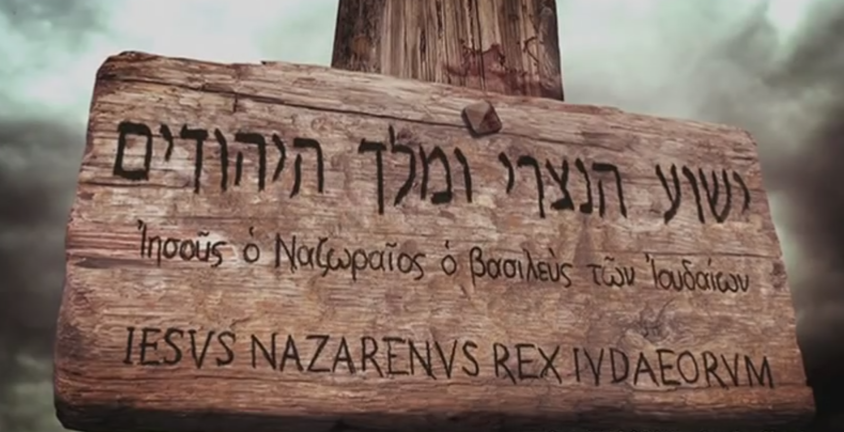

26 Then released he Barabbas unto them: and when he had scourged Jesus, he delivered him to be crucified. 27 Then the soldiers of the governor took Jesus into the common hall, and gathered unto him the whole band of soldiers. 28 And they stripped him, and put on him a scarlet robe. 29 And when they had platted a crown of thorns, they put it upon his head, and a reed in his right hand: and they bowed the knee before him, and mocked him, saying, Hail, King of the Jews! 30 And they spit upon him, and took the reed, and smote him on the head. 31 And after that they had mocked him, they took the robe off from him, and put his own raiment on him, and led him away to crucify him. 32 And as they came out, they found a man of Cyrene, Simon by name: him they compelled to bear his cross. 33 And when they were come unto a place called Golgotha, that is to say, a place of a skull, 34 They gave him vinegar to drink mingled with gall: and when he had tasted thereof, he would not drink. 35 And they crucified him, and parted his garments, casting lots: that it might be fulfilled which was spoken by the prophet, They parted my garments among them, and upon my vesture did they cast lots. 36 And sitting down they watched him there; 37 And set up over his head his accusation written, THIS IS JESUS THE KING OF THE JEWS. (Matt 27:26-37)

Having reached the mid-point of Holy Week, we may have seen our sordid and guilt-ridden faces in the mirror of God’s Word; that image being reflected by Peter, Pilate,the two thieves, Barabbas and the false, hypocritical professors of the Sanhedrin. None were flattering, but salvation by Grace is not about flattery, but about humble repentance. You and I were relieved of our burdens of sin by the Lord just as the sentence of death was paid by Jesus Christ for Barabbas. We may think that we were not all that bad, but such an opinion arises from a pharisaical heart. In fact, not a single one of us could have been LESS guilty than Barabbas! The big difference in the Elect of God from Barabbas & Pontius Pilate is not in their presumed righteousness, but in the righteousness of the Savior who bore their sins on the Cross of Calvary.

We are all of us represented by one or more of the antagonist of Christ on that fateful day. Let us examine how the entire world, and each of its leading institutions, is represented by those who had a direct role in the crucifixion of the Lord Jesus Christ:

- The first representative is from the criminal world, Barabbas. But Barabbas is the least guilty of all present that day of the blood of Jesus. His role was passive. He was released at the whim of the masses and not of his own plea. There were also the two thieves with whom Christ was crucified.
- The active participation of the mightiest secular power in the world – the Roman Empire represented by the Roman Proconsul, Pontius Pilate. Pilate, too, was less guilty than some such as the Priests and Pharisees. Jesus answered, Thou couldest have no power at all against me, except it were given thee from above: therefore he that delivered me unto thee hath the greater sin. 12 And from thenceforth Pilate sought to release him: (John 19:11-12)
- There on that day were the soldiers who cruelly mocked and abused Jesus. They did it out of a lust for blood for He had not been accused of anything to upset their sentiments.
- There were there the rulers of the Jews who insisted on a death sentence for a man of total innocence.
- Religionists were represented by the priests and Pharisees who incited the mob to call for the crucifixion of Christ in lieu of Barabbas! Most modern day churches would do the same today – in fact, they already do so by their disregard of Scripture and love of worldly pleasures.

If you and I had passed by that day, we, too, were included in the indictment of righteousness: “And they that passed by reviled him, wagging their heads, And saying, Thou that destroyest the temple, and buildest it in three days, save thyself. If thou be the Son of God, come down from the cross.” (Matt 27:39-40) Here we have the secular power, the criminal world, the national rulers, the religious rulers (fallen church), the soldiers under arms, and the crowd of daily observers. You and I fit in that criminal line-up one or more times. The great hymn singer of Canada, George Beverly Shea, used to sing with great power and gusto the hymn, “Were You there when They Crucified my Lord.” How sad I was made as a young lad to hear the words of this song sung every morning on our radio (in those days, every radio station offered prayer, preaching and hymn-singing each morning.) I had difficulty understanding that I was there, but my mother said that I was, so I knew it to be true. We were ALL there!

The scourging of Jesus has often been sufficient to cause the death of those who endure it. It is a shameful and heartless punishment that is joyfully watched by crowds today in Islamic countries. It is sadistic and cruel, and it has no end to promote justice. “Then released he Barabbas unto them: and when he had scourged Jesus, he delivered him to be crucified.” Yes, Barabbas, being an insurrectionist murderer, is released to his own kind, the crowd (you and me), who screamed for the crucifixion of the Lord in his stead.

Please bear in mind that Jesus was virtuous and modest of apparel. He would never have exposed His naked body to any man, but He was stripped on two occasions – once before the soldiers, and later on the cross for all to see. How His modesty must have been offended by that one ordeal! “Then the soldiers of the governor took Jesus into the common hall, and gathered unto him the whole band of soldiers. And they stripped him, and put on him a scarlet robe.” This was not a prescribed part of his punishment, but the evil heart of men is ingenious in its inventions of cruelty.

Please observe to what extremes that evil imagination of the heart can take: “And when they had platted a crown of thorns, they put it upon his head, and a reed in his right hand: and they bowed the knee before him, and mocked him, saying, Hail, King of the Jews! And they spit upon him, and took the reed, and smote him on the head. And after that they had mocked him, they took the robe off from him, and put his own raiment on him, and led him away to crucify him.” Why do you suppose the soldiers platted the crown of thorns? It was both to ridicule and to cause pain to the Lord. The thorns were approximately one to two inches long and very sharp. They would pierce the outer skin and channel between the skin and the scalp. It was a total mockery of Christ as Savior of the World – a title given to Augustus Caesar when crowned by a wreath of olive by his soldiers. It was also an echo of the sin of Adam’s Fall in the Garden at Eden: God said to Adam – “cursed is the ground for thy sake; in sorrow shalt thou eat of it all the days of thy life; Thorns also and thistles shall it bring forth to thee; and thou shalt eat the herb of the field.” (Gen 3:17-18) Those thorns worn by Christ symbolized the sin that infects every soul of their father Adam. The only inoculation to that disease is the blood of Christ which He is ready to offer. The soldiers, moreover, beat Jesus over the head with the reed – intentionally to cause severe pain from the thorns.

“And as they came out, they found a man of Cyrene, Simon by name: him they compelled to bear his cross. And when they were come unto a place called Golgotha, that is to say, a place of a skull, They gave him vinegar to drink mingled with gall: and when he had tasted thereof, he would not drink.” Though the distance to Calvary was probably less than a mile, Jesus was severely weakened by His beatings and mocking. Stumbling under the weight of the sins that the cross represented, the procession was delayed and no amount of the whipping of the guard could arouse Jesus to that awesome burden. Simon of Cyrene was the man blessed and privileged to carry that cross for our Lord. He may not have realized the blessing at the time, but I am sure he did learn of it before he passed from this life. Jesus refused the deadening effect of the mixed drink. He determined to suffer the full measure of pain in payment of our redemption.

“And they crucified him, and parted his garments, casting lots: that it might be fulfilled which was spoken by the prophet, They parted my garments among them, and upon my vesture did they cast lots.” Have we not read of this sorrowful account of the casting of lots someplace before? Yes! We read it in the Messianic Psalm 22:18!

To his credit (if any could be granted such a one), Pontius Pilate wrote a partial truth of the title of Christ: “And set up over his head his accusation written, THIS IS JESUS THE KING OF THE JEWS.” The Pharisees and priest vociferously objected, but Pilate refused to back down. But one point should be made: Jesus was not only the King of the Jews, but the King of Kings – and even of Emperor Augustus! Read the account from the Gospel of St. John: “And Pilate wrote a title, and put it on the cross. And the writing was, JESUS OF NAZARETH THE KING OF THE JEWS. This title then read many of the Jews: for the place where Jesus was crucified was nigh to the city: and it was written in Hebrew, and Greek, and Latin. Then said the chief priests of the Jews to Pilate, Write not, The King of the Jews; but that he said, I am King of the Jews. Pilate answered, What I have written I have written. (John 19:19-22)

The crowd that called for the crucifixion of our Lord was on that Broad Way – a way that I pray the readers of this devotion have long since abandoned. All who remain in that crowd of the world will likewise perish with them. “Enter ye in at the strait gate: for wide is the gate, and broad is the way, that leadeth to destruction, and many there be which go in thereat:” (Matt 7:13)

Our Lord walked the painful Way of the Cross – the Via Dolorosa – for you and me. He made a Way for us by His death, burial and resurrection so that we may likewise carry our cross and count death as a twinkling of the eye after which we arise with the beauty of the morning Sun Rise. His Way is the Way, the Truth and the Life! Because strait is the gate, and narrow is the way, which leadeth unto life, and few there be that find it. (Matt 7:14)

