Holy Saturday – The Resurrection, 4 April 2105 Anno Domini

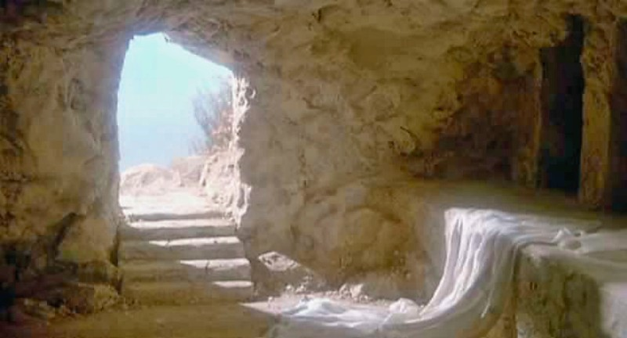

The first day of the week cometh Mary Magdalene early, when it was yet dark, unto the sepulchre, and seeth the stone taken away from the sepulchre. (John 20:1)

We observe the resurrection of Christ in all its glory at this time – perhaps a day early, but we should always check our road maps of Easter before we launch out into the deep. It is not altogether inappropriate to undertake the observance of Christ’s resurrection on Saturday as it could very well have happened on Saturday evening as the Sabbath began to dawn toward the first day of the week. In the end of the sabbath, as it began to dawn toward the first day of the week, came Mary Magdalene and the other Mary to see the sepulchre. (Matt 28:1) I will remind the reader that the “end of the Sabbath” always occurs at sundown on our Saturday. One thing is certain from the text: Christ did not arise at sunrise on Sunday as some churches promote in their sunrise services. It was yet dark when Mary Magdalene came to the tomb. But those are the non-essentials. The essential beauty of Easter is that Jesus did rise from the Garden Tomb.

You will note that the stone blocking the entrance to the tomb had already been rolled away before daylight. St. Matthew records: In the end of the sabbath, as it began to dawn toward the first day of the week, came Mary Magdalene and the other Mary to see the sepulchre. And, behold, there was a great earthquake: for the angel of the Lord descended from heaven, and came and rolled back the stone from the door, and sat upon it. His countenance was like lightning, and his raiment white as snow: And for fear of him the keepers did shake, and became as dead men. (Matt 28:1-4) In the Hebrew calendar, the Sabbath ended at sunset on the 7th day of the week and the first day began at sundown. How long after sundown it was before Christ arose is up to speculation, and I will not venture there. (another non-essential) The point I would like to raise is this: Why did the Angel roll the stone away? Apparently, when the guards awoke, there was no body in the tomb. They fled to Pilate and did not return (because there was no reason given the body was no longer in the tomb).

Did our Lord need someone (an Angel) to roll away the stone? I think not. There is evidence to suggest that locked doors did not impede His entry in the Upper Room at His post-resurrection appearance to the disciples. So if the stone was not rolled away to allow the resurrected Christ to emerge from the tomb, why was it rolled back? I believe it was rolled back so that the world could witness an EMPTY TOMB!

Having lived in the Middle East for several years, my experience tells me that the first Easter morning was brilliant with light once the sun arose. The tomb was in a Garden near Golgotha. A garden is a place for growing flowers and shrubs. I am sure the garden was typically bordered by tall slender cedars, and the fragrance of roses permeated the environs thereof.

But early, while it was yet dark, the slender figure of a woman could be seen hurrying from corner to corner of Jerusalem and out the gate toward the Garden. It was at an hour that would not be considered safe or proper for a lone woman to be wondering the streets. It may have been that Mary Magdalene had wondered the streets with different intentions many times before. But this morning, her great love of Jesus drove her from bed and into the streets and by-ways of the city, and on to the Garden where she had last seen the body of Jesus laid in a borrowed tomb. You will remember that only the women, and John, remained courageously near the cross. And many women were there beholding afar off, which followed Jesus from Galilee, ministering unto him: Among which was Mary Magdalene, and Mary the mother of James and Joses, and the mother of Zebedee's children. (Matt 27:55-56) Yes, Mary was one of those women! Mary never lost sight of the body of Jesus until He had been laid in the tomb – her love was the kind that adheres to its object, and Christ her Lord was the object of her love. And when Joseph had taken the body, he wrapped it in a clean linen cloth, And laid it in his own new tomb, which he had hewn out in the rock: and he rolled a great stone to the door of the sepulchre, and departed. And there was Mary Magdalene, and the other Mary, sitting over against the sepulchre. (Matt 27:59-61) She even lingered near the tomb until the coming Sabbath requirements bid her depart.

As you will know, Jesus always kept the Sabbath, and this Sabbath was no exception. He lay in the Garden Tomb over the Sabbath Day, and rose sometime after the end of the Sabbath at sunset on the seventh day. For certain it is that it was at least on the first day of the week since that day began at sundown on the seventh day.

So Mary Magdalene is bothered in her soul about what she would do at the tomb. She had gone to further anoint the body of Jesus, but she was worried about the stone obstructing its entrance. There would be no man, at this hour, to roll the stone away for her. As the good old hymn says, Mary had “come to the Garden alone, while the dew was still on the roses.” Approaching the tomb, her worries were greatly increased at seeing the stone already rolled away. There was no one in sight, so how could this be? Perhaps someone had desecrated the tomb of her beloved Lord? The following text reveals that she must have looked inside the tomb: Then she runneth, and cometh to Simon Peter, and to the other disciple, whom Jesus loved, and saith unto them, They have taken away the Lord out of the sepulchre, and we know not where they have laid him. (John 20:2) The two men – Peter and John – come running to investigate. The two men enter the tomb finding it empty, but the grave clothes neatly folded. Something in the evidence they found caused them to know that Christ had risen. Then cometh Simon Peter following him, and went into the sepulchre, and seeth the linen clothes lie, And the napkin, that was about his head, not lying with the linen clothes, but wrapped together in a place by itself. Then went in also that other disciple, which came first to the sepulchre, and he saw, and believed. (John 20:6-8) The two men leave Mary alone in her heartbreak. She was weeping bitterly.

Mary stood without at the sepulchre weeping: and as she wept, she stooped down, and looked into the sepulchre, And seeth two angels in white sitting, the one at the head, and the other at the feet, where the body of Jesus had lain. And they say unto her, Woman, why weepest thou? (John 20:11-13) Mary had come to find a dead body which she still loved more than life, but she was in for a surprise. When the angels looked at poor Mary standing without the tomb, they could see behind her as well. They could clearly see the figure standing behind Mary. They must have been exultant with joy! She saith unto them, Because they have taken away my Lord, and I know not where they have laid him. (John 20:13) The dead and missing body of a beloved Friend and Savior is certainly cause for weeping. But she persisted in trying to determine the body’s whereabouts – and she soon would!

And when she had thus said, she turned herself back, and saw Jesus standing, and knew not that it was Jesus. (John 20:14) How many times have we been troubled about being alone without Christ when He stands just before us! The profuse tears of Mary blinded her in the same way as those of Hagar did by the Fountain of the Wilderness. She saw Jesus, but he seemed very blurry through the tears. She mistook Him for the Gardener! But do you know what? Jesus IS the Gardener and Giver of Life! Jesus saith unto her, Woman, why weepest thou? whom seekest thou? She, supposing him to be the gardener, saith unto him, Sir, if thou have borne him hence, tell me where thou hast laid him, and I will take him away. (John 20:15)

There was nothing in the voice to alert her to the Personage with whom she spoke even though the words of Jesus were precisely the same as that of the angels. The Lord may often surprise us with joy at finding Him where we think not. But no one can call your name as Jesus does. It is sharp and distinct and different from every other voice. Even the dead body of Lazarus at Bethany responded to his name being called forth by Jesus. Jesus saith unto her, Mary. She turned herself, and saith unto him, Rabboni; which is to say, Master. (John 20:16) Once Jesus had called Mary’s name, there was no need for further explanation. Once He calls your name, you will know and respond, too. No one could call Mary’s name with the same love, tenderness, and authority. Her tears of mourning turned into tears of absolute joy! That is what Christ does for the poor sinner, and for those whom He has called. What a blessed Easter morning was this! Mary came seeking the dead body of her Lord, and found the risen body of her Savior! So Mary became the first messenger to deliver the fullness of the Gospel of the risen Christ. Mary Magdalene came and told the disciples that she had seen the Lord, and that he had spoken these things unto her. (John 20:18)

Postscript
There is much ado made about Peter as the Pillar Stone of the Church. That is a Roman fallacies. The Rock upon which the Church is built is Jesus Christ. Peter (Petros) means ‘small stone’. Petras, by which Christ makes reference to Himself, means large Rock. Indeed, Christ is the Rock, and Peter (and you and I) are chips off that Rock if we belong to Christ. Peter himself makes adequate distinction: To whom coming, as unto a living stone, disallowed indeed of men, but chosen of God, and precious, Ye also, as lively stones, are built up a spiritual house, an holy priesthood, to offer up spiritual sacrifices, acceptable to God by Jesus Christ. Wherefore also it is contained in the scripture, Behold, I lay in Sion a chief corner stone, elect, precious: and he that believeth on him shall not be confounded. Unto you therefore which believe he is precious: but unto them which be disobedient, the stone which the builders disallowed, the same is made the head of the corner. (1 Peter 2:4-7)

But there is a great point that I want to make about Peter. As you recall, Peter has denied Christ three times the night of His trial. He is the only disciple to have so egregiously done so. He has not distinguished himself by his actions. He is bitterly pained at having done so, and having Christ turn and look him in the face on his third denial. He wept bitterly, and must have suffered tremendous regret over the time of the entombment of Jesus. I hope you will consider what the angels said to the women gathered at the tomb: But go your way, tell his disciples and Peter that he goeth before you into Galilee: there shall ye see him, as he said unto you. (Mark 16:7) I hope you noticed the particular reference to Peter when referring to the other disciples – “and Peter.” God is no respecter of persons, and this was no honorific in mentioning Peter’s name specifically. I believe the Lord knew what Peter had suffered over the past hours. He knew the anguish in Peter’s heart wondering if he had so offended and disgraced his sovereign Lord that there could be no rapprochement with his Lord. Even at such a time, the love of Christ for His own is evidenced in this message to Peter by name. Our Lord takes particular regard for us, too, not because we are special human beings in His service, but because He knows our every weakness and still loves us dearly in spite of our warts and weaknesses. He loved us enough, not only to die for our sins on Good Friday, but to defeat death and Hell in His Easter resurrection for us. Do you glory in that thought, friend?

The stone was rolled away not so that Jesus could come out, but rather that Mary and the disciples could come in.

