Devotion, Monday of Holy Week, 30 March 2105 Anno Domini

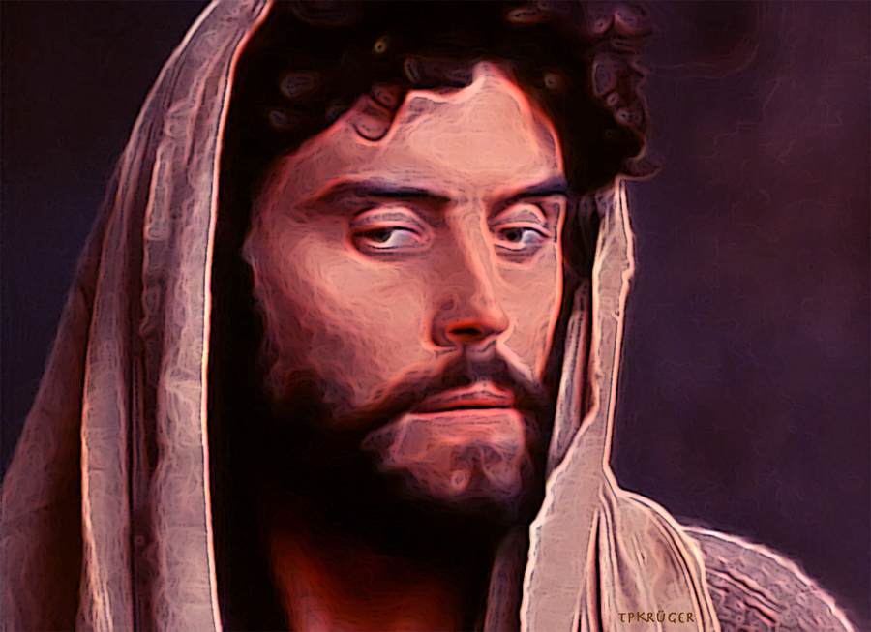

And when he had dipped the sop, he gave it to Judas Iscariot, the son of Simon. And after the sop Satan entered into him. Then said Jesus unto him, That thou doest, do quickly. Now no man at the table knew for what intent he spake this unto him. For some of them thought, because Judas had the bag, that Jesus had said unto him, Buy those things that we have need of against the feast; or, that he should give something to the poor. He then having received the sop went immediately out: and it was night. (John 13:26-30)

It is my opinion the saddest passage of the Gospel is this 30th verse of John 13, “He having received the sop went immediately out: and it was dark.” The Lord’s Supper had just been instituted and administered by our Lord to all – including Judas Iscariot. By woe unto those who receive the Lord’s Supper unworthily, and Judas had clearly done so. His great sin had begun long before this night. No, there were no points of vicissitude in the character of Judas – he was bad through and through. Our Lord knew him to be a devil when He chose him. (John 6:70-71) His commission of the most heinous sin of all time was in perfect conformity with his depraved nature. Implicit in the Gospel is the fact that he was a greedy fellow, and cared little for acts of humble contrition.

When Judas finally departed from Christ, he went out and it was dark – not just the passing darkness of nine nightwatches, but the eternal darkness of Hell. Judas never beheld another sunrise for he had committed suicide ere the dawn would break over the eastern skies of Jerusalem. How different was Nicodemus from Judas. Nicodemus came out of that midnight meeting with Christ into the brilliant day Light of the Gospel; but Judas, who had known Christ well, left the Light of the World into that eternally long night. By the way, Satan did not have to force his way into the heart of Judas. Judas left the door to his heart invitingly open to Satan! How sad that a single soul must spend an eternity in smothering darkness, but, tragically, there will be millions and billions who will not see light again once they close their eyes in this life, except the glowing embers of the fires of Hell.

It seems likely that Judas saw in Jesus an opportunity to advance a politically, and personally lucrative, agenda. This was entirely consistent with his record as a disciple. He was able to betray his Lord for silver, and then seal the deal with a kiss of treachery!

We open our Holy Week readings with the two culprits responsible for the acts of treachery and betrayal that led to the crucifixion of Jesus – the Sanhedrin, and Judas Iscariot – the man of perdition.

The Sanhedrin, headed by the High Priest, Caiaphas, vigorously prosecuted the trial and conviction of Jesus even though not a single shred of evidence of guilt was produced. The Roman Governor, Pontius Pilate declared his innocence repeatedly, yet was a political pawn easily intimidated by a vociferous minority of priests and lawyers, with the complicity of those crowds who had shouted “Hosanna” the same week at His entry into Jerusalem, now transformed into an unruly mob.

When the morning was come, all the chief priests and elders of the people took counsel against Jesus to put him to death: And when they had bound him, they led him away, and delivered him to Pontius Pilate the governor. (Matt 27:1-2)

You may remember that Caiaphas unwittingly spoke a solemn prophecy when pressed on how to handle the popular appeal of the Lord among the people of Jerusalem: 47 Then gathered the chief priests and the Pharisees a council, and said, What do we? for this man doeth many miracles. 48 If we let him thus alone, all men will believe on him: and the Romans shall come and take away both our place and nation. 49 And one of them, named Caiaphas, being the high priest that same year, said unto them, Ye know nothing at all, 50 Nor consider that it is expedient for us, that one man should die for the people, and that the whole nation perish not. 51 And this spake he not of himself: but being high priest that year, he prophesied that Jesus should die for that nation; 52 And not for that nation only, but that also he should gather together in one the children of God that were scattered abroad. (John 11:47-52) And Jesus did, indeed, die to save every citizen of that heavenly nation called the Kingdom of God!

Now we turn to a more searching look at Judas as revealed in the Holy Week text from Matthew 27. At the outset, we will note of the fact that Judas repented of his sin – though not in the way that could help him. Then Judas, which had betrayed him, when he saw that he was condemned, repented himself, and brought again the thirty pieces of silver to the chief priests and elders, Saying, I have sinned in that I have betrayed the innocent blood. And they said, What is that to us? see thou to that. And he cast down the pieces of silver in the temple, and departed, and went and hanged himself. (Matt 27:3-5) Simple regret, or sorrow, over our actions is not the kind of repentance that will open a crack in heaven’s gate wide enough for us to slither through. Pharaoh, though repenting that he had not allowed the Children of Israel to go from Egypt before the death of his son, nevertheless abrogated his promise and pursued after them - and had his bones washed clean in the waters of the Red Sea. King Saul, too, sought counsel of the Lord’s prophet, but disregarded the counsel to his own ruin. David, a great sinner, however, repented with deep contrition, and was forgiven and spared.

There was another traitor on the night of the trial of Jesus. Do you remember who it was? It was the man, Peter, who denied Christ three times in the night. Yet Peter went out and wept bitterly tears of contrition. It was not a calculated and intentioned betrayal, but one made out of weakness of courage. But the betrayal of Judas was a considered and intentional betrayal. So what was amiss with his repentance? What are the facts?

- Judas recognized that his betrayal led to the condemnation of Jesus.
- He repented & confessed, but not to God – to the priests. Remember, a priest cannot grant absolution, only God has that authority.
- He tried to make restitution, but that was too late. He was trying to repent by his own works. Like Cain, he tried to bring the wrong sacrifice from the wrong source.
- Trying to justify himself through self-efforts, he was left to self to perish.
- He returned the blood money! Though money can betray a best friend, money cannot buy an ounce of salvation.
- Being his own savior and master of his fate, he died at the hands of that master by hanging himself. (much like the author of Invictus – Henley) There is no greater loss than the loss of one’s own soul. Certainly, thirty pieces of silver could never compensate for the loss of the soul of Judas. He was left with only terror and hopelessness than words could not express. He HATED himself enough to commit self-murder. His betrayal of Jesus into the hands of the enemy resulted in the betrayal of himself into the hands of the devil the very night of his reprobation.

Please observe, during your vigil of Holy Week, these two men – Peter and Judas. Neither Peter, nor Judas, was compelled to respond in the different manner in which they did respond to their sin. It is very likely that you and I fit into the mold of one, or the other, of these two men.

Coming to know Christ as your Lord and Savior (long after He already knew you to be); you have definitely been a Peter standing in the courtyard of the venal and profane who curse God, and slander the good Name of our Lord. Being in the minority, as the righteous of the Lord always are, we may have suffered the same moments of dread, doubt and fear as Peter. We may have acted as if we were not the Christian that we have professed to be. Later, in the solitude of our prayers, we felt, intensely, the sting of shame and contrition that denial of the Lord always evokes. When we have lacked courage to stand up against the slander lodged against a dear friend, how we dread to look that friend in the eye at the occasion of our next meeting! We are weak vessels, and our sins separate us, too, from our Lord. But the Lord knows our every weakness, and has paid dearly for every sin that we commit and repent of, or good deeds omitted, by His precious blood.

There is another whose bloodline is not of Christ, but of the Adversary. That sort is characterized fully by Judas. He was a devil from the first. His spirit never soared above the gutters and sewers of worldly want. The great master, Da Vinci, depicted him well in his painting, The Last Supper. Each disciple flanking Jesus has light reflecting from their faces. But Judas’ face is covered by a shadow portraying the coming darkness into which his soul shall sink. His right hand is clutching, greedily, the money bag. The salt shaker has been knocked over by the same hand holding the money bag which was an omen of damnation in the time of Da Vinci. One last prophetic clue is given in the original painting on the wall of the Santa Maria delle Gracie in Milan (often omitted in Walmart copies): Peter is holding a knife behind Judas’ back signifying his coming death; but the knife is pointing AWAY from Judas! Why? Because, though Judas would die that very night, he would not die at the hands of any man but his own. Judas was EVIL. His character of sin had been so habitual and pervasive that his conscience had been seared as with a hot iron. Though rain can be expected from afternoon clouds, Judas was a desert cloud that built up in the afternoon offering false promise, but gave not a drop of rain. The Holy Spirit never ceases to attempt communion with our consciences, but if we have blocked the spiritual channels by which He speaks, no communion takes place.

So, in the final analysis, we have Peter and Judas. Which of these two are you?

