First Thursday of Eastertide, 9 April 2105 Anno Domini

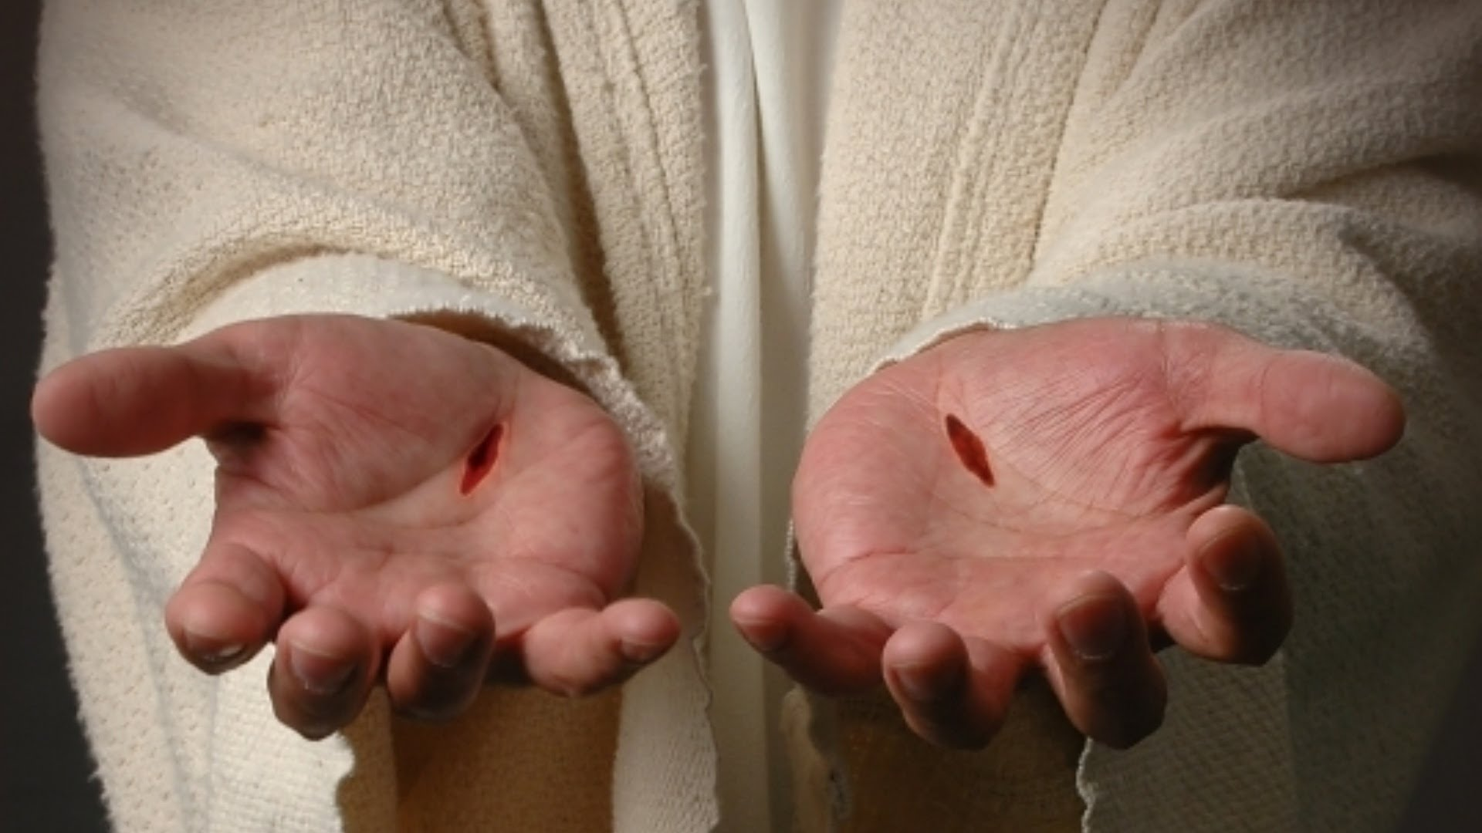

24 But Thomas, one of the twelve, called Didymus, was not with them when Jesus came. 25 The other disciples therefore said unto him, We have seen the Lord. But he said unto them, Except I shall see in his hands the print of the nails, and put my finger into the print of the nails, and thrust my hand into his side, I will not believe. 26 And after eight days again his disciples were within, and Thomas with them: then came Jesus, the doors being shut, and stood in the midst, and said, Peace be unto you. 27 Then saith he to Thomas, Reach hither thy finger, and behold my hands; and reach hither thy hand, and thrust it into my side: and be not faithless, but believing. 28 And Thomas answered and said unto him, My Lord and my God. 29 Jesus saith unto him, Thomas, because thou hast seen me, thou hast believed: blessed are they that have not seen, and yet have believed. 30 And many other signs truly did Jesus in the presence of his disciples, which are not written in this book: 31 But these are written, that ye might believe that Jesus is the Christ, the Son of God; and that believing ye might have life through his name. (John 20:24-31)

There is no great preponderance of evidence to suggest Thomas was any more of a doubter of the Resurrection than all of the others. You will recall in previous verses of this chapter when Jesus appeared to the disciples behind closed doors that Jesus openly showed them the nail prints in His hands and the stab wound in His side – THEN they were glad! For some unknown reason, Thomas was not with the other disciples at the first appearance of Jesus to the disciples. Many speculate that Thomas was doubtful of any good outcome from the crucifixion of our Lord, but that is nowhere expressed in Scripture though, perhaps, implied by the narrative. But there is no question that Thomas doubted that Christ had arisen. We do not know how far the doubts of other disciples extended, but we do know that Thomas doubted. Peter and John had already seen the empty tomb, and heard the account given by the women of the appearance of Jesus; yet, they were fearful and not glad to see the Lord until after Jesus had showed them His nail-scarred hands and the wound in His side: 20 And when he had so said, he shewed unto them his hands and his side. Then were the disciples glad, when they saw the Lord. (John 20:20)

Though witnesses had seen Christ, the disciples were slow to believe – not just Thomas – for we read: Afterward he appeared unto the eleven as they sat at meat, and upbraided them with their unbelief and hardness of heart, because they believed not them which had seen him after he was risen. (Mark 16:14) But, though the others doubted, they do not seem to have doubted to the same degree as Thomas. We are well-advised to limit our beliefs to the express teachings of the Apostles and not doubt. The Lord’s Table of every traditional Anglican Church has at least two candles displayed at Communion. The candle on the right (facing out) is the Gospel candle representing the Gospel Light of Jesus Christ and His teaching. The candle on the weak side (left) represents the Apostolic Light and their teaching concerning Christ. Both the Gospels and the Epistles give balance and perspective to the teachings of Christ and His Church maintained in truth through the apostolic authority that resides therein.

Continuing with our study of Thomas, he had heard the report of the Resurrection from those who were in the locked room at His first appearing to the disciples there; but it was not the first reports of His resurrection. These same disciples, ere the appearing of Christ among them, had ALSO received reports from the women of His resurrection. It did not seem that they were totally convinced until Christ appeared to them in Person. The other disciples therefore said unto him, We have seen the Lord. But he said unto them, Except I shall see in his hands the print of the nails, and put my finger into the print of the nails, and thrust my hand into his side, I will not believe. Moreover, Thomas was just as thoroughly convinced at the appearance of Christ when he came face-to-face with Him as was the others. There is no evidence Thomas had to place his hands in the stab wound to believe though he had averred the same earlier. There is something of greater persuasion involved in coming face-to-face with the Lord. We must all do so to know Him well.

You will remember the woman who came to the Well of Jacob at noonday outside the gate of Sychar. It is true that the beginnings of faith are sown by the testimony of others, but the testimony of others are the lower lights that guide the great ship of the soul into the safe harbor, but it is the Great Lighthouse of God’s Word (Jesus Christ) that saves them from the ravaging storms of the sea of life and beckons them to the safety of the harbor of God’s Grace. And many of the Samaritans of that city believed on him for the saying of the woman, which testified, He told me all that ever I did. So when the Samaritans were come unto him, they besought him that he would tarry with them: and he abode there two days. And many more believed because of his own word; And said unto the woman, Now we believe, not because of thy saying: for we have heard him ourselves, and know that this is indeed the Christ, the Saviour of the world. (John 4:39-42) The first evidences of faith may come from others, but the fullness of faith that stakes its soul thereon comes from a direct encounter with the Word.

One point of great gravity: The apostles Woman at the Well was never the same after encountering, first hand, the Lord Jesus Christ! Her life changed from that of an adulterous woman to a woman of virtue. The apostles, too, were radically changed by their encounter with the risen Savior. No longer were they timid and fearful. No longer were they, along with Thomas, doubtful and uncertain. From the moment of their meeting with the risen Christ, they were fearless, courageous, and full of a burning desire to share the Gospel. If we lack that desire, we need to re-examine our testimony, and get a double serving of our daily bread – the Word of God.

26 And after eight days again his disciples were within, and Thomas with them: then came Jesus, the doors being shut, and stood in the midst, and said, Peace be unto you. Apparently Thomas has dried his powder a bit, for he is, at least, among the disciples eight days later, perhaps tantalized by their witness if not fully believing it. Jesus comes to them in their private gathering even though the doors are shut. There is a mystery we cannot know about His glorified body for it was able to pass through material barriers at ease. The tomb was probably already empty when the angel rolled the stone away for the world to witness the empty tomb, not to afford Jesus a means out of it. He “stood in the midst” of them. In Anglican churches, the pulpit is always shifted to the right side of the sanctuary (facing the congregants). The Lord’s Table and Cross are at the center rear of the sanctuary. Why is this so? Because the Lord’s Table represents the place of Christ, and His place is always in the midst of the worshippers and at the honored place. The pulpit is never at the center of the sanctuary because man cannot usurp the place of Christ in the center of worship. For where two or three are gathered together in my name, there am I in the midst of them. (Matt 18:20) Other Reformed churches follow this example as well.

27 Then saith he to Thomas, Reach hither thy finger, and behold my hands; and reach hither thy hand, and thrust it into my side: and be not faithless, but believing. There is no evidence that Thomas followed through with his former claim of faith – that he must see the nail prints and thrust his hand into the wound in the Lord’s side. Christ uses Thomas’ own words to shame him for his little faith. “Do not require, Thomas, a visible sign, for every act of faith.” Faith is more than visual sight – it is heart knowledge.

28 And Thomas answered and said unto him, My Lord and my God. Now overcome with the glory and overpowering presence of Christ, Thomas drops his pre-condition of faith and claims the Person of Christ in awe and astonishment. When the overpowering Presence of the Lord overshadows our souls, we need no visible proofs of the Presence.

29 Jesus saith unto him, Thomas, because thou hast seen me, thou hast believed: blessed are they that have not seen, and yet have believed. Jesus delivers a mild rebuke to Thomas for his lack of faith, and confers an honor upon those who believe the Gospels and Apostles in their testimony of Himself without physical evidence. Have we, too, believed the Word of the Gospels and the Epistles as read on appointed days? Can there be any cause not to believe? Did the villagers of Sychar believe the words of a woman of documented ill-repute when she carried the news of Christ from Jacob’s Well to her former courtiers and others? And many of the Samaritans of that city believed on him for the saying of the woman, which testified, He told me all that ever I did. So when the Samaritans were come unto him, they besought him that he would tarry with them: and he abode there two days. And many more believed because of his own word; And said unto the woman, Now we believe, not because of thy saying: for we have heard him ourselves, and know that this is indeed the Christ, the Saviour of the world. (John 4:39-42) We are drawn to Christ by the Words of His Gospel and the testimony of the Apostles (Epistles), but then we must digest those beautiful Words of Truth so that we, too, may know the object of the Word (Jesus) in a personal way.

30 And many other signs truly did Jesus in the presence of his disciples, which are not written in this book.” The Apostle of Love freely admits that there are many other works what Christ did that are not recorded by him or any other. And there are also many other things which Jesus did, the which, if they should be written every one, I suppose that even the world itself could not contain the books that should be written. Amen. (John 21:25) These are the Words with which John concludes his record. He apparently intended to say that those things that Jesus did in His earthly ministry were so numerous and of such magnitude that they could not be included in any single book, or collection thereof, of writing. He was absolutely correct in saying that - even if speaking allegorically! Certainly, if all the works of Christ in Creation were to be enumerated, the world itself could not hold them for, even that, was made by His divine Hands.

31 But these are written, that ye might believe that Jesus is the Christ, the Son of God; and that believing ye might have life through his name. This kind of belief is a contrast to that belief averred by Thomas. It is believing the testimony of Christ and His Apostles. And John insists that in believing we must go beyond simple belief of circumstances – we must believe unto Eternal Life in Christ. Believing is one thing, acting upon that belief is another in allowing the Word to sink deep into the hidden chambers of one’s heart, and being transformed into the likeness of Christ. Have you believed and been thus transformed, beloved friend?

Conclusion
We have a greater cause to believe than did the disciples on the day of the resurrection. They had only a few witnesses, at first, upon which to believe. But we have a Great Cloud of Witnesses – even secular history itself bears a reluctant record. But greater than all of these, we have the inward testimony of the Holy Ghost which was lacking on the Day of resurrection.

Do you have that witness within?

