Exodus – Chapter 37 – 12 March 2015, Anno Domini (Year of our Lord)

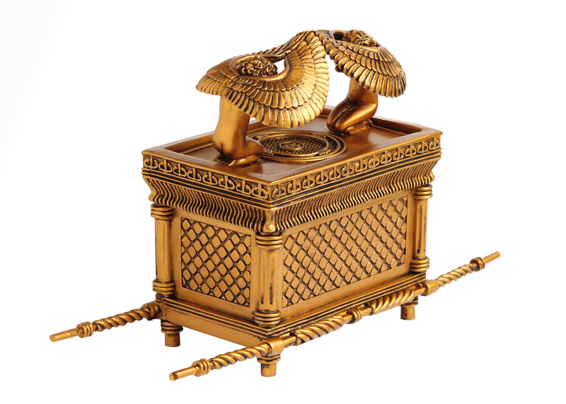
Furthermore we have had fathers of our flesh which corrected us, and we gave them reverence: shall we not much rather be in subjection unto the Father of spirits, and live? (Heb 12:8-9)

40 Let all things be done decently and in order (1 Cor 14:40)

Meticulous attention to detail and a conviction to obey, precisely, the Words of the Lord, are the salient points of these latter chapters of Exodus. There is no a single Word of Scripture that does not bear the utmost importance to us. Reading the introductory verses from Hebrews and 1 Corinthians, we see that it is a character and practice of the devout Christian to pay the utmost reverence to God (especially in worship – before and after), and to do all things in good order. Reverence for God’s Presence, and Holy, decent order in worship, are two qualities that are missing in most modern-day churches. Where there is not a Godly order in worship, the service will fall into those practices devised by man and which will not remain holy and reverential. Need I point out those aberrant AND abhorrent practices of unrestrained carnal worship of the charismatic’s and many TV evangelists? Thus, God sets standards and limits to worship, and it is always in good order and reverential if it is acceptable to God. (forgive my polemical approach to theology)

1 And Bezaleel made the ark of shittim wood: two cubits and a half was the length of it, and a cubit and a half the breadth of it, and a cubit and a half the height of it: 2 And he overlaid it with pure gold within and without, and made a crown of gold to it round about. 3 And he cast for it four rings of gold, to be set by the four corners of it; even two rings upon the one side of it, and two rings upon the other side of it. 4 And he made staves of shittim wood, and overlaid them with gold. 5 And he put the staves into the rings by the sides of the ark, to bear the ark. 6 And he made the mercy seat of pure gold: two cubits and a half was the length thereof, and one cubit and a half the breadth thereof. 7 And he made two cherubims of gold, beaten out of one piece made he them, on the two ends of the mercy seat; 8 One cherub on the end on this side, and another cherub on the other end on that side: out of the mercy seat made he the cherubims on the two ends thereof. 9 And the cherubims spread out their wings on high, and covered with their wings over the mercy seat, with their faces one to another; even to the mercy seatward were the faces of the cherubims. (Ex 37:1-9)

The Ark, representing the very abode of God in His Justice and Righteousness, was the first article of furniture made by Bezaleel, and it was made of pure gold. The Ark of the Covenant was made first, because it represented the essential contract between God and His People, if He would deign to allow their abode with Him. Though God is LOVE, He is first of all righteous and just. God has given us His Laws to obey. The Tables of the Law were contained in the Ark to establish the fact that God requires a perfect righteousness of His people. It also represents the place of safety for God’s people.

The first Ark of Noah was a shadow of that Ark to come for the Tabernacle and, later, the Temple; and this, too, was a foreshadow of that perfect Ark of Safety to come in the Person of the only Begotten Son of God! It not only contained the Law, but also the Manna (or Bread which came down from Heaven) which also alludes to Jesus Christ who is the Bread of Heaven. I am the bread of life: he that cometh to me shall never hunger; and he that believeth on me shall never thirst. But I said unto you, That ye also have seen me, and believe not. All that the Father giveth me shall come to me; and him that cometh to me I will in no wise cast out. For I came down from heaven, not to do mine own will, but the will of him that sent me. And this is the Father's will which hath sent me, that of all which he hath given me I should lose nothing, but should raise it up again at the last day. (John 6:35-39)

The Ark was covered by two winged-Cherubim who covered the Ark and faced toward its center which was the MERCY SEAT. The Mercy Seat was the lid (or door) to the Ark and represents the redemption from sin made available by the Father through the sacrifice of His Son, Jesus. Without mercy, we stand naked and unjustified before a Holy God!

10 And he made the table of shittim wood: two cubits was the length thereof, and a cubit the breadth thereof, and a cubit and a half the height thereof: 11 And he overlaid it with pure gold, and made thereunto a crown of gold round about. 12 Also he made thereunto a border of an handbreadth round about; and made a crown of gold for the border thereof round about. 13 And he cast for it four rings of gold, and put the rings upon the four corners that were in the four feet thereof. 14 Over against the border were the rings, the places for the staves to bear the table. 15 And he made the staves of shittim wood, and overlaid them with gold, to bear the table. 16 And he made the vessels which were upon the table, his dishes, and his spoons, and his bowls, and his covers to cover withal, of pure gold. (Ex 37:10-16)

Next in order of construction was the Shew Bread Table (or the Table for the Bread of Presence). This Table will seem familiar to those who observe the proper serving of the Holy Communion by partaking of the Bread of the Spiritual Presence of Christ (His Body) at the Table of the Lord. Facing the Most Holy Place, the Shew Bread Table (representing the continual Presence of Christ to us) was on the right side of the Holy Place. The Presence of God the Father is represented, I believe, by the Ark and Most Holy Place, in the Tabernacle. Jesus Christ, being the Second Person of the Godhead, is represented (in the Tabernacle of the time) by the Bread of Presence which must be passed in order to reach the Ark. We cannot approach God in His righteousness without having Christ as our Passover. On the way to Mount Sinai, the people first passed by Mount Horeb from which the Great Rock effused a merciful Fountain of Living Waters. That Rock was Christ!

Finally, the Candlestick of Seven Lights was made to stand across from the Shew Bread Table on the left side of the Holy Place as one faces the Most Holy Place and Vail. 17 And he made the candlestick of pure gold: of beaten work made he the candlestick; his shaft, and his branch, his bowls, his knops, and his flowers, were of the same: 18 And six branches going out of the sides thereof; three branches of the candlestick out of the one side thereof, and three branches of the candlestick out of the other side thereof: 19 Three bowls made after the fashion of almonds in one branch, a knop and a flower; and three bowls made like almonds in another branch, a knop and a flower: so throughout the six branches going out of the candlestick. 20 And in the candlestick were four bowls made like almonds, his knops, and his flowers: 21 And a knop under two branches of the same, and a knop under two branches of the same, and a knop under two branches of the same, according to the six branches going out of it. 22 Their knops and their branches were of the same: all of it was one beaten work of pure gold. 23 And he made his seven lamps, and his snuffers, and his snuffdishes, of pure gold. 24 Of a talent of pure gold made he it, and all the vessels thereof. (Ex 37:17-24) This Candlestick with her Seven Lights must represent the revealing Light of the Holy Ghost. But the Comforter, which is the Holy Ghost, whom the Father will send in my name, he shall teach you all things, and bring all things to your remembrance, whatsoever I have said unto you. (John 14:26) I might add that light itself is invisible. It is manifested by the things that it reveals to our vision. The Holy Ghost does not speak of Himself, but always points to the Lord Jesus Christ – unlike the false beliefs of some churches.

So we have the Three Persons of the Godhead revealed in the tabernacle furniture. The Ark (Father), the Bread of Presence (Son), and the Candlestick (Holy Ghost). The Holy Ghost opens our eyes, in light, to the Son which provides us access to the Father. So what else is needed? To come to Christ means that we must accept His sacrifice on our behalf through repentance. So, for our prayers, the Tabernacle needed an Altar of Incense.

25 And he made the incense altar of shittim wood: the length of it was a cubit, and the breadth of it a cubit; it was foursquare; and two cubits was the height of it; the horns thereof were of the same. 26 And he overlaid it with pure gold, both the top of it, and the sides thereof round about, and the horns of it: also he made unto it a crown of gold round about. 27 And he made two rings of gold for it under the crown thereof, by the two corners of it, upon the two sides thereof, to be places for the staves to bear it withal. 28 And he made the staves of shittim wood, and overlaid them with gold. 29 And he made the holy anointing oil, and the pure incense of sweet spices, according to the work of the apothecary. (Ex 37:25-29)

You will remember the Bronze Altar at the entrance to the court of the Tabernacle. This represented the sacrifice of Christ for our sins. But now we have an Altar of Incense past the Shew Bread Table and Candlestick that stands immediately before the Vail of the Ark. This is an altar of prayer – prayer is represented by the incense rising to God from the people. Once we have accepted the sacrifice of Christ (at the Bronze Altar) we may now proceed to the continual Presence of Christ in the Holy Place. He is always with us! But we may oft times fail in our obedience. Our prayers of repentance stand before the Most Holy Place at which we plead the blood of Christ for our forgiveness and supplication. By His death, Jesus rent the Vail from top to bottom affording us direct access to the Father’s Throne of Mercy.

I must admit that this may seem a bit difficult for those not deeply committed to Bible study; but I have set the meanings forth as simply as I know how. Knowing the mysteries of the Tabernacle will help us to better understand the nature of Christ and the Godhead as revealed more abundantly in the Gospels.

