Exodus – Chapter 33 – 4 March 2015, Anno Domini (Year of our Lord)

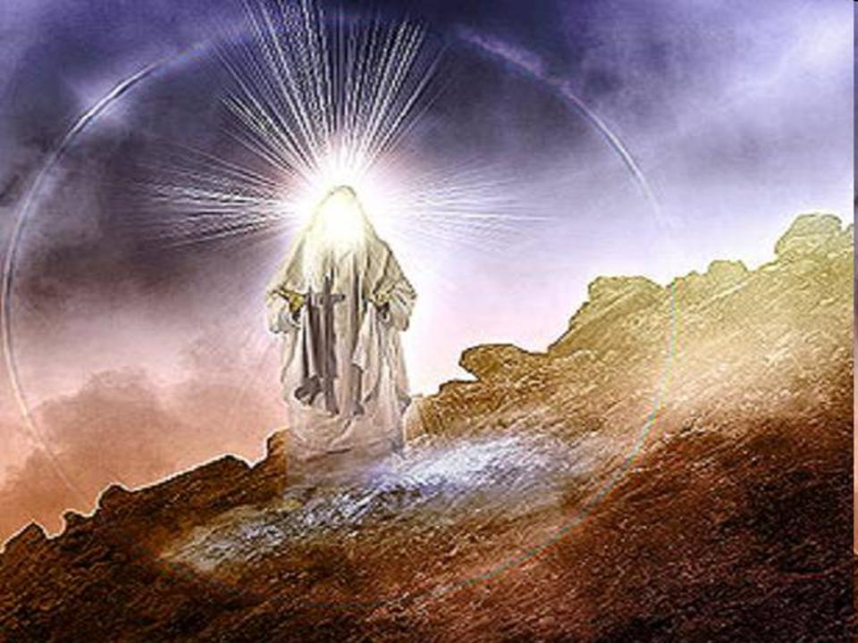

5 For the LORD had said unto Moses, Say unto the children of Israel, Ye are a stiffnecked people: I will come up into the midst of thee in a moment, and consume thee: therefore now put off thy ornaments from thee, that I may know what to do unto thee.

Sin ALWAYS separates us from a Holy God. The one thing that offends God beyond measure is spiritual adultery (idolatry). Those who are committed reprobate sinners are already damned and are so far separated from God as Hell is distant from Heaven; but the professing Christian who claims the salvation of Christ, and then is deceived by the charms and attraction of false religions promising prosperity, sex and replacing the sovereignty of God with SELF, will incur the full and present wrath of God. This, the Children of Israel have done in turning to false gods of silver and gold, and the lusts of the flesh. They had enjoyed the miraculous rescue of God from bondage in Egypt, and His daily provision for their needs in the wilderness. Yet, they have turned to the sordid and dissolute lifestyle of the profligate sinner and idolater.

So God, not being capable of tolerating sin in His Presence, has moved outside the camp of the Israelites. It is a disgrace to the church today that many more devoted Christians are without the greater camp claiming Christ, than those within. Christ Himself was sacrificed without the camp, and those who are in a sincere relationship with Christ may feel it imperative to leave the modern church of sinful error and live without the gate with God.

It is sadly true that it is possible to live in a presumed living relationship with the Lord, but the Lord has refused to abide with YOU. He abides at a distance, and that is a tragic circumstance that has eternal implications to our souls.

1 And the LORD said unto Moses, Depart, and go up hence, thou and the people which thou hast brought up out of the land of Egypt, unto the land which I sware unto Abraham, to Isaac, and to Jacob, saying, Unto thy seed will I give it: 2 And I will send an angel before thee; and I will drive out the Canaanite, the Amorite, and the Hittite, and the Perizzite, the Hivite, and the Jebusite: 3 Unto a land flowing with milk and honey: for I will not go up in the midst of thee; for thou art a stiffnecked people: lest I consume thee in the way. The angel of the Lord will no longer accompany His chosen people. Instead, God sends “an angel” to guide and direct them. Though many in the camp of the Israelites are of the physical seed of Abraham, few are of the promised seed of faith of Abraham. This will remain true until Shiloh comes. Only those who believe the promises made to Abraham are the true children of Israel without respect to racial or national boundaries.

4 And when the people heard these evil tidings, they mourned: and no man did put on him his ornaments. 5 For the LORD had said unto Moses, Say unto the children of Israel, Ye are a stiffnecked people: I will come up into the midst of thee in a moment, and consume thee: therefore now put off thy ornaments from thee, that I may know what to do unto thee. 6 And the children of Israel stripped themselves of their ornaments by the mount Horeb. Knowing that the angel that now leads is not the great Angel of the Lord with God’s “name in Him” is further profound evidence to them that the Lord will no longer be personally with them even if His protection remains. Those same kind of ornaments from which the Golden Calf was made are the kinds that they now cast aside to demonstrate some modicum of contrition. Perhaps now is the time for Christian churches to cast aside the ornaments of false worship (tongues and false miracles) that have defined them for many years now.

7 And Moses took the tabernacle, and pitched it without the camp, afar off from the camp, and called it the Tabernacle of the congregation. And it came to pass, that every one which sought the LORD went out unto the tabernacle of the congregation, which was without the camp. 8 And it came to pass, when Moses went out unto the tabernacle, that all the people rose up, and stood every man at his tent door, and looked after Moses, until he was gone into the tabernacle. 9 And it came to pass, as Moses entered into the tabernacle, the cloudy pillar descended, and stood at the door of the tabernacle, and the LORD talked with Moses. 10 And all the people saw the cloudy pillar stand at the tabernacle door: and all the people rose up and worshipped, every man in his tent door. The full Tabernacle was yet to be constructed, so this was doubtless a temporary tent of worship for the congregation. Moses labels it the Tabernacle of the Congregation. Now the Lord would not be entering the camp of His miscreant people, but would descend on the Tabernacle without the camp to talk with Moses.

11 And the LORD spake unto Moses face to face, as a man speaketh unto his friend. And he turned again into the camp: but his servant Joshua, the son of Nun, a young man, departed not out of the tabernacle. Moses had lost no credibility with God since Moses had not participated in the idol worship of the Children of Israel. Joshua, too, had remained faithful to God and remained in the good graces of the Most High. In fact, Joshua would later be privileged to lead Israel into the Promised Land in lieu of Moses.

12 And Moses said unto the LORD, See, thou sayest unto me, Bring up this people: and thou hast not let me know whom thou wilt send with me. Yet thou hast said, I know thee by name, and thou hast also found grace in my sight. 13 Now therefore, I pray thee, if I have found grace in thy sight, shew me now thy way, that I may know thee, that I may find grace in thy sight: and consider that this nation is thy people. Moses is living up to his role as an intercessor for his people and as a type of Christ. Remember the words of Christ on the night of His betrayal into the hands of His enemies: “I have manifested thy name unto the men which thou gavest me out of the world: thine they were, and thou gavest them me; and they have kept thy word. Now they have known that all things whatsoever thou hast given me are of thee. For I have given unto them the words which thou gavest me; and they have received them, and have known surely that I came out from thee, and they have believed that thou didst send me. I pray for them: I pray not for the world, but for them which thou hast given me; for they are thine. And all mine are thine, and thine are mine; and I am glorified in them.” (John 17:6-10) Moses is praying for that which only Christ was able to confirm – those who rightly belong to the family of God.

14 And he said, My presence shall go with thee, and I will give thee rest. 15 And he said unto him, If thy presence go not with me, carry us not up hence. 16 For wherein shall it be known here that I and thy people have found grace in thy sight? is it not in that thou goest with us? so shall we be separated, I and thy people, from all the people that are upon the face of the earth. Moses, because of the unfaithfulness of his people, begins to have doubts and fears. God has promised to go with Moses, but not the people (except at a distance). Moses, like Jesus, refuses to be saved alone – he desires that he and his people find grace in the eyes of the Lord, or nothing.

17 And the LORD said unto Moses, I will do this thing also that thou hast spoken: for thou hast found grace in my sight, and I know thee by name. For the sake of Moses, God says that He will agree to all of the terms Moses prays for. Though the people themselves are not worthy, they will find grace based on the merits of Moses’ faith. Is this not the way that we are accounted righteous before the Lord as well – “not weighing our own merits, but pardoning our offenses, through Jesus Christ or Lord.” (from the Invocation, 1928 Book of Common Prayer)

18 And he said, I beseech thee, shew me thy glory. 19 And he said, I will make all my goodness pass before thee, and I will proclaim the name of the LORD before thee; and will be gracious to whom I will be gracious, and will shew mercy on whom I will shew mercy. 20 And he said, Thou canst not see my face: for there shall no man see me, and live. 21 And the LORD said, Behold, there is a place by me, and thou shalt stand upon a rock: 22 And it shall come to pass, while my glory passeth by, that I will put thee in a clift of the rock, and will cover thee with my hand while I pass by: 23 And I will take away mine hand, and thou shalt see my back parts: but my face shall not be seen. (Ex 33:1-23) Here is a mystery that I will not pretend to fully comprehend, but fully believe I certainly do.

What points do I not understand?
I do not know in what way the glory of the Lord was made visible to Moses.
I do not know why this was important for Moses to see since he communed personally with the Lord.

What points I do understand?
I do know that God revealed Himself in part to Moses visually based on the text itself.
I do know that God makes it clear that He will have mercy on whom He pleases.
I do know that Moses was hidden by God in the cleft of a Rock – this Rock I believe to represent the Lord Jesus Christ, and, since this occurred at Mount Horeb, could likely be that same Rock which Moses struck and out of it flowed bountiful fountains of water. God protected Moses from His own brilliance.

Conclusion
Our churches today are no less wicked than the Roman church at the time of the Reformation, perhaps even more so. We have turned to false gods of easy-believism, false miracles, exaltation of self, opulence, unfaithfulness to the Commandments of God, and false prophets. This falling away, God has tolerated for a very long time. But you may trust the Word of God that He will not withhold His hand of judgment forever. We need men such as Moses and Joshua to stand in the hedge and hold high the Gospel Banner. And we need to rally about that Ancient Landmark of God’s Word which is represented by that banner.

I believe God has already withdrawn from the camps of most churches today. But, hopefully, He has not gone out of sight - just as the Tabernacle was just without the camp. If America continues on the path of hedonism, fornication, licentious abandon, and irreverence for the things of God, we may be certain that God will remove His Tabernacle such a distance away from us that we may be assured of a terrible destruction.

