Exodus – Chapter 32 Part Two – 28 February 2015, Anno Domini (Year of our Lord)

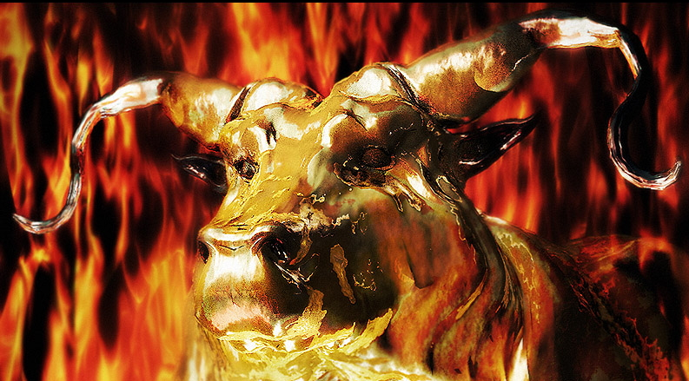

OH, REALLY? … I cast it into the fire, and there came out this calf.

15 And Moses turned, and went down from the mount, and the two tables of the testimony were in his hand: the tables were written on both their sides; on the one side and on the other were they written. 16 And the tables were the work of God, and the writing was the writing of God, graven upon the tables. (Ex 32:15-16)

What solemnly grave and profound words are these in verses 15 and 16! These were written by the very hand of God and represent fully His perfect will. It is best that we remember that each word of the Holy Bible is also His words as if written by His own hand – they are providentially and perfectly preserved by god in every language of mankind. But only God Himself is Author of Law and Justice. Only He is able to write, at first, His Law on Tables of Stones; and, later, on the fleshly chambers of the human heart: For this is the covenant that I will make with the house of Israel after those days, saith the Lord; I will put my laws into their mind, and write them in their hearts: and I will be to them a God, and they shall be to me a people.” (Heb 8:10) Forasmuch as ye are manifestly declared to be the epistle of Christ ministered by us, written not with ink, but with the Spirit of the living God; not in tables of stone, but in fleshy tables of the heart. (2 Cor 3:3) I hasten to add that this writing is made with the ink of Love and not legal constraint.

Moses has been warned of God of the evil that is taking place in the camp of the Children of Israel. It must have been a rare ecstasy that Moses experienced on the Mount on the presence of the Lord – a quiet and spiritual ecstasy, not the babbling ecstasy professed by the charismatic clan. There are mountaintop experiences to which every Christian can hail back. But we cannot forever remain on the mountaintop else we may become so heavenly inclined that we are no earthly good. The times come when we must return to the valley where the world of sin suffers in bondage to Satan. “And Moses turned, and went down from the mount.” After a face-to-face encounter with God, there is always a need to put the spiritual truths learned to use among those who perish.

“. . . the tables were written on both their sides; on the one side and on the other were they written.” There seems to have been two tables of the law with the Commandments written on either side so that they could have been read from all directions. Whether our vantage point is of the East or the West, we read the same Law. In Christ, culture is not a reason to miss the Law. As Moses descended from the Mount, the discordant sounds of the Camp came to his ears. The voice of the world is always warlike when contrasted with the infallible Word of God. “And when Joshua heard the noise of the people as they shouted, he said unto Moses, There is a noise of war in the camp.” (Ex 32:17) Joshua was such a devoted disciple of God that he waited the forty days and forty nights halfway up the Mount. His faithful ears must have been anguished by the noise he had heard arising from the Camp. How soon can the piety of good people be turned to orgy even in our modern churches! Churches in America that once were intolerant of open sin, now call evil good, and good evil in conformity with the prophecy of Isaiah: Woe unto them that call evil good, and good evil; that put darkness for light, and light for darkness; that put bitter for sweet, and sweet for bitter! (Isaiah 5:20) When I was a child, the term ‘homosexuality’ was a filthy joke. Now it is heralded as dignified alternative to Godly marriage – what wicked insanity!

The example that Joshua sets in His faithfulness is not unlike that of the faithful and persevering servant of God who may not be privileged to be called to Holy Orders, but rather serves God with the fullness of his being.

And he said, It is not the voice of them that shout for mastery, neither is it the voice of them that cry for being overcome: but the noise of them that sing do I hear. (Ex 32:18) Moses knew that it was not the sound of conventional war, but another kind of war – spiritual warfare fanned by inordinate desires of the flesh. God had already informed Moses of what was taking place. This song was a great contrast to that the people sang with Moses in Exodus 15. It might be compared the church singing “I Surrender ALL” on Sunday and living a life of impurity throughout the week.

And it came to pass, as soon as he came nigh unto the camp, that he saw the calf, and the dancing: and Moses' anger waxed hot, and he cast the tables out of his hands, and brake them beneath the mount. (Ex 32:19) The closer one gets to the world, the more of its evil can be seen. Some have said as a matter of trivia, including myself, that Moses was first to break all of the Commandments. In fact, I do not believe Moses broke the Law of God, but acted out of righteous indignation. It was, doubtless, symbolic of the anger of God. Today, I see too little of righteous indignation among Christians, especially clergymen, at the wicked and blasphemous nature of the world today. God does not frankly condemn anger. He would most likely be disappointed that we would not be angry at the murder, rape, and pillage occurring today in Syria and Iraq, or the sadistic abuse of little children at all levels of modern society. We have reached a point in the modern church in which judgment against sin is classified as wicked, and anger of any type is condemned. But Jesus tells us the anger, based on sound reason, is appropriate. “But I say unto you, That whosoever is angry with his brother without a cause shall be in danger of the judgment:” (Matt 5:22)

And he took the calf which they had made, and burnt it in the fire, and ground it to powder, and strawed it upon the water, and made the children of Israel drink of it. (Ex 32:20) What a judgmental act of Moses! But one which was TOTALLY justified! Many of my Korean Christian friends who converted to Christ from Buddhism take their old idols of Buddha and burn them in fire until only ashes remain. If only desires and attitudes of our time could be ground down and burned in the flames of God’s righteous wrath.

How often do ministers who ought to know better allow themselves to be led away in bondage of sin by influential members of the church! And Moses said unto Aaron, What did this people unto thee, that thou hast brought so great a sin upon them? (Ex 32:21) What is your own price for compromise – do you have one? Aaron was left in charge just as today’s clergy are left to stand up for Christ. He was doubtless moved by the emotion of pride when he would be able to satisfy the desires of ALL the people. Some today are still trying to satisfy ALL the people by being “all things to all men.”

And Aaron said, Let not the anger of my lord wax hot: thou knowest the people, that they are set on mischief. For they said unto me, Make us gods, which shall go before us: for as for this Moses, the man that brought us up out of the land of Egypt, we wot not what is become of him. And I said unto them, Whosoever hath any gold, let them break it off. So they gave it me: then I cast it into the fire, and there came out this calf. (Ex 32:22-24) This excuse is quite familiar to us if we remember our excuses to mom over the cookie jar, but totally inappropriate for a grown-up man of God. The Cloud of the Lord was even still visible atop Sinai, yet these people wanted little man-made gods to lead them back to the bondage of Egypt. How disgusting! Aaron did not even offer a word of objection or of explanation as to why the desires of the people were wrong. Instead of objecting to their desires, he submits to their godless intentions. Can you imagine casting into a fire a great mass of gold and out of that fire a molten calf emerges? Is this the first example of evolution? Of course, evolution is even more ridiculous. At least the calf was not alive, but the evolutionists believe life was formed from masses of hot gas and an amalgamation of chemicals. I believe I can figure out the source of the hot gases.

And when Moses saw that the people were naked; (for Aaron had made them naked unto their shame among their enemies: (Ex 32:25) Not only were they naked in physical appearance, but also naked to the judgment of God. Was Moses at fault for pronouncing judgment against these hellions? Not at all, because it was the clear judgment of God. When we use God’s word to judge sin, it is not our own judgment we use, but God’s.

Then Moses stood in the gate of the camp, and said, Who is on the LORD'S side? let him come unto me. And all the sons of Levi gathered themselves together unto him. And he said unto them, Thus saith the LORD God of Israel, Put every man his sword by his side, and go in and out from gate to gate throughout the camp, and slay every man his brother, and every man his companion, and every man his neighbour. And the children of Levi did according to the word of Moses: and there fell of the people that day about three thousand men. For Moses had said, Consecrate yourselves to day to the LORD, even every man upon his son, and upon his brother; that he may bestow upon you a blessing this day. (Ex 32:26-29) On this day the curse of Genesis 49:7 against the Levites was broken on their stand for God. “Cursed be their anger, for it was fierce; and their wrath, for it was cruel: I will divide them in Jacob, and scatter them in Israel.” Now they will be dispersed among the tribes of Israel for God’s purpose and not as a punishment. If any considers this an ancient and hard cruel punishment, they would be wrong, for god will bring an even greater punishment on unbelievers at the Last Day at the return of the Lord.

There are types and figures of Christ in the Old Testament, yet none are perfect types. All are as inferior to Christ as mud is to Gold. Moses here takes on an aura of the type of Christ: And it came to pass on the morrow, that Moses said unto the people, Ye have sinned a great sin: and now I will go up unto the LORD; peradventure I shall make an atonement for your sin. And Moses returned unto the LORD, and said, Oh, this people have sinned a great sin, and have made them gods of gold. Yet now, if thou wilt forgive their sin--; and if not, blot me, I pray thee, out of thy book which thou hast written. (Ex 32:30-32) Moses is willing to die for his people just as Christ died for us; however, Moses could only offer to die for their physical lives. Christ died for our eternal lives. God now says that Moses cannot die for the people for such issues are left to God alone. And the LORD said unto Moses, Whosoever hath sinned against me, him will I blot out of my book. (Ex 32:33) That would include you and me were it not for the shed blood of Christ!

Now here is a cardinal lesson to man: God does not change His plans due to the failures and wickedness of man. Man simply suffers loss after loss until he awakens to the obedience required to God. Therefore now go, lead the people unto the place of which I have spoken unto thee: behold, mine Angel shall go before thee: nevertheless in the day when I visit I will visit their sin upon them. (Ex 32:34) Judgment belongs to the Lord, and He will surely execute judgment against those who are disobedient. God tells Moses to continue in the calling God as ordained him to follow. We may become discouraged and even angry at the disloyalty of our Christian friends, but God commands that we continue on the path He has set our feet and continue in the way He leads. His Angel will lead the faithful minister and Christian. God does not forget unrepented sin. In due time, He will visit the sins of the people upon their heads. And the LORD plagued the people, because they made the calf, which Aaron made. (Ex 32:35)

Our churches today have turned themselves into centers of entertainment and sin. Do we suppose that God will not visit their sins upon them and their nation?

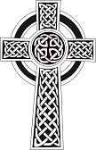

In actuality, it is by government fiat to be recognized as superior to actual marriage.

