Exodus – Chapter 29 – The Service and the Sacrifice – 18 February 2015, Anno Domini (Year of our Lord)

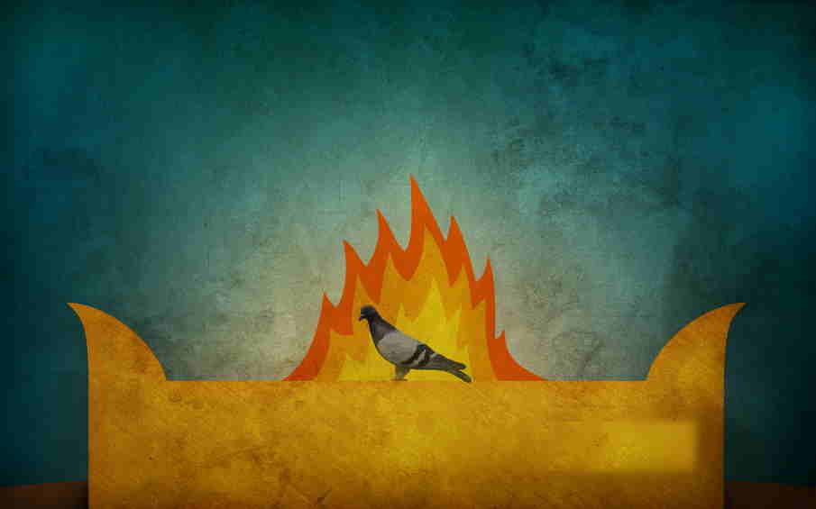

And I will sanctify the tabernacle of the congregation, and the altar: I will sanctify also both Aaron and his sons, to minister to me in the priest's office. And I will dwell among the children of Israel, and will be their God. And they shall know that I am the LORD their God, that brought them forth out of the land of Egypt, that I may dwell among them: I am the LORD their God. (Ex 29:44-46)

These mid chapters of Exodus regarding the Tabernacle and the Priesthood are challenging passages upon which to comment; however, the salient point of all is this: God dwells always among His people. He is forever mindful of us during our moments of triumph as well as those troublesome days of dire straits. The twelve stones worn upon the chest of the High Priest represented the full twelve tribes of Israel so that the High Priest, too, was appropriately aware of each household of Israel. Our Lord was mindful of each of our names when He died upon the cross for us. “Can a woman forget her sucking child, that she should not have compassion on the son of her womb? yea, they may forget, yet will I not forget thee. Behold, I have graven thee upon the palms of my hands; thy walls are continually before me.” (Isaiah 49:15-16) Our names were graven (cut) into the flesh of His hands on the cross at Calvary. He is our Emmanuel (God with us) in the same sense that was prefigured by the Tabernacle as an abode of God among the Children of Israel.

In a sense, every believer is a minister – a priest – with a duty to share the Gospel of Christ; however, God does set apart men to perform the fuller duties of leading, teaching, and guiding the flock of Christ on earth. The ordained ministry of Holy Orders of the Church provide the means by which God calls a man to the ministry, the man responds, and the Church recognizes that call. It is done with utmost formality for formality represents reverence, respect and an attitude of rectitude.

Many of the points raised in Chapter 29 have already been overwhelmed by their fulfillment in Christ; however, I will comment on certain aspects of the chapter that may shed greater light on our understanding of what those fore-shadowing’s were, and how they were fulfilled, in Christ. Today happens to be Ash Wednesday. On the Sunday following, the Church will observe the First Sunday of Lent. It signals the approaching passion of Christ and the end of His earthly ministry; however, on the First Sunday in Lent, we will read the Gospel account of the very beginning of our Lord’s earthly ministry – His baptism, confirmation by the Father and Holy Ghost, and His temptation in the wilderness for forty days and nights. As Aaron is consecrated High Priest of that Wilderness Tabernacle, our Lord was consecrated to become High Priest of the Kingdom of Heaven by His baptism and temptation at the door of His ministry.

This present chapter is full of symbols and types of Christ. Take the first verse for example: And this is the thing that thou shalt do unto them to hallow them, to minister unto me in the priest's office: Take one young bullock, and two rams without blemish. (Ex 29:1) The consecration of the Priests began with the sacrifice of a young bullock (the cross of Christ in His prime of manhood). Aaron, destined to be anointed as High Priest, was consecrated BEFORE the animal sacrifice because he was a Type of Christ, and Christ would become His own sacrifice at Calvary. Aaron’s sons would be anointed FOLLOWING the animal sacrifice. There is never a consecration without first taking up the cross. The two rams symbolize His Kingly Character. Next, “And unleavened bread, and cakes unleavened tempered with oil, and wafers unleavened anointed with oil: of wheaten flour shalt thou make them.” (Ex 29:2) Unleavened bread is pure and free of any corrupting influences just as the life of Christ was perfect in every regard. The anointing oil represents the Holy Spirit that was upon Christ in full measure from the moment of His formal calling (baptism in Jordan Waters). “For he whom God hath sent speaketh the words of God: for God giveth not the Spirit by measure unto him.” (John 3:34) The wheaten flour represents the purity of the crushed and broken body of Christ as in our Holy Communion Service.

“And thou shalt put them into one basket, and bring them in the basket, with the bullock and the two rams.” (Ex 29:3) Please observe all elements mentioned in Verse 1 and 2 are placed into one basket symbolizing that they all symbolize some aspect of Christ. In the Passover Seder, the Jews still wrap three pieces of Matzo Bread (unleavened and grilled bread with pierces in each) individually (representing the Three Persons of the Godhead). But they then wrap the three together in one bundle after breaking the middle piece (Christ) and hiding it for the children to find at the end of the meal. Whoever finds the broken body of Christ wins a prize. Of course, the Jews do not recognize this mystery in their Passover.

“And Aaron and his sons thou shalt bring unto the door of the tabernacle of the congregation, and shalt wash them with water.” (vv4) Now, the door of the consecration of Christ was the Wilderness Temptation. Aaron and his sons were brought through the door of the Tabernacle at their consecration to the Priestly Offices. Having the rams, bullock, and bread for the sacrifice, they proceed to the Bronze Laver for the washing (symbolically) with the Word. “ . . . . but ye are washed, but ye are sanctified, but ye are justified in the name of the Lord Jesus, and by the Spirit of our God.” (1 Cor 6:11b)

The next two verses (5 & 6) makes mention of the garments (vestments) to be placed upon Aaron. Aaron was to be consecrated as High Priest and therefore fulfills the type and figure of Christ. This is the only instance in which a mitre is appropriate for a man. It is totally inappropriate at our day because the High Priest stood in the place and shadow of Christ. But Christ has fulfilled the Law as our High Priest and He alone is worthy of the mitre and crown. Once the sacrifice had been made at the entrance of the Tabernacle (the cross), and the washing, or cleansing, by the Word had been evidenced in the life of those being consecrated, then was the oil of anointing applied – symbolizing the imposition of the Holy Ghost upon the heads of the ministers.

Christ came as a Redeemer and Savior to be sacrificed for us. He was washed by the Jordan Waters, and was directly anointed by the Holy Ghost (the Dove that descended upon Him). He was confirmed by the Father – “Thou art my beloved Son; in thee I am well pleased.” (Luke 3:22)

There is an Order of Administration to the consecration service herein revealed. The sons are consecrated as priests after the sacrifice; Aaron, the High Priest, before. (vs 9-14) The sacrifice described in verse 10 demonstrates the transfer of their sins upon the innocent sacrifice which would become our Lord at Golgotha. The sacrifice was commanded by the Lord to be sacrificed at the Door of the Tabernacle – a fact of prophecy that was mandated by God for Christ to be that sacrifice ere being named our High Priest. (see 1 Pet 1:18-20) “12 And thou shalt take of the blood of the bullock, and put it upon the horns of the altar with thy finger, and pour all the blood beside the bottom of the altar.” The horns of the altar were located at every cardinal point – north, south, east and west - signifying that the coming sacrifice of Christ would be for peoples of all quarters of the earth. “13 And thou shalt take all the fat that covereth the inwards, and the caul that is above the liver, and the two kidneys, and the fat that is upon them, and burn them upon the altar.” This demonstrates the very life center of the animal sacrificed. The fat of that portion means that God will give His very best (His only Begotten Son) to redeem us of our sins.

“14 But the flesh of the bullock, and his skin, and his dung, shalt thou burn with fire without the camp: it is a sin offering.” This, too, points directly to Christ as our Sin-Offering. The skin of the animal, and its dung, represents the curse of sin that has made us unworthy to come before God on our own right. Those were burned and buried without the camp just as Christ was sacrificed without the gates of the city (Jerusalem).

Verses 15 & 16 designate the sprinkling of blood on the altar of the two rams. This represents the offerings of substitution and identification of Christ – our Substitute on the cross and the One by whom all believers identify themselves as CHRISTIANS!

I will pass over the intervening verses regarding sacrifices, all of which point in varied ways to Christ, and leave the discerning study of the reader to open their eyes to the beauty of it all. A detailed commentary on this chapter would take volumes of books to cover. I will point out that the morning and evening sacrifice (of a lamb) was a continual and daily sacrifice stressing the necessity of the believer to daily (at first and last light) to place his faith in the saving sacrifice of our Lord. These burnt offerings of a lamb at morning and evening were done at the very door of the Tabernacle (at the Altar for Burnt Offerings) to impress upon our understanding that entry to worship was of no benefit without Christ with us. He is with us now, He will be with us tomorrow, and forever; and particularly in the communion Service at which “two or three are gathered together in my Name.”

“45 And I will dwell among the children of Israel, and will be their God.” This is the promise of His presence from Abraham to us-ward. He is our Emmanuel. He has His Temple today, and it is the heart of the believer. He ABIDES there forever.

“46 And they shall know that I am the LORD their God, that brought them forth out of the land of Egypt, that I may dwell among them: I am the LORD their God.” This promise applies just as dramatically to us today as to the children of the Wilderness Journey. This life is our Wilderness Journey. Egypt (of whatever geographical definition) is our lives of bondage to sin. God cannot abide sin in His Presence; therefore He has made a way for our sins to be removed, and the righteousness of His son to be imputed to us as our own righteousness. It is the only means by which God can abide with us. Are you not over-joyed that God has made such a provision of grace for us?

