Exodus – Chapter 27 – Tabernacle Furnishing – 12 February 2015, Anno Domini (Year of our Lord)

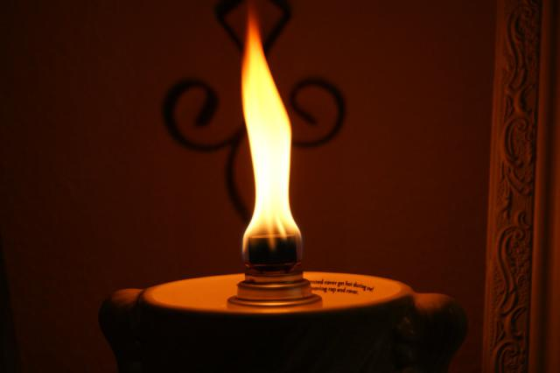

Chapter 27 continues a detailed account of the design and accoutrements of the Tabernacle – the place of abode of God with His people. There are three distinct areas described in this chapter:

- Altar of Burnt Offerings
- Court of the Tabernacle
- Oil for the Lamp

I realize the difficulty in understanding the terminology and symbols of these current chapters in Exodus, but God did not have them written to bore us, but for our enlightenment. Did I say ‘current’ chapters? Most certainly, I did, for every Word of Scripture is current throughout all time and Eternity. Those figures and symbols of Exodus are physical imageries that relate to more glorious spiritual truths in our day if we can but understand. If we seek and thirst for knowledge, the Good Lord will open our eyes to greater mysteries than our souls can contain. But we are not ‘welfare’ Christians; we must be laboring in the Word to study and understand if we desire the Bread of Heaven. “For even when we were with you, this we commanded you, that if any would not work, neither should he eat.” (2 Thess 3:10) This counsel applies as much to our souls as to our physical bodies.

Altar of Burnt Offerings
1 And thou shalt make an altar of shittim wood, five cubits long, and five cubits broad; the altar shall be foursquare: and the height thereof shall be three cubits. 2 And thou shalt make the horns of it upon the four corners thereof: his horns shall be of the same: and thou shalt overlay it with brass. 3 And thou shalt make his pans to receive his ashes, and his shovels, and his basons, and his fleshhooks, and his firepans: all the vessels thereof thou shalt make of brass. 4 And thou shalt make for it a grate of network of brass; and upon the net shalt thou make four brasen rings in the four corners thereof. 5 And thou shalt put it under the compass of the altar beneath, that the net may be even to the midst of the altar. 6 And thou shalt make staves for the altar, staves of shittim wood, and overlay them with brass. 7 And the staves shall be put into the rings, and the staves shall be upon the two sides of the altar, to bear it. 8 Hollow with boards shalt thou make it: as it was shewed thee in the mount, so shall they make it. (Ex 27:1-8)

This Altar of Burnt Offerings was the first piece of furniture that would confront one entering the open courtyard of the Tabernacle. It differs in several distinct particulars from the Altar of Incense before the Holy of Holies. Upon this Altar were the sacrifices of the people offered prior to further entrance into the Tabernacle. This Altar of Sacrifice was the prerequisite for further acceptance and worship by God. The consuming fire of God was ever present on this Altar and was provided with a firepan to hold that Fire of God when the Tabernacle was being moved about. The Fire of the Holy Spirit of God constantly burns, in the same way, in the hearts of all believers for whom the Eternal Sacrifice was made by our Lord Jesus Christ. Being covered by that sacrifice is the first order of business in the worship of God. The Altar of Incense before the Holy of Holies served a different purpose. The ascending smoke of the incense represented the prayers and petitions of God’s Chosen Elect up to Heaven. By the way: the horns of the altar were there for the purpose of securing the sin offering. If a man was charged with a grievous sin, he might flee to the horns of the Altar and, thus grasping them in contrition, be saved from the wrath to come. These four horns might remind us of the salvation Christ offers to nations and tribes from the four corners of the world. His mercy and salvation is available to all who flee to Him for Mercy!

Court of the Tabernacle
9 And thou shalt make the court of the tabernacle: for the south side southward there shall be hangings for the court of fine twined linen of an hundred cubits long for one side: 10 And the twenty pillars thereof and their twenty sockets shall be of brass; the hooks of the pillars and their fillets shall be of silver. 11 And likewise for the north side in length there shall be hangings of an hundred cubits long, and his twenty pillars and their twenty sockets of brass; the hooks of the pillars and their fillets of silver. 12 And for the breadth of the court on the west side shall be hangings of fifty cubits: their pillars ten, and their sockets ten. 13 And the breadth of the court on the east side eastward shall be fifty cubits. 14 The hangings of one side of the gate shall be fifteen cubits: their pillars three, and their sockets three. 15 And on the other side shall be hangings fifteen cubits: their pillars three, and their sockets three. 16 And for the gate of the court shall be an hanging of twenty cubits, of blue, and purple, and scarlet, and fine twined linen, wrought with needlework: and their pillars shall be four, and their sockets four. 17 All the pillars round about the court shall be filleted with silver; their hooks shall be of silver, and their sockets of brass. 18 The length of the court shall be an hundred cubits, and the breadth fifty every where, and the height five cubits of fine twined linen, and their sockets of brass. 19 All the vessels of the tabernacle in all the service thereof, and all the pins thereof, and all the pins of the court, shall be of brass. (Ex 27:9-19)

As one entered the first veil of the Tabernacle, he came into a rather large, open air enclosure containing, first of all, the Altar of Burnt Offerings; and secondly, the Brazen Laver at which the priests washed before entering the Holy Place. In our own day, we no longer need the intercession of a priest for the absolution of our sins, but rely upon our High Priest, the Lord Jesus Christ, for absolution. Therefore, we all have had the great sacrifice made on our behalf by the Lord Jesus Christ at the Altar of Burnt Offerings, and we now must approach the Brazen Laver individually. In the traditional Book of Common Prayer, the observance of this cleansing prior to reception of Holy Communion is performed by the people praying the Collect for Purity at the beginning of the Communion Service.

The court yard represents meaning for the Church today: “It was typical of the visible church of God on earth, which, though an enclosure, and is separated from the world, yet consists of professors, good and bad, of real saints and hypocrites; as into this court Israelites of every character, sex, and state entered. In David's time it was divided into various courts, and what answered to it when the temple was built were the several apartments called the courts of the priests, where they sacrificed, and the court of Israel, where the men Israelites worshipped, and the court of the women, where they were by themselves; and in later times there was another court separate from these, called the court of the Gentiles, into which they might enter” (Our good Baptist theologian, Dr. John Gill, 1697 – 1771)

The Court of the Tabernacle separated the child of God from the world without. Though we must live under the same open sky, we are separated by walls of mercy from the world and its evils.

The Oil for the Lamp
20 And thou shalt command the children of Israel, that they bring thee pure oil olive beaten for the light, to cause the lamp to burn always. 21 In the tabernacle of the congregation without the vail, which is before the testimony, Aaron and his sons shall order it from evening to morning before the LORD: it shall be a statute for ever unto their generations on the behalf of the children of Israel. (Ex 27:20-21)

Christ is a Forever-Burning Light to us. He never goes out. During the long night watches, He is the Bright and Morning Star. During the brilliant Light of Day, He is the Sun of Righteousness and the Day Star. His Light always illuminates before Him just as the Candlesticks of the Holy Place lit the place before the Ark of Testimony (representing Christ). How do we keep that Light of Christ burning always? By boldly going forth to teach and preach the Gospel to all the world, both by Word and Deed. 34 For where your treasure is, there will your heart be also. 35 Let your loins be girded about, and your lights burning; 36 And ye yourselves like unto men that wait for their lord, when he will return from the wedding; that when he cometh and knocketh, they may open unto him immediately. (Luke 12:34-36)

It is my prayer that each of us of faith will keep ready the oil of the Holy Ghost for our Lamps that our Lights might be burning when He comes.

