Exodus – Chapter 26 – The Tabernacle – 7 February 2015, Anno Domini (Year of our Lord)

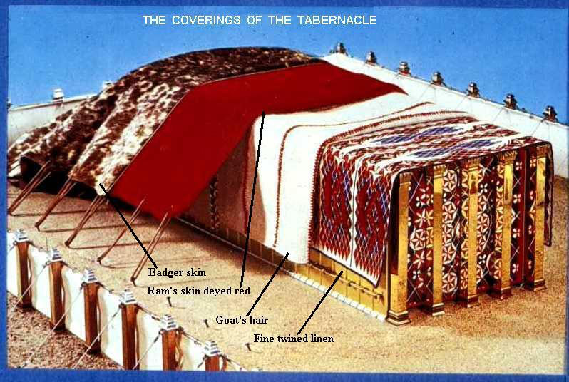

In these chapters of Exodus, much ado is made of numbers. God does, or says, nothing by happenstance. The numbers have symbolic meaning. For example, the number ‘three’ represents the divine and perfect number of God in the Trinity. One or two straight lines cannot construct an image – three lines are required. This reflects the Three-Dimensionality of the Triune God. Three dimensions are required to define any matter. The dimensions of God’ being infinite in all directions, pervades all time and space. Six is the number of man since he was created on the sixth day of Creation. The number seven represents divine completeness – seven days were required for the Creation. The study of numbers in the Scriptures is referred to as Numerology. The definition of numerology is: “Bible numerology is the study of individual numbers in Scripture. It relates particularly to the meaning of numbers, both literal and symbolic.” Much more can be made of numerology than the Scriptures provide, therefore, we will try to adhere only to those important symbols that are clearly defined in Scripture as we interpret the various numbers of items found in the Tabernacle. There have been definitive studies made by theologians of the past on numerology including that of EW Bullinger, descendant of the great Swiss reformer, Johann Bullinger.

1 Moreover thou shalt make the tabernacle with ten curtains of fine twined linen, and blue, and purple, and scarlet: with cherubims of cunning work shalt thou make them. 2 The length of one curtain shall be eight and twenty cubits, and the breadth of one curtain four cubits: and every one of the curtains shall have one measure. 3 The five curtains shall be coupled together one to another; and other five curtains shall be coupled one to another. 4 And thou shalt make loops of blue upon the edge of the one curtain from the selvedge in the coupling; and likewise shalt thou make in the uttermost edge of another curtain, in the coupling of the second. 5 Fifty loops shalt thou make in the one curtain, and fifty loops shalt thou make in the edge of the curtain that is in the coupling of the second; that the loops may take hold one of another. 6 And thou shalt make fifty taches of gold, and couple the curtains together with the taches: and it shall be one tabernacle. (Ex 26:1-6)

The number FIVE is generally conceded to represent the number of GRACE. Present and active during the Creation of the world was Father, Son, and Holy Ghost. Out of that Creation came the world, and its wholeness is referred to as four corners in scripture; therefore, according to Bullinger and others, the number four signifies the world. Man fell in the Garden and an act of Grace was required to lift him from his fallen state. The number five is God’s grace granted to fallen man. There were five curtains on either side of the Tabernacle signifying the covering of grace given to the people of God.

The number TEN may have special significance when we consider how the number is incorporated throughout scripture. Ten seems to signify divine order and perfection. Our number system is based on multiples of ten. Noah was ten generations removed from Adam, and Noah found grace in the eyes of the Lord. (Genesis 5:1-32). Shem was the father of the Semitic peoples (the same from which the Hebrews sprang). Abraham is tenth in his generations from Shem (son of Noah). There are Ten Commandments. (Ex 20:1-17) There were ten plagues executed against Egypt to free the Children of Israel. (Ex 7:14-12:40) There are ten virgins representing the Kingdom of Heaven in the parable of Jesus. (Matthew 25:1-13) There are many other references to the number ten as being significant, but I believe those just pointed out to be sufficient to inform us of that importance.

Of greater meaning to us than any possible significance of the numbers is the simplicity and symbology that the Tabernacle design has for us in understanding the provision of God for His people. Dispensing with the speculation on numerology, let us look at the simple beauty of the Tabernacle and its meaning. The Tabernacle manifested the abode of God with, and among, His people. Wherever they traveled, whether in plenty or scarcity, in the Wilderness, God was with them. God makes His presence among His people in ways that are most needful and understandable to them. As we live in the wilderness of this world, Christ comes to dwell as well in a tabernacle of flesh. Spiritually, our Lord still dwells in that tabernacle of flesh which is the heart of the believer.

7 And thou shalt make curtains of goats' hair to be a covering upon the tabernacle: eleven curtains shalt thou make. 8 The length of one curtain shall be thirty cubits, and the breadth of one curtain four cubits: and the eleven curtains shall be all of one measure. 9 And thou shalt couple five curtains by themselves, and six curtains by themselves, and shalt double the sixth curtain in the forefront of the tabernacle. 10 And thou shalt make fifty loops on the edge of the one curtain that is outmost in the coupling, and fifty loops in the edge of the curtain which coupleth the second. 11 And thou shalt make fifty taches of brass, and put the taches into the loops, and couple the tent together, that it may be one. 12 And the remnant that remaineth of the curtains of the tent, the half curtain that remaineth, shall hang over the backside of the tabernacle. 13 And a cubit on the one side, and a cubit on the other side of that which remaineth in the length of the curtains of the tent, it shall hang over the sides of the tabernacle on this side and on that side, to cover it. 14 And thou shalt make a covering for the tent of rams' skins dyed red, and a covering above of badgers' skins. (Ex 26:7-14) Not a great deal of thought is required to realize that these elaborate layers of curtains of goat’s hair would block out any light from the world. The light of the world is artificial, but the Light of God is Truth. So the Christian should blot out those false glimmers and gleams of the world’s false lights and keep his heart illumined by that Light of God within the Temple of God – which is the heart. The outward appearance of the tabernacle was rough and dark, but inside there was the Light of God. The true Church may appear as that impoverished Church of Smyrna, but that church was inwardly rich in the grace of God. (Rev 2:8-11)

Verses 15 thru 30 give detailed instruction for the construction of acacia wood boards overlaid with gold for the inner walls of the Tabernacle. You may wonder how a primitive people would have been handy at such engineering challenges; but, remember, the children of Israel were captives in Egypt for four hundred years. They worked with their hands in every art and craft required in the building of palaces, pyramids, and parapets. They knew how to BUILD things. God never gives us a greater task than we are capable of performing. Not only were the interior walls of the Tabernacle appealing for beauty, but the acacia wood fragrance was sweet and heavenly. Even perfumes today are made from that fragrance. The fragrance of the heart devoted to God should also emit a sweet fragrance and appeal to all who know it in beauty.

The curtain covering the entrance to the Holy of Holies made the entrance undiscoverable until the fullness of time arrived in which the curtain was rent from top to bottom at the death of Christ. 31 And thou shalt make a vail of blue, and purple, and scarlet, and fine twined linen of cunning work: with cherubims shall it be made: 32 And thou shalt hang it upon four pillars of shittim wood overlaid with gold: their hooks shall be of gold, upon the four sockets of silver. 33 And thou shalt hang up the vail under the taches, that thou mayest bring in thither within the vail the ark of the testimony: and the vail shall divide unto you between the holy place and the most holy. (Ex 26:31-33) Only the High Priest of the Temple was later privileged to enter, once each year (at Passover) the Holy of Holies.

The High Priest was our intermediary between God and the people of God. He still is …………. only our High Priest today is the Lord Jesus Christ! Our High Priest (Christ) is able to draw ever so closely with God the Father for He is of His same substance, being His only Begotten Son. He does not go annually into the Holy of Holies but rather ABIDES there. Seeing then that we have a great high priest, that is passed into the heavens, Jesus the Son of God, let us hold fast our profession. For we have not an high priest which cannot be touched with the feeling of our infirmities; but was in all points tempted like as we are, yet without sin. Let us therefore come boldly unto the throne of grace, that we may obtain mercy, and find grace to help in time of need. (Heb 4:14-16) So also Christ glorified not himself to be made an high priest; but he that said unto him, Thou art my Son, to day have I begotten thee. As he saith also in another place, Thou art a priest for ever after the order of Melchisedec. Who in the days of his flesh, when he had offered up prayers and supplications with strong crying and tears unto him that was able to save him from death, and was heard in that he feared; Though he were a Son, yet learned he obedience by the things which he suffered; And being made perfect, he became the author of eternal salvation unto all them that obey him; Called of God an high priest after the order of Melchisedec. (Heb 5:5-10)
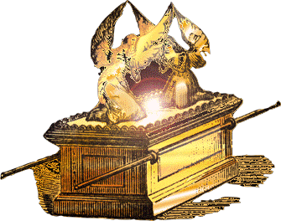

And thou shalt put the mercy seat upon the ark of the testimony in the most holy place. (Ex 26:34) The Mercy Seat is the Rest we have in Christ prefigured here. He is the Foundation (Ark) of that Mercy Seat.

And thou shalt set the table without the vail, and the candlestick over against the table on the side of the tabernacle toward the south: and thou shalt put the table on the north side. (Ex 26:35) The Lord’s Table was to be placed outside the Vail of the Holy of Holies on the north side (side of God) and the candelabra was placed on the south side. The high priest, in approaching the Holy of Holies went between the Lord’s Table with the Bread of Heaven (symbolically, Christ) and the Candle Sticks representing Christ (also) as the Light of the World. The seven Candles, you will recall, represent the seven churches and their angels.

There were two veils to the Tabernacle, the Outer Veil which was the entrance, and the Inner Veil which concealed the Holy of Holies. 36 And thou shalt make an hanging for the door of the tent, of blue, and purple, and scarlet, and fine twined linen, wrought with needlework. 37 And thou shalt make for the hanging five pillars of shittim wood, and overlay them with gold, and their hooks shall be of gold: and thou shalt cast five sockets of brass for them. (Ex 26:36-37) All things, in God’s plan, are made in order and the labors are fairly divided. The men did the heavy lifting, and the women did the fine needlework for the curtains. In the Temple of God, there are many varied stones. But every stone is vitally important since God is a stickler for detail. Somewhere in the Temple of God, there is a “you-shaped” void which only your stone can fill. He will have each one that He has chosen and called for His purpose. Have you discovered that calling in Christ?

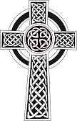

Taches are hooks or fasteners
Shittim Wood, today called Acacia or in Hawaii Koa. Acacia seyal is thought to be the shittah-tree of the Bible, which supplied shittim-wood. According to the Book of Exodus, this was used in the construction of the Ark of the Covenant.

