Exodus – Chapter 25 – Part Two – Furnishing the Altar – 6 February 2015, Anno Domini (Year of our Lord)

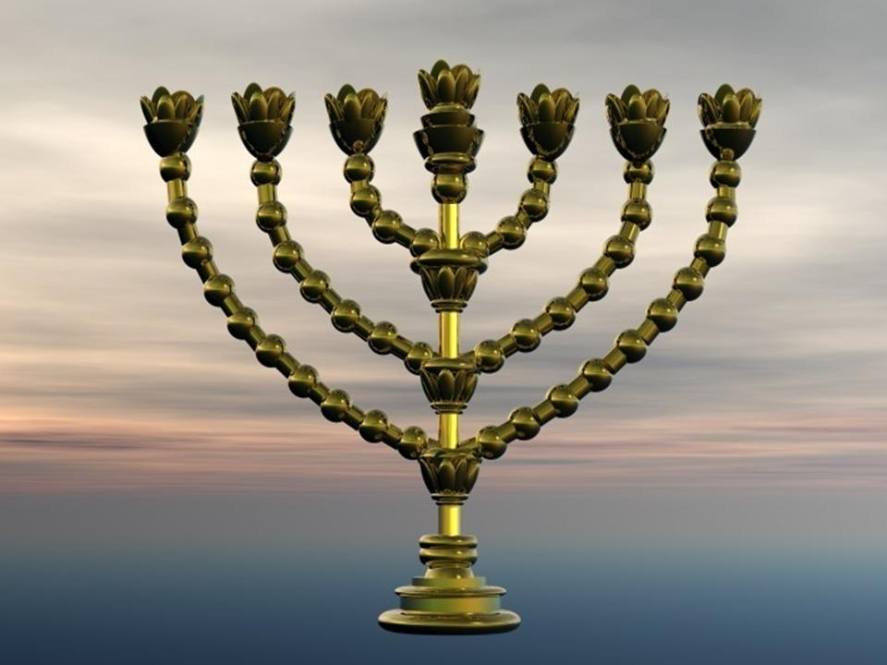

And thou shalt make a candlestick of pure gold: of beaten work shall the candlestick be made: his shaft, and his branches, his bowls, his knops, and his flowers, shall be of the same.

Go ye therefore, and teach all nations, baptizing them in the name of the Father, and of the Son, and of the Holy Ghost: Teaching them to observe all things whatsoever I have commanded you: and, lo, I am with you alway, even unto the end of the world. Amen. (Matt 28:19-20)

In a day when instant gratification and well-meaning count more than absolute obedience and exactly following instruction, it is difficult to convey the importance of doing things exactly God’s way without any admixture of our own volition and opinion. We are satisfied if we can understand the Gospel ‘approximately’ and will not study the Word to show our selves approved. “Study to shew thyself approved unto God, a workman that needeth not to be ashamed, rightly dividing the word of truth.” (2 Tim 2:15) We have become spoiled by a multiple-choice world that requires no subjective response to challenges. But before we become the kind of teacher to which Christ refers in our opening verse above, we must become masters of all that Christ taught – that is, “all things whatsoever I have commanded you” - not MOST things, or SOME things, but ALL things.

The English Reformers were very diligent in replicating the form of worship of the ancient Church Fathers. Those elaborate and superstitious practices of the Roman Church were rejected in favor of a restoration of the ancient forms practiced by the apostles. If we closely observe formal Anglican Worship – and by that I mean precise worship in accord with the traditional Book of Common Prayer – you will find a biblical basis for each and every rubric. Such worship conforms closely to the Thirty Nine Articles of Religion and ads no fantasy of man to its form. As we continue to examine this chapter of Exodus, we will gain some insightful understanding of the manner in which primitive Christian worship was conducted.

23 Thou shalt also make a table of shittim wood: two cubits shall be the length thereof, and a cubit the breadth thereof, and a cubit and a half the height thereof. (Ex 25:23) This Table will be consistent with the Lord’s Table of the Holy Communion in the traditional Anglican Church. It was not excessively large or high. It was approximately one yard wide, 25 inches high, and a half yard deep. In order to emphasize the dignity and reverence due this Table, it was overlaid and trimmed in precious gold. All who worship God should do so in dignity and reverence of His Holiness. He does not expect a poor man to wear a silk suit to church, but He does expect him to wear clean garments of his Sunday’s best. The Lord’s Table was to be treated with the same care as the Ark; i.e. it was not to be carried about by human hands, but by the staves and rings attached thereto.

29 And thou shalt make the dishes thereof, and spoons thereof, and covers thereof, and bowls thereof, to cover withal: of pure gold shalt thou make them. 30 And thou shalt set upon the table shewbread before me alway. (Ex 25:29-30) These vessels on the Table comport with those of the Altar service used in our worship services. The Shewbread was the unleavened Bread of the Communion Service we observe. It stands for God’s constant Communion with His people, and the Bread was always on the Table to signify a constant feeding, by His Word, of His people. In the process of time, we learned that the Shewbread represents the Body of our Lord sacrificed for us from before the foundation of the world. The Table was position centrally in the Tabernacle just as the Lord’s Table – not the pulpit – is centered in the forward most area of the sanctuary.

Why do we provide candles on the Lord’s Table? Because, like in the Temple and Tabernacle, those candles represent the Light of God’s Word. In our reformed tradition, the candle on the right side (facing outward) represents the Light of the Gospel of Jesus Christ; the candle on the left represents the Light of the Gospel as preached by the Apostles. I once had a good and biblically centered Baptist minister accuse me of being Roman Catholic. When I asked him why, he responded that we had a cross and candles on our ‘altar.’ I responded that we did not have an altar as the Baptist and Romans had – it is the Lord’s Table; and the cross was a symbol of what Christ had done for us (the same which he displayed on the steeple of his Baptist church). I described the meaning of the candles and reminded him of the descriptive words of Christ in Revelations of St. John: I saw seven golden candlesticks; And in the midst of the seven candlesticks one like unto the Son of man, clothed with a garment down to the foot, and girt about the paps with a golden girdle. (Rev 1:12-13) 20 The mystery of the seven stars which thou sawest in my right hand, and the seven golden candlesticks. The seven stars are the angels of the seven churches: and the seven candlesticks which thou sawest are the seven churches. (Rev 1:20) Remember therefore from whence thou art fallen, and repent, and do the first works; or else I will come unto thee quickly, and will remove thy candlestick out of his place, except thou repent. (Rev 2:5) I then very lovingly pointed out to my Baptist brother that our Anglican Church still possessed HER candles. I do not know what happened to his.

31 And thou shalt make a candlestick of pure gold: of beaten work shall the candlestick be made: his shaft, and his branches, his bowls, his knops, and his flowers, shall be of the same. (Ex 25:31) All was to be hammered out by hand. The flowers, too, were made of gold. Today, we may be disposed to place flowers on the Lord’s Table, or above it, but God had no dead thing on His Table, and cut flowers are dead.

32 And six branches shall come out of the sides of it; three branches of the candlestick out of the one side, and three branches of the candlestick out of the other side: 33 Three bowls made like unto almonds, with a knop and a flower in one branch; and three bowls made like almonds in the other branch, with a knop and a flower: so in the six branches that come out of the candlestick. (Ex 25:32-33) Please note the meticulous detail God demands. He desire absolute correctness in our worship – not bringing in fables of men, but of His Word alone. The three branches on each side constituted six candlesicks in addition to the central candle – a total of SEVEN representing the perfection and completeness of God and His Seven Fold Truth.

God leaves nothing to our imagination in the precise design of his implements of worship in the Tabernacle. 37 And thou shalt make the seven lamps thereof: and they shall light the lamps thereof, that they may give light over against it. 38 And the tongs thereof, and the snuffdishes thereof, shall be of pure gold. 39 Of a talent of pure gold shall he make it, with all these vessels. (Ex 25:37-39) These lamps are similar to our Lord’s Table candle lighters used by acolytes to both light and extinguish the candles. Purity in the precious gold represents the purity of God’s Word.

The candlelabra of the Tabernacle represents the Light of God shining in a dark place for such a place was the Tabernacle – intentionally so to more fully represent the darkness of the world in need of that Light of God. We have also a more sure word of prophecy; whereunto ye do well that ye take heed, as unto a light that shineth in a dark place, until the day dawn, and the day star arise in your hearts. (2 Peter 1:19) Of course, this heralds the coming in the Brightness of the Sun of our Lord Jesus Christ!

The last verse in this chapter is a firm warning to Moses, and to us: 40 And look that thou make them after their pattern, which was shewed thee in the mount. (Ex 25:40) Be sure, Moses, to make these articles precisely as described to you on Mount Sinai. No human innovation in worship is acceptable. It is likely that the Apostle Paul was mindful of this particular warning when he said: Hold fast the form of sound words, which thou hast heard of me, in faith and love which is in Christ Jesus. (2 Tim 1:13) Do not ameliorate the Words of God with those of men. Those Words are Holy and precise. The Tabernacle was a foreshadowing of the Church of God whose strong foundation and Chief Cornerstone is the Lord Jesus Christ. And are built upon the foundation of the apostles and prophets, Jesus Christ himself being the chief corner stone; In whom all the building fitly framed together groweth unto an holy temple in the Lord: In whom ye also are builded together for an habitation of God through the Spirit. (Eph 2:20-22)

It is my prayer that we will remember to keep Holy our worship of the Lord and attend our worship service with the reverence and dignity due His Holy Name.

