Exodus – Chapter 25 – Part One – Civil and Statutory Laws – 5 February 2015, Anno Domini (Year of our Lord)

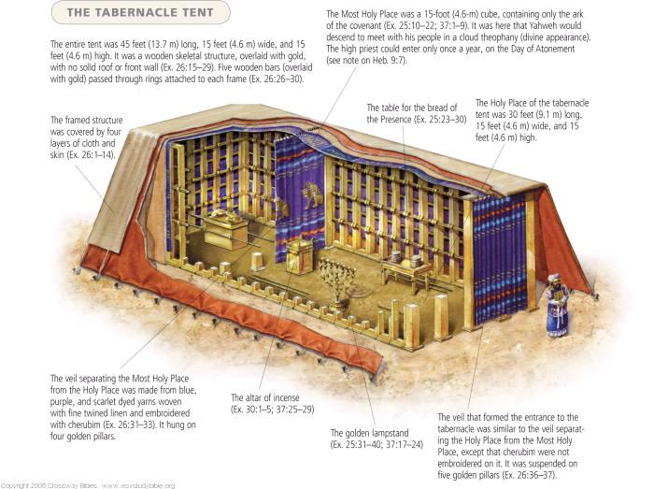

And the LORD spake unto Moses, saying, Speak unto the children of Israel, that they bring me an offering: of every man that giveth it willingly with his heart ye shall take my offering. (Ex 25:1-2)

Offerings willingly given are the only ones that please the heart of God. If tithes, or offerings, are given out of a sense of obligation instead of charity, it comes from the mind and not the heart. Burdensome tithes that the giver feels constrained by law to give are no different than taxes paid to a government. We all know that when the government forces her citizens to pay taxes in order to distribute that wealth to others who have no labored for that wealth is not charity, but coercion. The heart is the depository of one’s love and generosity – not a sense of reason or constraint conceived in the minds of men.

If God is our Father and our God, the proper place for Him to live is among us. After all, our hearts are the very Temple of God. “Know ye not that ye are the temple of God, and that the Spirit of God dwelleth in you? If any man defile the temple of God, him shall God destroy; for the temple of God is holy, which temple ye are.” (1 Cor 3:16-17) God does not barge in where He is not welcomed, but to those who are His chosen and elect, He dwells with them always. Christ did not come as a visitor, but rather to ABIDE with us. He is therefore called ‘Immanuel” (God with us) in Isaiah 7:14 and Matt 1:23 among others. We are made members of the family of God by way of adoption and are, therefore, to live together with our Father and Lord. Upon pointing the way of Holiness in obedience to His Law, God now deigns to live among His people: “Make me a sanctuary; that I may dwell among them.” (Ex 25:8) God could have easily dwelled in the splendor of the thundering cloud atop Sinai, but that is not close enough. He wants to live in the midst of His people – of you and me. “Where two or three are gathered together in my Name, there I am in the midst of them.” (Matt 18:20). It is that Presence that we observe in the Communion of the Lord’s Supper.

Make Me a Sanctuary

This word, Sanctuary, means a Holy Place. Wherever God dwells is Holy above all else. I believe it to be remarkable that God allows His little children (you and me) to have a part in making a place for Him. Had He desired, He could have spoken the Word and He would have had an opulent palace in which to dwell; but His children are in the Wilderness, and He, too, will abide in the Wilderness with them. And this is the offering which ye shall take of them; gold, and silver, and brass, And blue, and purple, and scarlet, and fine linen, and goats' hair, And rams' skins dyed red, and badgers' skins, and shittim wood, Oil for the light, spices for anointing oil, and for sweet incense, Onyx stones, and stones to be set in the ephod, and in the breastplate. (Ex 25:3-7) God gives us great blessings of mercy and riches; however, He expects His people to give the best they have in their service to Him and others – not our left-overs.

This sanctuary will become the Wilderness Tabernacle. God gives detailed plans for its construction and every vessel and furniture that it will contain. According to all that I shew thee, after the pattern of the tabernacle, and the pattern of all the instruments thereof, even so shall ye make it. (Ex 25:9)

The Ark of the Tabernacle

God gives elaborate detail on the construction of an Ark and precisely of what that Ark shall be constructed, and contain. Before studying this profound piece of furniture, let us discuss that which is not revealed at first regarding the Ark which was to occupy the Holy of Holies (the place of God) the Veil. We may read of this in the next chapter (26:31) and will discuss then in greater detail; but it is important for us to look ahead a bit in order to grasp the profundity of the Ark, the Holy of Holies, and the Veil. The Veil was to cover the entrance of the Holy of Holies where the Ark would reside. It blocked all view of the Presence of God symbolized by the Ark. Only the High Priest was privileged to enter there once a year at Passover. It was designed to be a dark sign of the inability of the people, in their unholy sins, to approach near to God. This Veil was later installed on in the Temple with the same function. It is the same Veil that was torn from top to bottom at the moment of Christ’s full sacrifice. Jesus, when he had cried again with a loud voice, yielded up the ghost. And, behold, the veil of the temple was rent in twain from the top to the bottom; and the earth did quake, and the rocks rent. (Matt 27:50-51)

Because, before the Redemption of Christ, we could not approach God except through an intermediary, the death of Christ on the cross opened the door of Heaven to all who dare approach the Throne of Grace and Mercy. No longer was there a curtain to preclude man’s approach to God. The Veil was torn top to bottom because the rent had to be made by God on High and not man (who had no power to do so). This is a beautiful and intriguing truth of Scripture which we will later explore further. It is for this reason that the priests in reformed Anglicanism does not have authority to grant absolution to sinners – only God has that prerogative. So the priest may only pronounce that absolution according to God’s stated intention to absolve all who truly repent.

Another interesting point to be raised here is that the Ark (Holy of Holies) which also relates to Anglican worship is the fact that the Holy of Holies (place of God) occupied the central focus of the Tabernacle. It is for this reason that the pulpit is removed to the right side (facing outward) and the Lord’s Table is centrally positioned for the serving of the Bread (manna) and Wine of the Communion. It is not because, as many moderns teach, that the Sacrament of Holy Communion is consider central to all worship – it is the honored place of God in the midst of His people.

Please observe the particular care of both construction and handling that was to be evinced in the reverence paid to the Ark. And they shall make an ark of shittim wood: two cubits and a half shall be the length thereof, and a cubit and a half the breadth thereof, and a cubit and a half the height thereof. And thou shalt overlay it with pure gold, within and without shalt thou overlay it, and shalt make upon it a crown of gold round about. And thou shalt cast four rings of gold for it, and put them in the four corners thereof; and two rings shall be in the one side of it, and two rings in the other side of it. And thou shalt make staves of shittim wood, and overlay them with gold. And thou shalt put the staves into the rings by the sides of the ark, that the ark may be borne with them. The staves shall be in the rings of the ark: they shall not be taken from it. (Ex 25:10-15) The Ark was not to be handled by human hands, therefore the rings and staves were to remain in place always.

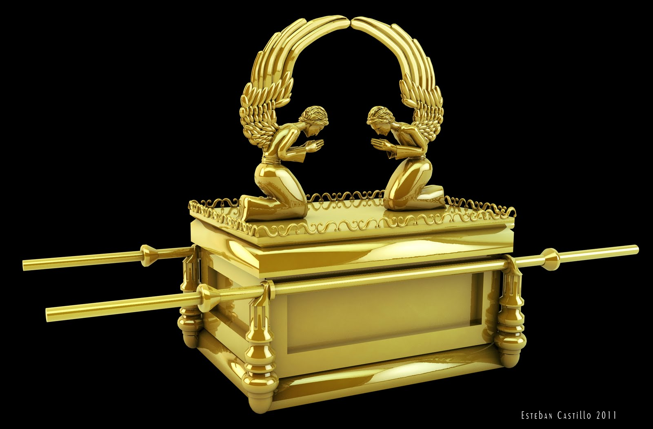

And thou shalt put into the ark the testimony which I shall give thee. And thou shalt make a mercy seat of pure gold: two cubits and a half shall be the length thereof, and a cubit and a half the breadth thereof. (Ex 25:16-17) The Ark was to be the legal depository for the Covenant and testimony God gave His people. It would contain other symbols as well as we will read later. But above the written Law was always hovering the Mercy Seat. If there were no constraining Law, there would be no need of Mercy. What, after all, is sin? It is the transgression of the Law of God. “. . . for sin is the transgression of the law.” (1 John 3:4) If the Law of God had been made null and void, there would be no sin to confess or repent of.

18 And thou shalt make two cherubims of gold, of beaten work shalt thou make them, in the two ends of the mercy seat. 19 And make one cherub on the one end, and the other cherub on the other end: even of the mercy seat shall ye make the cherubims on the two ends thereof. 20 And the cherubims shall stretch forth their wings on high, covering the mercy seat with their wings, and their faces shall look one to another; toward the mercy seat shall the faces of the cherubims be. 21 And thou shalt put the mercy seat above upon the ark; and in the ark thou shalt put the testimony that I shall give thee. (Ex 25:18-21) I believe this physical example of the Tabernacle reflects precisely the same figures and design of the Throne of God in Heaven. The Mercy Seat is above the Ark containing the Law because Mercy trumps Law.

It is in the Holy of Holies that the Lord will meet with Moses, and succeeding High Priests, to deliver His counsel to His people – until the sacrifice of the Lord Jesus Christ (before mentioned). “And there I will meet with thee, and I will commune with thee from above the mercy seat, from between the two cherubims which are upon the ark of the testimony, of all things which I will give thee in commandment unto the children of Israel.” (Ex 25:22) Is it possible for those of us of the modern church to comprehend the fullness of privilege with which we have been blessed by the redemption of Christ? No longer must we anxiously wait beyond the courtyard to learn the will and Word of God. We now have the privilege to approach the Holy of Holies individually and plead our case to God rather than going through an intermediary. Hopefully, we will make that appearance before God and the Mercy Seat in our prayers daily to such an August Sovereign as we have in our Lord Jesus Christ.
