Exodus – Chapter 24 – Civil and Statutory Laws – 4 February 2015, Anno Domini (Year of our Lord)

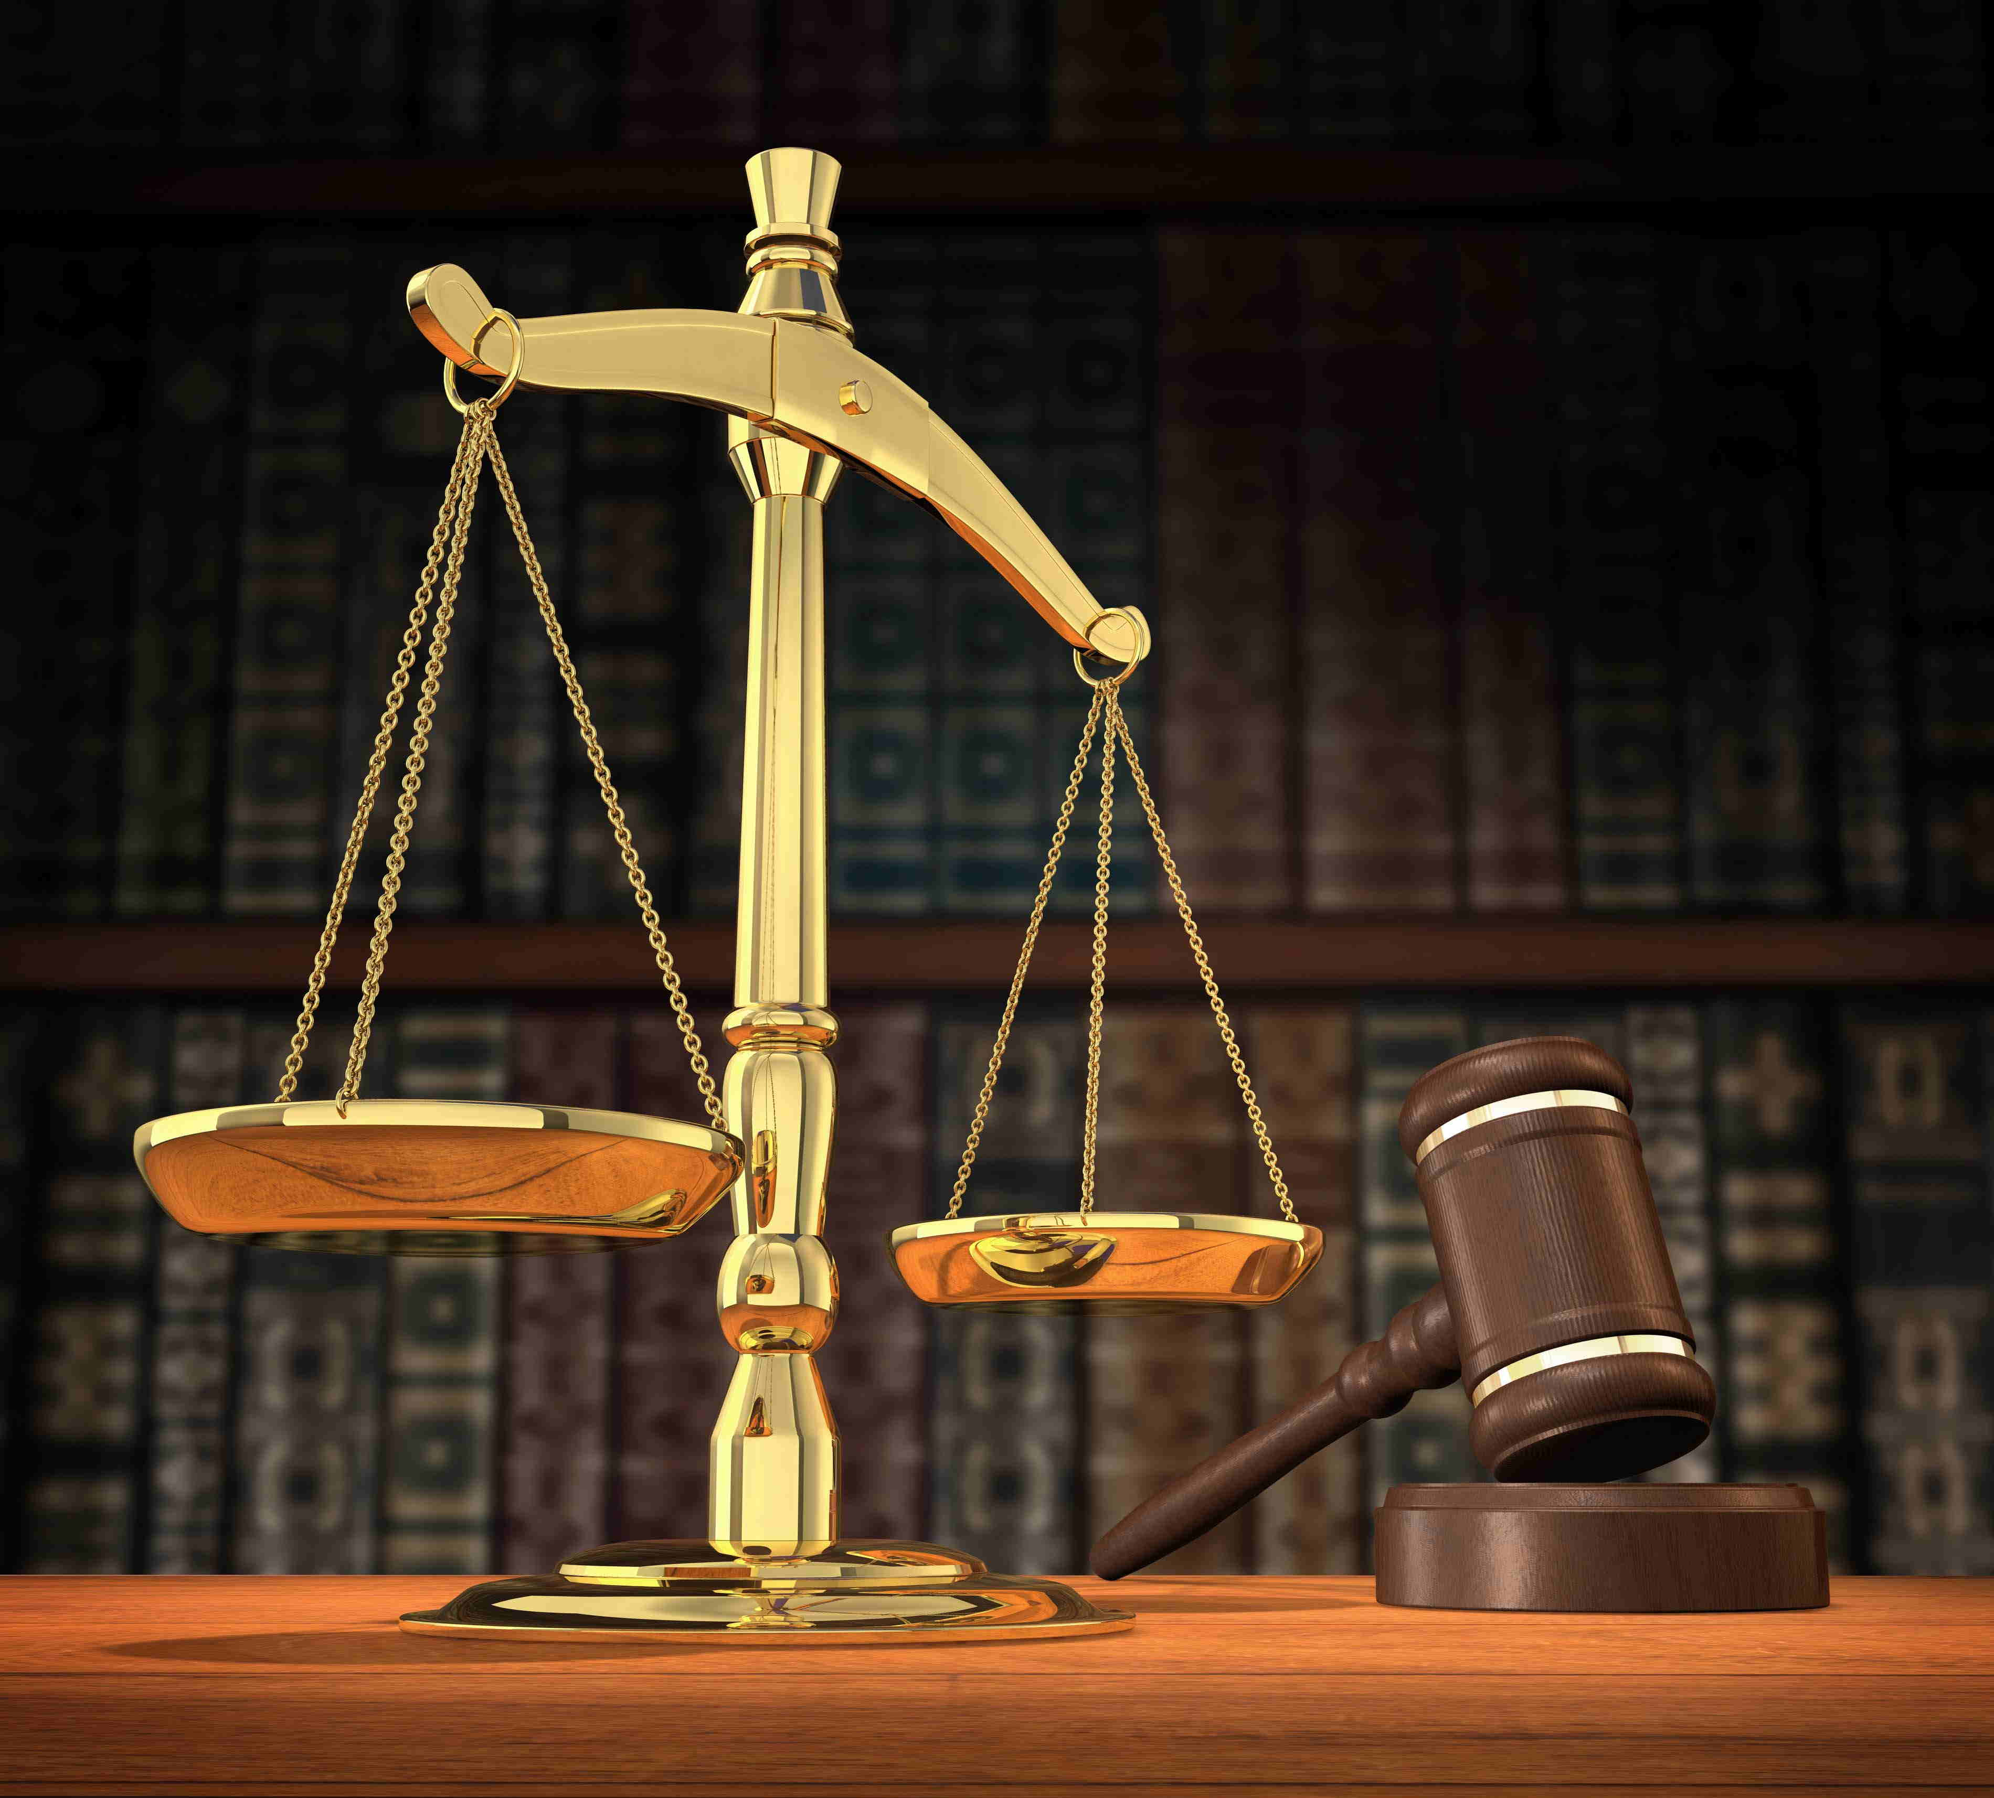

And he took the book of the covenant, and read in the audience of the people: and they said, All that the LORD hath said will we do, and be obedient. And Moses took the blood, and sprinkled it on the people, and said, Behold the blood of the covenant, which the LORD hath made with you concerning all these words. (Ex 24:7-8)

The Children of Israel were sprinkled by the blood of the covenant in the Wilderness as a prophetic reflection of that Blood of the Covenant wherewith the Altar and the Children of God would be sprinkled in the same manner in the New Testament Covenant. A covenant is not in force unless both parties enter therein. This is an early example of baptism as a sign of covenant relationship in the Church. The blood sprinkled on the Altar signified the covenant on God’s part to lead, defend, and save the Children of Israel. Conversely, the sprinkling of blood on the people signified their responsibility to love, obey, and honor God. The sprinkling of Blood for the Church of today occurred at Calvary when that Fountain of Saving Blood was opened for us. Our baptism into the Church occurs when we, with a true and contrite heart, make a public demonstration of our faith by baptism into the Church.

It is noteworthy to mention, And Moses wrote all the words of the LORD. (Ex 24:4) A written contract is far more enforceable than a verbal one since it allows for no ambiguities. The Written Word of God has much more impact on our hearts than to hear them spoken since we can read for comprehension and even gage our speed of learning in our reading. It is a permanent and immutable record of the thoughts of God toward us. For the word of the LORD is right; and all his works are done in truth. He loveth righteousness and judgment: the earth is full of the goodness of the LORD. By the word of the LORD were the heavens made; and all the host of them by the breath of his mouth. (Psalms 33:4-6)

God appears in His glory to Moses and His ministers: Then went up Moses, and Aaron, Nadab, and Abihu, and seventy of the elders of Israel: And they saw the God of Israel: and there was under his feet as it were a paved work of a sapphire stone, and as it were the body of heaven in his clearness. And upon the nobles of the children of Israel he laid not his hand: also they saw God, and did eat and drink. (Ex 24:9-11)

Not only did Moses write down, as a scribe, every Word the Lord had spoken regarding the covenant, God Himself will write His Laws on Tables of Stone: And the LORD said unto Moses, Come up to me into the mount, and be there: and I will give thee tables of stone, and a law, and commandments which I have written; that thou mayest teach them. (Ex 24:12) There was episcopal order to the calling of Moses to meet with God. Though the people who were still of infantile understanding were not called into God’s presence, the Seventy Elders were allowed to accompany Moses up to a point, but were counseled to remain in worship afar off. And he said unto the elders, Tarry ye here for us, until we come again unto you: and, behold, Aaron and Hur are with you: if any man have any matters to do, let him come unto them. (Ex 24:14)

We now read of the astonishing majesty of the Lord as He appeared to Moses and Joshua: And Moses went up into the mount, and a cloud covered the mount. And the glory of the LORD abode upon mount Sinai, and the cloud covered it six days: and the seventh day he called unto Moses out of the midst of the cloud. And the sight of the glory of the LORD was like devouring fire on the top of the mount in the eyes of the children of Israel. And Moses went into the midst of the cloud, and gat him up into the mount: and Moses was in the mount forty days and forty nights. (Ex 24:15-18)

The brilliant countenance of God was shrouded in the cloud atop Sinai. It is not likely that Moses could have lived had he seen the full radiance of God with his bare eyes, so God is shrouded in the cloud. The six days of preparation is akin to the six days of Creation. God waits those six days before calling to Moses out of the cloud. Even with the veil of cloud surrounding His Person, God appears as a devouring fire to the Children of Israel standing afar off. His glory can penetrate the fog of doubt and fear that may be precluding those who desire His salvation. You will remember another cloud in which the Lord Jesus was shrouded on the Mount of Transfiguration. (Matt 17:2) Moses was present in THAT cloud as well.

At this point, I believe it appropriate for a further discussion of that Transfiguration event in the New Testament. You will recall that Moses, Elijah, and the Lord Jesus Christ at first appeared together to the disciples. The bodies of Elijah and Moses were clearly discernible as to their true identities. Of what significance is this? Moses died on Mount Nabal and God buried him there. Elijah did not suffer death but was translated. But the point here is that saints, whether translated directly to heaven at the last day, or resurrected at that time, will appear in their bodies that are discernible to us.

God was in the Cloud at Sinai, and God (the Lord Jesus Christ) was in the Cloud at the Mt. of Transfiguration. God is demonstrating His consistent plan of salvation in that Cloud of Sinai and Mt. of Transfiguration. Salvation began at Sinai and the giving of the Law. The Law could not save, but could bring its hearer to conviction of sin and repentance. The Law was represented by Moses in the Cloud atop the Mount of Transfiguration. The satisfaction for the terms of the Law which we were not able to perfectly keep is represented in the Person of Jesus Christ. His appearance was also gleaming white in brilliant Light as was His Father’s atop Sinai in the cloud.

“Forty Days and Forty Nights” were required for Moses to understand all of the implications, given by God, of the Law and its import. “Forty Days and Forty Nights” were required for the judgment of God to rain upon the earth during the days of Noah. “Forty Days and Forty Nights” was the time allotted for Christ to endure deprivation, temptation, and thirst in the Wilderness in preparing for the sacrifice that would open the doors of Heaven for all who would believe and trust in that satisfaction made for our sins in breaking God’s Law. Do you see that Scarlett Thread that runs through all time from Genesis 3 to Revelations – the Blood Line of Christ who purchased us with His life’s blood at Calvary? Do you know Him to be your Savior? If not, is it not high time to make that salvation sure?

