Exodus – Chapter 20 – Part Seven (The Seventh Commandment) - 21 January 2015, Anno Domini (Year of our Lord)
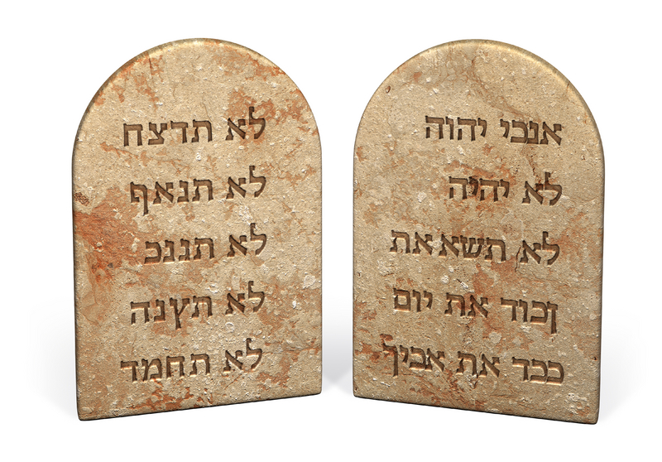
Thou shalt not commit adultery. (Ex 20:14)

For of old time I have broken thy yoke, and burst thy bands; and thou saidst, I will not transgress; when upon every high hill and under every green tree thou wanderest, playing the harlot. (Jer 2:20)

Have you considered how closely related to the First Commandment is the Seventh? Carnal adultery is very much akin to spiritual idolatry, and the Lord often uses the carnal nature of adultery to describe the spiritual sin of turning to other gods beside God Almighty. Man struggles to remain faithful to God but his eyes are easily turned away to the idols of gold, silver, flesh, and power of the world. He has not dedicated his whole heart to His God, and the demons hide away in the dark corners thereof. In fact, God does not own the heart that He does not own wholly. There can be no space in the heart, which is the Temple of God, for God AND the demons and idols of the flesh.

In the above quoted verse from Jeremiah 2:20, God is making reference to spiritual idolatry when he names His apostate people as harlots. They play the harlot “upon every green hill and under every green tree.” This is demonstrated in the following: “Ye shall utterly destroy all the places, wherein the nations which ye shall possess served their gods, upon the high mountains, and upon the hills, and under every green tree: And ye shall overthrow their altars.” (Deut 12:2-3) and “My people ask counsel at their stocks, and their staff declareth unto them: for the spirit of whoredoms hath caused them to err, and they have gone a whoring from under their God. 13 They sacrifice upon the tops of the mountains, and burn incense upon the hills, under oaks and poplars and elms, because the shadow thereof is good: therefore your daughters shall commit whoredom, and your spouses shall commit adultery.” (Hosea 4:12-13) This application to lewdness and whoredom is also reflected in that great church of the last days (the Woman who Rides the Beast) in Revelation 17. The modern church of today seems to be very much like that Woman. She has sold herself to the world, and brought all of the ravishing delights of the world into her chambers.

In recognizing God’s figurative use of adulterous intent to reflect spiritual truths, we must, at the same time, recognize the absolutes intended of carnal adultery that God forbids. The family is the hearthstone and anchor of society and the Church. Without strong families, nations will perish. The model set forth in Genesis is that which God intended forever since it is a model of Christ and His Church. Marriage is the only proper venue for sexual gratification. All sex outside the bonds of marriage is fornication and adultery. God created one man and one woman as the basis for that marriage model. Any other form of marriage relationship is abomination in the eyes of the Lord. The great America, Noah Webster, wrote: “All carnal intercourse between the sexes, except in lawful marriage is forbidden. The evils that proceed from a violation of God's law on this subject, are unspeakably great. The injuries to health, the dissipation of property, the ruin of female character, the destruction of family happiness, and the abandonment of all moral and religious principle, with the final loss of the soul, are among the woeful consequences of this wickedness. The institution of marriage was intended to prevent a promiscuous intercourse of sexes, which sinks men to brutes; also to preserve chastity, and to foster all the kind and tender affections that contribute to bind society together, prevent broils, jealousy and hatred, and unite mankind in harmony and peace. The man that disturbs the peace of a family by leading astray one of its members, incurs guilt next to that of murder. The restraints laid upon mankind by the law of God, in this particular, are essential to human happiness.”

Adultery is such a serious sin that our Lord placed it BEFORE the Sixth Commandment in Mark 10:19 – “Thou knowest the commandments, Do not commit adultery, Do not kill.” (Mark 10:19) Fidelity in the marriage union is the second duty we owe our neighbor. Conjugal honor is more important to a man than his own life. According to God’s Holy Institution, man and woman become one flesh in the marriage bond. (Gen 2:24). The Lord equates desire (even that not acted upon) with the same seriousness as the overt act. To hate is to kill - (Matt 5:21-26). The same is true for adultery because it is so closely related to spiritual idolatry. “Ye have heard that it was said by them of old time, Thou shalt not commit adultery: But I say unto you, That whosoever looketh on a woman to lust after her hath committed adultery with her already in his heart. And if thy right eye offend thee, pluck it out, and cast it from thee: for it is profitable for thee that one of thy members should perish, and not that thy whole body should be cast into hell. And if thy right hand offend thee, cut it off, and cast it from thee: for it is profitable for thee that one of thy members should perish, and not that thy whole body should be cast into hell. It hath been said, Whosoever shall put away his wife, let him give her a writing of divorcement: But I say unto you, That whosoever shall put away his wife, saving for the cause of fornication, causeth her to commit adultery: and whosoever shall marry her that is divorced committeth adultery.” (Matt 5:27-32) So, like idolatry, we find that murder and adultery can be committed spiritually even if not physically.

Chastity is, according to modern fashion, passé. But the Moral Law of God considers the violation of chastity, except in the bonds of marriage, as a sin comparable with murder. God does not rest His Law and Will on the whims of popular fashion. His Law is fixed and immutable!

The adulterous man or woman is not satisfied with the Law of the Holiness of Marriage laid down by God. They have wandering eyes and lusts that they seek to satisfy – either in their imaginations, or in their physical beings. God Almighty, being an avid Reader (of the thoughts of the heart), is not deceived by our thoughts or hidden actions. No thought is hidden, and every line of your life is written. As the great Omar Khayyam writes in his classic poem, the Rubaiyat:

LXX
The Ball no question makes of Ayes and Noes,
But Here or There as strikes the Player goes;
And He that toss'd you down into the Field,
He knows about it all--He knows--HE knows!

LXXI
The Moving Finger writes; and, having writ,
Moves on: nor all your Piety nor Wit
Shall lure it back to cancel half a Line,
Nor all your Tears wash out a Word of it.

While it is true that all of our evil and wicked deeds are matters of historical fact, there is One who can call the pencil of our soul back to cancel out the guilt of our past sins – that would be the Finger of God who writes with one end of the pencil, and erases repented sins with the other.

There is no sin beyond the arm of God to forgive and remit. The blood of our Lord Jesus Christ is sufficient to cover all sin. But we must be drawn as in the great net of the fisherman to the shore where God’s Holy Angels will separate the good from the bad fish.

Here are two passages upon which to hang our hearts and our hopes:

Come unto me, all ye that labour and are heavy laden, and I will give you rest. 29 Take my yoke upon you, and learn of me; for I am meek and lowly in heart: and ye shall find rest unto your souls. 30 For my yoke is easy, and my burden is light. (Matt 11:28-30)

All that the Father giveth me shall come to me; and him that cometh to me I will in no wise cast out. For I came down from heaven, not to do mine own will, but the will of him that sent me. And this is the Father's will which hath sent me, that of all which he hath given me I should lose nothing, but should raise it up again at the last day. And this is the will of him that sent me, that every one which seeth the Son, and believeth on him, may have everlasting life: and I will raise him up at the last day. (John 6:37-40)

The great lesson of the SEventh Commandment is “to love the Lord thy God with all they heart, with all thy strength, and with all they mind;” and the second is like unto it, “To love thy neighbor (including spouse) as thyself!”

