Exodus – Chapter 20 – Part Six (The Sixth Commandment) - 16 January 2015, Anno Domini (Year of our Lord)
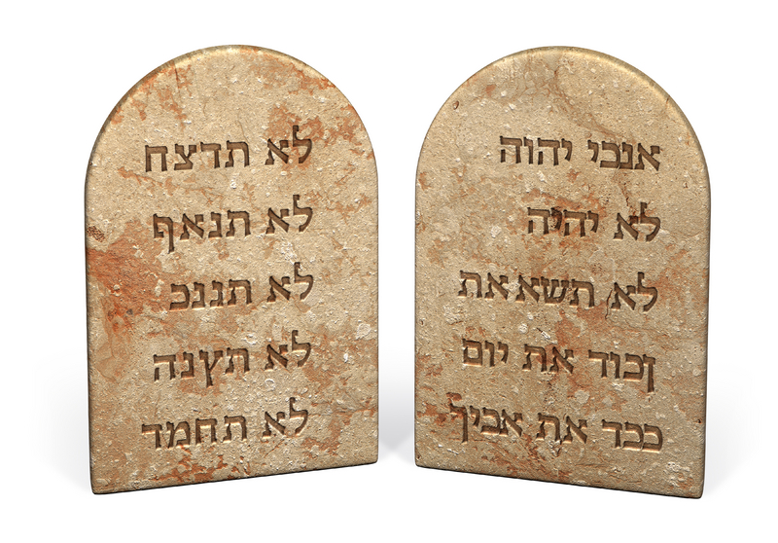
13 Thou shalt not kill. (Ex 20:13)

We now take up the shortest of the Commandments in length, but one of greater depth and preeminence than some others. What does this Commandment mean when it says, Thou shalt not kill? When the word kill is used in connection with the sixth Commandment, it invariably means ‘murder’ – “Thou shalt do no murder” as the Book of Common Prayer declares in the Decalogue for Holy Communion. The word for kill is ‘murder, or slay’ in both the Greek and Hebrew renderings. It means to kill with evil and premeditated intent. (xcr Ratsach). This is the word meaning in verse 13 above, and it refers to the wanton taking of human life. Moreover, Jesus uses the term ‘murder’ in quoting the Commandment in Mark 10:18. I believe that will settle the issue altogether.

Just as the Passover was brought to fuller meaning and depth by Christ, as was the Sabbath, so was the application of all other of the Commandments. If to look upon a woman to lust after her is not only ‘equivalent’ to adultery, but is, in fact, adultery; so is the mental resolution to hate someone enough to desire their death. That, too, is murder. Hate is murder for it would destroy the life of the object of its scorn. Though the inward desire may not be outwardly satisfied, the guilt remains from the standpoint of intent. The fact that we do not consummate the act of murder for fear of retribution or imprisonment does not mean that the guilt of the crime does not linger.

There is an active act of murder and a passive committal of the act. Active murder is the actual act of forcefully depriving another of the means of life by violent measures. This would be the kind of murder performed by knives, guns, strong hands, blunt object, etc. Abortion, as well, is an active and violent act of murder. A passive act of murder would be to allow someone to die whose life you would you would have been capable of saving. This kind of murder may occur as a result of neglect or of intentionally withholding the resources for life that you could have provided. There is murder in wars, even war justified by an immoral enemy, as well when innocents are killed needlessly along with the combatants.

It might be well to observe how this Commandment, and others, are related by Christ back to the very first of the Commandments demonstrating how dependent all of the other succeeding Commandments are upon the keeping of the first. Please read this narrative in the life of Jesus from the Gospel of St. Matthew:

16 And, behold, one came and said unto him, Good Master, what good thing shall I do, that I may have eternal life? 17 And he said unto him, Why callest thou me good? there is none good but one, that is, God: but if thou wilt enter into life, keep the commandments. 18 He saith unto him, Which? Jesus said, Thou shalt do no murder, Thou shalt not commit adultery, Thou shalt not steal, Thou shalt not bear false witness, 19 Honour thy father and thy mother: and, Thou shalt love thy neighbour as thyself. 20 The young man saith unto him, All these things have I kept from my youth up: what lack I yet? 21 Jesus said unto him, If thou wilt be perfect, go and sell that thou hast, and give to the poor, and thou shalt have treasure in heaven: and come and follow me. 22 But when the young man heard that saying, he went away sorrowful: for he had great possessions. (Matt 19:16-22)

Please note the manner in which the young man approaches our Lord. The Gospel of St. Mark describes the young man as running to Christ and kneeling before Him. And when he was gone forth into the way, there came one running, and kneeled to him. (Mark 10:17). This was well and good so far; however, see how the young man addresses Jesus: “Good Master, what shall I do that I may inherit eternal life? (Mark 10:17) Bear with me as we examine the deeper meaning of the exchange revealed in this passage. What was wrong with the young man’s address of Jesus? It was the fact that he referred to Jesus as “good Master” – a term that merely meant good teacher. He did not recognize Christ as Lord and the divine Son of God. Now, if we have digested that small kernel of meaning, let us answer another question that follows hard on: “What shall I do to inherit eternal life?” What is wrong with THAT question, friends? Is there any good works we can do to merit eternal life? No, we are saved by grace and not good works lest any man should boast. (Ephesians 2:9)

Jesus then asks the young man a searching question: 18 And Jesus said unto him, Why callest thou me good? there is none good but one, that is, God. Why do you suppose Jesus asked that question? Was Jesus saying that He Himself was not good? Not at all! Jesus is hinting to the young man of Himself as Lord and Savior. Jesus is God the Son, and Jesus is good; but the young man has failed to recognize His Lord in the flesh.

But to provide the young man with a meaningful answer, Jesus gives the young man a reminder that no man is capable of a perfect obedience to God’s Commandments: 19 Thou knowest the commandments, Do not commit adultery, Do not kill, Do not steal, Do not bear false witness, Defraud not, Honour thy father and mother. Jesus is cleverly leading the young man to a self-realization of his immense failure in keeping the Commandments. 20 And he answered and said unto him, Master, all these have I observed from my youth. Do you believe it is true that the young man has perfectly kept the Commandments from his birth? It is not likely – as a matter of fact, it is not possible! It must be noted that the young man probably FELT that he had done so. Many consider themselves righteous with vain pride.

Jesus has engaged the young man with a spirit of love to lead him into a growing knowledge of the righteousness of God and complete depravity of himself. The motive of Jesus in His interview is strictly love and not antagonistic: 21 Then Jesus beholding him loved him, and said unto him, One thing thou lackest: go thy way, sell whatsoever thou hast, and give to the poor, and thou shalt have treasure in heaven: and come, take up the cross, and follow me. Herein lies the crux of the matter of sin revealed in the heart of the young suppliant. What did Jesus mean in telling the young man to go and sell all that he had and give to the poor, and take up his cross and follow him? Does God expect every person of means to sell all that they have and become a pauper for Christ? Not at all! The point is this: The young man considers himself righteous in keeping the Commandments. He even boasts of it. But, in fact, Jesus has proven that the young man has not even kept the very first Commandment. He has another god besides God Almighty – the god of riches and power. We are the light of the world insofar as we are the reflected light of Christ (in the same way that the moon, generating no light, reflects the light of the Sun). If we allow any physical body to come between us and our Light Source, we are eclipsed in utter darkness. The young man allows his wealth to be his god instead of the God of Heaven.

This idea is proven in the next line: 22 And he was sad at that saying, and went away grieved: for he had great possessions.” This is a sad conclusion to a hopeful encounter. He went away grieved. He could not put his love for God above his love for money. It was his downfall.

So keeping all of the other Commandments, including the sixth, Thou shalt do no murder, depends totally and completely upon our keeping the first Commandment. Loving, honoring, glorifying and worshipping God Alone means loving and honoring all that is His. If we love our neighbors as ourselves, we will do no murder upon them. “Thou shalt not kill” is the first of the Commandments solely particular to our relationship with others. Why is that the case? I believe it is because to kill is to violate each of the following Commandments of duty to others. Murder forecloses the hurt and ruin of all other violations of Commandments that follow because it deprives the person of his very life and all possessions and future hope. Without life, there can be no theft of property. But murder has stolen all that the man owns in total.

In conclusion, murder is a grave sin (no pun intended), but all killing of others is not necessarily sin. Killing in defense of one’s person or property, or his family relations, or friends, is not murder. It is warranted by Holy Scripture. Killing in the righteous cause of a person’s country and liberties is not murder. To cowardly flee the duties of defense of country and liberty, leaving them exposed to certain death or deprivation, may be considered murder in the eyes of the Lord since it may result in the wanton killing of fellow citizens – of this I am not certain, but believe it to be the case. God will resolve that issue to our hearts in due time.

Have you ever hated another human being in your heart? Has your hate blinded your eyes to your duty of love and honor of God’s Creation and creatures?

