Exodus – Chapter 20 – Part Five (The Fifth Commandment) - 16 January 2015, Anno Domini (Year of our Lord)

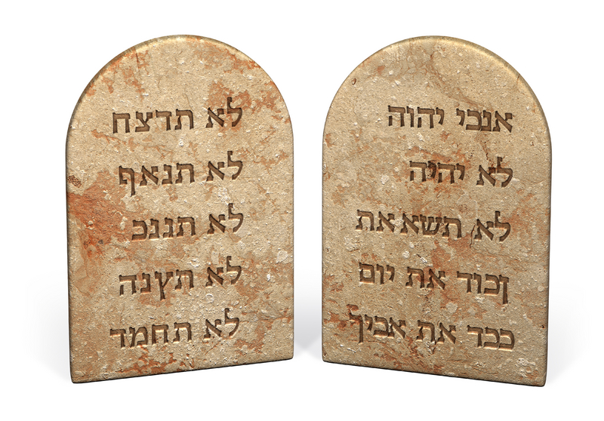
Honour thy father and thy mother: that thy days may be long upon the land which the LORD thy God giveth thee. (Ex 20:12)

Here is a Commandment of far greater depth of meaning than most in Christendom have understood. Of course, it must be understood that the Ten Commandments are not ten separate laws each of which stand alone – the Ten Commandments are a unified Code of God’s Laws to be obeyed out of love and not fear. However, many in our day separate the Tables of the Law thusly: The first four Commandments are considered to reflect our duty to God alone; and the last six are considered to reflect our duty to mankind alone. Though this argument has some merit, I believe it fails to recognize the fifth Commandment as belonging to the first four and ALSO to the last five as well! I consider the fifth Commandment a transition Commandment between the two major divisions of duty and love.

You will recall, again, the summary of the Law given by the Lord Jesus Christ: Thou shalt love the Lord thy God with all thy heart, and with all thy soul, and with all thy mind. This is the first and great commandment. And the second is like unto it, Thou shalt love thy neighbour as thyself. On these two commandments hang all the law and the prophets. (Matt 22:37-40) There is a unifying thread that summarizes, even in greater detail, these two summaries – that is LOVE! The kind of Love Jesus tells us to show to God first is the same kind of love we are to harbor for our neighbors. How is that reasonable? Because Love itself is indivisible! We are told to love God first because, without love for God, we cannot love our neighbors in the way that we are commanded to do. In fact, the unifying force that binds the Ten Commandments into one great Unified Law is that of LOVE. We cannot, in any wise, keep the Commandments out of a sheer sense of duty and responsibility – we can only keep them all out of what Jesus refers to as AGAPE love (a love that places its object above every personal consideration). If we love our neighbor as ourselves, our neighbor will not go naked, hungry, or without shelter while we have the means to provide for ourselves.

So the fifth Commandment, without overtly stating the obvious, places LOVE at its heart. God has given us the benefit of a mother and father so that we can know the kind of love He has for us better. The human infant is born as the most helpless of all creatures. The foal of a horse can immediately struggle up and walk after birth. Baby chickens can soon hop about spritely after hatching. But the baby human is totally dependent upon parents for its subsistence. It cannot speak, understand words, walk, or express love. It can only express greed and want and dissatisfaction with its condition. It cannot control its bodily constitution and must be fed, cleaned and pampered by a mother and father who gain no visible reward from their labors – except satisfaction of the love they have for the ungrateful, crying and mess-making baby. Only a mother could believe a screaming child with dirty diapers is so sweet and beautiful! The baby is a drain on the family resource of physical, financial, social existence.

Is that not exactly how we must appear to God is our lost and depraved state as willful sinners? We are constantly making a mess of ourselves. We make decisions that only a fool could admire. We dress disrespectfully, and we consume things we should not. But God knows us – He knows that we are His (if we are) long before we know it. He watches and broods over us. He saves us from destruction when we have not merited a kind thought from His Divine Majesty. He may allow us to wander into dangerous playgrounds, but He is there watching. He places challenges and restraints before us to preserve our lives until we are grown up enough to realize that we have not made ourselves, but it is He that hath made us. He slowly teaches us HIS language and His thoughts. In time, if we become His Chosen Ones, our thoughts will be His thoughts even if our outward manifestations fail to reflect the inward grace of His love.

Honor is both a sense and a duty that we owe to a greater power in our lives. We owe duty and honor to, first, our parents because they are the first beings we are able to love. Loving them, and knowing them, will lead us to know and honor better our Father in Heaven who has not only given us life, but also parents to care for us until we are able to stagger along alone. My son, hear the instruction of thy father, and forsake not the law of thy mother: For they shall be an ornament of grace unto thy head, and chains about thy neck. (Prov 1:8-9)

We owe honor to our nation and fellow countrymen so long as the laws of our country are subordinate to the Law of God – and they MUST always be so to be legitimate!

The Person of God is clearly reflected in His use of the term, mother AND father. It takes both mother and father to provide for us in the likeness of God. Both represent the Person of God in our early lives. The Lord not only gives us life, and bodies able to experience joy; but He also gives us, in addition to caring parents, a land upon which to place our feet and to conduct our earthly labors.

When we recite the 5th Commandment, what goes through our mind most exclusively? Is it not always our earthly mother and father? Have we forgotten that the 5th Commandment also refers to the Father of us all? To Him be all Honor and Glory, both now and forever!

Are you beginning to picture how the 5th Commandment fits so perfectly between the first four and the last five Commandments? It is a transition that God gives us between our duties of love to Him and those same perspectives toward our family, friends, and neighbors. The transition is the strongest example of sacrificial love that our mortal minds can grasp.

If we love and honor our earthly parents, our lives will be richly blessed by a lasting love and sacrifice those parents will make for us – even at the moment of death. Our lives will be rich with the green pastures of love at home where we feed in peace and joy. Our health, too, will reflect that better breeding that comes through honor and love of parents. God tells that keeping this Commandment will gives us longness of days upon the land He has given us. He goes even further in another part of His Word: Thou shalt keep therefore his statutes, and his commandments, which I command thee this day, that it may go well with thee, and with thy children after thee, and that thou mayest prolong thy days upon the earth, which the LORD thy God giveth thee, for ever. (Deut 4:40) Keeping the Commandments of God will inure to the benefit – not only of our personal spiritual and physical health – but also to the children with whom the Lord blesses us.

To summarize: the Fifth Commandment follows those Commandments that inform of us of Who God is, what He is NOT, and primary duties that we owe to Him as our Lord and Sovereign. The fifth Commandment follows on the same train of thought to inform us that we are to honor our mother and father. He is our true mother and father in the sense that He is the First Cause who gave us life, liberty and the joy that exceedeth all joys. Of course, if we are disobedient and disrespectful to our earthly parents whom we can see an touch, how much less will we be inclined to honor and obey, love and respect, the God of Heaven who speaks only through the medium of His Written Word to a warm and receptive heart? So all those things that we owe to Mom and Dad are the same, to an even greater degree, that we owe to God in Heaven – our Eternal Father.

