Exodus – Chapter 20 – Part Four (The Fourth Commandment) - 15 January 2015, Anno Domini (Year of our Lord)

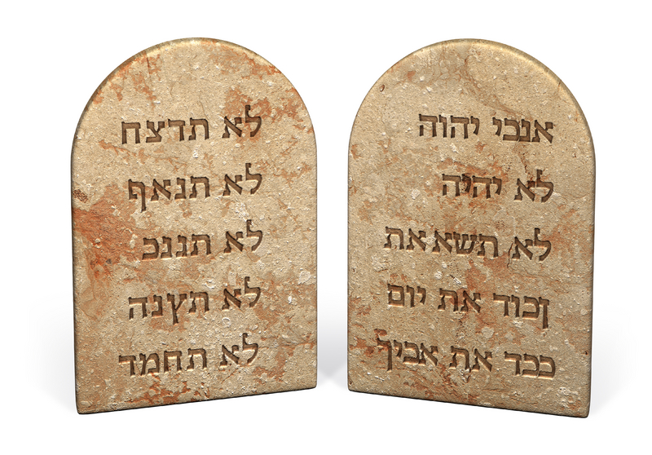

Remember the sabbath day, to keep it holy. Six days shalt thou labour, and do all thy work: But the seventh day is the sabbath of the LORD thy God: in it thou shalt not do any work, thou, nor thy son, nor thy daughter, thy manservant, nor thy maidservant, nor thy cattle, nor thy stranger that is within thy gates: For in six days the LORD made heaven and earth, the sea, and all that in them is, and rested the seventh day: wherefore the LORD blessed the sabbath day, and hallowed it. (Ex 20:8-11)

Many Bible scholars today seem to believe that God’s issuance of the Ten Commandments was the moment of institution of the Holy Sabbath. I disagree for it is mentioned in Genesis: 1 Thus the heavens and the earth were finished, and all the host of them. 2 And on the seventh day God ended his work which he had made; and he rested on the seventh day from all his work which he had made. 3 And God blessed the seventh day, and sanctified it: because that in it he had rested from all his work which God created and made. (Gen 2:1-3) Again it was observed in Egypt as well in the wilderness Journey prior to Sinai: And he said unto them, This is that which the LORD hath said, To morrow is the rest of the holy sabbath unto the LORD: bake that which ye will bake to day, and seethe that ye will seethe; and that which remaineth over lay up for you to be kept until the morning. (Ex 16:23) and So the people rested on the seventh day. (Ex 16:30) Though the Sabbath was not instituted at Sinai, it was, indeed, codified into the Table of the Law.

It is important to note God begins this Commandment with the word, REMEMBER. It is important because God does not want us to forget, or take for granted, this serious Commandment. He tells us to remember the Sabbath for He knows that we will be inclined to disregard it. You may feel that you are keeping the Sabbath today, but you may not be. Is Sunday the Sabbath Day? No, it is the first day of the week. The Sabbath is the seventh day of the week which the Spanish calendar still depicts as Sábado. Sunday, by consensus, was set aside by the early church as an appropriate day to set aside to formally worship the Lord, but it is not the Sabbath described in the 4th Commandment. The Hebrew Sabbath began at sundown Friday evening and continued till sundown on Saturday. It is intriguing to know that Jesus was laid in the Garden Tomb precisely at the beginning of Sabbath, and had already arisen before light of day on Sunday (see John 20:1). So we do not know the precise moment that Christ broke the bonds of death and rose from the grave. It could have been 4 A.M. or it could even have been at sundown on Saturday – the end of the Sabbath. One thing we do know is this: Christ kept that Sabbath Day in the rest of death in the Tomb!

There have been numerous and voluminous works written to show that the Hebrew Sabbath was changed from Saturday to Sunday, but all such attempts fall far short of success. The Sabbath was not changed and still remains inviolate today for Christians. I realize that you are probably thinking that I am proposing that we must still observe the strict observance on a Seventh Day Sabbath – no, I am not; however, I believe that Christ became our Passover when He died a substitutionary death for us on the brow of Calvary: Purge out therefore the old leaven, that ye may be a new lump, as ye are unleavened. For even Christ our passover is sacrificed for us. (1 Cor 5:7) In the same sense, I believe that Christ became our Sabbath (Rest). Can we do any good works apart from Christ working in and through us? No, we are incapable of such works.

None of our Christian labors are ours, but belong to Christ working in our members. Neither yield ye your members as instruments of unrighteousness unto sin: but yield yourselves unto God, as those that are alive from the dead, and your members as instruments of righteousness unto God. (Romans 6:13) For it is God which worketh in you both to will and to do of his good pleasure. (Phil 2:13) The only works we can take credit for are those of sin and disobedience, for the carnal man is unable to please God. Again, he limiteth a certain day, saying in David, To day, after so long a time; as it is said, To day if ye will hear his voice, harden not your hearts. For if Jesus had given them rest, then would he not afterward have spoken of another day. There remaineth therefore a rest to the people of God. For he that is entered into his rest, he also hath ceased from his own works, as God did from his. (Heb 4:7-10)

The Greek word for REST in the above verse is (sabbatismovß) or Sabbatismos (sab-bat-is-mos') which means, ‘keeping Sabbath.’ In my own personal opinion, I understand the Sabbath not to have been abrogated by Christ, but rather made more stringent. Not only do we keep one day in seven as Sabbath, but seven days in seven, for Christ is our eternal Sabbath. All that we do, think, and value is centered on the Lord Jesus Christ, if we are devout and serious Christians. Our labors are His labors, and we have that rest promised by God in Christ.

Though Christ has become our Sabbath for rest in God, our physical bodies are not immune to weariness and exhaustion. Therefore, the one day in seven principle for physical rest remains needful for the mortal body. Governments from China to France, from Soviet Russia to Nazi Germany, have attempted eliminate any day of rest at all in the week, but to no avail. The Sabbath Day was not only a spiritual rest granted to ancient Israel, but a physical rest given to all mankind in God’s natural laws.

Our keeping of God’s Sabbath today is to allow Christ to labor in and through our members. If we step back and allow Christ to work in us, we will discover that we have the attributes of the great Eagle. We will not grow weary in good works because those good works came not of our labors but of Christ. Hast thou not known? hast thou not heard, that the everlasting God, the LORD, the Creator of the ends of the earth, fainteth not, neither is weary? there is no searching of his understanding. He giveth power to the faint; and to them that have no might he increaseth strength. Even the youths shall faint and be weary, and the young men shall utterly fall: But they that wait upon the LORD shall renew their strength; they shall mount up with wings as eagles; they shall run, and not be weary; and they shall walk, and not faint. (Isaiah 40:28-31)

The Day of Worship for the Christian is EVERY day. Every day in the life of the Christian is hallowed by God. Our first conscious thoughts should be to glorify our Lord, just as did the shepherd of Israel: 1 O God, thou art my God; early will I seek thee: my soul thirsteth for thee, my flesh longeth for thee in a dry and thirsty land, where no water is; 2 To see thy power and thy glory, so as I have seen thee in the sanctuary. (Psalms 63:1-2) We will seek His face early – even before we prepare food for the belly, we will seek to satisfy the void in the heart.

And not only will our search for God and glorying in Him be in the daylight hours, but also the dark nights of the soul: My soul shall be satisfied as with marrow and fatness; and my mouth shall praise thee with joyful lips: When I remember thee upon my bed, and meditate on thee in the night watches. (Psalms 63:5-6) There are far too many of us who take a flippant view of our duties, and love, for God. We believe that we can depend only upon a weekly sermon and reading of the Gospel and we are set for a week of forgetfulness in the world. Really? No, we need the daily bread of the Word, of prayer, and of dependence upon our Creator. It is by His power and discretion that we receive the next breath of life (did we labor for it?). And it is from His gracious will that our heart performs the very next beat. None of the basic functions of life come as a result of our labor, but from God. He continues those labors of His in maintaining our lives day by day, seven days a week. He is truly our Sabbath Rest in every way.

There is no man to enforce the Sabbath. It is God who commanded it. His Voice thundered it from the Smokey Heights of Sinai. That same Voice also thundered again on the Mount of Transfiguration: This is my beloved Son, in whom I am well pleased; hear ye him. And when the disciples heard it, they fell on their face, and were sore afraid. And Jesus came and touched them, and said, Arise, and be not afraid. And when they had lifted up their eyes, they saw no man, save Jesus only. (Matt 17:5-8) Arise, be not afraid. The Law of God is no longer written on Tables of Stone, but by Love upon the sinews of our hearts – written, not with pick and hammer on stone tables, but by the Blood of the Lord Jesus Christ on the soft, fleshly chambers of our hearts!

