Exodus – Chapter 20 – Conclusion – 28 January 2015, Anno Domini (Year of our Lord)
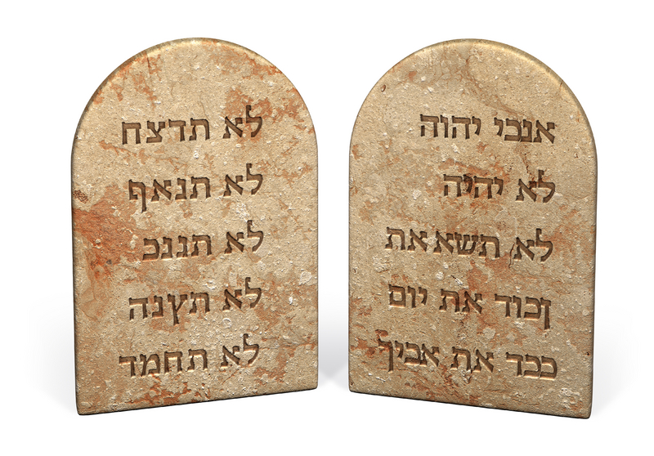
The fear of the LORD is the beginning of wisdom: a good understanding have all they that do his commandments: his praise endureth for ever. (Psalms 111:10)

18 And all the people saw the thunderings, and the lightnings, and the noise of the trumpet, and the mountain smoking: and when the people saw it, they removed, and stood afar off. 19 And they said unto Moses, Speak thou with us, and we will hear: but let not God speak with us, lest we die. 20 And Moses said unto the people, Fear not: for God is come to prove you, and that his fear may be before your faces, that ye sin not. 21 And the people stood afar off, and Moses drew near unto the thick darkness where God was. (vs 18-21)

The purpose of the Commandments was never to comfort, but to CONVICT! Without the conviction that leads to repentance, there could follow no salvation. It is precisely the fear evoked in a sinful heart that is the only means of making an opening for God to enter thereunto. Before we came to reverence God, we first came to fear His righteous indignation at our disobedience. This fear drove us to endeavor to know Him better that we may satisfy His wrath against us and seek ways and means under His government to justify ourselves and to become acceptable vessels in His Kingdom. Remember the Pharisee and the Publican? 10 Two men went up into the temple to pray; the one a Pharisee, and the other a publican. 11 The Pharisee stood and prayed thus with himself, God, I thank thee, that I am not as other men are, extortioners, unjust, adulterers, or even as this publican. 12 I fast twice in the week, I give tithes of all that I possess. 13 And the publican, standing afar off, would not lift up so much as his eyes unto heaven, but smote upon his breast, saying, God be merciful to me a sinner. 14 I tell you, this man went down to his house justified rather than the other: for every one that exalteth himself shall be abased; and he that humbleth himself shall be exalted. (Luke 18:10-14)

The sense of guilt and sin that possessed the heart of the publican drove him to flee to the Temple grounds to seek the forgiving grace of God. It was not sudden impulse that brought him to this state. It was an awesome and growing fear that had nagged at his heart for quite a long time. The more he thought about the Law of God, the larger and more egregious grew his burdens of sin. Finally, that fear drove him to the Throne of Grace. The Pharisee had no such fear. In fact, he was quite confident in his self-righteousness. But self-righteousness is an oxymoron/since self is always contradictory to righteousness. For all have sinned, and come short of the glory of God. (Romans 3:23) In the Publican’s reverence for God, he feared to approach too near. He stood afar off to plead his cause. This is entirely appropriate since the sinner is far removed from God until he turns to Him with a broken and a contrite heart. (Psalm 51:17)

It is difficult to comprehend the awe and fear evinced in the hearts of a primitive people gathered about the foot of Mount Sinai, when “all the people saw the thunderings, and the lightnings, and the noise of the trumpet, and the mountain smoking: and when the people saw it, they removed, and stood afar off.” Such a scene had never been observed before by them, or any others. They did not know God in an intimate way though He had been their strong Defense and Champion in bringing them out of Egypt, feeding an watering them in the wilderness, and now deigning to bring to them His Law from the heights of Sinai. God demonstrated His loving grace in Egypt and since before He revealed His Law.

It is clearly obvious from the description of these events that those who do not know God intimately are, at first, struck with fear that drives them a respectful distance away, while those who know Him intimately are drawn into His Clouds of Mystery just as was Moses. In demonstrating His mighty power and majesty, God intended to 1) gain the undivided attention of the people: 2) insist upon their utmost respect and obedience; and 3) to reveal to them their sins and great need for the Redeemer that He had decreed to send from before the foundation of the world. Dr. C.A. Goodhart contrasts the two responses to this fear as follows:

“When Christ was upon the earth, so winning was his graciousness that crowds flocked to him, and one man at least exclaimed, “Lord, I will follow thee whithersoever thou goest.” But at the same time so terrible was the manifestation of his power, that there were those who “besought him that he would depart out of their coasts.” God is love, and God is power, and wherever he is, be exhibits both qualities; but there are some who sea mainly the love, and there are others who see only the power. Hence the Divine presence at once attracts and repels, charms men and affrights them. The Israelites invited to draw near to God, and hold with him direct communication, after brief trial, decline the offer, and will have an intermediary.”

God has made a dramatic introduction of Himself to the Children of Israel. He had worked many mighty miracles and curses in Egypt; He had spared Israel from all these plagues, and especially, the last of the Passover Lamb while they were yet in Goshen; He had brought them forth across the Red Sea bed and baptized them at once as a nation anointed by Him and chosen; He had provided Manna when rations failed, and even meat; and He had given them water from the Rock of Horeb (a part of Sinai demonstrating that grace also comes by way of the Law) which Rock represented His only Begotten Son, Jesus Christ whom Moses struck to open. The lance that opened the side of Christ on the cross was a fuller revelation of that opened Rock from which poured forth redeeming blood and the Water of Life. In case this was not enough, God now reveals Himself in a veil of cloud and lightning from atop Sinai:

22 And the LORD said unto Moses, Thus thou shalt say unto the children of Israel, Ye have seen that I have talked with you from heaven. 23 Ye shall not make with me gods of silver, neither shall ye make unto you gods of gold. 24 An altar of earth thou shalt make unto me, and shalt sacrifice thereon thy burnt offerings, and thy peace offerings, thy sheep, and thine oxen: in all places where I record my name I will come unto thee, and I will bless thee. 25 And if thou wilt make me an altar of stone, thou shalt not build it of hewn stone: for if thou lift up thy tool upon it, thou hast polluted it. 26 Neither shalt thou go up by steps unto mine altar, that thy nakedness be not discovered thereon. (Ex 20:18-26)

Please note the serious reinforcement God makes of the Second Commandment in verse 22 & 23. He has their fearful and undivided attention at this moment as they tremble from all of the thundering from the Divine Cloud on Sinai. At least, though they may forget later, they know this is the One God who is so mightily present on Sinai. So God goes to the Second Commandment to demonstrate its gravity. Little images of non-gods made of gold or silver bear no resemblance to God – they cannot move, think, or benefit in any way. These were simple creations of the great God. God contrasts His own simple nature to that attributed to false gods of precious metal, wood or stone: “An altar of earth thou shalt make unto me, and shalt sacrifice thereon thy burnt offerings, and thy peace offerings, thy sheep, and thine oxen: in all places where I record my name I will come unto thee, and I will bless thee.” God would have Israel to know that it is not the sophistication of the altar, but the God to whom it is dedicated that is important. Our hearts, too, are altars to God – and they are made from the dust of the earth, are they not?

“And if thou wilt make me an altar of stone, thou shalt not build it of hewn stone: for if thou lift up thy tool upon it, thou hast polluted it.” The substance of which the altar of God is made must remain as God made it. It is not the labor of our hands that consecrate the altar, for our works are entirely unprofitable. If we attempt to add a single chip by the works of our hands to the overcoming salvation of God, we have polluted the altar (our hearts). We can claim no righteousness in our works, but salvation is all of grace. Here is a strong warning to the elaborate, gaudy articles and utensils used in Romish churches and others that tend to worship the structure or building more than the One to whom it is dedicated.

“Neither shalt thou go up by steps unto mine altar, that thy nakedness be not discovered thereon.” There seem, to me, to be two logical and rational reasons for this last verse:

- Owing to the full flowing robes, or even knee length ‘kilts’ of men of that day, modesty of appearance should have been observed in going up to the altar. If there were an elevation of steps, that modesty would have been compromised;

- God does not desire HIGH altars. Such ornate and high structures often diminish the reverence owed to God alone. We all remember that the Taj Mahal was begun to honor the memory of an Indian princess, but in its years of construction, the edifice became more important than the princess who was to be memorialized. We have many, many Taj Mahals depicted in modern churches.

We all seem to want to be the First Church – bigger, richer, and better than all around. That mentality will only feed the fires in which they shall be consumed at the Last Day. God wants the flesh and blood altars of a tender heart, not an ornately constructed temple that worships itself more than its Creator.

May the AOC never become such a Church.

