Exodus – Chapter 20 – Part One (Giving the Law) - 9 January 2015, Anno Domini (Year of our Lord)

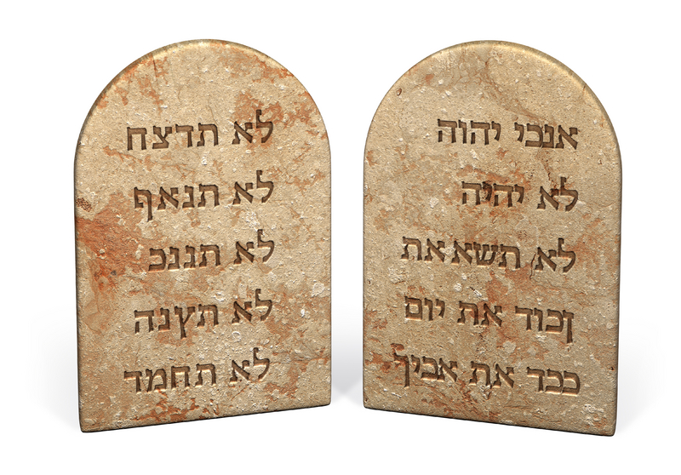

The Word of God is a crystalline mirror to our souls revealing our utter depravity contrasted with His perfect righteousness. It is a total Law, but divided into two perspectives – the first delineating our duty and obligations to God, and the second those same duties and obligations owed to our fellow man. The summary of the Law given by Christ which He quoted from the Old Testament, perfectly divides those duties of the two Tables:

31 The first of all the commandments is, Hear, O Israel; The Lord our God is one Lord: 30 And thou shalt love the Lord thy God with all thy heart, and with all thy soul, and with all thy mind, and with all thy strength: this is the first commandment. 31 And the second is like, namely this, Thou shalt love thy neighbour as thyself. There is none other commandment greater than these. (Mark 12:29-31) See how they are postulated in the Old Testament: 4 Hear, O Israel: The LORD our God is one LORD: 5 And thou shalt love the LORD thy God with all thine heart, and with all thy soul, and with all thy might.” (Deut 6:4-5) and . . . thou shalt love thy neighbour as thyself: I am the LORD. (Lev 19:18b)

The Commandments of God we are about to see in this chapter written on Tables of Stone were intended to be inscribed on a more malleable fabric with the coming of Christ: “Forasmuch as ye are manifestly declared to be the epistle of Christ ministered by us, written not with ink, but with the Spirit of the living God; not in tables of stone, but in fleshy tables of the heart.” (2 Cor 3:3) The Law, being our school teacher, was revealed to our hearts as a budding rose whose pealing petals revealed more and more of the Love of God that defined its essence to us and revealed their deeper meaning.

As we contemplate each of the Commandments, let us not lose sight of the fact that the Ten constitute the whole of God’s Commandments, and each is an integral part of that whole. The two distinctive tables of the Commandments are distinguished by the Summary of the Law given by our Lord above. The traditional manner of dividing those two tables is to assert that the first four represent our duty to God, and the last six, our duty to fellow man. But I respectfully would stipulate a slight difference in this division. Though I agree that the last six do relate to our duties to our fellow man, I believe the first FIVE describe our duties to God. “But”, you say, “there are only Ten Commandments!” True, but I consider the fifth to be a transition of emphasis between God and man. God is also our ultimate Father as our earthly father is a lower office. We are to honor God even more devoutly than we do our earthly father for we would have neither mother nor father had the Lord not granted us the privilege.

1And God spake all these words, saying, (Ex 20:1) In a military or naval command, it is the Commanding General/Admiral who issues orders relating to the elements of disposition or movement of an army or naval group. Those orders, for an Army Group, begin: General Orders # _ _. All readers of such orders will recognize that they are issued by, or at the behest, of the Commanding General – they are his orders and bear the authority of his role as Commanding General. Here we see the same in the introductory line to the Ten Commandments. It is God by whose authority these Commandments are issued. Just as there is no higher authority in an Army Command than the Commanding General; so in the whole Universe, there is no higher Authority, or issuing authority, than the Sovereign of the Universe – GOD! So the opening line establishes His Authority and the import of that which follows. Remember, it is God speaking – not lightly to be dismissed!

2 I am the LORD thy God, which have brought thee out of the land of Egypt, out of the house of bondage. (Ex 20:2) Who is the LORD your God? Isn’t that the first question that begs the answer from every living soul? Is your god of wood, silver, gold, precious gems, fancy automobiles, opulent mansions – what? Is there any vision or commodity that possesses your thoughts to the exclusion of all others? THAT is your god! The Lord God is not a commodity, or a desired status. God is a PERSON, and not only a Person, but the Creator of all that you can see, feel, touch and imagine. He made the universe, He flung the heavenly bodies into their orbits, He made the earth and all that is in the earth – including tiny YOU! He is All-Knowing and Ever-Present in all places and times. He it is who has delivered Israel from bondage in Egypt, and from the sins of today. If you are free born, it is because He has created a new heart in you. He is the Triune God self-existing in Three Persons. Those three are clearly present in the first verse of Genesis, and the last of Revelations. Do you remember His graces to you, or do you believe that you are self-made (some trick, huh?).

We are to remember God and His Lordship and Sovereignty at all times. If we know Him as Lord and Savior, He is with us to guide, direct, and sanctify. He is with always, even to the end of the world – and beyond. God wants us to REMEMBER Him! “I am the LORD thy God!” The shepherd of Bethlehem remembered God always. Read the words of David in the Wilderness: 3 Because thy lovingkindness is better than life, my lips shall praise thee. 4 Thus will I bless thee while I live: I will lift up my hands in thy name. 5 My soul shall be satisfied as with marrow and fatness; and my mouth shall praise thee with joyful lips: 6 When I remember thee upon my bed, and meditate on thee in the night watches. (Psalms 63:3-6) You may say, “But of course I remember God every day. I at least say grace before every meal. Really? Is that sufficient? Since your next heartbeat and breath comes by His grace, don’t you think we might do better than that? Do we remember Him during the night watches on our beds? Meditate – do we MEDITATE on His Holy word and Presence?

The huddled masses of Israel trembled beneath the smoking peak of Mount Sinai as this Voice of God spoke to them. At that time, there were no doubters, only those whose hearts were filled with fear and dread as God revealed His Law. That Law revealed exposed their sin and the nakedness of each hearer before Him. It was intended so in order to hold their attention, and to burn an indelible image on their memories. For faith and knowledge begins with fear, but ends in love.

It will be profitable for us if we remember that this day was that of Pentecost. Just as in the Pentecost of Acts 2, there was no confused babbling in the words spoken. God spoke clearly to every man, woman, and child of that gathering – and to us today . . . . “I am the LORD thy GOD!” He is the Lord your God even if you do not know Him either to your everlasting joy, or unending sorrow.

3 Thou shalt have no other gods before me. (Ex 20:3) Is this not the first and great Commandment from which all others are fixed? Friends, do you have other gods beside God the Father, God the Son, and God the Holy Ghost? Is money a god to you that forecloses your service to God? Do you spend more time and thought on how to acquire wealth, rise in the corporate ranks, or acquire a better house than your neighbors than you do in considering your eternal destiny? Do you make a pretended showing of piety once a week before a minister who preaches ABOUT the Word? Is it not better to go to the Source of the Spring and drink the Living Waters where they emerge from the ground than to drink downstream of the herd where man and beast have polluted the waters? Preaching is important, but we must be fully informed of Scripture in order not to be deceived by any man – even ministers.

In a real sense, the Ten Commandments are not only arbitrary laws laid down by God to subjects of a Kingdom – though it is that. The Commandments are, in the best sense, a covenant of marriage between God and His Elect. They shall be written on Stone Tables at Sinai, but transcribed in blood on the soft sinews of our hearts at Calvary’s brow. Can you fathom the depth of that truth! No sinner (guilty of breaching the Commandments) will enter into the presence of God in Heaven. How then can we be accounted justified and righteous at the last day, for no man has lived in perfection of the Law but One – the Lord Jesus Christ. The terms of the Law require death for all who are guilty of the disobedience of a single Commandment. 23 For the wages of sin is death; but the gift of God is eternal life through Jesus Christ our Lord. (Romans 6:23) Are the Commandments nullified by the sacrificial death of Christ? No, not at all, but the penalty was paid by Him to all who are the called and chosen according to His purpose! Just as the babes of Goshen were saved by the blood of an innocent lamb, smeared on the doorpost and lintels, so are we whose hearts have our doorways and chambers marked by that precious Blood of the Lamb of God. We have His righteousness imputed to us if we believe on Him with all of our hearts. He is the Lord our God!

We have become a society of instant gratification in all things, and multiple choice answers on all exams. We seek the shortcuts and easy roads of life. Though those roads appear ‘easy’ they turn out to be most grueling and catastrophic in the destination to which they lead. Yes, they are BROAD, and, yes, they lead to the easy down-slope of life, but look to the end ahead of fire and hurt! With God, the Way that may seem hard at first glance, and not the popular road, and one whose incline is upward and onward, will at last prove the easiest and most joyful of all. We cannot be double-minded when it comes to God. He wants our hearts and minds alone and will not share with the lesser gods of this world.

Friend, who is your God and who receives the greater measure of your thoughts, deeds, and love?

