Exodus – Chapter 18, 2 January 2015, Anno Domini (Year of our Lord)

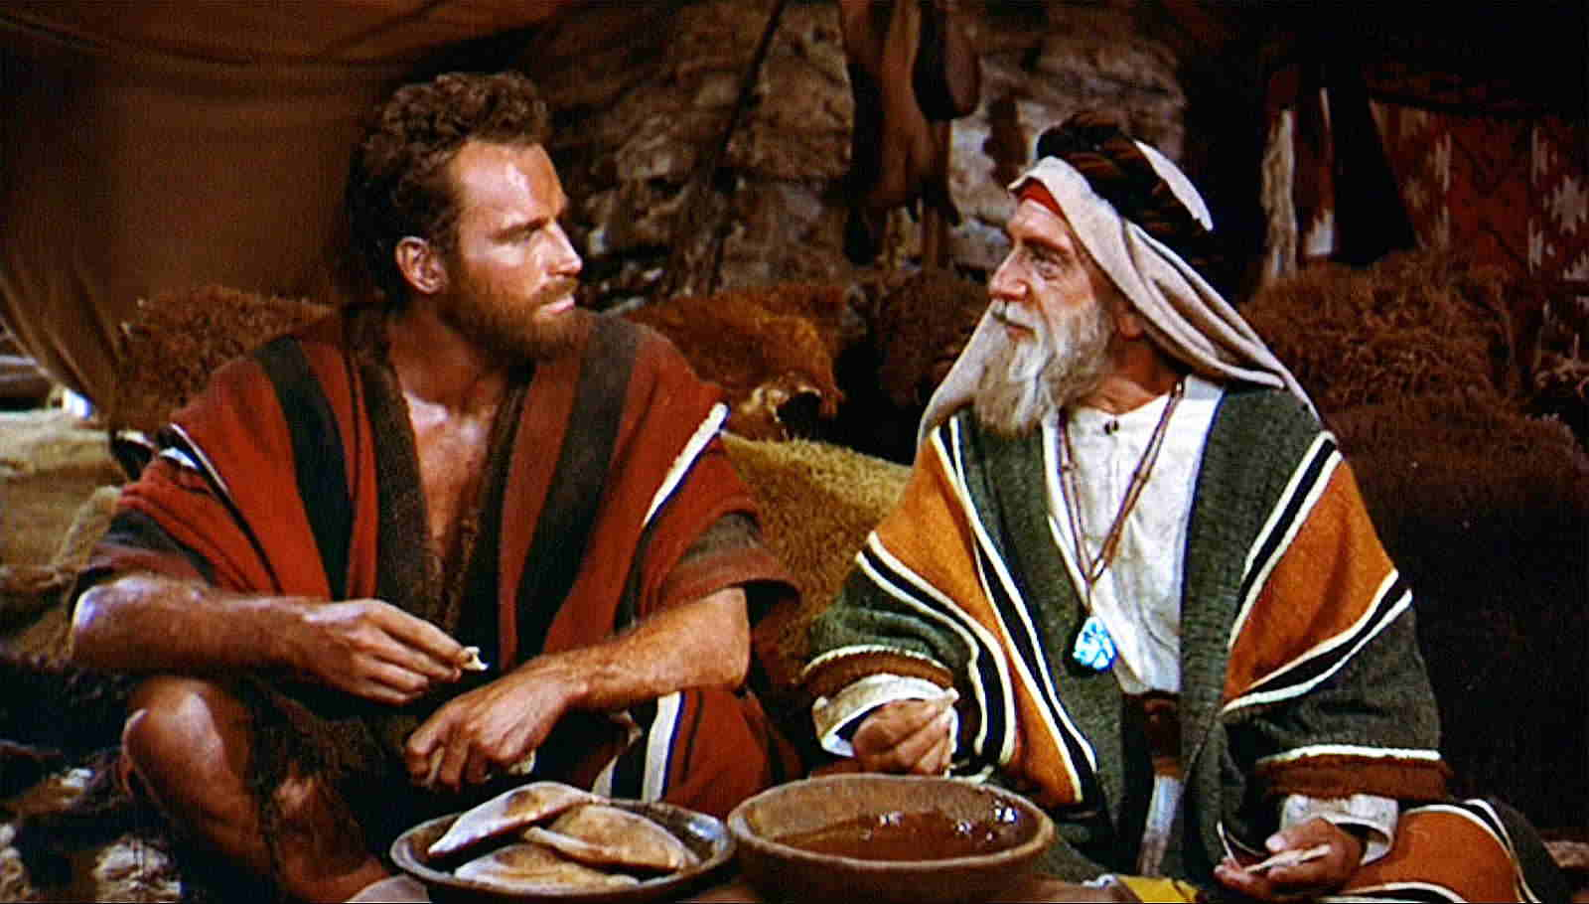

Jethro rejoiced for all the goodness which the LORD had done to Israel, whom he had delivered out of the hand of the Egyptians. (Exodus 18:9)

And well should we all rejoice at the good the Lord has done for His people whom He has delivered from the power of death and of the devil!

In Chapter 17 we read of the great Rock of Horeb on Sinai that Moses was commanded by God to strike with his rod. The great Rock was split, and out gushed living Water. Insofar as Horeb is at Sinai, and the rod of Moses represented the Law, the grace of God came by way of the Law which Christ (the Great Rock) satisfied (see 1 Cor 10:4 & John 19:34). God supplied not only the Bread of Heaven to His people, but the Water of Life as well.

It seems apparent from the following verses that Moses must have sent Zipporah, his wife, away from Egypt with his two sons, back to her father Jethro. It is my speculation, as well as my hope, that this was a precaution of Moses to protect them from retribution by Pharaoh.

1 When Jethro, the priest of Midian, Moses' father in law, heard of all that God had done for Moses, and for Israel his people, and that the LORD had brought Israel out of Egypt; 2 Then Jethro, Moses' father in law, took Zipporah, Moses' wife, after he had sent her back, 3 And her two sons; of which the name of the one was Gershom; for he said, I have been an alien in a strange land: 4 And the name of the other was Eliezer; for the God of my father, said he, was mine help, and delivered me from the sword of Pharaoh: 5 And Jethro, Moses' father in law, came with his sons and his wife unto Moses into the wilderness, where he encamped at the mount of God: 6 And he said unto Moses, I thy father in law Jethro am come unto thee, and thy wife, and her two sons with her.

It is a bit unsettling that Jethro refers to the two boys as “her” two sons since they are also the sons of Moses. It begs a further understanding of the separation of Moses and Zipporah. Both boys were named by Moses to reflect his life – Gershom means, I am a foreigner; and Eliezer means ‘God is my help.’ Since scripture does not reveal the reasons for the separation, I prefer to conclude my own opinion stated above.

Moses next happily relates all that the Lord has done in alleviating the struggles of the people in coming out of Egypt. Jethro must have been quite impressed to see Moses at the head of a nation of about two million people (including children).

7 And Moses went out to meet his father in law, and did obeisance, and kissed him; and they asked each other of their welfare; and they came into the tent. 8 And Moses told his father in law all that the LORD had done unto Pharaoh and to the Egyptians for Israel's sake, and all the travail that had come upon them by the way, and how the LORD delivered them. 9 And Jethro rejoiced for all the goodness which the LORD had done to Israel, whom he had delivered out of the hand of the Egyptians. 10 And Jethro said, Blessed be the LORD, who hath delivered you out of the hand of the Egyptians, and out of the hand of Pharaoh, who hath delivered the people from under the hand of the Egyptians. 11 Now I know that the LORD is greater than all gods: for in the thing wherein they dealt proudly he was above them. 12 And Jethro, Moses' father in law, took a burnt offering and sacrifices for God: and Aaron came, and all the elders of Israel, to eat bread with Moses' father in law before God.

It seems Moses and his fellows enjoyed somewhat of a limited communion with Jethro and his hosts. Jethro was a priest of the Midianites – enemies of the children of Israel as we shall read later. But Jethro seems to come to an understanding the God of Israel is the true God of all.

13 And it came to pass on the morrow, that Moses sat to judge the people: and the people stood by Moses from the morning unto the evening. 14 And when Moses' father in law saw all that he did to the people, he said, What is this thing that thou doest to the people? why sittest thou thyself alone, and all the people stand by thee from morning unto even? 15 And Moses said unto his father in law, Because the people come unto me to enquire of God: 16 When they have a matter, they come unto me; and I judge between one and another, and I do make them know the statutes of God, and his laws.

Jethro was a man of the desert hill country. Such men, as I learned in Iran, are gifted with an innate wisdom of life. Jethro sees, and hears, how Moses has taken upon himself to judge such a host of people in matters of daily life and justice. The hosts of Israel must approach two million people since there were 600,000 men who came out of Egypt. Practically all of them had families that would swell the ranks to at least the larger number. How could one man hope to adequately judge such a host in all matters of equity, and still have time to eat and sleep? Jethro observed this impossibility immediately. It happens in churches often. A good minister begins a good ministry dedicated to God. He must do yeoman’s work from the beginning to establish the Church on the firm foundation that is Christ. As his numbers grow, God sends others to help – but the minister is so accustomed to doing all by himself, he may fail to use the helpers God sends. At last he is overwhelmed by the enormity of the work, and may despond of it. In fact, the suggestion of Jethro to diversify the process into greater numbers of wise counselors is the strength of the Church at worship. In our own Reformed Anglican Church, we have three orders for ministry – Deacon, Priest, and Bishop (there is not title for ‘arch’ bishop in the Ordinal or Thirty Nine Articles).

But the concept applies equally well, not only to the authority of ministry, but the process of worship as well. Our worship is not to be man-centered. It is for this reason that we have responsive readings, communal prayers (Lord’s Prayer being best example), prayers and creeds uttered in common, and hymn singing. Worship is not centered on a man standing in the center of the sanctuary, but upon all worshippers worshipping in communion the same Lord.

17 And Moses' father in law said unto him, The thing that thou doest is not good. 18 Thou wilt surely wear away, both thou, and this people that is with thee: for this thing is too heavy for thee; thou art not able to perform it thyself alone. 19 Hearken now unto my voice, I will give thee counsel, and God shall be with thee: Be thou for the people to God-ward, that thou mayest bring the causes unto God: 20 And thou shalt teach them ordinances and laws, and shalt shew them the way wherein they must walk, and the work that they must do. 21 Moreover thou shalt provide out of all the people able men, such as fear God, men of truth, hating covetousness; and place such over them, to be rulers of thousands, and rulers of hundreds, rulers of fifties, and rulers of tens: 22 And let them judge the people at all seasons: and it shall be, that every great matter they shall bring unto thee, but every small matter they shall judge: so shall it be easier for thyself, and they shall bear the burden with thee. 23 If thou shalt do this thing, and God command thee so, then thou shalt be able to endure, and all this people shall also go to their place in peace. 24 So Moses hearkened to the voice of his father in law, and did all that he had said. 25 And Moses chose able men out of all Israel, and made them heads over the people, rulers of thousands, rulers of hundreds, rulers of fifties, and rulers of tens. 26 And they judged the people at all seasons: the hard causes they brought unto Moses, but every small matter they judged themselves. 27 And Moses let his father in law depart; and he went his way into his own land.

The wisdom of Jethro’s counsel has proven solid advice for the organization of churches since. There must be many hands that belong to God to conduct His labors. It is even directed in the New Testament. 40 Let all things be done decently and in order. (1 Cor 14:40) Order requires organization. Organization compels order. Please observe the same counsel instituted in the Book of Acts:

1 And in those days, when the number of the disciples was multiplied, there arose a murmuring of the Grecians against the Hebrews, because their widows were neglected in the daily ministration. 2 Then the twelve called the multitude of the disciples unto them, and said, It is not reason that we should leave the word of God, and serve tables. 3 Wherefore, brethren, look ye out among you seven men of honest report, full of the Holy Ghost and wisdom, whom we may appoint over this business. (Acts 6:1-3)

Reverence and good order are foundation stones of Reformed worship. Let us adhere to both in the Light of Scripture.

In point of fact, like the word fairness, the word arch is not found in the Bible at all. To be fair, the word fair is found in the Bible, but only in the sense of fair young maiden, that is nice to look at, kind and and sweet.

