Exodus – Chapter 17, 19 December 2014, Anno Domini

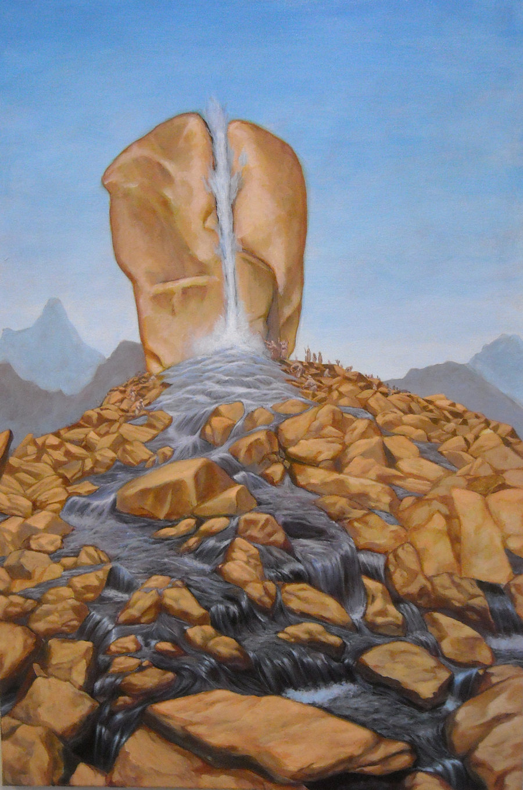

The Great Rock of Horeb!
Like Manna in the Wilderness, truth lies scattered about the camp of all who search the Scriptures and bother to gather it in daily. The Children have traveled from Egypt and the Wilderness of Sin enroute to Sinai, the Mount of the giving of the Law. Just as a pot of Manna was placed in the Ark, alongside the Tables of Commandments, so, too, are grace and law kept in balance to complement one another in the Kingdom of God. Horeb means ‘desert;’ but is also sometimes used to refer to Sinai. The Law, in its deepest meaning, is pure grace though to our meager understanding and obedience, it has become a curse. Have you ever considered that you were saved through the provisions of the Law – and that such salvation was a means of Grace and Law combined? How so, you may ask?

God gave the Law at Sinai, and man could not keep that law or satisfy its demands. The Manna (Bread of Heaven) and the Water of Life (from the Rock of Horeb) were given as a contrast to the inviolate law of God at Sinai as an expression of that pure grace manifested in the Manna and Water from the Rock at Horeb. This is further illustrated in the present travels of Israel being hallway between Sin (Egypt) and Sinai (Law). The only means by which we can approach obedience to the Law of God is by the means of Grace. Who’s Grace? The Grace of our Lord Jesus Christ! He came and lived a sinless life. He died a substitutionary death for us (under the terms of the Law) - for the wages of sin is death, and those wages MUST be satisfied. Christ satisfied that requirement and death sentence by the unimaginable depth of Grace He had in His Heart for you and me. He purchased us, not as slaves, but as brothers and sisters, friends, in the Kingdom of Heaven. His grace and love were sufficient to satisfy that debt. So you see we were, indeed, saved under the terms of the Law of God. But, at the same time, we are saved by that immeasurable Grace of Jesus Christ – not by any good works on our part, but all on His.

As Israel approached Mount Horeb, a great stone held vigilance over them and the valley below – the Rock of Horeb! What is that Rock so very important to our understanding of the whole Counsel of God? It is because that Rock symbolizes our Lord Jesus Christ – His love and grace despite our self-will and disobedience. Chapter 10 of 1 Corinthians is particularly illuminating on the subject and we have not space or time to expound upon all of it; however, read what Paul says of the Rock at Horeb: 1 Moreover, brethren, I would not that ye should be ignorant, how that all our fathers were under the cloud, and all passed through the sea; 2 And were all baptized unto Moses in the cloud and in the sea; 3 And did all eat the same spiritual meat; 4 And did all drink the same spiritual drink: for they drank of that spiritual Rock that followed them: and that Rock was Christ. 5 But with many of them God was not well pleased: for they were overthrown in the wilderness. (1 Cor 10:1-5) Is it not amazing how consistent and unified are the Scriptures from Genesis to Revelations! It is not possible to understand the import of what Christ accomplished for us fully without an understanding of the first Passover, and an understanding of our own Wilderness journey (and that of Israel). It is not possible to fully comprehend the Passover in Egypt without discovering its fuller meaning in the sacrifice of Christ at Mount Calvary (the same range upon which Abraham intended to sacrifice his dearly beloved son, Isaac).

1 And all the congregation of the children of Israel journeyed from the wilderness of Sin, after their journeys, according to the commandment of the LORD, and pitched in Rephidim: and there was no water for the people to drink. (Ex 17:1) There is a profound observance to be made here: The Children of Israel murmured in the Wilderness of sin for bread. God rained bread down from Heaven upon their stiff-necked heads. They were faithless even after witnessing the strong arm of the Lord in their salvation in Egypt and in the dividing of the might waters of the Red Sea! If Bread can be compared to the Word of God, and it is so for Christ is the Bread of Heaven, and He is also the Word Incarnate, then Water may be compared to the Spirit that animates the Word. As Jesus said to the demurring Woman at the Well, after establishing the Truth (Word) of the prophesied Messiah: But the hour cometh, and now is, when the true worshippers shall worship the Father in spirit and in truth: for the Father seeketh such to worship him. God is a Spirit: and they that worship him must worship him in spirit and in truth. (John 4:23-24) The Word (Body) is Truth, and the Spirit (Love) is the Water – both essential for life of the spirit of man. So the people murmured and whined for Bread while they were yet not far from their bondage in sin (Egypt). God, by His Grace, provided that Bread. Now, they murmur for want of WATER! What miserable creatures are they – and we – without faith in the works of God.

2 Wherefore the people did chide with Moses, and said, Give us water that we may drink. And Moses said unto them, Why chide ye with me? wherefore do ye tempt the LORD? 3 And the people thirsted there for water; and the people murmured against Moses, and said, Wherefore is this that thou hast brought us up out of Egypt, to kill us and our children and our cattle with thirst? (Ex 17:2-3) Does this not begin to sound like a broken record? There is a great distance between the grace of God and the tolerance of man. If I were God, I would probably have snuffed these miserable miscreants out on the spot – but lucky for them, I am not God. God is long suffering and full of Grace. Moreover, He is working out His amazing plan of salvation in the lesson He teaches us through Israel’s experiences. Though impertinent and nagging, He shows a level of mercy that they would have received from no earthly potentate – and they are precisely like you and me as our fears often grow and our faith falters!

When the people murmur against a Godly minister, he has no other resort than to the Lord: 4 And Moses cried unto the LORD, saying, What shall I do unto this people? they be almost ready to stone me. (Ex 17:4) Yes, they killed the prophets of God and came close to stoning Moses after all he had done through the guidance of the Lord for them.

The Lord will always answer directly the earnest prayers of His chosen and anointed: 5 And the LORD said unto Moses, Go on before the people, and take with thee of the elders of Israel; and thy rod, wherewith thou smotest the river, take in thine hand, and go. 6 Behold, I will stand before thee there upon the rock in Horeb; and thou shalt smite the rock, and there shall come water out of it, that the people may drink. And Moses did so in the sight of the elders of Israel. 7 And he called the name of the place Massah (Heb: temptation), and Meribah (Heb: strife), because of the chiding of the children of Israel, and because they tempted the LORD, saying, Is the LORD among us, or not? (Ex 17:5-7) There is to this day on Mount Horeb (a large Rock reputed to be the same that Moses struck. It is of tremendous size, but is clean-split from top to bottom. God will always stand before His ministers if they serve Him in both Spirit and in Truth. Jesus Christ was broken for you and me. We observe the breaking of that Body (Bread) in the Communion service. Out of Christ springs forth effulgent Springs of Living Water.

Sin and Doubt Precede War and Struggle:

8 Then came Amalek, and fought with Israel in Rephidim. 9 And Moses said unto Joshua, Choose us out men, and go out, fight with Amalek: to morrow I will stand on the top of the hill with the rod of God in mine hand. 10 So Joshua did as Moses had said to him, and fought with Amalek: and Moses, Aaron, and Hur went up to the top of the hill. 11 And it came to pass, when Moses held up his hand, that Israel prevailed: and when he let down his hand, Amalek prevailed. 12 But Moses' hands were heavy; and they took a stone, and put it under him, and he sat thereon; and Aaron and Hur stayed up his hands, the one on the one side, and the other on the other side; and his hands were steady until the going down of the sun. 13 And Joshua discomfited Amalek and his people with the edge of the sword.

The Body is One – the Church is the Body of Christ. God has granted us the privilege to serve Him as ministers, and if not ministers of the Word, then we are allowed to hold up the hands of the ministers of God. The holding up of the hands of Moses was tantamount to those of the Lord, for Moises was God’s anointed. God made Moses worthy of his Calling in Christ.

14 And the LORD said unto Moses, Write this for a memorial in a book, and rehearse it in the ears of Joshua: for I will utterly put out the remembrance of Amalek from under heaven. 15 And Moses built an altar, and called the name of it Jehovahnissi: 16 For he said, Because the LORD hath sworn that the LORD will have war with Amalek from generation to generation. (Ex 17:8-16)

Woe unto those nations who forget their heritage in God. We are to write the miraculous salvation of armies and nations in a book for our children to read that they forget not that it is the Lord who is the Captain of Battles, and not we ourselves. Have we done so for our dear American children. Are they taught the manner in which God established us as a nation, foremost among the nations of the earth? Have we allowed our children to wander from the old paths in which our fathers walked? “Thus saith the LORD, Stand ye in the ways, and see, and ask for the old paths, where is the good way, and walk therein, and ye shall find rest for your souls. But they said, We will not walk therein.” (Jer 6:16) Dear Christian patriot: Have we declined to obey the Lord in walking in the old paths and teaching our children to do the same? The name Moses gave the place of victory against Amalek, Jehovahnissi – the Lord is my Banner!

Is He YOURS?

