Exodus – Chapter 14 - 11 December 2014, Anno Domini

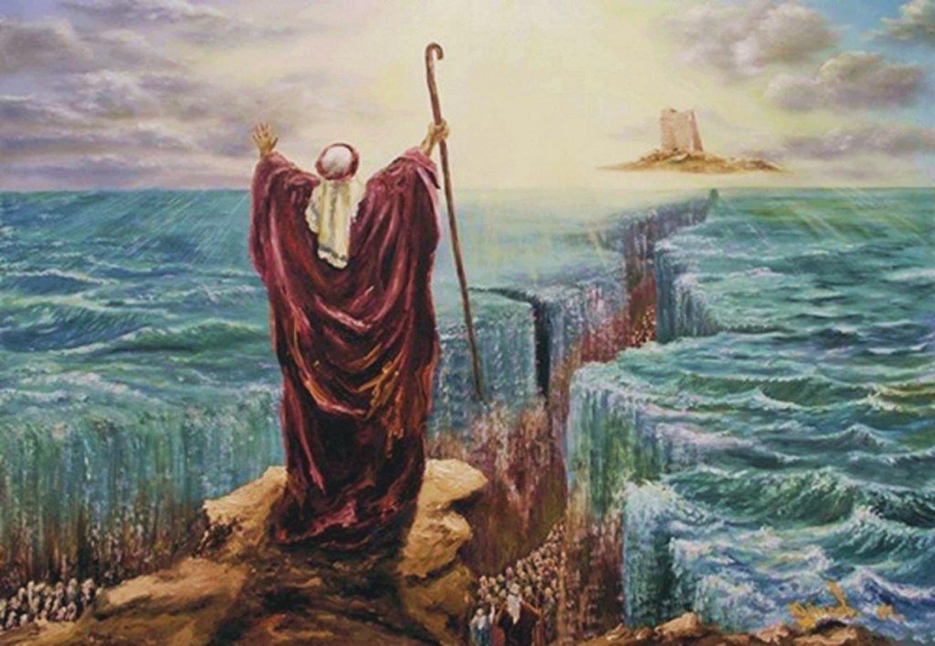

This chapter consists of four main stages:

- God, by design, draws Pharaoh’s Egyptian army to follow hard on the Children of Israel. His purpose is to entrap that army and demonstrate the power of Almighty God against an overweening and wicked sovereign;
- The murmuring of God’s people due to their lack of faith (murmurs always arise from that cause);
- God’s final Operations Order to Moses revealing His perfect plan to both save Israel and destroy Pharaoh;
- National Israel is baptized, in toto, under waters of the Red Sea and Pharaoh’s army is destroyed, in toto, in those same waters. “Moreover, brethren, I would not that ye should be ignorant, how that all our fathers were under the cloud, and all passed through the sea; And were all baptized unto Moses in the cloud and in the sea.” (1 Cor 10:1-2)

God instructs the Israelites in their journey
1 And the LORD spake unto Moses, saying, 2 Speak unto the children of Israel, that they turn and encamp before Pihahiroth, between Migdol and the sea, over against Baalzephon: before it shall ye encamp by the sea. 3 For Pharaoh will say of the children of Israel, They are entangled in the land, the wilderness hath shut them in. 4 And I will harden Pharaoh's heart, that he shall follow after them; and I will be honoured upon Pharaoh, and upon all his host; that the Egyptians may know that I am the LORD. And they did so. 5 And it was told the king of Egypt that the people fled: and the heart of Pharaoh and of his servants was turned against the people, and they said, Why have we done this, that we have let Israel go from serving us? 6 And he made ready his chariot, and took his people with him: 7 And he took six hundred chosen chariots, and all the chariots of Egypt, and captains over every one of them. 8 And the LORD hardened the heart of Pharaoh king of Egypt, and he pursued after the children of Israel: and the children of Israel went out with an high hand. 9 But the Egyptians pursued after them, all the horses and chariots of Pharaoh, and his horsemen, and his army, and overtook them encamping by the sea, beside Pihahiroth, before Baalzephon. (Exodus 14:1-9)

One clear note is sounded here on the Lord’s plan: He brings the Children of Israel to a seeming impasse in the marshes of the Red Sea – not for their ruin, but to demonstrate His mighty power to save. The Children of Israel were seemingly trapped in their position – hemmed in by marshes on one side, and the Sea on the other. They appeared easy pickings for the Egyptians. God not only knows the thoughts of the hearts of His people, but He also reads the thoughts of the hearts of the wicked. He knows Pharaoh’s character like a book because He is the one who made him. The mysteries of God are beyond our finding out. That which is a means of salvation to the people of God is also found to be trap for their enemies. As my Korean wife says: “God will kill ONE bird with TWO stones.”

The Israelites murmur
10 And when Pharaoh drew nigh, the children of Israel lifted up their eyes, and, behold, the Egyptians marched after them; and they were sore afraid: and the children of Israel cried out unto the LORD. 11 And they said unto Moses, Because there were no graves in Egypt, hast thou taken us away to die in the wilderness? wherefore hast thou dealt thus with us, to carry us forth out of Egypt? 12 Is not this the word that we did tell thee in Egypt, saying, Let us alone, that we may serve the Egyptians? For it had been better for us to serve the Egyptians, than that we should die in the wilderness. 13 And Moses said unto the people, Fear ye not, stand still, and see the salvation of the LORD, which he will shew to you to day: for the Egyptians whom ye have seen to day, ye shall see them again no more for ever. 14 The LORD shall fight for you, and ye shall hold your peace.” (Exodus 14:10-14)

It is easy to imagine the awe and fear of the defenseless Children of Israel as they see such a mighty army arrayed in all of the best accoutrements of war against them. Imagine: God has worked so many miracles in Egypt on the behalf of Israel. He has sent ten great plagues against the Egyptians, yet they remained untouched by those plagues. But they still doubt the power of the Lord to save them from Pharaoh’s army. Are we not the same faithless people today as were those of that day? One thing the Christian should always bear in mind: regardless of our triumph over mighty armies, the Battle is the Lord’s. “Thus saith the LORD unto you, Be not afraid nor dismayed by reason of this great multitude; for the battle is not yours, but God's.” (2 Chron 20:15)

Here we see that amazing promise of God in verses 13 & 14: 13 And Moses said unto the people, Fear ye not, stand still, and see the salvation of the LORD, which he will shew to you to day: for the Egyptians whom ye have seen to day, ye shall see them again no more for ever. 14 The LORD shall fight for you, and ye shall hold your peace.” If we stand still with faith, the Lord will do the fighting and the good works of our lives. We need take credit for no victory or any good works apart from the Lord.

God instructs Moses
15 And the LORD said unto Moses, Wherefore criest thou unto me? speak unto the children of Israel, that they go forward: 16 But lift thou up thy rod, and stretch out thine hand over the sea, and divide it: and the children of Israel shall go on dry ground through the midst of the sea. 17 And I, behold, I will harden the hearts of the Egyptians, and they shall follow them: and I will get me honour upon Pharaoh, and upon all his host, upon his chariots, and upon his horsemen. 18 And the Egyptians shall know that I am the LORD, when I have gotten me honour upon Pharaoh, upon his chariots, and upon his horsemen. 19 And the angel of God, which went before the camp of Israel, removed and went behind them; and the pillar of the cloud went from before their face, and stood behind them: 20 And it came between the camp of the Egyptians and the camp of Israel; and it was a cloud and darkness to them, but it gave light by night to these: so that the one came not near the other all the night. (Exodus 14:15-20)

The Light of God issuing forth from the cloud toward Israel at night was light to them, but the dark cloud was the side that faced the enemy and caused them to stumble in darkness. This cloud by day and fire by night was the very Angel of God – the Lord Himself. He went before the Children to point the Way; and He moved behind them when protection and salvation were necessary. The Lord Jesus Christ was that One who followed the Children in the wilderness. “ . . . for they drank of that spiritual Rock that followed them: and that Rock was Christ.” (1 Cor 10:4) Jesus is the Captain of our souls, and He is the One who “has our back” in battle.

The Israelites pass through the Red Sea
21 And Moses stretched out his hand over the sea; and the LORD caused the sea to go back by a strong east wind all that night, and made the sea dry land, and the waters were divided. 22 And the children of Israel went into the midst of the sea upon the dry ground: and the waters were a wall unto them on their right hand, and on their left. (Exodus 14:21-22)

The outstretched hand of Moses represented the outstretched arm of God. It is a sweet grace of God that He allows His children to have a ‘hand’ in His mighty works – but it is His power that parts the waters and not that of Moses! This miracle of the parting of the waves of the Red Sea is most extraordinary. The waters at the point of crossing are said to be more than 75 ft. deep. Imagine the two walls of water (one on the advancing side and the other on the receding side) being held erect and in place to make a way for the Children of Israel to cross over. That strong east wind was a heated tempest that dried the ground under their feet. Coming from the east, it must of necessity pass over the Empty Quarter of the Arabian Desert – the largest desert in the world (just to the east of the Red Sea). The air is completely devoid of humidity and will dry anything it touches.

23 And the Egyptians pursued, and went in after them to the midst of the sea, even all Pharaoh's horses, his chariots, and his horsemen. 24 And it came to pass, that in the morning watch the LORD looked unto the host of the Egyptians through the pillar of fire and of the cloud, and troubled the host of the Egyptians, 25 And took off their chariot wheels, that they drave them heavily: so that the Egyptians said, Let us flee from the face of Israel; for the LORD fighteth for them against the Egyptians. (Ex 14:23-25)

The Egyptians pursued on the heels of the Children of Israel into the bed of the Sea. But the Pillar of Fire that followed them waited its due season to slam the door of the trap on the Egyptians. Once the entire Egyptian army was in the bed of the Sea, God peered back at them from the Cloud and the Light was blinding and caused confusion for the chariots and cavalry of the Egyptians. IT is likely that the traces and horses of the chariots became entangled together and must have been abandoned. It is interesting to note that a number of chariot wheels have been discovered fairly well preserved at the bottom of the Red Sea only recently.

http://www.bing.com/images/search?q=chariot+wheels+discovered+at+red+sea&id=23E8F360CCDBDE606B18E16F584656D6799B9232&FORM=IQFRBA)

26 And the LORD said unto Moses, Stretch out thine hand over the sea, that the waters may come again upon the Egyptians, upon their chariots, and upon their horsemen. 27 And Moses stretched forth his hand over the sea, and the sea returned to his strength when the morning appeared; and the Egyptians fled against it; and the LORD overthrew the Egyptians in the midst of the sea. 28 And the waters returned, and covered the chariots, and the horsemen, and all the host of Pharaoh that came into the sea after them; there remained not so much as one of them. 29 But the children of Israel walked upon dry land in the midst of the sea; and the waters were a wall unto them on their right hand, and on their left. 30 Thus the LORD saved Israel that day out of the hand of the Egyptians; and Israel saw the Egyptians dead upon the sea shore. 31 And Israel saw that great work which the LORD did upon the Egyptians: and the people feared the LORD, and believed the LORD, and his servant Moses. (Ex 14:26-31)

To have experienced such a mighty work of God in their salvation would seem to have sealed their faith forever, but succeeding history proves that these stiff-necked people took occasion to murmur against Moses and the Lord at a later time as if the Lord had never lifted a hand in their defense. How fickle are we in trusting both the power and mercy of God!

It seems God sanctifies not only individuals, but nations, to His purpose as He did here with the descendants of our father, Abraham. The entire nation was baptized under the waters of the Red Sea. They were symbolically covered by the Crimson Blood of Christ in both the Passover of the Angel of Death, and the Pass-under the crimson Sea with the Angel of Life. But there were yet many who were not all clean as was not Judas. We must come before the Lord in humility and repentance to receive Him wholly. Have you done?

