Exodus – Chapter 13 - 10 December 2014, Anno Domini

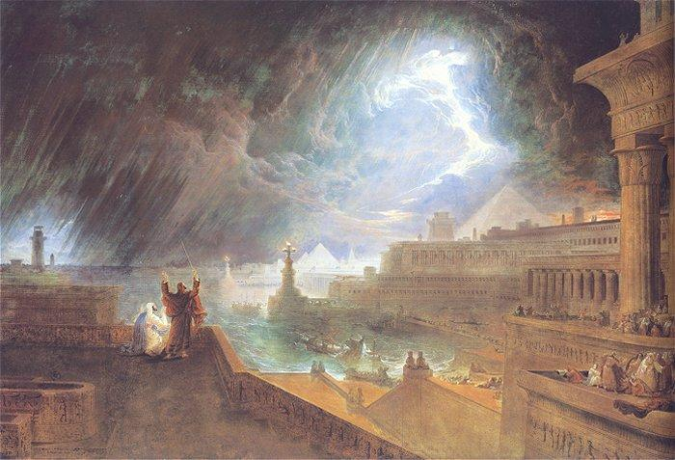

The gravity of this chapter, and the next few chapters, of Exodus are of such profound meaning that it becomes difficult to relate the depth of meaning in a devotional format. I urge the reader to study these chapters for a deeper understanding. Hopefully, today’s devotion, and the next, will serve to outline your studies.

On a somewhat dismal Sunday afternoon, two men were walking on the Road to Emmaus lamenting the events of the past three days (the crucifixion and burial of their great Teacher. They had thought that He could not be killed by any man, but there you have it. He is dead and buried – or so they believed. Suddenly, a third party joins in their conversation and asks the reason for their despondency. They are surprised that there is any so foolish or uninformed as to not know the sordid events that has stolen their own joy in all of the region. Little did they know that the Savior, whose death they mourned, walked by their very side. The life of the Christian is like that. During the moments that our faith seems to plunge to the depths of the sea and we fill alone and abandoned by God and man, The One who is BOTH God and man is walking right beside us in our sorrow and doubts. How blind if the faithless eye!

In the passage today, God has brought the Children of Israel on the way to leave Egypt. He has promised to bring them out, and He has done so with a Mighty Arm. He is with them on the way just as He is with us on our way (if we are His). “And Moses said unto God, Who am I, that I should go unto Pharaoh, and that I should bring forth the children of Israel out of Egypt? And he said, Certainly I will be with thee; and this shall be a token unto thee, that I have sent thee: When thou hast brought forth the people out of Egypt, ye shall serve God upon this mountain.” (Ex 3:11-12) Just as surely as the Lord was with the two men on the Road to Emmaus, He is with you and me as we travel the Road of Life. As the Children leave Goshen, God directs their way just as He directs our own steps today.

The firstborn are sanctified to God
1 And the LORD spake unto Moses, saying, 2 Sanctify unto me all the firstborn, whatsoever openeth the womb among the children of Israel, both of man and of beast: it is mine. You will observe that the just as the Lord required the first born of Egypt in that terrible Passover night, so He requires the consecration of Israel’s first-born to Himself. The foundation of this duty rested on the fact that the Israelites, having had their first-born preserved by a distinguishing act of grace from the general destruction that overtook the families of the Egyptians, were bound in token of gratitude to consider them as the Lord's peculiar property. The called out in the Church of the First Born are likewise consecrated to God. “To the general assembly and church of the firstborn (the Lord Jesus Christ), which are written in heaven, and to God the Judge of all, and to the spirits of just men made perfect.” (Heb 12:23) Redemption of the first-born male child of Israel required the sacrifice of a lamb.

The Passover Commanded
3 And Moses said unto the people, Remember this day, in which ye came out from Egypt, out of the house of bondage; for by strength of hand the LORD brought you out from this place: there shall no leavened bread be eaten. 4 This day came ye out in the month Abib. 5 And it shall be when the LORD shall bring thee into the land of the Canaanites, and the Hittites, and the Amorites, and the Hivites, and the Jebusites, which he sware unto thy fathers to give thee, a land flowing with milk and honey, that thou shalt keep this service in this month. 6 Seven days thou shalt eat unleavened bread, and in the seventh day shall be a feast to the LORD. 7 Unleavened bread shall be eaten seven days; and there shall no leavened bread be seen with thee, neither shall there be leaven seen with thee in all thy quarters. 8 And thou shalt shew thy son in that day, saying, This is done because of that which the LORD did unto me when I came forth out of Egypt. 9 And it shall be for a sign unto thee upon thine hand, and for a memorial between thine eyes, that the LORD'S law may be in thy mouth: for with a strong hand hath the LORD brought thee out of Egypt. 10 Thou shalt therefore keep this ordinance in his season from year to year. (Ex 13:3-10)

ABIB roughly equates of our March-April period on the modern calendar. This is the Passover that is to be kept as an observance forever. We still keep the Passover in our observance of Holy Communion. There are two significant symbols here that gives us a better understanding of the nature of the Lord’s Supper – Egypt and Leaven! Egypt prophetically symbolizes the Life of Sin. God has redeemed us through the Blood of the Lamb from our penalty for sin. Leaven represents the spreading effects of sin and false doctrine. It is for this reason that we consume unleavened bread in the Communion. The Bread represents the Body of Christ, and Christ was sinless; therefore the symbol must remain consistent with that which is being symbolized. Matzo bread is a fitting symbol of that unleavened bread of the Passover. For convenience, we use the unleavened wafer today.

The firstborn of beasts are set apart
11 And it shall be when the LORD shall bring thee into the land of the Canaanites, as he sware unto thee and to thy fathers, and shall give it thee, 12 That thou shalt set apart unto the LORD all that openeth the matrix, and every firstling that cometh of a beast which thou hast; the males shall be the LORD'S. 13 And every firstling of an ass thou shalt redeem with a lamb; and if thou wilt not redeem it, then thou shalt break his neck: and all the firstborn of man among thy children shalt thou redeem. 14 And it shall be when thy son asketh thee in time to come, saying, What is this? that thou shalt say unto him, By strength of hand the LORD brought us out from Egypt, from the house of bondage: 15 And it came to pass, when Pharaoh would hardly let us go, that the LORD slew all the firstborn in the land of Egypt, both the firstborn of man, and the firstborn of beast: therefore I sacrifice to the LORD all that openeth the matrix, being males; but all the firstborn of my children I redeem. 16 And it shall be for a token upon thine hand, and for frontlets between thine eyes: for by strength of hand the LORD brought us forth out of Egypt.

Here I should point out that all who are the redeemed of the Lord (the OT & NT Church) are those for whom the Blood of Christ (the First-Born) was shed in propitiation for sins. The observance of Passover is a memorial to the redemption of God’s people from slavery in Egypt. The observance of the new Passover (Holy Communion) is the memorial of the redemption of the People of God from sin by the shed blood of the First-Born – Jesus Christ – the Lamb of God.

The Israelites go out of Egypt, and carry Joseph's bones with them
“17 And it came to pass, when Pharaoh had let the people go, that God led them not through the way of the land of the Philistines, although that was near; for God said, Lest peradventure the people repent when they see war, and they return to Egypt: 18 But God led the people about, through the way of the wilderness of the Red sea: and the children of Israel went up harnessed out of the land of Egypt. 19 And Moses took the bones of Joseph with him: for he had straitly sworn the children of Israel, saying, God will surely visit you; and ye shall carry up my bones away hence with you. 20 And they took their journey from Succoth, and encamped in Etham, in the edge of the wilderness. (Exodus 13:17-20)

You are reminded of the promise Joseph demanded from his brethren that his bones not be left in Egypt. “And Joseph took an oath of the children of Israel, saying, God will surely visit you, and ye shall carry up my bones from hence.” (Gen 50:25) When we leave sin and Egypt, we are to leave no part of our persons behind – only those things that belong to sin unlike the wife of Lot who could not bear leaving her luxuries in Sodom and cast a longing, and salty, look back.

God neither forsakes nor leaves His people

“21 And the LORD went before them by day in a pillar of a cloud, to lead them the way; and by night in a pillar of fire, to give them light; to go by day and night: 22 He took not away the pillar of the cloud by day, nor the pillar of fire by night, from before the people.” (Ex 13:21-22) “Lo, I am with you alway, even unto the end of the world. Amen.” (Matt 28:20) “I will never leave thee, nor forsake thee.” (Heb 13:5) He is ALWAYS with His people. Not only did God send forth the Pillar of Fire by Night, and the Pillar of a Cloud by Day, but God Himself was in that Pillar to defend His people, Israel. Those who travel in the dark streets of night need light from without themselves. For the Christian, walking in this dark and sinful world, we need the Light of God’s Word. We dare not go a single day without that Light! The Pillar of Cloud and Fire serves to both lead us, and to defend us from the enemy who “walks about as a roaring lion seeking whom he may devour.” The Pillar of Cloud is called the Glory, and that Cloud-Pillar is represented on the Seal of the United States above the great Eagle. How we need, but have abandoned today, that leading of God in our national life.

There are eight verses in the National Anthem of Serbia every line of which makes strong reference to the salvation of God for their country. Perhaps we could revert to back to “God Bless our Native Land” as a more fitting anthem. For your information I include the National Anthem of Serbia below:

God of Justice
God of Justice, You who saved us
From the disasters of the past,
Today, hear the voices of Your children,
And be our salvation, just as in old times.

Defend with Your mighty hand,
That very future Serbia walks to,
God save; God defend,
Serbian lands and Serbian people!

Bind them closer, fellow Serbians
Teach them everlasting love,
United our enemies we'll conquer
This shall defend us all.

Serbia's golden fruits are now ripe
gracing high from liberty's tree,
God save; God defend,
Serbian lands and Serbian people!

Save all Serbians from Your anger,
Thunder coming from up above,
Bless every Serbian village,
Mountain, meadow, town and home!

When the days of battle happen,
to the victory lead the pace,
God save, God defend,
Serbian lands and Serbian people!
In that sepulcher of years
Serbia's glory rises anew,
A new era now is dawning,
A new beginning, God gave us!

Sustain for us the Serbian fatherland,
just like the five centuries passed,
God save, God defend,
Thus entreats the Serbian people!

This anthem is a fitting prayer to which we can utter, “AMEN!”

