Exodus – Chapter 12 – Part 2 - 6 December 2014, Anno Domini

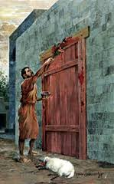

The only power the ungodly understand is brute force. Reason and compassion do not register in their hearts. The Lord gave Pharaoh every reason to know that He was the God of all, but Pharaoh disbelieved in the face of insurmountable miracles. The plagues sent upon Egypt have been gradually escalating to the point of this final plague which transcends all others. The sins of Pharaoh will be visited upon both the wicked and the innocent of Egypt. Most nations have precisely the rulers they deserve. It is impossible for a free people (whose hearts are also free) to be ruled by a ten-horned despot; but a vulgar and ignorant people are quite easy to oppress. The lack of logic and reason among the people of America has brought down upon their shoulders, for the first time, the specter of oppression and totalitarian rule. Who can they blame but themselves? The same is true in Egypt. The people will suffer for their choices as do any people who abandon righteous rule.

In the early days of my education, people still described a lady or a gentleman as a person of ‘good breeding.’ Such reference became passé with the onslaught of politically correct speech and hatred of classical manners and art. But what is good breeding if not the proper and Godly nurture of children by a Godly mother and father? It means transferring the faith and beliefs of the parents to the child, polite manners, and compassionate heart. Bad breeding is allowing the child to become as wicked as the imagination will accommodate. “Then Moses called for all the elders of Israel, and said unto them, Draw out and take you a lamb according to your families, and kill the passover.” (Ex 12:21) Worship and faith, to the ancient Hebrews, involved the whole family as did the selection of the Passover lamb and its benefits.

“And ye shall take a bunch of hyssop, and dip it in the blood that is in the bason, and strike the lintel and the two side posts with the blood that is in the bason; and none of you shall go out at the door of his house until the morning.” (Ex 12:22) The commandment of God was to each family member. NONE were to go outside during that darkest of nights in Egypt. The blood, both above and on adjacent doorposts, protected all inside the house from the curse of death. This is a hint of the meaning of baptism of children as a covenantal practice. Just as the whole house of Zaccheus was saved by his coming to Christ, so the head of every household is responsible for bringing his children to Christ.

The Angel of Death was restrained by the Lord from entering any dwelling that was marked by the blood of the lamb. The same is true today. When the Lord passes over the host of all living and dead at the last trumpet, He will not countenance the Angel of Death to touch any under the Blood of the Lamb of God – we are marked by the Blood of Christ! “For the LORD will pass through to smite the Egyptians; and when he seeth the blood upon the lintel, and on the two side posts, the LORD will pass over the door, and will not suffer the destroyer to come in unto your houses to smite you.” (Ex 12:23) Now, it must be noted, the Lord already knows who are His and who are not; but the application of the blood was a sign of a more profound Passover to come. God does require faith and obedience from His people, and provides them means of demonstrating the same.

“And ye shall observe this thing for an ordinance to thee and to thy sons for ever. 25 And it shall come to pass, when ye be come to the land which the LORD will give you, according as he hath promised, that ye shall keep this service.” (Ex 12:24-25) The inauguration of the Passover in Egypt was not temporary change in the way the Lord expects His people to worship. He is the same today, yesterday, and forever; it was the beginning of a perpetual observation for all of Israel – the Old Testament Church, as well as the New Testament Church. Our Easter would more correctly be called the Passover rather than Easter. The term “Easter’ appears only once in Scripture in a reference by the wicked Herod (Acts 12:4) and has no meaning related to Passover. Our Holy Communion is a Passover observance, for Christ has become our Passover, and it is His body and blood we observe in the elements at the Lord’s Table – just as the Passover lamb and unleavened bread were consumed in Goshen.

The explanation of our Lord’s Passover is very clearly explained: “And it shall come to pass, when your children shall say unto you, What mean ye by this service? That ye shall say, It is the sacrifice of the LORD'S passover, who passed over the houses of the children of Israel in Egypt, when he smote the Egyptians, and delivered our houses. And the people bowed the head and worshipped.” (Ex 12:26-27) The explanation is further clarified in the New Testament: “Purge out therefore the old leaven, that ye may be a new lump, as ye are unleavened. For even Christ our passover is sacrificed for us: Therefore let us keep the feast, not with old leaven, neither with the leaven of malice and wickedness; but with the unleavened bread of sincerity and truth.” (1 Cor 5:7-8)

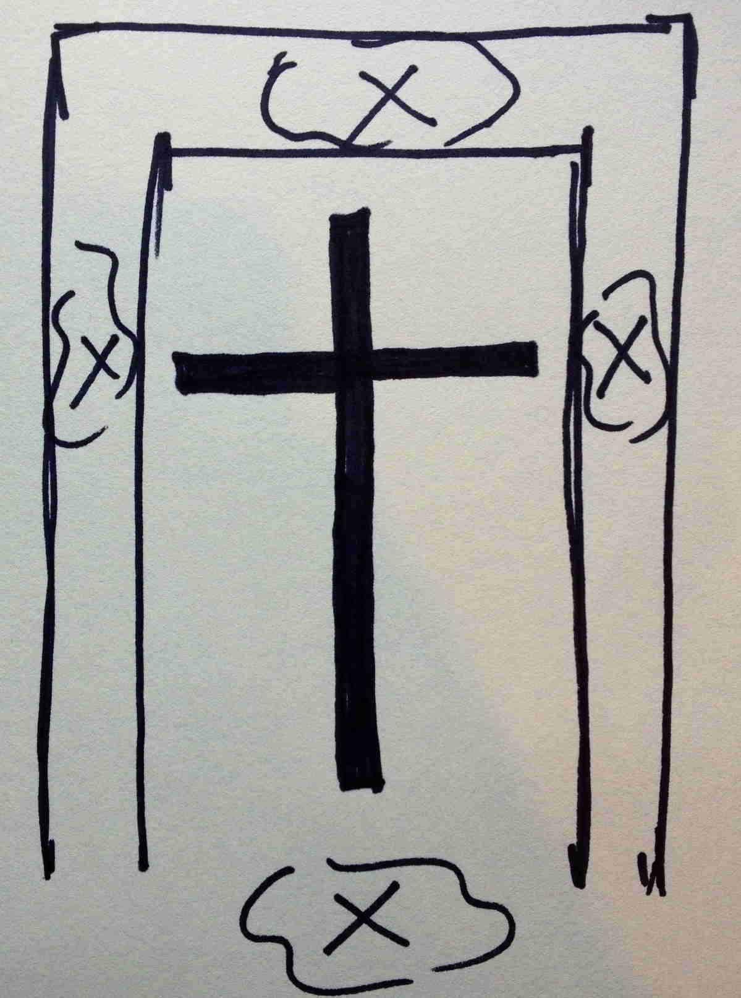
It is altogether fitting that we study the deeper meaning of the Passover of Christ compared with that in Egypt. Benjamin Keach, in his book - “Preaching from the Types and Metaphors of the Bible” - lists more than twenty five parallels of exact application between that first Passover and the final Passover of Christ. We are to teach our children of the meaning as well. How many adults, much less children, partake of the Holy Communion without an inkling of the depth of its meaning? Do we bow our own heads in worship, or do we practice a charismatic “free-for-all” in bedlam! “And the children of Israel went away, and did as the LORD had commanded Moses and Aaron, so did they.” (Ex 12:28)

The judgment of God against a land knows no distinction of class or position. “And it came to pass, that at midnight the LORD smote all the firstborn in the land of Egypt, from the firstborn of Pharaoh that sat on his throne unto the firstborn of the captive that was in the dungeon; and all the firstborn of cattle.” (Ex 12:29) As we can see, even the beasts of the field suffered judgment that horrible night in Egypt. “And Pharaoh rose up in the night, he, and all his servants, and all the Egyptians; and there was a great cry in Egypt; for there was not a house where there was not one dead.” (Ex 12:30) That great cry in the night in Egypt was not singular, but the general population in common, rising up, with Pharaoh, too, to mourn the death of a precious child. The wicked may presume that they are getting away with a life of sin, but the judgments of God will come in due time and bring even the wicked to their knees.

“And he called for Moses and Aaron by night, and said, Rise up, and get you forth from among my people, both ye and the children of Israel; and go, serve the LORD, as ye have said. Also take your flocks and your herds, as ye have said, and be gone; and bless me also. And the Egyptians were urgent upon the people, that they might send them out of the land in haste; for they said, We be all dead men.” (Ex 12:31-33) This is a precise fulfillment of the prophecy of Moses, based upon God’s counsel, in Chapter 11: “And all these thy servants shall come down unto me, and bow down themselves unto me, saying, Get thee out, and all the people that follow thee: and after that I will go out. And he went out from Pharaoh in a great anger.” (Ex 11:8) Moses spoke with the knowledge God had imparted previously: “Yet will I bring one plague more upon Pharaoh, and upon Egypt; afterwards he will let you go hence: when he shall let you go, he shall surely thrust you out hence altogether.” (Ex 11:1) As always, God’s Word was fulfilled to the jot and tittle.

“And the people took their dough before it was leavened, their kneadingtroughs being bound up in their clothes upon their shoulders. And the children of Israel did according to the word of Moses; and they borrowed of the Egyptians jewels of silver, and jewels of gold, and raiment: And the LORD gave the people favour in the sight of the Egyptians, so that they lent unto them such things as they required. And they spoiled the Egyptians.” (Ex 12:34-36) This was not a dishonest borrowing. They were simply receiving from the Egyptians a tiny remuneration for years and centuries of forced slavery and persecution.

“And the children of Israel journeyed from Rameses to Succoth, about six hundred thousand on foot that were men, beside children. And a mixed multitude went up also with them; and flocks, and herds, even very much cattle.” (Ex 12:37-38) It appears from this passage that there were a small number of Egyptians who came to fear the True God of the Universe during the time of plagues against their sovereign.

“Now the sojourning of the children of Israel, who dwelt in Egypt, was four hundred and thirty years. And it came to pass at the end of the four hundred and thirty years, even the selfsame day it came to pass, that all the hosts of the LORD went out from the land of Egypt. It is a night to be much observed unto the LORD for bringing them out from the land of Egypt: this is that night of the LORD to be observed of all the children of Israel in their generations.” (Ex 12:40-42) What a night that was! What a night of fear and doubt the apostles experienced during the time of Jesus’ body lying in the Garden Tomb! This was that Night of the Lord!

We learn in Exodus 13:4 the coming out of Egypt occurred during the month of Abib (Nisan). The month of Abib corresponds to the month of Nisan in the Hebrew calendar. It is the first month of the year and symbolizes “coming out”. It was this time that Noah’s Ark rested on Ararat, Abraham was called out, Isaac was born, the Tabernacle raised in the Wilderness, John the Baptist began his ministry, and the Great Passover of Christ (His crucifixion) occurred.

And the LORD said unto Moses and Aaron, This is the ordinance of the passover: There shall no stranger eat thereof.” (Ex 12:43) This warning applies with even greater import today: “Wherefore whosoever shall eat this bread, and drink this cup of the Lord, unworthily, shall be guilty of the body and blood of the Lord. But let a man examine himself, and so let him eat of that bread, and drink of that cup. For he that eateth and drinketh unworthily, eateth and drinketh damnation to himself, not discerning the Lord's body.” (1 Cor 11:27-29) “But every man's servant that is bought for money, when thou hast circumcised him, then shall he eat thereof. A foreigner and an hired servant shall not eat thereof.” (Ex 12:44-45)

“In one house shall it be eaten; thou shalt not carry forth ought of the flesh abroad out of the house; neither shall ye break a bone thereof. All the congregation of Israel shall keep it.” (Ex 12:46-47) In the Church, the family of God comes together under one roof to partake of the Communion. The Communion Service symbolizes our Oneness with Christ!

THE STRANGER:
“And when a stranger shall sojourn with thee, and will keep the passover to the LORD, let all his males be circumcised, and then let him come near and keep it; and he shall be as one that is born in the land: for no uncircumcised person shall eat thereof. One law shall be to him that is homeborn, and unto the stranger that sojourneth among you.” (Ex 12:48-49) God deals with His people of today by the same rule that He dealt with ancient Israel – for all who believe in the Promised Seed of Abraham are Israel indeed. The Church recognizes this Oneness by means of the Sacrament of Baptism and the Lord’s Supper. The children of Israel were strangers in Egypt, and all others are strangers in Israel until they are admitted to the family of God (Israel). You and I were strangers until we came near by faith to Christ.

“Thus did all the children of Israel; as the LORD commanded Moses and Aaron, so did they.” (Ex 12:50) Do we, too, believe all that the prophets have said concerning God’s Word and His only Begotten Son; and, if we have believed, have we obeyed all that has been commanded?

“And it came to pass the selfsame day, that the LORD did bring the children of Israel out of the land of Egypt by their armies.” (Ex 12:51) Egypt, scripturally, represents sin and idolatry. The Children of Israel were brought out of that sodden land en masse. Though it was Pharaoh who was forced at last to recognize the True God and to release the people, it was nonetheless by the Hand of the Lord that they were set free.

We may now brace ourselves for even more wonderful works and miracles of the Lord that have direct meaning to us today.

