Exodus – Chapter 12 – Part 1 - 5 December 2014, Anno Domini

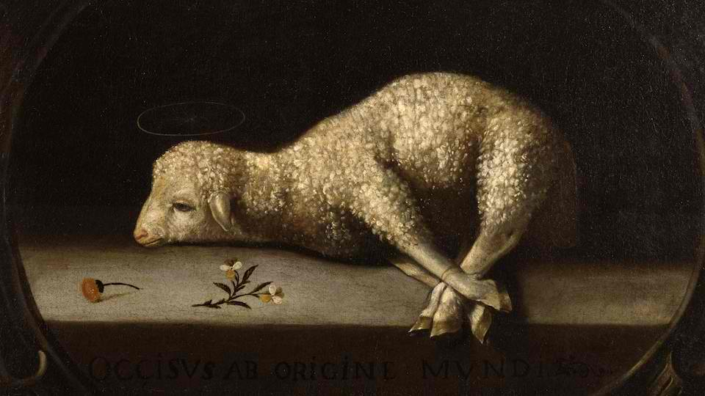

The Pharaoh of Egypt was worshipped as a god of the land. He should not feel all that exclusive, however, since frogs and beetles were so recognized as well. In actuality, the great struggle between Moses and Pharaoh was one that symbolized the historic, Edenic struggle between false gods and the True God of Heaven.

This chapter rises to singular importance in its representation of the deep and full meaning of redemption by the blood of Christ – in fact, so important that I will cover the chapter in two parts. The reader must bear in mind, however, that the depth of meaning is of far too great a magnitude to be covered in many volumes of books except those sixty-six books of our Holy Bible. The first Passover represents a stark parallel to that greater Passover of the Lamb of God on the brow of Calvary Mountain. The Passover in Egypt was a mere image of that which was to be culminated by the death of our Lord Jesus Christ – the true Passover Lamb and, in fact, our PASSOVER! “Purge out therefore the old leaven, that ye may be a new lump, as ye are unleavened. For even Christ our passover is sacrificed for us: Therefore let us keep the feast, not with old leaven, neither with the leaven of malice and wickedness; but with the unleavened bread of sincerity and truth.” (1 Corinthians 5:7-8)

The tenth plague that God issues against Pharaoh and the land of Egypt could be rationally considered their tithe of blood to God, for the tithe is a tenth of the first-fruits of the people. The tenth plague requires the lives of the first-born of Egypt (first fruits of the very people). It is the bitter tithe of a cursed people as contrasted with that of a Holy people such as Israel was considered by the Lord.

The chapter might be divided in the following parts:

- God’s dealing with Pharaoh
  - Pharaoh’s lack of heed for the first nine plagues
  - The final plague of death of first borns (the Passover) (12:14-28)
- Redemption of God’s people
  - By blood – 12:12-36
  - By power – (12:37-14:31) First Stage of Journey (12:37-51)

“And the LORD spake unto Moses and Aaron in the land of Egypt, saying, This month shall be unto you the beginning of months: it shall be the first month of the year to you.” (Ex 12:1-2) I need not remind the serious Bible scholar of the New Birth and Life that begins when one is covered by the Blood of the Pascal (Passover) Lamb – it begins not only a new year, but a new creation as well. Here is the Passover of Christ – “Therefore if any man be in Christ, he is a new creature: old things are passed away; behold, all things are become new.” (2 Cor 5:17) In the Hebrew calendar, the first day of Passover is Nissan 15 (April 11 this year of 2015) - very appropriate for this is the beginning of the old Hebrew year (Spring, when life is created). “Speak ye unto all the congregation of Israel, saying, In the tenth day of this month they shall take to them every man a lamb, according to the house of their fathers, a lamb for an house: And if the household be too little for the lamb, let him and his neighbour next unto his house take it according to the number of the souls; every man according to his eating shall make your count for the lamb. Your lamb shall be without blemish, a male of the first year: ye shall take it out from the sheep, or from the goats: And ye shall keep it up until the fourteenth day of the same month: and the whole assembly of the congregation of Israel shall kill it in the evening.” (Ex 12:3-6) Have you considered the points of exact congruence of the passive lamb of Goshen to that of the true Passover Lamb of God? Jesus Christ was the Lamb of God – without blemish or spot: “Forasmuch as ye know that ye were not redeemed with corruptible things, as silver and gold, from your vain conversation received by tradition from your fathers; But with the precious blood of Christ, as of a lamb without blemish and without spot: Who verily was foreordained before the foundation of the world, but was manifest in these last times for you.” (1 Peter 1:18-20) Moreover, Jesus came as a Son of His Father (a male). He died in the very bud and bloom of His manhood. He was taken from among men and was the only one who was worthy to die in our stead for our sins. He was sacrificed on Passover Eve – at the very moment (6 PM) of the Temple sacrifice of the Passover Lamb. The next day was dawning at sunset – the beginning of the High Sabbath (2nd day of Passover – the night on which the first-born of Egypt had died and the first-born of Israel were spared). That high Sabbath would have been the 15th of Nissan when Pharaoh awakened to the horror of his first-born being dead! “And they shall take of the blood, and strike it on the two side posts and on the upper door post of the houses, wherein they shall eat it.” (Ex 12:7) In brushing the blood of the Passover lamb on the sides of the door (vertical strokes, and the lintels (upper posts of the houses - horizontal) they were unwittingly using that same pattern that the cross makes with its vertical and horizontal beams. The long vertical beam of the cross illustrates our duty to God; the shorter horizontal beam illustrates our duty to our neighbor as outlined in the Great and Second Commandment: “Thou shalt love the Lord thy God with all thy heart, and with all thy soul, and with all thy mind. This is the first and great commandment. And the second is like unto it, Thou shalt love thy neighbour as thyself. On these two commandments hang all the law and the prophets.” ¯¯

“And they shall eat the flesh in that night, roast with fire, and unleavened bread; and with bitter herbs they shall eat it. Eat not of it raw, nor sodden at all with water, but roast with fire; his head with his legs, and with the purtenance thereof. And ye shall let nothing of it remain until the morning; and that which remaineth of it until the morning ye shall burn with fire. And thus shall ye eat it; with your loins girded, your shoes on your feet, and your staff in your hand; and ye shall eat it in haste: it is the LORD'S passover.” ¯¯ Observe how this reflects our observance of the Lord’s Supper. The Bread is Unleavened for leaven represents sin, or false doctrine. (Matthew 16:12) They were to consume it ALL – as we consume ALL of the Bread and Cup of the Holy Communion (it represents the Body and Blood of our Lord). Note also that this represents “the Lord’s Passover” – not a mere tradition of men!

In actuality, we observe in this passage the inauguration of the Lord’s Supper, or PASSOVER: “For I will pass through the land of Egypt this night, and will smite all the firstborn in the land of Egypt, both man and beast; and against all the gods of Egypt I will execute judgment: I am the LORD. And the blood shall be to you for a token upon the houses where ye are: and when I see the blood, I will pass over you, and the plague shall not be upon you to destroy you, when I smite the land of Egypt. And this day shall be unto you for a memorial; and ye shall keep it a feast to the LORD throughout your generations; ye shall keep it a feast by an ordinance for ever.” (Ex 12:12-14) Though our mode of observance was changed by the Lord on the night of His betrayal, we are nonetheless commanded to keep the Passover of the Lord forever. Those who are saved by the Blood of Christ from that darkness and death that will come upon the land may partake of the Lord’s Supper worthily and enjoy the bliss of knowing that the Angel of Death will Passover them at the last day. When that awesome Angel sees the Blood of Christ over the doorposts and lintels of your heart, he will PASSOVER you and you shall LIVE!

“Seven days shall ye eat unleavened bread; even the first day ye shall put away leaven out of your houses: for whosoever eateth leavened bread from the first day until the seventh day, that soul shall be cut off from Israel. And in the first day there shall be an holy convocation, and in the seventh day there shall be an holy convocation to you; no manner of work shall be done in them, save that which every man must eat, that only may be done of you.” (Ex 12:15-16) Leaven, as a type of sin, was removed from all homes. Then at twilight, as the 14th day of Nisan was ending, the Passover lambs were slain. Sunset initiated the first day of the Feast of Unleavened Bread. Nisan 15 was a "High Sabbath". Bread baked without yeast was eaten during the seven days of the feast. Sunset began the 15th day of Nisan. Jesus was buried, just in time for the Feast of Unleavened Bread. But in the grave His body did not decay or see corruption. That Passover the sinless unleavened 'Bread of Heaven' was revealed as that long awaited perfect sacrifice for sin. Thus He fulfilled the Feast of Unleavened Bread and the Passover Lamb.

“And ye shall observe the feast of unleavened bread; for in this selfsame day have I brought your armies out of the land of Egypt: therefore shall ye observe this day in your generations by an ordinance for ever. In the first month, on the fourteenth day of the month at even (the very moment of Christ death), ye shall eat unleavened bread, until the one and twentieth day of the month at even. Seven days shall there be no leaven found in your houses: for whosoever eateth that which is leavened, even that soul shall be cut off from the congregation of Israel, whether he be a stranger, or born in the land. Ye shall eat nothing leavened; in all your habitations shall ye eat unleavened bread.” (Ex 12:17-20) Leaven represents sin, and bread represents (in the Communion) the Pure and Sinless Body of Christ – therefore the symbol must be consistent with that being symbolized. It is for this reason that we eat unleavened bread (usually a wafer) in Holy Communion. “Ye cannot drink the cup of the Lord, and the cup of devils: ye cannot be partakers of the Lord's table, and of the table of devils.” (1 Cor 10:21) It is also for this reason that we must not come to the Lord’s Table bearing malice toward our brother. “Therefore if thou bring thy gift to the altar, and there rememberest that thy brother hath ought against thee; Leave there thy gift before the altar, and go thy way; first be reconciled to thy brother, and then come and offer thy gift.” (Matt 5:23-24)

The Passover in Egypt was only new to Pharaoh and his people. But the true Passover was ordained from before the Foundations of the World. Even in the dim and glimmering eternities past, that Passover was ordained of God to be our salvation in all time – both BEFORE and AFTER the actual crucifixion, for that which is ordained of God is ordained by the Great I AM – existing in the Eternal Presence – and is already reality.

