Exodus – Chapter 11 - 4 December 2014, Anno Domini

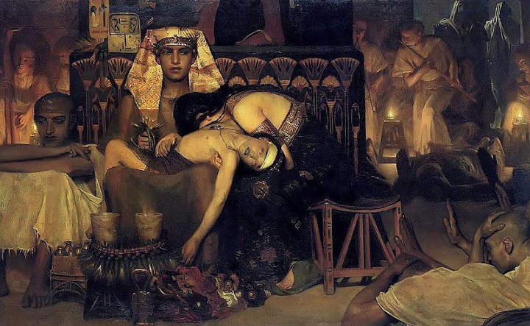

Pharaoh could not undersigned that God does not threaten, He promises and never goes back on a promise

In Chapter Eleven, God prepares the ground for one of the most spectacularly blessed events for the people of God in all Scripture – the PASSOVER! Though the Passover first takes place in Egypt, it will find its fulfillment in a Garden Tomb outside the gates of Jerusalem. The matchless grace of God is fore-shadowed in the Passover (Pascal) Lamb exemplifying the Lord Jesus Christ - “Forasmuch as ye know that ye were not redeemed with corruptible things, as silver and gold, from your vain conversation received by tradition from your fathers; But with the precious blood of Christ, as of a lamb without blemish and without spot: Who verily was foreordained before the foundation of the world, but was manifest in these last times for you.” (1 Peter 1:18-20)

It is regrettable for the children of Egypt that they shall suffer for the wickedness of their rulers, and especially Pharaoh, but it has ever been so in the history of nations. “When the righteous are in authority, the people rejoice: but when the wicked beareth rule, the people mourn.” (Prov 29:2) And surely there is destined, by the mighty Hand of God, a great day of mourning for the people of Egypt!

You will remember that Pharaoh, by his own words, is abandoned by God (and his prophet, Moses) to judgment. “And Pharaoh said unto him, Get thee from me, take heed to thyself, see my face no more; for in that day thou seest my face thou shalt die. And Moses said, Thou hast spoken well, I will see thy face again no more. (Ex 10:28-29) The gradually escalating judgments of the past few days were nothing compared to that which is about to befall Pharaoh and all of the people of Egypt. Now God will deal in a final way with Pharaoh.

God's message to the Israelites to borrow jewels of their neighbors:
“1 And the LORD said unto Moses, Yet will I bring one plague more upon Pharaoh, and upon Egypt; afterwards he will let you go hence: when he shall let you go, he shall surely thrust you out hence altogether. 2 Speak now in the ears of the people, and let every man borrow of his neighbour, and every woman of her neighbour, jewels of silver, and jewels of gold. 3 And the LORD gave the people favour in the sight of the Egyptians. Moreover the man Moses was very great in the land of Egypt, in the sight of Pharaoh's servants, and in the sight of the people.” For four hundred years, the people of Egypt have gotten wealth from the forced labors of the Children of Israel. It is not at all unjust that the riches of gold and silver be transferred to their rightful owners who labored for them.

Moses threatens Pharaoh with the death of the firstborn
“4 And Moses said, Thus saith the LORD, About midnight will I go out into the midst of Egypt: 5 And all the firstborn in the land of Egypt shall die, from the firstborn of Pharaoh that sitteth upon his throne, even unto the firstborn of the maidservant that is behind the mill; and all the firstborn of beasts. 6 And there shall be a great cry throughout all the land of Egypt, such as there was none like it, nor shall be like it any more. 7 But against any of the children of Israel shall not a dog move his tongue, against man or beast: that ye may know how that the LORD doth put a difference between the Egyptians and Israel. 8 And all these thy servants shall come down unto me, and bow down themselves unto me, saying, Get thee out, and all the people that follow thee: and after that I will go out. And he went out from Pharaoh in a great anger. 9 And the LORD said unto Moses, Pharaoh shall not hearken unto you; that my wonders may be multiplied in the land of Egypt. 10 And Moses and Aaron did all these wonders before Pharaoh: and the LORD hardened Pharaoh's heart, so that he would not let the children of Israel go out of his land.” (Ex 11:1-10)

If faith is a miracle, how much greater is the miracle of unbelief of Pharaoh after witnessing the many mighty works of the Lord. Nine miracles in a row have resulted in havoc and ruin in the land of Egypt, yet Pharaoh still denies God’s power. As the foreboding clouds of dissolution appear on America’s horizon, will her ungodly rulers yet deny the God of blessings and comfort? Pharaoh did so, and the wicked of our day will follow suit.

One of the greatest mysteries in all time and eternity is about to unfold.

