Exodus – Chapter 6 – 5 November 2014, Anno Domini - from Belgrade, Serbia

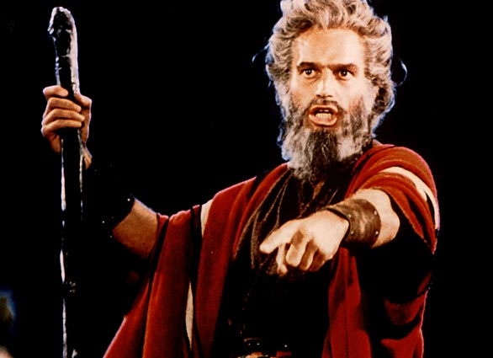
“Thus saith the LORD God of Israel, Let my people go.”

Chapter Six of Exodus provides a reinforcement of God’s Commands to Moses to go before Pharaoh. God, for the first time, reveals His identity as Jehovah – the Existing One; however, this differs little from His previous revelation of Himself as the Great I AM, eternally existing in the Divine Presence.

These are the major topics of the chapter:

- God reassures Moses that He will not only cause Pharaoh to release the Israelites, but cause Him to drive them from Egypt. (Exodus 6:1-5)
- God sends Moses to deliver His message to the Children of Israel. (Exodus 6:6-8)
- They fail to listen due to their oppression. (Exodus 6:9)
- God told Moses to go to tell Pharaoh to let the Israelites go (Exodus 6:10-12)
- Following these events are recorded the names of the family heads of the tribes of Israel. (Exodus 6:13-27)
- Moses again complains of his lack of speaking ability – this is growing old hat. (Exodus 6:28-30)

God gives to Moses His plans to humble Pharaoh and bring His Children out of Egypt. From the historical perspective, we know that this is a sealed and certified event; but remember this is all based on a future promise on the part of God to Israel. Even when God brings a number of plagues against this land and her sovereign, Pharaoh, it seems impossible that the king will let them go. This reminds us of the importance of relying on the perfect Word of God and trust in Him when all else looks impossible.

In a way, Moses is a whiner like many of our own modern-day wonders. He makes excuses and is not very ingenuous at coming up with new, imaginative ones.

God shares His special name with Moses, never before told to any man – Jehovah. This name is referred to as the Tetragrammaton in Hebrew writings and is printed without the vowels thusly, YHVH, (there is no J sound in the Hebrew). It was considered too Holy for man to pronounce so it is thusly written without the vowels.

And God spake unto Moses, and said unto him, I am the LORD: And I appeared unto Abraham, unto Isaac, and unto Jacob, by the name of God Almighty, but by my name JEHOVAH was I not known to them. And I have also established my covenant with them, to give them the land of Canaan, the land of their pilgrimage, wherein they were strangers. And I have also heard the groaning of the children of Israel, whom the Egyptians keep in bondage; and I have remembered my covenant. Wherefore say unto the children of Israel, I am the LORD, and I will bring you out from under the burdens of the Egyptians, and I will rid you out of their bondage, and I will redeem you with a stretched out arm, and with great judgments: And I will take you to me for a people, and I will be to you a God: and ye shall know that I am the LORD your God, which bringeth you out from under the burdens of the Egyptians. And I will bring you in unto the land, concerning the which I did swear to give it to Abraham, to Isaac, and to Jacob; and I will give it you for an heritage: I am the LORD. (Ex 6:2-8)

Notice God finds it necessary to continually remind His prophets of His promises as if teaching a class of first day kindergarteners! We are very quick to learn the ways of the world, but learning the things of God somehow takes much longer. Perhaps it is because the things of God require a response of faith and the things of the world require no faith at all. This reveals the grave necessity of daily Bible readings. How many Christians claim to be Bible scholars but open their Bibles less than once or twice per week instead of daily (or even morning and evening)?

It must be admitted that this business of prophecy is a new thing for Moses. He doesn’t seem to have fallen into stride with it as yet, but he certainly shall do so before the reaches Jordan Waters. “And Moses spake so unto the children of Israel: but they hearkened not unto Moses for anguish of spirit, and for cruel bondage.” (Ex 6:9) If these people had a spark of faith, it seems that they would have eagerly grasped at the hope offered through Moses, but they did not, being a stiff-necked people.

“And the LORD spake unto Moses, saying, Go in, speak unto Pharaoh king of Egypt, that he let the children of Israel go out of his land.” (Ex 6:10-11) Moses fails to realize that God knows exactly what He is talking about. So God orders Moses once more to go before Pharaoh. From the point of view of mortal man, Moses makes perfect sense in his response to the Lord; but to a man of faith, his response is shallow and lacking in true faith. “And Moses spake before the LORD, saying, Behold, the children of Israel have not hearkened unto me; how then shall Pharaoh hear me, who am of uncircumcised lips?” (Ex 6:12) Ah, yes, here we have that same old, bland excuse. But think of the logic in the purely human sense: His own people will not hear and believe. How shall a mighty king hear and believe?

“And the LORD spake unto Moses and unto Aaron, and gave them a charge unto the children of Israel, and unto Pharaoh king of Egypt, to bring the children of Israel out of the land of Egypt.” (Ex 6:13) What part of these General Orders does Moses not understand? They seem fairly clear from my understanding. The Lord is quite narrow-minded is He not. Once He has made a course of action to pursue, neither Hell nor High Water will deter Him. It is a done deed!

I will not labor the reader with the next several verses (14-26) that give a record of the twelve tribes and their family heads, but the reader is urged to consult them for clarity.

“These are they which spake to Pharaoh king of Egypt, to bring out the children of Israel from Egypt: these are that Moses and Aaron.” (Ex 6:27) Despite the groanings of the Children of Israel, their family heads agree to go with Moses, and Aaron before Pharaoh. Moses must have possessed more persuasive power than he imagined to accomplish this. Perhaps that power was God!

Moses is a humble man and here, in these last verses, reviews for us his shortcomings of faith at the time of the Lord’s speaking to him: “And it came to pass on the day when the LORD spake unto Moses in the land of Egypt, That the LORD spake unto Moses, saying, I am the LORD: speak thou unto Pharaoh king of Egypt all that I say unto thee. And Moses said before the LORD, Behold, I am of uncircumcised lips, and how shall Pharaoh hearken unto me?” (Ex 6:28-30) He is perfectly willing to admit that he was weak of faith at first, but, in case you are feeling smug in your faith with your hindsight, would you have responded differently if the Lord commanded you to go to the commander of the murderous ISIS fighters and demand that their hostages be set free? REALLY?

